LEARNING WITH SELECTED FEATURES
ABSTRACT:
Feature selection is the task of choosing a small subset of features that is sufficient to predict the target labels well. Here, instead of trying to directly determine which features are better, we attempt to learn the properties of good features. For this purpose we assume that each feature is represented by a set of properties, referred to as meta-features. This approach enables prediction of the quality of features without measuring their value on the training instances. We use this ability to devise new selection algorithms that can efficiently search for new good features in the presence of a huge number of features, and to dramatically reduce the number of feature measurements needed
EXISTING SYSTEM:
- This observation is notable since it explains the existence of a universal set of features (prototypes) that enables recognition of most objects, regardless of whether the prototypes were taken from pictures that contain the relevant objects or not.
- This result supports the existence of a universal set of features (universal-dictionary) that can be used for recognition of most objects.
- The existence of such a dictionary is a key issue in computer vision and brain research. We also showed that when the selection of features is based on metafeatures it is possible to derive better generalization bounds on the combined problem of selection and classification.

Disadvantage of Existing System
- We demonstrate our algorithms on a handwritten digit recognition problem and a visual object category recognition problem.
- In addition, we show how this novel viewpoint enables derivation of better generalization bounds for the joint learning problem of selection and classification,
- The main motivations for feature selection are computational complexity, reducing the cost of measuring features, improved classification accuracy and problem understanding
PROPOSED SYSTEM :
- Krupka and Tishby (2007) proposed a framework that incorporates prior knowledge on features, which is represented by meta-features, into learning.
- They assume that a weight is assigned to each feature, as in linear discrimination, and they use the meta-features to define a prior on the weights.
- The main motivations for feature selection are computational complexity, reducing the cost of measuring features, improved classification accuracy and problem understanding

ADVANTAGE:
- In feature extraction the original input features (for example, pixels) are used to generate new, more complicated features (for example logical AND of sets of 3 binary pixels).
- In the most common selection paradigm an evaluation function is used to assign scoresto subsets of features and a search algorithm is used to search for a subset with a high score
- While in their work meta-features are used for learning a better classifier, in this work meta-features are used for feature selection
LITRATURE REVIEW:
TITTLE | AUTHOR | DESCRIPTION
The size of the weights is more important than the size of the network. | P.L. Bartlett. | This paper shows that if a large neural network is used for a pattern classification problem, and the learning algorithm finds a network with small weights that has small squared error on the training patterns, then the generalization performance depends on the size of the weights rather than the number of weights.
Learning Theory and Kernel Machines | A. Blum and J. Langford | These methods formulate learning and estimation problems in a reproducing kernel Hilbert space (RKHS) of functions defined on the data domain, expanded in terms of a kernel.
Mcsvm_1.0: C code for multiclass svm, 2003 | K. Crammer. | n this tutorial, we’ll introduce the multiclass classification using Support Vector Machines (SVM). We’ll first see the definitions of classification, multiclass classification, and SVM. .
Training invariant support vector machines., | Big data analytics  services for enhancing business intelligence, | We describe and review all known methods for doing so in support vector machines, provide experimental results, and discuss their respective merits.
INTRODUCTION :
- In many supervised learning tasks the input is represented by a very large number of features, many of which are not needed for predicting the labels. Feature selection is the task of choosing a small subset of features that is sufficient to predict the target labels well.
- The main motivations for feature selection are computational complexity, reducing the cost of measuring features, improved classification accuracy and problem understanding.
- Feature selection is also a crucial component in the context of feature extraction. In feature extraction the original input features (for example, pixels) are used to generate new, more complicated features (for example logical AND of sets of 3 binary pixels). Feature extraction is a very useful tool for producing sophisticated classification rules using simple classifiers
BLOCK DIAGRAM:
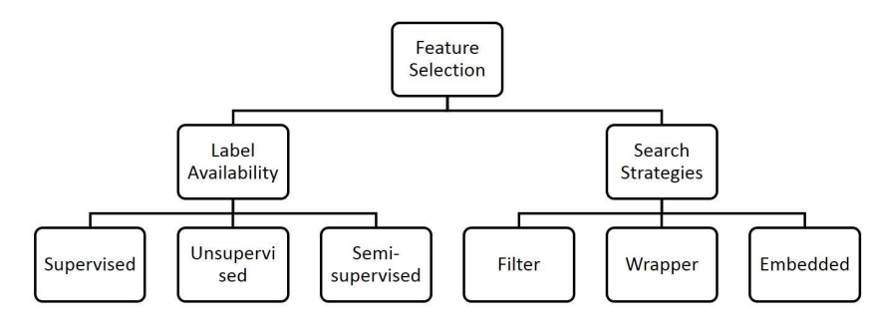
ARCHITECTURE DIAGRAM :
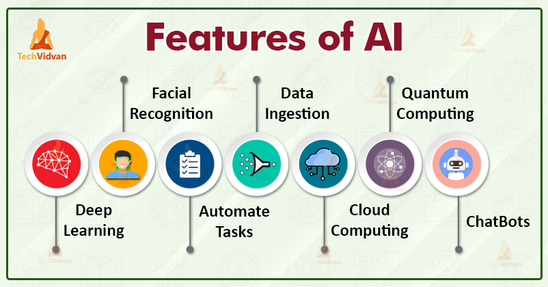
SOFTWARE REQUIREMENTS:
- Operating System : Windows 10
- Platform : python
HARDWARE REQUIREMENTS:
- Keyboard
- Mouse
- Hard disk 500GB
- Ram 4 G

CONCLUTION :
- About the feature search procedure, the number of subsets that can be extracted from the initial set is exponential in the number of initial features.
- In most cases, this results in the impossibility to test all possible subsets, even when the relevance criterion is simple to compute or estimate.
- The distance measure, e.g., the Euclidean distance measure, is a very traditional discrimination or divergence measure.
- The dependence measure, also called the correlation measure, is mainly utilized to find the correlation between two features or a feature and a class.
- The consistency measure is heavily relied on the training data set and discussed for feature selection in Dash and Liu (2003).
REFERENCE :
- 1.P.L. Bartlett. The size of the weights is more important than the size of the network. IEEE Transactions on Information Theory, 1998.
- 2.A. Blum and J. Langford. Pac-mdl bounds. Learning Theory and Kernel Machines, 2003.
- 3.K. Crammer. Mcsvm_1.0: C code for multiclass svm, 2003. http://www.cis.upenn.edu/∼crammer.
- 4.D. Decoste and B. Schölkopf. Training invariant support vector machines. Machine Learning, 2002
- 5.L. Ein-Dor, O. Zuk, and E. Domany. Thousands of samples are needed to generate a robust gene list for predicting outcome in cancer. Proceedings of the National Academy of Sciences, 2006.
- 6.D. Gabor. Theory of communication. J. IEE, 93:429–459, 1946.
- 7.R. Gilad-Bachrach, A. Navot, and N. Tishby. Margin based feature selection - theory and algorithms. In International Conference on Machine Learning (ICML), 2004.
- 8.R. Greiner. Using value of information to learn and classify under hard budgets. In NIPS Workshop on Value of Information in Inference, Learning and Decision-Making, 2005.
- 9.I. Guyon and A. Elisseeff. An introduction to variable and feature selection. Journal of Machine Learning Research, 2003.
- 10.I. Guyon, J. Weston, S. Barnhill, and V. Vapnik. Gene selection for cancer classification using support vector machines. Machine Learning, 46, 2002.
- 11. M. W. Kadous and C. Sammut. Classification of multivariate time series and structured data using constructive induction. Machine Learning, 2005.
- 12.M. J. Kearns and U. V. Vazirani. An Introduction to Computational Learning Theory. MIT Press, Cambridge, MA, USA, 1994.
- 13.R. Kohavi and G.H. John. Wrapper for feature subset selection. Artificial Intelligence, 97(1-2): 273–324, 1997.
- 14.E. Krupka and N. Tishby. Generalization from observed to unobserved features by clustering. Journal of Machine Learning Research, 2008.
- 15. E. Krupka and N. Tishby. Incorporating prior knowledge on features into learning. In International Conference on Artificial Intelligence and Statistics (AISTATS), 2007.

