MACHINE LEARNING TO IDENTIFY PSYCHOMOTOR BEHAVIORS OF DELIRIUM FOR PATIENTS IN LONG-TERM CARE FACILITY
ABSTRACT:
This study aimed to develop accurate and explainable machine learning models for three psychomotor behaviors of delirium for hospitalized adult patients.A prospective pilot study was conducted with 33 participants admitted to a long-term care facility between August 10 and 25, 2020. During the pilot study, we collected 560 cases that included 33 clinical variables and the survey items from the short confusion assessment method (S-CAM), and developed a mobile-based application.Multiple machine learning algorithms, ncluding four rule-mining algorithms (C4.5, CBA, MCAR, and LEM2) and four other statistical learning algorithms (LR, ANNs, SVMs with three kernel functions, and random forest), were validated by paired Wilcoxon signed-rank tests on both macro-averaged F1 and weighted average F1-measures during the 10-times stratified 2-fold cross-validation.
EXISTING SYSTEM:
- Our findings are consistent with those existing in the literature except those related to prevalence. It should be noted that other studies have mainly focused on incidence rather than prevalence
- Moreover, our results, following existing literature, shows that to predict correctly delirium is more useful to use predictive models that consider many factors collected routinely
- These methods may also help in small case-series even if they are thought to be useful for large data sets. MLT can identify complex relations between variables and are helpful in structuring predictive models to personalize healthcare assistance.
Disadvantage of Existing System
- Patients with a psychiatric illness already diagnosed at admission, with communication problems (such as aphasia, coma status), or with a terminal disease, were excluded from the study.
- An experienced nurse explained the purpose of the study and obtained informed consent from the patient or his next of kin when the participant was unable to give his consent. Study participants were evaluated with the 4AT instrument by three trained nursing students.
- The project was conducted within the framework of thesis preparation of the nursing student and it was approved by the internal offices at the University Hospital of Padova.

PROPOSED SYSTEM :
- Previous studies on predicting delirium proposed the Neelon and Champagne confusion scale (NEECHAM)
- This study aimed to develop accurate and explainable machine learning models for three psychomotor behaviors of delirium for hospitalized adult patients
- In particular, the onset of delirium in elderly patients is associated with increased medical expenses, a high risk of falls and bedsores [10, 11], and a higher mortality rate within one year after discharge than in no-delirium inpatients
ADVANTAGE:
- A random forest (RF) algorithm was used to evaluate the association between the subject’s characteristics and the 4AT score screening tool for delirium.
- Both CAM and Nu-DESC scales were used to compare the ability of random forest (RF) models in predicting the risk of delirium episodes
- Bellelli for the first time, used the 4AT score to assess patients at risk for delirium.
- Machine learning techniques (MLTs) have been widely used in data-driven prediction models, for example in dementia or delirium as well with performances comparable with traditional logistic regression and included into clinical workflow
LITRATURE REVIEW:
TITTLE | AUTHOR | DESCRIPTION
Diagnostic and Statistical Manual of Mental Disorders, 5th ed. | AAmerican Psychiatric Association | Since a complete description of the underlying pathological processes is not possible for most mental disorders, it is important to emphasize that the current diagnostic criteria are the best available description.
‘‘A Marker of Vulnerability in Older People | Bellelli, G.; Brathwaite, J.S.; Mazzola, P. Delirium. | Delirium is an acute neuropsychiatric syndrome and one of the most common presenting symptoms of acute medical illnesses in older people.
S.K. Predisposing and Precipitating Factors for Delirium in Hospitalized Older Patients | Inouye, | Although these studies identify key risk factors for delirium, they do not allow the examination of the interrelationship of predisposing and precipitating factors
M. Educating Family Caregivers for Older Adults about Delirium | Bull, M.J.; Boaz, L.; Jermé | Before implementing such partnership models, it is important to examine the effectiveness of educating family caregivers about delirium.
INTRODUCTION :
- Delirium is a psycho-organic syndrome characterized by an alteration in attention and consciousness, with disorganized psychic activity, fragmentation of psychic processes that appear untied and upset.
- Delirium has a multifactorial etiology, in which internal predisposing factors (susceptibility) interact with external precipitating ones .
- In contrast to dementia, delirium is often reversible with early detection and treatment of underlying causes.
- For delirium, there are many risk factors that may change according to the characteristics of the patient.
- In literature, risk factors for delirium were evaluated in systematic reviews according to the type of patients. Risk of delirium is higher in very old patients
BLOCK DIAGRAM:
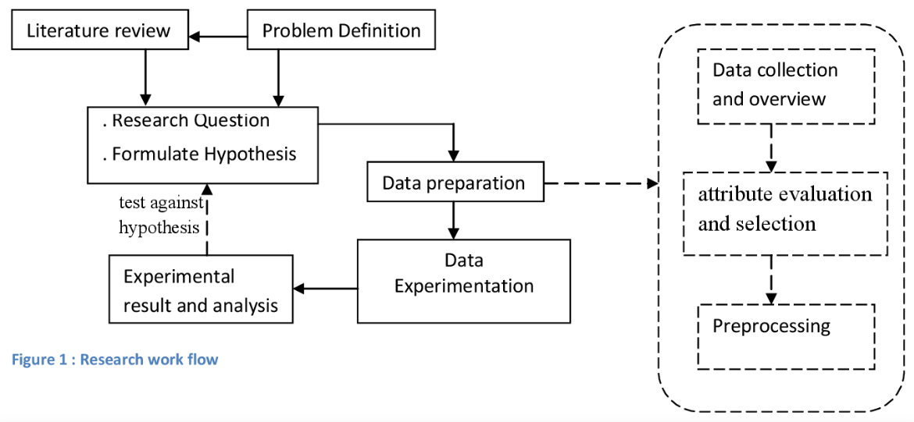
ARCHITECTURE DIAGRAM :
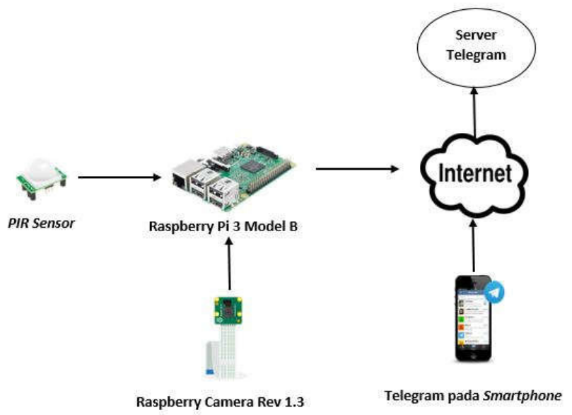

SOFTWARE REQUIREMENTS:
- Operating System : Windows 10
- Platform : python
HARDWARE REQUIREMENTS:
- Keyboard
- Mouse
- Hard disk 500GB
- Ram 4 G

CONCLUTION :
- Early detection of delirium must be a purpose to pursue in wards with a high percentage of risk factors, to adequately treat them and to avoid side effects.
- The routine uses of a simple instrument, such as the 4AT scale, could help to increase the awareness of delirium among health care workers.
- Healthcare personnel, especially nurses, thanks to their strictly engagements with patients, must be trained to easily recognize risk factors for delirium. As hypothesized in the recent work of Oberai et al. 2021 nurses require educational intervention that include a variety of teaching style
REFERENCE :
- 1. American Psychiatric Association. Diagnostic and Statistical Manual of Mental Disorders, 5th ed.; American Psychiatric Association: Washington, DC, USA, 2013; ISBN 978-0-89042-555-8.
- 2. Bellelli, G.; Brathwaite, J.S.; Mazzola, P. Delirium: A Marker of Vulnerability in Older People. Front. Aging Neurosci. 2021, 13, 626127. [CrossRef] [PubMed]
- 3. Inouye, S.K. Predisposing and Precipitating Factors for Delirium in Hospitalized Older Patients. Dement. Geriatr. Cogn. Disord. 1999, 10, 393–400. [CrossRef] [PubMed]
- 4. Bull, M.J.; Boaz, L.; Jermé, M. Educating Family Caregivers for Older Adults about Delirium: A Systematic Review. Worldviews Evid. Based Nurs. 2016, 13, 232–240. [CrossRef] [PubMed]
- 5. Bellelli, G.; Morandi, A.; Di Santo, S.G.; Mazzone, A.; Cherubini, A.; Mossello, E.; Bo, M.; Bianchetti, A.; Rozzini, R.; Zanetti, E.; et al. “Delirium Day”: A Nationwide Point Prevalence Study of Delirium in Older Hospitalized Patients Using an Easy Standardized Diagnostic Tool. BMC Med. 2016, 14, 106. [CrossRef]
- 6. Marquetand, J.; Bode, L.; Fuchs, S.; Hildenbrand, F.; Ernst, J.; von Kaenel, R.; Boettger, S. Risk Factors for Delirium Are Different in the Very Old: A Comparative One-Year Prospective Cohort Study of 5831 Patients. Front. Psychiatry 2021, 12, 655087. [CrossRef]
- 7. Wu, J.; Yin, Y.; Jin, M.; Li, B. The Risk Factors for Postoperative Delirium in Adult Patients after Hip Fracture Surgery: A Systematic Review and Meta-Analysis. Int. J. Geriatr. Psychiatry 2021, 36, 3–14. [CrossRef]
- 8. Visser, L.; Prent, A.; Banning, L.B.D.; van Leeuwen, B.L.; Zeebregts, C.J.; Pol, R.A. Risk Factors for Delirium after Vascular Surgery: A Systematic Review and Meta-Analysis. Ann. Vasc. Surg. 2021. [CrossRef]
- 9. Rong, X.; Ding, Z.-C.; Yu, H.; Yao, S.-Y.; Zhou, Z.-K. Risk Factors of Postoperative Delirium in the Knee and Hip Replacement Patients: A Systematic Review and Meta-Analysis. J. Orthop. Surg. 2021, 16, 76. [CrossRef]
- 10. Tomlinson, E.J.; Phillips, N.M.; Mohebbi, M.; Hutchinson, A.M. Risk Factors for Incident Delirium in an Acute General Medical Setting: A Retrospective Case–Control Study. J. Clin. Nurs. 2017, 26, 658–667. [CrossRef]
- 11. Zhou, S.; Deng, F.; Zhang, J.; Chen, G. Incidence and Risk Factors for Postoperative Delirium after Liver Transplantation: A Systematic Review and Meta-Analysis. Eur. Rev. Med. Pharmacol. Sci. 2021, 25, 3246–3253. [CrossRef]
- 12. Watt, J.; Tricco, A.C.; Talbot-Hamon, C.; Pham, B.; Rios, P.; Grudniewicz, A.; Wong, C.; Sinclair, D.; Straus, S.E. Identifying Older Adults at Risk of Delirium Following Elective Surgery: A Systematic Review and Meta-Analysis. J. Gen. Intern. Med. 2018, 33, 500–509. [CrossRef]
- 13. Maldonado, J.R. Delirium in the Acute Care Setting: Characteristics, Diagnosis and Treatment. Crit. Care Clin. 2008, 24, 657–722. [CrossRef]
- 14. Leslie, D.L.; Marcantonio, E.R.; Zhang, Y.; Leo-Summers, L.; Inouye, S.K. One-Year Health Care Costs Associated with Delirium in the Elderly Population. Arch. Intern. Med. 2008, 168, 27–32. [CrossRef]
- 15. Fortini, A.; Morettini, A.; Tavernese, G.; Facchini, S.; Tofani, L.; Pazzi, M. Delirium in Elderly Patients Hospitalized in Internal Medicine Wards. Intern. Emerg. Med. 2014, 9, 435–441. [CrossRef]

