PREDICTING BRAIN AGE USING MACHINE LEARNING ALGORITHMS A COMPREHENSIVE EVALUATION
ABSTRACT:
The rise of machine learning has unlocked new ways of analysing structural neuroimaging data, including brain age prediction. In this state-of-the-art review, we provide an introduction to the methods and potential clinical applications of brain age prediction. Studies on brain age typically involve the creation of a regression machine learning model of age-related neuroanatomical changes in healthy people. This model is then applied to new subjects to predict their brain age. The difference between predicted brain age and chronological age in a given individual is known as ‘brain-age gap’.
EXISTING SYSTEM:
- The main outcome measure in brain age prediction is the difference between an individual’s predicted age and their chronological age, which is referred to as ‘brain-age gap’ in the present review.
- Studies of clinical groups typically estimate the mean brain-age gap across all patients and then either compare it to the mean brain-age gap of a control group or to zero, where predicted and chronological age are equal
Disadvantage of Existing System
- This outcome can be attributed to LSTM’s storing memory and solving the gradient vanishing problem
- CNN canautomatically notice and extract the appropriate internalstructure from a time series dataset to create in-depthinput features, using convolution and pooling operations.
- Also, CNN and LSTM algorithms are resilient to noisetolerance and accuracy for time-series classiﬁcation.
PROPOSED SYSTEM :
- Brain age models tend to be affected by regression to the mean, so the age of younger subjects is overestimated and the age of older subjects is underestimated.
- Various statistical approaches have been proposed to correct for this age bias . Whether a study took age bias into account therefore is an important factor for their interpretation.

ADVANTAGE:
- Recent studies compared the performance of commonly used models like support vector regression and relevance vector regression to provide guidance on the most suitable model choices for brain age prediction however, as demonstrated by Wolpert in what is known as the ‘no free lunch’ theorem for machine learning, the performance of different models will depend on the characteristics of the datasets, so there is no single best model for a certain task.
- Nevertheless, in direct comparison to the commonly used shallow machine learning approaches like relevance vector regression, deep learning approaches appear to be comparable (MAE 4-5 years) or superior (MAE 7-8 years versus MAE 5-6 years)
LITRATURE REVIEW:
TITTLE | AUTHOR | DESCRIPTION
Estimating the age of healthy subjects € from T1-weighted MRI scans using kernel methods: Exploring the influence of various parameters. | Franke K, Ziegler G, Kloppel S, Gaser C. | The early identification of brain anatomy deviating from the normal pattern of growth and atrophy, such as in Alzheimer's disease (AD), has the potential to improve clinical outcomes through early intervention.
‘‘Introduction to machine learning. In: Mechelli A, Vieira S, editors. Machine learning: Methods and applications to brain disorders. Academic Press | Vieira S, Pinaya W, Mechelli A. | Machine Learning is an area of artificial intelligence involving the development of algorithms to discover trends and patterns in existing data.
Predicting age using neuroimaging: Innovative brain ageing biomarkers. Trends Neurosci | ] Cole JH, Franke K | The brain changes as we age and these changes are associated with functional deterioration and neurodegenerative disease.
Brain age predicts mortality., | Big data analytics  services for enhancing business intelligence, | Age-associated disease and disability are placing a growing burden on society. However, ageing does not affect people uniformly.

INTRODUCTION :
- Ageing and its associated health conditions present a major challenge to individuals and societies worldwide.
- To address this challenge, increasing efforts are being made towards the early detection of age-related diseases with the ultimate aim of preventing or delaying their progression.
- The effects of ageing on the brain can be measured through an approach known as brain age prediction, which builds on the well-established relationship between age and neuroanatomy across the lifespan
- The past decade has seen an exponential increase in studies on brain age .
- The majority of these involve the application of machine learning methods to structural neuroimaging data.
BLOCK DIAGRAM:
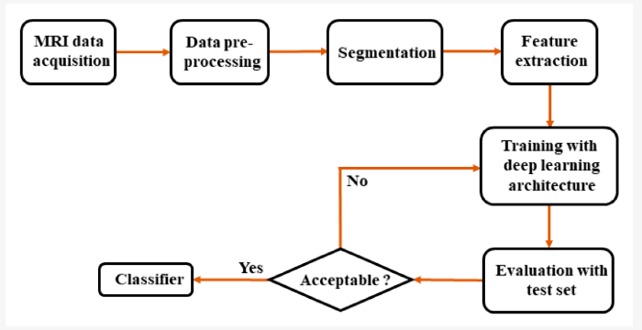
ARCHITECTURE DIAGRAM :
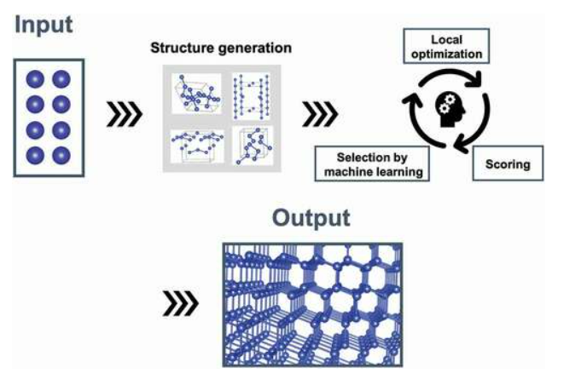
SOFTWARE REQUIREMENTS:
- Operating System : Windows 10
- Platform : python
HARDWARE REQUIREMENTS:
- Keyboard
- Mouse
- Hard disk 500GB
- Ram 4 G

CONCLUTION :
- The increasing recognition of the clinical potential of brain age prediction has led to an exponential increase in the number of patient studies, but it has not been translated to clinical practice yet.
- Its clinical implementation will require greater evidence of clinical utility and cost-effectiveness, as well as translation of current machine learning models into practical and acceptable tools that can be used by clinicians without specialised methodological expertise.
- To this end, the brain-age gap of an individual patient could be integrated within personalised reports of online clinical tools
REFERENCE :
- [1] Franke K, Ziegler G, Kloppel S, Gaser C. Estimating the age of healthy subjects € from T1-weighted MRI scans using kernel methods: Exploring the influence of various parameters. Neuroimage 2010;50(3):883–92.
- [2] Vieira S, Pinaya W, Mechelli A. Introduction to machine learning. In: Mechelli A, Vieira S, editors. Machine learning: Methods and applications to brain disorders. Academic Press; 2020. p. 1–20.
- [3] Cole JH, Franke K. Predicting age using neuroimaging: Innovative brain ageing biomarkers. Trends Neurosci 2017;40(12):681–90.
- [4] Cole JH, Ritchie SJ, Bastin ME, Valdes Hern andez MC, Munoz Maniega S, Royle N, ~ et al. Brain age predicts mortality. Mol Psychiatry 2018;23:1385–92.
- [5] Lombardi A, Monaco A, Donvito G, Amoroso N, Bellotti R, Tangaro S. Brain Age Prediction With Morphological Features Using Deep Neural Networks: Results From Predictive Analytic Competition 2019. Front Psychiatry 2021;11(January):1–15.
- [6] Han LKM, Dinga R, Hahn T, Ching CRK, Eyler LT, Aftanas L, et al. Brain aging in major depressive disorder: results from the ENIGMA major depressive disorder working group. Mol Psychiatry 2020.
- [7] Valizadeh SA, H€ anggi J, Merillat S, J ancke L. Age prediction on the basis of brain € anatomical measures. Hum Brain Mapp 2017;38(2):997–1008.
- [8] Gutierrez Becker B, Klein T, Wachinger C. Gaussian process uncertainty in age estimation as a measure of brain abnormality. Neuroimage 2018;175 (March):246–58.
- [9] Aycheh HM, Seong JK, Shin JH, Na DL, Kang B, Seo SW, et al. Biological brain age prediction using cortical thickness data: A large scale cohort study. Front Aging Neurosci 2018;10(252):1–14.
- [10] Chung Y, Addington J, Bearden CE, Cadenhead K, Cornblatt B, Mathalon DH, et al. Use of machine learning to determine deviance in neuroanatomical maturity associated with future psychosis in youths at clinically high risk. JAMA Psychiatry 2018;75(9):960–8.
- [11] Le TT, Kuplicki RT, McKinney BA, Yeh H-W, Thompson WK, Paulus MP, et al. A nonlinear simulation framework supports adjusting for age when analyzing BrainAGE. Front Aging Neurosci 2018;10(317):1–11.
- [12] Lee WH, Antoniades M, Schnack HG, Kahn RS, Frangou S. Brain age prediction in schizophrenia: does the choice of machine learning algorithm matter? Psychiatr Res Neuroimaging 2021;310(111270):1–8.
- [13] Monte-Rubio GC, Falc on C, Pomarol-Clotet E, Ashburner J. A comparison of vari- ous MRI feature types for characterizing whole brain anatomical differences using linear pattern recognition methods. Neuroimage 2018;178(May):753–68.
- [14] Ly M, Yu GZ, Karim HT, Muppidi NR, Mizuno A, Klunk WE, et al. Improving brain age prediction models: Incorporation of amyloid status in Alzheimer’s disease. Neurobiol Aging 2020;87:44–8.
- [15] Lowe LC, Gaser C, Franke K. The effect of the APOE genotype on individual Brain- € AGE in normal aging, Mild cognitive impairment, and Alzheimer’s Disease. PLoS One 2016;11(7):1–25

