QUANTUM-INSPIRED MACHINE LEARNING FOR 6G FUNDAMENTALS, SECURITY, RESOURCE ALLOCATIONS, CHALLENGES, AND FUTURE RESEARCH DIRECTIONS
ABSTRACT:
Quantum computing is envisaged as an evolving paradigm for solving computationally complex optimization problems with a large-number factorization and exhaustive search.Recently, there has been a proliferating growth of the size of multi-dimensional datasets, the input-output space dimensionality, and data structures. Hence, the conventional machine learning approaches in data training and processing have exhibited their limited computing capabilities to support the sixth-generation (6G) networks with highly dynamic applications and servicesIn this regard, the fast developing quantum computing with machine learning for 6G networks is investigated. Quantum machine learning algorithm can significantly enhance the processing efficiency and exponentially computational speed-up for effective quantum data representation and superposition framework, highly capable of guaranteeing high data storage and secured communications.We present the state-of-the-art in quantum computing and provide a comprehensive overview of its potential, via machine learning approaches.

EXISTING SYSTEM:
- Building fault-tolerant solutions for deploying quantum-inspired ML is an important direction to explore, and it is worth considering how existing solutions would be scaled to fit the requirements of security for the new generation of radios.
- The only difference in their operations lies in the communication between the network layers. For classical NNs, at the end of a given process, the existing perceptron duplicates its output to the next perceptron layer of the network.
Disadvantage of Existing System
- Quantum computing is envisaged as an evolving paradigm for solving computationally complex optimization problems with a large-number factorization and exhaustive search.
- “The curse of dimensionality” coupled with the exploration strategy problem leads to difficult problems in practical applications as the number of datasets grows exponentially with its dimension.
- The emerging QC is a promising paradigm and can play a significant role in addressing computationally complex problems, such as large-number factorization non-convex optimization, and exhaustive computation and search.
PROPOSED SYSTEM :
- QC capabilities incorporated into ML are proposed to address this challenge. The integration of QC capability with the ML algorithms can help in the effective utilization of big data analytic in the IoT environments
- A graph neural network-based framework was proposed to address resource allocation problems in wireless IoT networks
- To address the issue of big data, a quantum-inspired SVM algorithm has been proposed to enhance achieve exponential speed-up for least squares SVM
- Specifically a topic like a hybrid algorithm, proposed algorithms that partially run both on quantum computers and classical computers can be further investigated.
ADVANTAGE:
- A cost function is used to determine the effectiveness of a NN, which measures the network output proximity to the expected output
- An unsupervised machine learning (UML) algorithm is used to analyze and classify unlabeled datasets
- The role of oracles, which are used differently for algorithms providing security to the networks and infrastructures. Security of quantum-inspired ML for 6G would need a considerable understanding of the post-quantum attacks as the protocols built for quantum-enabled systems are breachable with enhanced capacity, computing power and cloning
LITRATURE REVIEW:
TITTLE | AUTHOR | DESCRIPTION
‘Wireless Information and Power Transfer: Theory and Practice | D. W. K. Ng, T. Q. Duong, C. Zhong and R. Schober, | The volume bridges the gap between theory and practice, contains an informative introduction to the topic and offers an overview of the important challenges regarding WIPT systems and communications networks..
‘‘"An adaptive network security system for iot-enabled maritime transportation", ,” . | E. Gyamfi, J. A. Ansere, M. Kamal, M. Tariq and A. Jurcut, , | The dynamics in the attack processes in IoT-enabled MTS networks keep changing, which makes a traditional offline or batch ML-based attack detection systems intractable to apply.
"5G optimized caching and downlink resource sharing for smart cities", | N.-S. Vo, T. Q. Duong, M. Guizani and A. Kortun | In smart cities, millions of things, systems, and people are interconnected and communicate with each other over wireless sensor networks, Internet of Things (IoT), and 5G networks.
An overview of sustainable green 5G networks" | Q. Wu, G. Y. Li, W. Chen, D. W. K. Ng and R. Schober, | In addition, some technical challenges and potential research topics for realizing sustainable green 5G networks are also identified.

INTRODUCTION :
- Due to the rapid growth of dimensionality of the sample input and output space, huge data processing, and limited storage capacity, data training via traditional machine learning (ML) methods using out-fashioned central processing units is faced with data transmission delays.
- Specifically, the optimal resource allocation for future wireless communications is a major research challenge.
- With the rising pace and continuous demands of wireless data traffic, a prolific beyond fifth-generation (5G) is a promising technology for future mobile communication .

BLOCK DIAGRAM:
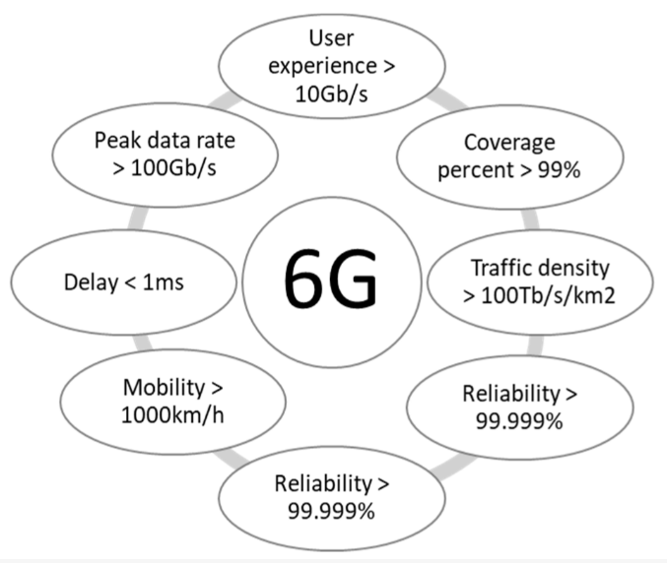

ARCHITECTURE DIAGRAM :

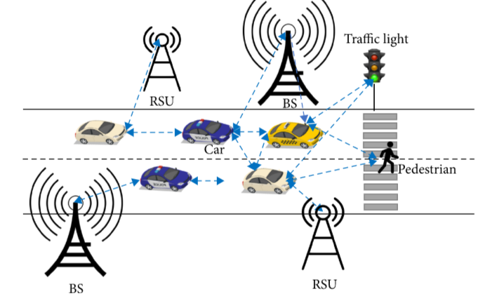

SOFTWARE REQUIREMENTS:
- Operating System : Windows 10
- Platform : python

HARDWARE REQUIREMENTS:
- Keyboard
- Mouse
- Hard disk 500GB
- Ram 4 G

CONCLUTION :
- This work has extensively reviewed the emerging technologies over QC with ML, 6G technology, classical computers, and quantum ML algorithms.
- More importantly, several potential applications for quantum ML algorithms have been identified and discussed.
- Furthermore, this study provides the recent novel applications of quantum-inspired future networks, research challenges and future directions.
- Therefore, this study provides insights into QC with ML and offers substantial guidelines for the quantum developers and researchers of the next generation of quantum computers and how they transform the quantum ML algorithms into practical applications

REFERENCE :
- 1.D. W. K. Ng, T. Q. Duong, C. Zhong and R. Schober, Wireless Information and Power Transfer: Theory and Practice, Hoboken, NJ, USA:Wiley, 2019.
- 2.E. Gyamfi, J. A. Ansere, M. Kamal, M. Tariq and A. Jurcut, "An adaptive network security system for iot-enabled maritime transportation", IEEE Trans. Intell. Transp. Syst..
- 3.N.-S. Vo, T. Q. Duong, M. Guizani and A. Kortun, "5G optimized caching and downlink resource sharing for smart cities", IEEE Access, vol. 6, pp. 31457-31468, Aug. 2018.
- 4.Q. Wu, G. Y. Li, W. Chen, D. W. K. Ng and R. Schober, "An overview of sustainable green 5G networks", IEEE Wireless Commun., vol. 24, no. 4, pp. 72-80, Aug. 2017.
- 5.M. Giordani, M. Polese, M. Mezzavilla, S. Rangan and M. Zorzi, "Toward 6G networks: Use cases and technologies", IEEE Commun. Mag., vol. 58, no. 3, pp. 55-61, Mar. 2020.
- 6.G. Moore, "Moore's law", Electron. Mag., vol. 38, no. 8, 1965.
- 7.J. Vos, Quantum Computing in Action, New York, NY, USA:Simon and Schuster, 2022.
- 8.T. Hey, "Quantum computing: An introduction", Comput. Control Eng. J., vol. 10, no. 3, pp. 105-112, 1999
- 9.M. Hirvensalo, Quantum Computing, Berlin, Germany:Springer, 2003.
- 10.J. Nötzel and S. DiAdamo, "Entanglement-enhanced communication networks", Proc. IEEE Int. Conf. Quantum Comput. Eng., pp. 242-248, 2020.
- 11.T. Q. Duong, L. D. Nguyen, B. Narottama, J. A. Ansere, D. V. Huynh and H. Shin, "Quantum-inspired real-time optimisation for 6G networks: Opportunities challenges and the road ahead", IEEE Open J. Commun. Soc., vol. 3, pp. 1347-1359, 2022
- 12.D. Cozzolino, B. Da Lio, D. Bacco and L. K. Oxenløwe, "High-dimensional quantum communication: Benefits progress and future challenges", Adv. Quantum Technol., vol. 2, no. 12, 2019.
- 13.C. P. Williams et al., Explorations in Quantum Computing, Berlin, Germany:Springer, 1998.
- 14.A. Ekert and D. Bouwmeester, The Physics of Quantum Information: Quantum Cryptography Quantum Teleportation Quantum Computation, Berlin, Germany:Springer, 2000.
- 15.D. Daoyi, C. Chunlin and L. Hanxiong, "Reinforcement strategy using quantum amplitude amplification for robot learning", Proc. Chin. Control Conf., pp. 571-575, 2007.

