PREDICTION OF DIABETES EMPOWERED WITH FUSED MACHINE LEARNING
ABSTRACT:
In the medical field, it is essential to predict diseases early to prevent them. Diabetes is one of the most dangerous diseases all over the world. In modern lifestyles, sugar and fat are typically present in our dietary habits, which have increased the risk of diabetes To predict the disease, it is extremely important to understand its symptoms. Currently, machine-learning (ML) algorithms are valuable for disease detection.This article presents a model using a fused machine learning approach for diabetes prediction
EXISTING SYSTEM:
- The existing fuzzy decision system has achieved the accuracy of 94.87, which is higher than the other existing systems
- Through this diagnosis model, we can save several lives.
- Moreover, the death ratio of diabetes can be controlled if the disease is diagnosed and preventative measures are taken in early-stage.
Disadvantage of Existing System
- These algorithms are selected in this research after some initial experiments where we have found these techniques more effective for this problem.
- We used various accuracy measures, including: accuracy, specificity, sensitivity, precision, and F1 score in the Performance Evaluation stage.
- If the proposed model does not meet the learning requirements, it will be retrained
PROPOSED SYSTEM :
- The proposed fused ML model has a prediction accuracy of 94.87, which is higher than the previously published methods.
- The dataset used in the proposed system comes from the (University of California Irvine) UCI Machine Learning repository compiled by the hospital of Sylhet, Bangladesh.
- proposed a model that uses four ML algorithms – Support Vector Machine (SVM), C4.5 Decision Tree, K-Nearest Neighbor (KNN), and Naive Bayes to predict diabetes

ADVANTAGE:
- The dataset used in this research is divided into training data and testing data with a ratio of 70:30 respectively.
- The dataset used in the comes from the (University of California Irvine) UCI Machine Learning repository compiled by the hospital of Sylhet, Bangladesh.
LITRATURE REVIEW:
TITTLE | AUTHOR | DESCRIPTION
‘, Computer Vision and Machine Intelligence in Medical Image Analysis. London, U.K.: Springer,, | F. Islam, R. Ferdousi, S. Rahman, and H. Y. Bushra | The recent development in the areas of deep learning and deep convolutional neural networks has significantly progressed and advanced the field of computer vision and image analysis and understanding.
‘‘“WHO Reveals Leading Causes of Death and Disability | World Health Organization (WHO). | The estimates reveal trends over the last 2 decades in mortality and morbidity caused by diseases and injuries
UCI Machine Learning Repository | A. Frank and A. Asuncion | The UCI Machine Learning Repository is a collection of databases, domain theories, and data generators that are used by the machine learning community for the empirical analysis of machine learning algorithms.
A study on various machine learning algorithms used for prediction of diabetes mellitus,’ | G. Pradhan, R. Pradhan, and B. Khandelwal, | Diabetes mellitus (DM) has become one of the common disease in middle- and low-income countries.

INTRODUCTION :
- Diabetes is one of the world’s largest ongoing chronic metabolic disorders.
- There are two types of diabetes, Type-1, and Type-2. When the immune system damages pancreatic Beta cells (β-cells), Type-1 diabetes transpires inside the body, which leads to the release a tiny amount of insulin or no insulin.
- Type-2 diabetes is an autoimmune disease in which cells of the body fail to interact with insulin, or the pancreatic cells do not produce enough insulin to regulate blood glucose levels.
BLOCK DIAGRAM:
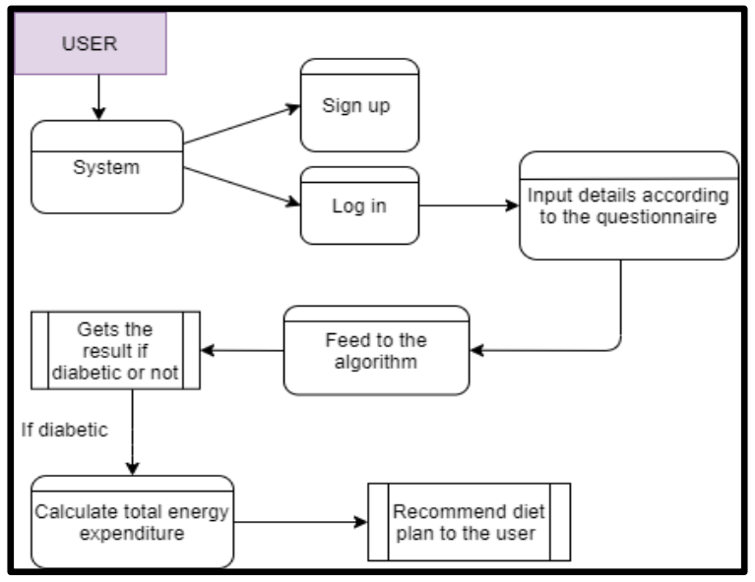
ARCHITECTURE DIAGRAM :
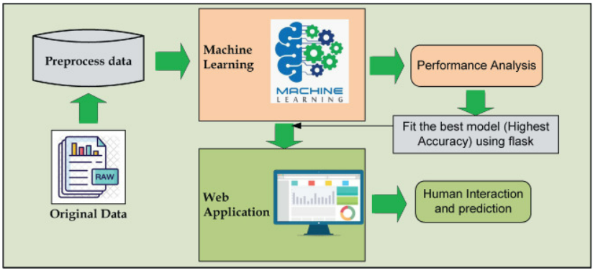

SOFTWARE REQUIREMENTS:
- Operating System : Windows 10
- Platform : python
HARDWARE REQUIREMENTS:
- Keyboard
- Mouse
- Hard disk 500GB
- Ram 4 G

CONCLUTION :
Though different models had been used for the prediction of diabetes, the accuracy of the proposed models in disease prediction has always been the main concern of researchers. Therefore, a new model is required in order to achieve higher prediction accuracy in diabetes predicti This researchproposed a machine learning based diabetes decision support system by using decision level fusion. Two widely used machine learning techniques are integrated in the proposed model by using the fuzzy logic. The proposed fuzzy decision system has achieved the accuracy of 94.87, which is higher than the other existing systems.

REFERENCE :
- [1] F. Islam, R. Ferdousi, S. Rahman, and H. Y. Bushra, Computer Vision and Machine Intelligence in Medical Image Analysis. London, U.K.: Springer, 2019.
- [2] World Health Organization (WHO). (2020). WHO Reveals Leading Causes of Death and Disability Worldwide: 2000–2019. Accessed: Oct. 22, 2021. [Online]. Available: https://www.who.int/news/item/09-12-2020-whoreveals-leading-causes-of-death-and-disability-worldwide-2000-2019
- [3] A. Frank and A. Asuncion. (2010). UCI Machine Learning Repository. Accessed: Oct. 22, 2021. [Online]. Available: http://archive.ics.uci.edu/ml
- [4] G. Pradhan, R. Pradhan, and B. Khandelwal, ‘‘A study on various machine learning algorithms used for prediction of diabetes mellitus,’’ in Soft Computing Techniques and Applications (Advances in Intelligent Systems and Computing), vol. 1248. London, U.K.: Springer, 2021, pp. 553–561, doi: 10.1007/978-981-15-7394-1_50.
- [5] S. Kumari, D. Kumar, and M. Mittal, ‘‘An ensemble approach for classification and prediction of diabetes mellitus using soft voting classifier,’’ Int. J. Cogn. Comput. Eng., vol. 2, pp. 40–46, Jun. 2021, doi: 10.1016/j.ijcce.2021.01.001.
- [6] M. A. Sarwar, N. Kamal, W. Hamid, and M. A. Shah, ‘‘Prediction of diabetes using machine learning algorithms in healthcare,’’ in Proc. 24th Int. Conf. Autom. Comput. (ICAC), Sep. 2018, pp. 6–7, doi: 10.23919/IConAC.2018.8748992.
- [7] S. K. Dey, A. Hossain, and M. M. Rahman, ‘‘Implementation of a web application to predict diabetes disease: An approach using machine learning algorithm,’’ in Proc. 21st Int. Conf. Comput. Inf. Technol. (ICCIT), Dec. 2018, pp. 21–23, doi: 10.1109/ICCITECHN.2018.8631968.
- [8] A. Mir and S. N. Dhage, ‘‘Diabetes disease prediction using machine learning on big data of healthcare,’’ in Proc. 4th Int. Conf. Comput. Commun. Control Autom. (ICCUBEA), Aug. 2018, pp. 1–6, doi: 10.1109/ICCUBEA.2018.8697439. .
- [9] S. Saru and S. Subashree. Analysis and Prediction of Diabetes Using Machine Learning. Accessed: Oct. 22, 2022. [Online]. Available: https://papers.ssrn.com/sol3/papers.cfm?abstract_id=3368308
- [10] P. Sonar and K. JayaMalini, ‘‘Diabetes prediction using different machine learning approaches,’’ in Proc. 3rd Int. Conf. Comput. Methodologies Commun.
- [11] S. Wei, X. Zhao, and C. Miao, ‘‘A comprehensive exploration to the machine learning techniques for diabetes identification,’’ in Proc. IEEE 4th World Forum Internet Things (WF-IoT), Feb. 2018, pp. 291–295, doi: 10.1109/WF-IoT.2018.8355130.
- [12] M. F. Faruque and I. H. Sarker, ‘‘Performance analysis of machine learning techniques to predict diabetes mellitus,’’ in Proc. Int. Conf. Electr., Comput. Commun. Eng. (ECCE), Feb. 2019, pp. 7–9, doi: 10.1109/ECACE.2019.8679365.
- [13] B. Jain, N. Ranawat, P. Chittora, P. Chakrabarti, and S. Poddar, ‘‘A machine learning perspective: To analyze diabetes,’’ Mater. Today: Proc., pp. 1–5, Feb. 2021, doi: 10.1016/J.MATPR.2020.12.445.
- [14] N. B. Padmavathi, ‘‘Comparative study of kernel SVM and ANN classifiers for brain neoplasm classification,’’ in Proc. Int. Conf. Intell. Comput., Instrum. Control Technol. (ICICICT), Jul. 2017, pp. 469–473, doi: 10.1109/ICICICT1.2017.8342608.
- [15] J. Liu, J. Feng, and X. Gao, ‘‘Fault diagnosis of rod pumping wells based on support vector machine optimized by improved chicken swarm optimization,’’ IEEE Access, vol. 7, pp. 171598–171608, 2019, doi: 10.1109/ACCESS.2019.2956221.

