META-TRANSFER LEARNING THROUGH HARD TASKS
ABSTRACT:
Meta-learning has been proposed as a framework to address the challenging few-shot learning setting. The key idea is to leverage a large number of similar few-shot tasks in order to learn how to adapt a base-learner to a new task for which only a few labeled samples are available. As deep neural networks (DNNs) tend to overfit using a few samples only, typical meta-learning models use shallow neural networks, thus limiting its effectiveness.
EXISTING SYSTEM:
- Typically, DNN weights are either fixed for feature extraction or simply fine-tuned for each task, while we learn a meta-transfer learner through all tasks, which is different in terms of the underlying learning paradigm.
- More importantly, our approach can generalize to existing few-shot learning models whose image features are extracted from DNNs on different architectures, for which we conduct extensive experiments
Disadvantage of Existing System
- It does not change DNN weights, thereby avoiding the problem of “catastrophic forgetting” when learning specific tasks in MTL
- This demonstrates our contribution of utilizing deeper neural networks to better tackle the few-shot classification problems.
- MTL” obtain consistent performance improvements over the original methods in both normal and challenging SSFSL settings by quit large margins, e.g. 13.7% on tieredImageNet w/D 1-shot. This validates the effectiveness of our method for tackling SSFSL problems.
PROPOSED SYSTEM :
- Meta-learning has been proposed as a framework to address the challenging few-shot learning setting
- Extensive comparisons to related works validate that our MTL approach trained with the proposed HT meta-batch scheme achieves top performance.
- A straight forward idea is to increase the amount of available data by data augmentation techniques . Several methods proposed to learn a data generator
- The bottom blocks compare the proposed HT meta-batch with the conventional meta-batch Note that here the FT stands for fine-tuning a classifier.

ADVANTAGE:
- Besides, the knowledge to transfer can be from multi-modal category models, e.g. the word embedding models used for zero-shot learning and trained attribute models used for social relationship recognition
- Then, we introduce the task-level data denotations used at two phases, i.e., meta-train and meta-test
- Stage-1 is called base-learning, where the crossentropy loss is used to optimize the parameters of the base-learner.
- The test loss is used to optimize the parameters of the meta-learner.
LITRATURE REVIEW:
TITTLE | AUTHOR | DESCRIPTION
‘Meta-transfer learning for few-shot learning, | Q. Sun, Y. Liu, T.-S. Chua, and B. Schiele | The key idea is to leverage a large number of similar few-shot tasks in order to learn how to adapt a base-learner to a new task for which only a few labeled samples are available.
‘‘“Meta-learning for semi-supervised fewshot classification,” . | M. Ren, E. Triantafillou, S. Ravi, J. Snell, K. Swersky, J. B. Tenenbaum, H. Larochelle, and R. S. Zemel, | In few-shot classification, we are interested in learning algorithms that train a classifier from only a handful of labeled
Deep learning,” Nature, | L. Yann, B. Yoshua, and H. Geoffrey, , | Deep learning allows computational models that are composed of multiple processing layers to learn representations of data with multiple levels of abstraction.
Deep residual learning for image recognition, | K. He, X. Zhang, S. Ren, and J. Sun,. | We present a residual learning framework to ease the training of networks that are substantially deeper than those used previously.

INTRODUCTION :
- A LTHOUGH deep learning systems have achieved great performance when sufficient amounts of labeled data are available there has been growing interest in reducing the required amount of data. Few-shot learning tasks have been defined for this purpose.
- The aim is to learn new concepts from a handful of training examples, e.g. from 1 or 5 training images.
- Humans tend to be highly effective in this context, often grasping the essential connection between new concepts and their own knowledge and experience, but it remains challenging for machine learning models.
BLOCK DIAGRAM:
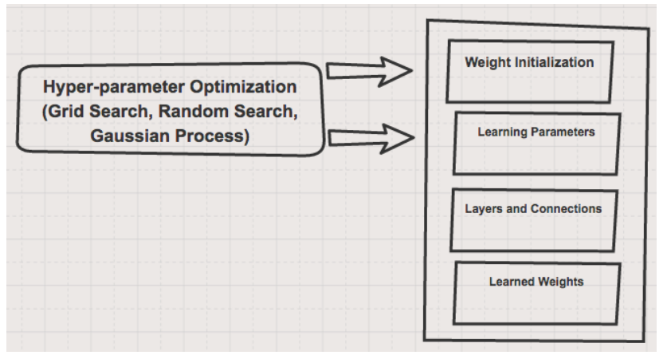
ARCHITECTURE DIAGRAM :
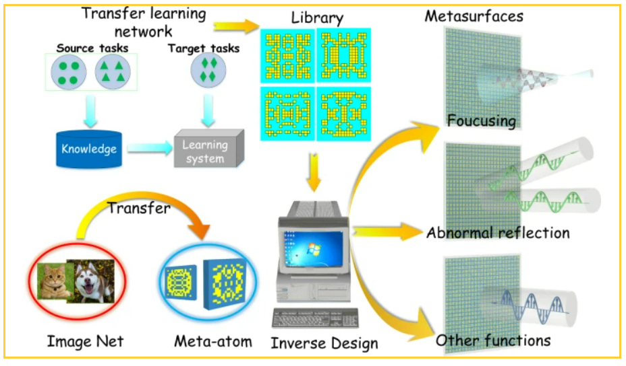
SOFTWARE REQUIREMENTS:
- Operating System : Windows 10
- Platform : python
HARDWARE REQUIREMENTS:
- Keyboard
- Mouse
- Hard disk 500GB
- Ram 4 G

CONCLUTION :
- In this paper, we show that our novel MTL model trained with HT meta-batch learning curriculum achieves the top performance for tackling few-shot learning problems.
- The key operations of MTL on pre-trained DNN neurons proved to be highly efficient for adapting learning experience to the unseen task.
- The superiority was particularly achieved in the extreme 1-shot cases on three challenging benchmarks – miniImageNet, tieredImageNet and FC100.
- The generalization ability of our method is validated by implementing MTL on the classical supervised few-shot models as well as the state-of-the-art semi-supervised few-shot models.
REFERENCE :
- [1] Q. Sun, Y. Liu, T.-S. Chua, and B. Schiele, “Meta-transfer learning for few-shot learning,” in CVPR, 2019.
- [2] M. Ren, E. Triantafillou, S. Ravi, J. Snell, K. Swersky, J. B. Tenenbaum, H. Larochelle, and R. S. Zemel, “Meta-learning for semi-supervised fewshot classification,” in ICLR, 2018.
- 3] L. Yann, B. Yoshua, and H. Geoffrey, “Deep learning,” Nature, vol. 521(7553), p. 436, 2015.
- [4] K. He, X. Zhang, S. Ren, and J. Sun, “Deep residual learning for image recognition,” in CVPR, 2016.
- [5] E. Shelhamer, J. Long, and T. Darrell, “Fully convolutional networks for semantic segmentation,” IEEE Trans. Pattern Anal. Mach. Intell., vol. 39, no. 4, pp. 640–651, 2017.

- [6] F. Li, R. Fergus, and P. Perona, “One-shot learning of object categories,” IEEE Trans. Pattern Anal. Mach. Intell., vol. 28, no. 4, pp. 594–611, 2006.
- [7] C. Finn, P. Abbeel, and S. Levine, “Model-agnostic meta-learning for fast adaptation of deep networks,” in ICML, 2017.
- [8] D. Clevert, T. Unterthiner, and S. Hochreiter, “Fast and accurate deep network learning by exponential linear units (elus),” in ICLR, 2016.
- [9] S. J. Pan, I. W. Tsang, J. T. Kwok, and Q. Yang, “Domain adaptation via transfer component analysis,” IEEE Trans. Neural Networks, vol. 22, no. 2, pp. 199–210, 2011.
- [10] A. Khoreva, R. Benenson, E. Ilg, T. Brox, and B. Schiele, “Lucid data dreaming for object tracking,” arXiv, vol. 1703.09554, 2017.
- [11] A. Mehrotra and A. Dukkipati, “Generative adversarial residual pairwise networks for one shot learning,” arXiv, vol. 1703.08033, 2017.
- [12] E. Schwartz, L. Karlinsky, J. Shtok, S. Harary, M. Marder, R. S. Feris, A. Kumar, R. Giryes, and A. M. Bronstein, “Delta-encoder: an effective sample synthesis method for few-shot object recognition,” in NeurIPS, 2018.
- [13] Y. Wang, R. B. Girshick, M. Hebert, and B. Hariharan, “Low-shot learning from imaginary data,” in CVPR, 2018.
- [14] Y. Xian, S. Sharma, B. Schiele, and Z. Akata, “f-VAEGAN-D2: A feature generating framework for any-shot learning,” in CVPR, 2019.
- [15] S. Bartunov and D. P. Vetrov, “Few-shot generative modelling with generative matching networks,” in AISTATS, 2018.

