MACHINE LEARNING BASED HEALTHCARE SYSTEM FOR INVESTIGATING THE.ASSOCIATION BETWEEN DEPRESSION AND QUALITY OF LIFE
ABSTRACT:
Machine learning (ML) algorithms are nowadays widely adopted in different contexts to perform autonomous decisions and predictions. Due to the high volume of data shared in the recent years, ML algorithms are more accurate and reliable since training and testing phases are more precise. An important concept to analyze when defining ML algorithms concerns adversarial machine learning attacks. These attacks aim to create manipulated datasets to mislead ML algorithm decisions. In this work, we propose new approaches able to detect and mitigate malicious adversarial machine learning attacks against a ML system. In particular, we investigate the Carlini-Wagner (CW), the fast gradient sign method (FGSM) and the Jacobian based saliency map (JSMA) attacksThe aim of this work is to exploit detection algorithms as countermeasures to these attacks. Initially, we performed some tests by using canonical ML algorithms with a hyperparameters optimization to improve metrics.Then, we adopt original reliable AI algorithms, either based on eXplainable AI (Logic Learning Machine) or Support Vector Data Description (SVDD). The obtained results show how the classical algorithms may fail to identify an adversarial attack, while the reliable AI methodologies are more prone to correctly detect a possible adversarial machine learning attack. The evaluation of the proposed methodology was carried out in terms of good balance between FPR and FNR on real world application datasets

EXISTING SYSTEM:
- Until now, this attack is considered as the most powerful among the existing attacks. Obviously, since the generation of malicious adversarial data is very accurate, computational times can be very long.
- ML and artificial intelligence (AI) algorithms have been applied to many and different contexts in recent years, from the healthcare world to intrusion detection systems in the field of IoT security.
Disadvantage of Existing System
- We chose the mentioned algorithms as they are among the most used ones for binary classification problems in recent machine learning literature .
- In the platooning dataset, on the other hand, a strong superposition of points between the two classes makes the detection a hard task. Finally, in the RUL estimation original problem, the healthy and fault classes are quite well separated and we will investigate how the different proposed attacks impact on this base performance
PROPOSED SYSTEM :
- The proposed activities are tested and evaluated on three different datasets: the first one is focused on network security (in particular, a DNS tunneling communication), the second one focused on vehicle platooning and the third one is a benchmark in predictive maintenance, consisting in Remaining Useful Life (RUL) estimation.
- Finally, in the RUL estimation original problem, the healthy and fault classes are quite well separated and we will investigate how the different proposed attacks impact on this base performance.

ADVANTAGE:
- Machine learning (ML) has become an increasingly used technology in every aspect of our lives.
- Then offers a broad overview of the most widely used and efficient methodologies for dealing with adversary attacks in AI fields.
- The perturbations performed by the adversarial machine learning attacks aim to be minimal to fool the model without an obvious change in the data used.
- We chose the mentioned algorithms as they are among the most used ones for binary classification problems in recent machine learning literature
LITRATURE REVIEW:
TITTLE | AUTHOR | DESCRIPTION
‘‘Machine learning: Trends, perspectives, and prospects. | Jordan, M.I.; Mitchell, T.M. , | Machine learning addresses the question of how to build computers that improve automatically through experience.
‘‘Deep learning. Nature | LeCun, Y.; Bengio, Y.; Hinton, G | Deep-learning models have become pervasive tools in science and engineering.
‘Consumer credit-risk models via machine-learning algorithms,’’ | Khandani, A.E.; Kim, A.J.; Lo, A.W, , | The effect of raising the airways resistance of 56 normal newborn babies by blocking alternate nostrils was studied by means of oesophageal intubation and the trunk plethysmograph.
An improvement by implementing a machine-learning approach to classical financial ratios. | Le, H.H.; Viviani, J.L. Predicting bank failure | This research compares the accuracy of two approaches: traditional statistical techniques and machine learning techniques, which attempt to predict the failure of banks.

INTRODUCTION :
- Machine learning (ML) has become an increasingly used technology in every aspect of our lives. It is adopted for image classification to prevent health diseases in cyber-security to detect cyber-attacks in the new industrial era (called industry 4.0 or in other fields.
- It has a significant impact on daily activities and the use of these algorithms aims to improve daily life by offering services and applications capable of making optimal autonomous decisions.
BLOCK DIAGRAM:
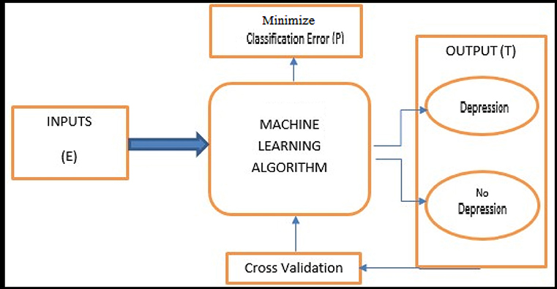
ARCHITECTURE DIAGRAM :
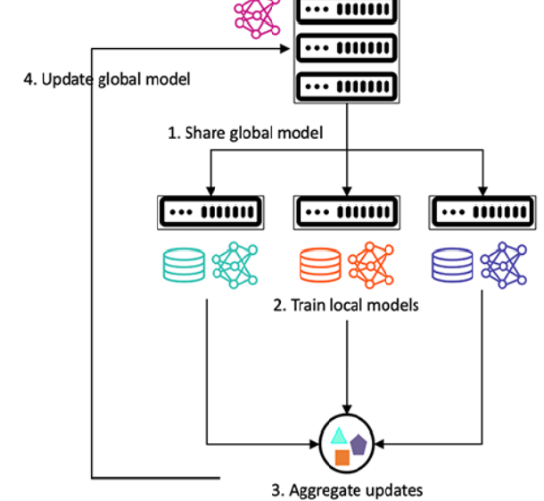
SOFTWARE REQUIREMENTS:
- Operating System : Windows 10
- Platform : python
HARDWARE REQUIREMENTS:
- Keyboard
- Mouse
- Hard disk 500GB
- Ram 4 G

CONCLUTION :
In this paper, we investigated an innovative approach to detect adversarial machine learning attacks by comparing canonical ML algorithms with two innovative Reliable AI approaches focused on eXplainable AI and on Support Vector Data Description (SVDD). In particular, we investigated three possible adversarial attacks, namely the Carlini-Wagner, the Fast Gradient Sign Method and the Jacobian based saliency map. The proposed approach plans to generate malicious datasets on the defensive side to train the algorithms by combining a malicious dataset with the legitimate one.
REFERENCE :
- Jordan, M.I.; Mitchell, T.M. Machine learning: Trends, perspectives, and prospects. Science 2015, 349, 255–260. [Google Scholar] [CrossRef]
- LeCun, Y.; Bengio, Y.; Hinton, G. Deep learning. Nature 2015, 521436–444. [Google Scholar] [CrossRef] [PubMed]
- Khandani, A.E.; Kim, A.J.; Lo, A.W. Consumer credit-risk models via machine-learning algorithms. J. Bank. Financ. 2010, 34, 2767–2787. [Google Scholar] [CrossRef][Green Version]
- Le, H.H.; Viviani, J.L. Predicting bank failure: An improvement by implementing a machine-learning approach to classical financial ratios. Res. Int. Bus. Financ. 2018, 44, 16–25. [Google Scholar] [CrossRef]
- Dua, S.; Acharya, U.R.; Dua, P. Machine Learning in Healthcare Informatics; Springer: Berlin/Heidelberg, Germany, 2014; Volume 56. [Google Scholar]
- Esteva, A.; Robicquet, A.; Ramsundar, B.; Kuleshov, V.; DePristo, M.; Chou, K.; Cui, C.; Corrado, G.; Thrun, S.; Dean, J. A guide to deep learning in healthcare. Nat. Med. 2019, 25, 24–29. [Google Scholar] [CrossRef] [PubMed]
- Callahan, A.; Shah, N.H. Machine learning in healthcare. In Key Advances in Clinical Informatics; Elsevier: Amsterdam, The Netherlands, 2017; pp. 279–291. [Google Scholar]
- Chen, T.; Guestrin, C. Xgboost: A scalable tree boosting system. In Proceedings of the 22nd ACM Sigkdd International Conference on Knowledge Discovery and Data Mining, San Francisco, CA, USA, 13–17 August 2016; pp. 785–794. [Google Scholar]
- Liaw, A.; Wiener, M. Classification and regression by randomForest. R News 2002, 2, 18–22. [Google Scholar]
- Polikar, R. Ensemble learning. In Ensemble Machine Learning; Springer: Berlin/Heidelberg, Germany, 2012; pp. 1–34. [Google Scholar]
- Weisberg, S. Applied Linear Regression; John Wiley & Sons: Hoboken, NJ, USA, 2005; Volume 528. [Google Scholar]
- Safavian, S.R.; Landgrebe, D. A survey of decision tree classifier methodology. IEEE Trans. Syst. Man Cybern. 1991, 21, 660–674. [Google Scholar] [CrossRef][Green Version]
- Gunning, D.; Aha, D.W. DARPA’s Explainable Artificial Intelligence (XAI) Program. AI Magazine 2019, 40, 44–58. [Google Scholar] [CrossRef]
- Lipton, Z.C. The mythos of model interpretability. Queue 2018, 16, 31–57. [Google Scholar] [CrossRef]
- Doshi-Velez, F.; Kim, B. Towards a rigorous science of interpretable machine learning. arXiv 2017, arXiv:1702.08608. [Google Scholar]

