CREDIT CARD FRAUD DETECTION USING STATE-OF-THE-ART MACHINE LEARNING AND DEEP LEARNING ALGORITHMS
ABSTRACT:
The usage of credit cards for online and regular purchases is exponentially increasing and so is the fraud related with it. A large number of fraud transactions are made every day. Various modern techniques like artificial neural network Different machine learning algorithms are compared, including Logistic Regression, Decision Trees, Random Forest, Artificial Neural Networks, Logistic Regression, K-Nearest Neighbors, and K-means clustering etc. are used in detecting fraudulent transactions. This paper uses genetic algorithm, and neural network which comprises of techniques for finding optimal solution for the problem and implicitly generating the result of the fraudulent transaction. The main aim is to detect the fraudulent transaction and to develop a method of generating test data. This algorithm is a heuristic approach used to solve high complexity computational problems. The implementation of an efficient fraud detection system is imperative for all credit card issuing companies and their clients to minimize their losses.
Keywords: Machine learning, Credit card, Electronic commerce, Fraud detection.

EXISTING SYSTEM:
- There are lots of issues that make this procedure tough to implement and one of the biggest problems associated with fraud detection is the lack of both the literature providing experimental results and of real-world data for academic researchers to perform experiments on.
- The reason behind this is the sensitive financial data associated with the fraud that has to be kept confidential for the purpose of customer’s privacy.
- Now, here we enumerate different properties a fraud detection system should have in order to generate proper results

Disadvantage of Existing System
- There are lots of issues that make this procedure tough to implement and one of the biggest problems associated with fraud detection is the lack of both the literature providing experimental results and of real-world data for academic researchers to perform experiments on.
- It improves the model's accuracy and avoids the over fitting problem
- Another problem related to this field is overlapping data. Many transactions may resemble fraudulent transactions when actually they are genuine transactions.
PROPOSED SYSTEM :
- For his valuable guidance for implementation of proposed system. We will forever remain a thankful for their excellent as well as polite guidance for preparation of this report. Also we would sincerely like to thank to HOD Pawar U.B. and other staff for their helpful coordination and support in project work
- have proposed a deep learning-based method for detecting fraud in credit card transactions. Using machine-learning algorithms such as support vector machine, k-nearest neighbor, and artificial neural network to predict the occurrence of fraud.

ADVANTAGE:
- The methods mostly used by hackers today is to attack end-to end technology and exploit human vulnerabilities.
- This algorithm is a heuristic approach used to solve high complexity computational problems.
- An algorithm that can be used for both regression and classification tasks, but it is most commonly used for classification.' Logistic Regression is used to predict categorical variables using dependent variables.
LITRATURE REVIEW:
TITTLE | AUTHOR | DESCRIPTION
‘‘A survey on enhanced subspace clustering | K. Sim, V. Gopalkrishnan, A. Zimek, and G. Cong | Subspace clustering finds sets of objects that are homogeneous in subspaces of high-dimensional datasets, and has been successfully applied in many domains.
‘‘‘Trade-based money laundering: Responding to an emerging threat,’ | S. Mcskimming | Subspace clustering is an extension of traditional clustering that seeks to find clusters in different subspaces within a dataset.
‘“Credit Card Fraud Detection Using Genetic-A Survey”,’’ | Nitu Kumari, S. Kannan and A. Muthukumaravel | People choose online payment and e-shopping; because of time convenience, transport convenience, etc.
“A Tool for Effective Detection of Fraud in Credit Card System” | Satvik Vats, Surya Kant Dubey, Naveen Kumar Pandey | Due to the rise and rapid growth of E-Commerce, use of credit cards for online purchases has dramatically increased and it caused an explosion in the credit card fraud..

INTRODUCTION :
- A credit card is a thin handy plastic card that contains identification information such as a signature or picture, and authorizes the person named on it to charge purchases or services to his account - charges for which he will be billed periodically.
- Today, the information on the card is read by automated teller machines (ATMs), store readers, bank and is also used in online internet banking system

BLOCK DIAGRAM:
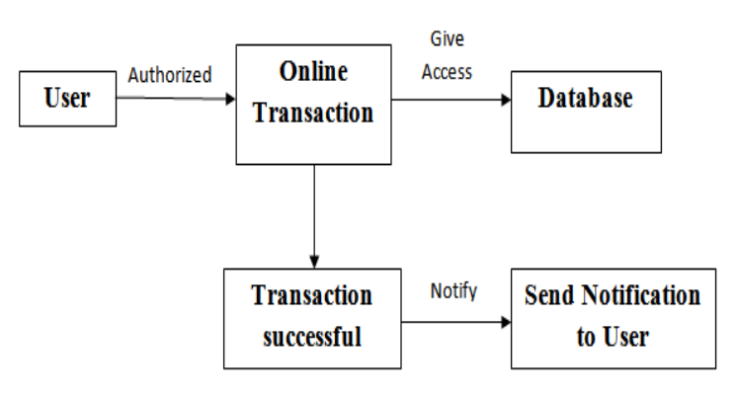
ARCHITECTURE DIAGRAM :
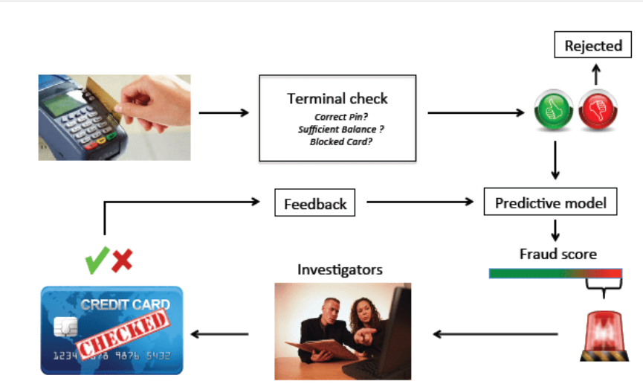
SOFTWARE REQUIREMENTS:
- Operating System : Windows 10
- Platform : python
HARDWARE REQUIREMENTS:
- Keyboard
- Mouse
- Hard disk 500GB
- Ram 4 G

CONCLUTION :
Credit card fraud becomes a serious concern to the world. Fraud brings huge financial losses to the world. This urged Credit card companies have been invested money to create and develop techniques to reveal and reduce fraud. The prime goal of this study is to define algorithms that confer the appropriate, and can be adapted by credit card companies for identifying fraudulent transactions more accurately, in less time and cost.
REFERENCE :
- 1] K. Sim, V. Gopalkrishnan, A. Zimek, and G. Cong -‘‘A survey on enhanced subspace clustering,’’ Data Mining Knowledge Discovery, vol. 26, no. 2, pp. 332–397, 2019.
- 2] S. Mcskimming -‘‘Trade-based money laundering: Responding to an emerging threat,’’ Deakin Law Rev, vol. 15, no. 1, 2020.
- 3] Nitu Kumari, S. Kannan and A. Muthukumaravel - “Credit Card Fraud Detection Using Genetic-A Survey” published by MiddleEast Journal of Scientific Research , IDOSI Publications,
- 4] Satvik Vats, Surya Kant Dubey, Naveen Kumar Pandey - “A Tool for Effective Detection of Fraud in Credit Card System”, published in International Journal of Communication Network Security ISSN: 2231 – 1882, Volume-2
- 5] S.H. Projects and W. Lovo , ―JMU Scholarly Commons Detecting credit card fraud : An analysis of fraud detection techniques,‖ 2020. [2] S. G and J. R. R, ―A Study on Credit Card Fraud Detection using Data Mining Techniques,‖ Int. J. Data Min. Tech. Appl., vol. 7, no. 1, pp. 21–24, 2018, doi: 10.20894/ijdmta.102.007.001.004
- 6] V. N. Dornadula and S. Geetha ―Credit Card Fraud Detection using Machine Learning Algorithms, Procedia Comput. Sci., vol. 165, pp. 631–641, 2019, doi: 10.1016/j.procs.2020.01.057.
- 7] A. H. Alhazmi and N. Aljehane - A Survey of Credit Card Fraud Detection Use Machine Learning, 2020 Int. Conf. Computes. Inf. Technol. ICCIT 2020, pp. 10–15, 2020, doi: 10.1109/ICCIT-144147971.2020.9213809
- 8] M. Kanchana, V. Chadda , and H. Jain - Credit card fraud detection,‖ Int. J. Adv. Sci. Technol., vol. 29, no. 6, pp. 2201–2215, 2020, doi: 10.17148/ijarcce.2016.5109. A. RB and S. K. KR, ―Credit Card Fraud Detection Using Artificial Neural Network,Glob. Transitions Proc, pp. 0–8,2021,doi: 10.1016/j.gltp.2021.01.00

