COGNITIVE WORKLOAD RECOGNITION USING EEG SIGNALS AND MACHINE LEARNING A REVIEW
ABSTRACT:
Machine learning and its subfield deep learning techniques provide opportunities for the development of operator mental state monitoring, especially for cognitive workload recognition using electroencephalogram (EEG) signals. Although a variety of machine learning methods have been proposed for recognizing cognitive workload via EEG recently, there does not yet exist a review that covers in-depth the application of machine learning methods. To alleviate this gap, in this paper, we survey cognitive workload and machine learning literature to identify the approaches and highlight the primary advances
EXISTING SYSTEM:
- In recent years, regardless of the task environments, the mean accuracies of existing methods to EEG workload recognition are almost over 80%, which seems acceptable for practical applications.
- Also, for code reproducibility, Roy et al. recommend that the published studies should clearly describe the architecture of models, the data used, or existing datasets used, whenever possible. Besides these, the studies should also include state-of-the-art baselines, and share code.
- In contrast to the intrinsic interpretable models, e.g., decision trees, many other existing machine learning approaches are non-interpretable black-box models

Disadvantage of Existing System
- Although a variety of machine learning methods have been proposed for recognizing cognitive workload via EEG recently, there does not yet exist a review that covers in-depth the application of machine learning methods
- In literature, various machine learning methods are proposed to handle those problems
- Several studies have used this dataset to validate their proposed machine learning models
- The frequency domain analysis is proposed to display the frequency information of EEG, with an assumption that EEG signals are stationary.
PROPOSED SYSTEM :
- Although a variety of machine learning methods have been proposed for recognizing cognitive workload via EEG recently, there does not yet exist a review that covers in-depth the application of machine learning methods
- In literature, various machine learning methods are proposed to handle those problems
- Several studies have used this dataset to validate their proposed machine learning models
- The frequency domain analysis is proposed to display the frequency information of EEG, with an assumption that EEG signals are stationary.

ADVANTAGE:
- Among them, EEG is one of the most widely used signals, due to its high temporal resolution, convenience, security, and cheapness.
- The commonly used physiological signals can be roughly divided into several categories, i.e., electroencephalogram (EEG), heart rate, eye movement, respiration, electromyogram, and skin
The widely used paradigms to experience cognitive workload are performed either under controlled laboratory conditions, e.g., cognitive task, or operating machine in real or simulated environments. We then categorize the paradigms into cognitive-oriented and operate-oriented
LITRATURE REVIEW:
TITTLE | AUTHOR | DESCRIPTION
“Neuroergonomics: a review of applications to physical and cognitive work, | R. Mehta, and R. Parasuraman. , | This paper provides a critical review of the neuroergonomic approach to evaluating physical and cognitive work, particularly in mobile settings.
‘‘Passive BCI in Operational Environments: Insights, Recent Advances, and Future Trends,. | P. Arico, G. Borghini, G. D. Flumeri, N. Sciaraffa, A. Colosimo, and F. Babiloni, | This minireview aims to highlight recent important aspects to consider and evaluate when passive brain-computer interface (pBCI) systems
“EEG-Based Spatio-Temporal Convolutional Neural Network for Driver Fatigue Evaluation,” | Z. Gao, X. Wang, Y. Yang, C. Mu, Q. Cai, W. Dang, and S. Zuo, , | As we know that all the computer networks are very much prone to inside and outside attacks in recent days due to its different types of use in every field..
“Emotional state classification from EEG data using machine learning approach,” | X. Wang, D. Nie, and B. Lu, “. | Recently, emotion classification from EEG data has attracted much attention with the rapid development of dry electrode techniques, machine learning algorithms.

INTRODUCTION :
- currently, with the advanced development of detection devices and machine learning techniques, human mental states monitoring such as fatigue emotion and cognitive workload has been widely used in the fields of human-robot interaction and passive brain-computer-interface.
- As a special case, cognitive workload or mental workload has gained increasing attention.
- It can be generally described as the ratio of a person’s available resource over the task demanded resources

BLOCK DIAGRAM:
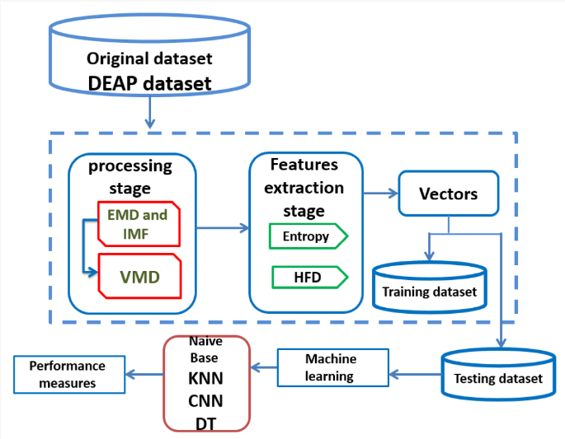
ARCHITECTURE DIAGRAM :
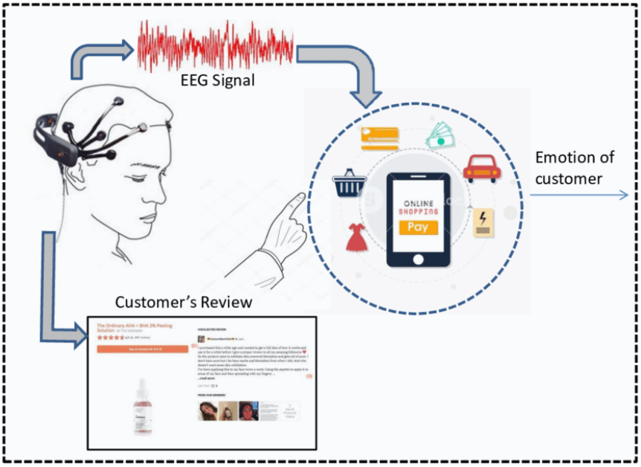
SOFTWARE REQUIREMENTS:
- Operating System : Windows 10
- Platform : python
HARDWARE REQUIREMENTS:
- Keyboard
- Mouse
- Hard disk 500GB
- Ram 4 G

CONCLUTION :
In this paper, we comprehensively review the available literature on EEG-based cognitive workload recognition using machine learning. We highlight the general steps of classical machine learning, i.e., data acquisition, preprocessing, feature extraction and selection, classification and evaluation. We also review several widely used deep learning models for workload recognition. Further, we discuss the main findings of this work.
REFERENCE :
- [1] R. Mehta, and R. Parasuraman, “Neuroergonomics: a review of applications to physical and cognitive work,” Frontiers in Human Neuroscience, vol. 7, no. 889, 2013-December-23, 2013.
- [2] P. Arico, G. Borghini, G. D. Flumeri, N. Sciaraffa, A. Colosimo, and F. Babiloni, “Passive BCI in Operational Environments: Insights, Recent Advances, and Future Trends,” IEEE Transactions on Biomedical Engineering, vol. 64, no. 7, pp. 1431-1436, 2017.
- [4] X. Wang, D. Nie, and B. Lu, “Emotional state classification from EEG data using machine learning approach,” Neurocomputing, vol. 129, pp. 94-106, 2014.
- [5] C. Wickens, “Multiple resources and performance prediction,” Theoretical Issues in Ergonomics Science, vol. 3, pp. 159 - 177, 2002.
- [6] J. Heard, C. E. Harriott, and J. A. Adams, “A Survey of Workload Assessment Algorithms,” IEEE Transactions on Human-Machine Systems, pp. 1-18, 2018.
- [7] S. G. Hart, “Development of NASA-TLX (Task Load Index): Results of Empirical and Theoretical Research,” Advances in Psychology, vol. 52, no. 6, pp. 139-183, 1988.
- [8] G. B. Reid, and T. E. Nygren, “The Subjective Workload Assessment Technique: A Scaling Procedure for Measuring Mental Workload,” Advances in psychology, vol. 52, pp. 185-218, 1988.
- [9] H. Tan, H. Wang, X. Zhang, X. Qu, and T. Zhang, “A Systematic Review of Physiological Measures of Mental Workload,” International Journal of Environmental Research and Public Health, vol. 16, pp. 2716, 2019
- [10] M. E. Smith, A. Gevins, H. Brown, A. Karnik, and R. Du, “Monitoring task loading with multivariate EEG measures during complex forms of human-computer interaction,” Human Factors, vol. 43, no. 3, pp. 366-380, 2001.
- [11] S. Lemm, B. Blankertz, T. Dickhaus, and K. Muller, “Introduction to machine learning for brain imaging,” NeuroImage, vol. 56, no. 2, pp. 387-399, 2011.
- [12] N. Sciaraffa, P. Aricò, G. Borghini, G. D. Flumeri, A. D. Florio, and F. Babiloni, "On the Use of Machine Learning for EEG-Based Workload Assessment: Algorithms Comparison in a Realistic Task," Human Mental Workload: Models and Applications, pp. 170-185, 2019
- [13] C. R. L., and N. Jim, “Measuring mental workload using physiological measures: A systematic review,” Applied Ergonomics, vol. 74, pp. 221-232, 2019.
- [14] E. Debie, R. F. Rojas, J. Fidock, M. Barlow, K. Kasmarik, S. G. Anavatti, M. Garratt, and H. A. Abbass, “Multimodal Fusion for Objective Assessment of Cognitive Workload: A Review,” IEEE Transactions on Systems, Man, and Cybernetics, pp. 1-14, 2019.
- [15] S. Oviatt, "Human-centered design meets cognitive load theory: designing interfaces that help people think." MM '06: Proceedings of the 14th ACM international conference on Multimedia, pp. 871-880, 2006.

