A REVIEW ON MACHINE LEARNING STYLES IN COMPUTER VISION—TECHNIQUES AND FUTURE DIRECTIONS
ABSTRACT:
Due to the advancement in the field of Artificial Intelligence (AI), the ability to tackle entire problems of machine intelligence. Nowadays, Machine learning (ML) is becoming a hot topic due to the direct training of machines with less interaction with a human.The scenario of manual feeding of the machine is changed in the modern era, it will learn automatically. Supervised and unsupervised ML techniques are used as a distinct purpose like feature extraction, pattern recognition, object detection, and classification.

EXISTING SYSTEM:
- Types of bogus are online websites or small companies, particularly start-up to create a mimic dataset for model training, creating the perfect dataset for research publication, offline survey collection, or nonexistent data.
- Identification of actual data from different sources and utilizes these collected datasets to find the unique outcome is one of the challenging tasks nowadays.

Disadvantage of Existing System
- The problem arises when conduct questionnaires, people can’t respond 100% as we expected results received according to the filling of questionnaires by people and training and testing the model through vague data generates error ratio
- Compressed and large-scale images are the problems in the dataset to accurately detect objects, this will help to easily detect vehicle and monitor their actives
- The research of computer vision is still facing the problem of the location of human joints in images
PROPOSED SYSTEM :
- The journey of computer vision (CV) started in 1960, where father of computer vision Larry Roberts proposed 3D geometrical information extraction from 2D perspective polyhedral concepts in his Ph.D. thesis at MIT
- At the initial stage, CV illustrates, extraction of crucial information through digital images using computational models. Elaborating dual goals, vision is used as an autonomous system for the engineering point of views just like a human can perform a visual task, while computational models applied in the human biological system for detecting symptoms of diseases in the body
ADVANTAGE:
- Supervised and unsupervised ML techniques are used as a distinct purpose like feature extraction, pattern recognition, object detection, and classification.
- SL, function to labelled training data, used to prediction.
- At last, SSL is the collaboration of both SL and USL, it has a small amount of labelled and large amount of unlabelled data, mainly used in information retrieval, image processing, and bio-information

LITRATURE REVIEW:
TITTLE | AUTHOR | DESCRIPTION
‘‘Automated Medication System for Rural and War Affected Areas | Sadhayo, Intesab Hussain, Muhammad Ibrahim Channa, and Asif Ali Laghari. , | Robot is machine like human beings working in hazardous situations, replace domain experts and provide accurate results.
‘‘Artificial intelligence: a modern approach. | Russell, Stuart J., and Peter Norvig | The long-anticipated revision of this 1 selling book offers the most comprehensive, state of the art introduction to the theory and practice of artificial intelligence for modern applications.
“A Definition of Artificial Intelligence.,’’ | Dobrev, Dimiter, , | Since the development of the digital computer in the 1940s.
Impact of artificial intelligence, robotics, and machine learning on sales and marketing. | Siau, K., and Yin Yang. | AI, robotics, and machine learning are impacting the field of sales and marketing in an unprecedented way.

INTRODUCTION :
- Image processing (IP) means process image through a digital computer. Utilization of algorithms for enhanced quality of an image, on the bases of this system, can extract crucial information from the image.
- There are two main types namely: analogous and digital image processing (DIP)
- . In IP, get input as an image and after process system retrieves output in the form of an image

BLOCK DIAGRAM:
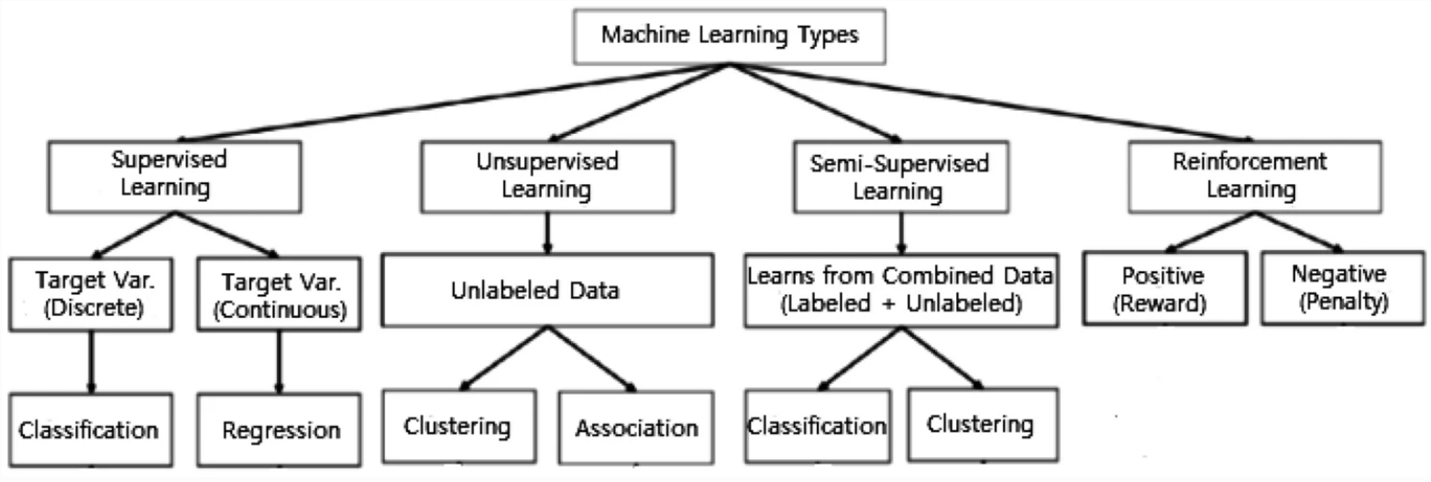
ARCHITECTURE DIAGRAM :
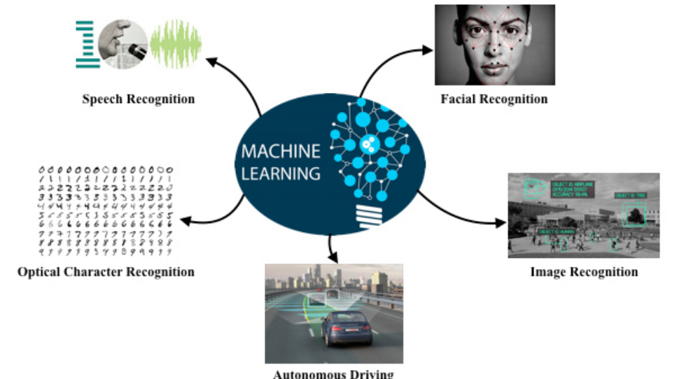
SOFTWARE REQUIREMENTS:
- Operating System : Windows 10
- Platform : python
HARDWARE REQUIREMENTS:
- Keyboard
- Mouse
- Hard disk 500GB
- Ram 4 G
CONCLUTION :
In this paper, the importance of ML in the image processing (IP) domain is highlighted and address the processes of digital image and how difficult is to feed the computer system. For this processes, the acquisition is the first step of IP where image can load and prepare for further process (briefly elaborate in image processing section).In the end, we get label image objects in the detection and recognition phases. Neural Networks (NN) is one of the ML algorithms, which aims to optimize solutions of the given problem to provide better solution and predicate output by providing input values.
REFERENCE :
- [1] Sadhayo, Intesab Hussain, Muhammad Ibrahim Channa, and Asif Ali Laghari. "Automated Medication System for Rural and War Affected Areas." Transactions on Machine Learning and Artificial Intelligence 3, no. 1 (2015): 08.
- [2] Russell, Stuart J., and Peter Norvig. Artificial intelligence: a modern approach. Malaysia; Pearson Education Limited, 2016.
- [3] Dobrev, Dimiter. "A Definition of Artificial Intelligence." arXiv preprint arXiv:1210.1568 (2012).
- [4] Siau, K., and Yin Yang. "Impact of artificia[7] Zhao, Ying, and Arjuna Flenner. "Deep Models, Machine Learning, and Artificial Intelligence Applications in National and International Security." AI Magazine 40, no. 1 (2019): 35-36.
- [8] Nichols, James A., Hsien W. Herbert Chan, and Matthew AB Baker. "Machine learning: applications of artificial intelligence to imaging and diagnosis." Biophysical reviews 11, no. 1 (2019): 111-118
- [9] Patton, Michael Quinn. "Qualitative research." Encyclopedia of statistics in behavioral science (2005).
- [10] Goertzen, Melissa J. ". Introduction to Quantitative Research and Data." Library Technology Reports 53, no. 4 (2017): 12-18.
- [11] Bzdok, Danilo, Martin Krzywinski, and Naomi Altman. "Points of significance: Machine learning: supervised methods." (2018): 5.
- [12] Camacho, Diogo M., Katherine M. Collins, Rani K. Powers, James C. Costello, and James J. Collins. "Next-generation machine learning for biological networks." Cell 173, no. 7 (2018): 1581-1592.
- [13] Chapelle, Olivier, Bernhard Scholkopf, and Alexander Zien. "Semi-supervised learning (chapelle, o. et al., eds.; 2006) [book reviews]." IEEE Transactions on Neural Networks 20, no. 3 (2009): 542-542.
- [14] Huang, T. "Computer vision: Evolution and promise." (1996).
- [15] Salman, Hasan, Md Nasir Uddin, Samuel Acheampong, and He Xu. "Design and Implementation of IoT Based Class Attendance Monitoring System Using Computer Vision and Embedded Linux Platform." In Workshops of the International Conference on Advanced Information Networking and Applications, pp. 25-34. Springer, Cham, 2019.

