A NOVEL TWO-MODE INTEGRAL APPROACH FOR THERMAL ERROR MODELING IN CNC MILLING-TURNING MACHINING CENTER
ABSTRACT:
Thermal errors have the largest contribution, as much as about 70%, to the machining inaccuracy of computer-numerical-controlled (CNC) machining centers. The error compensation method so far plays the most popular and effective way to minimize the thermal error. How to accurately and quickly build an applicable thermal error model (TEM) is the kernel work of thermal error compensation. On the basis of some comprehensive machine-learning schemes, past proposed TEMs had impressive merits for dealing with the thermal error modeling of single-function (milling or turning cutting) machine tools with only considering one set of thermal key points.

EXISTING SYSTEM:
- In this paper, the existing thermal error modeling methods for machine tools that have been researched and applied in the past ten years are introduced, classified, and summarized.
- considering that the solution of the existing gray prediction model GM(1,N) was not accurate enough, Tien [40] used gray control parameters to develop an improved model GMC(1,N) on the basis of GM(1,N).
- Hunan University devoted to solve the problem of low modeling efficiency of the existing thermal error modeling methods and unsatisfactory model prediction accuracy

Disadvantage of Existing System

- In order to solve these problems, Ma and Jiang used a hybrid particle swarm algorithm to optimize the structure of the BP neural network and to avoid unstable prediction performance.
- In order to solve the problem that the BP neural network cannot adjust independent parameters of new data in thermal error modeling,
- Hunan University devoted to solve the problem of low modeling efficiency of the existing thermal error modeling methods and unsatisfactory model prediction accuracy

PROPOSED SYSTEM :
- Indonesian scholars Chen and Hsu proposed a time-variant volumetric error model to comprehensively compensate the geometric and thermal errors of the machining center.
- proposed a new gray GMC(1,N) machine tool thermal error prediction method based on the CS algorithm named as CS-GMC(1,N) model
- They proposed a generalized RBF neural network modeling method and applied it to the thermal error modeling of the spindle box of a NC guide rail grinder
ADVANTAGE:
- Thermal error caused by thermal deformation is one of the most significant factors influencing the accuracy of the machine tool.
- Two-step method” to establish the thermal error model of a ball screw. In this method, BP neural network was first used to model the thermal deformation of the screw.
- key feature functions are more difficult to be extracted than the BP neural network, and its generalization performance is wors. Su et al. used the RBF neural network to build a more accurate thermal error model.

LITRATURE REVIEW:
TITTLE | AUTHOR | DESCRIPTION
Geometric, cutting-force induced and fixture-dependent errors. | Ramesh, R.; Mannan, M.A.; Poo, A.N. | Accuracy of machined components is one of the most critical considerations for any manufacturer.
‘‘surface Properties of the Machined Workpiece for Helical Mills,. | Bachrathy, D.; Insperger, T.; Stépán, G. | Stability and surface errors are investigated numerically for milling operations with a helical tool.
“Fixed Boundaries Receptance Coupling Substructure Analysis for Tool Point Dynamics Prediction.,” | Mancisidor, I.; Zatarain, M.; Munoa, J.; Dombovari, Z, | Estimation of that capacity requires to obtain the dynamic transfer function at the tool tip
“International Status of Thermal Error Research., | Bryan, J.B. | This paper is the result of a cooperative effort of STC “M” and STC ‘Q’ to review the field of thermal error research since the previous keynote paper was delivered in Ann Arbor in 1967. .

INTRODUCTION :
- As a symbol of the level of modern machinery manufacturing, precision machine tools are becoming more and more important. The requirements for the accuracy of machine tools are also increasing with the continuous development of industrial technology.
- There are many factors that affect the accuracy of machine tools such as geometric and kinematic errors, thermal errors, cutting-force induced errors, and other errors such as the tool wear and the errors induced by assembling and chattering .
BLOCK DIAGRAM:
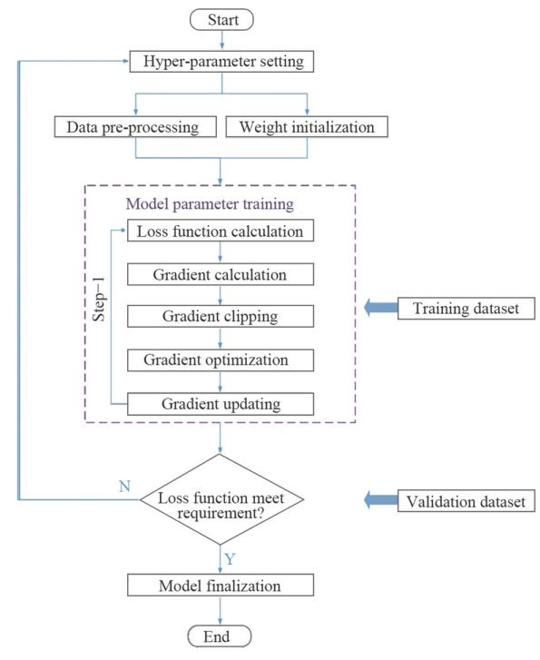
ARCHITECTURE DIAGRAM :
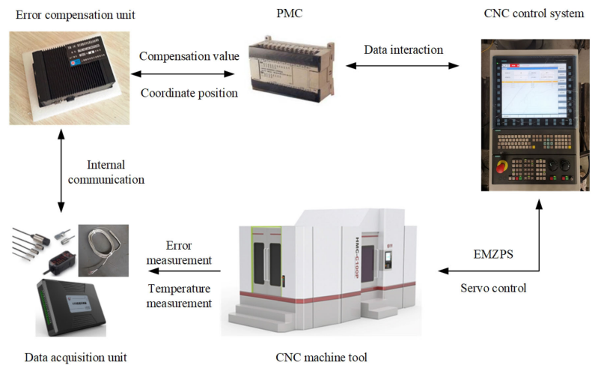
SOFTWARE REQUIREMENTS:
- Operating System : Windows 10
- Platform : python
HARDWARE REQUIREMENTS:
- Keyboard
- Mouse
- Hard disk 500GB
- Ram 4 G
CONCLUTION :
In the past ten years, more and more attention has been given to the research field of machine tool thermal errors. Some modeling methods such as LSSVM and neural network have performed well, but these type of models need many training samples and large number of calculations. It is easy to be invalidate in the process of adjusting weights, and they require a lot of time training samples, even with today’s highly developed computer hardware technology. Therefore, there is not a blowout development of the research on neural networks or SVM. However, with the continuous development of computer hardware technology, neural networks and other modeling methods will surely show more possibilities.

REFERENCE :
- Ramesh, R.; Mannan, M.A.; Poo, A.N. Error compensation in machine tools—A review: Part I: Geometric, cutting-force induced and fixture-dependent errors. Int. J. Mach. Tools Manuf. 2000, 40, 1235–1256. [Google Scholar] [CrossRef]
- Bachrathy, D.; Insperger, T.; Stépán, G. Surface Properties of the Machined Workpiece for Helical Mills. Mach. Sci. Technol. 2009, 13, 227–245. [Google Scholar] [CrossRef
- Mancisidor, I.; Zatarain, M.; Munoa, J.; Dombovari, Z. Fixed Boundaries Receptance Coupling Substructure Analysis for Tool Point Dynamics Prediction. Adv. Mater. Res. 2011, 223, 622–631. [Google Scholar] [CrossRef]
- 4.Bryan, J.B. International Status of Thermal Error Research. Cirp Ann. 1990, 39, 645–656. [Google Scholar] [CrossRef]
- 5.Ramesh, R.; Mannan, M.A.; Poo, A.N. Error compensation in machine tools—A review: Part II: Thermal errors. Int. J. Mach. Tools Manuf. 2000, 40, 1257–1284. [Google Scholar] [CrossRef]
- 6.Abele, E.; Altintas, Y.; Brecher, C. Machine tool spindle units. Cirp Ann. 2010, 59, 781–802. [Google Scholar] [CrossRef]
- 7.Pan, S.W. Summary of Research Status on Thermal Error Robust Modeling of NC Lathe. Tool Eng. 2007, 41, 10–14. [Google Scholar]
- 8.Ni, J. CNC machine accuracy enhancement through real-time error compenstation. J. Manuf. Sci. Eng. 1997, 119, 717–725. [Google Scholar] [CrossRef]
- 9.Liu, J.; Ma, C.; Wang, S. Precision loss modeling method of ball screw pair. Mech. Syst. Signal Process. 2020, 135, 106397. [Google Scholar] [CrossRef]
- 10.Grama, S.N.; Mathur, A.; Badhe, A.N. A model-based cooling strategy for motorized spindle to reduce thermal errors. Int. J. Mach. Tools Manuf. 2018, 132, 3–16. [Google Scholar] [CrossRef]
- 11Xu, Z.Z.; Liu, X.J.; Kim, H.K.; Shin, J.H.; Lyu, S.K. Thermal error forecast and performance evaluation for an air-cooling ball screw system. Int. J. Mach. Tools Manuf. 2011, 51, 605–611. [Google Scholar] [CrossRef]
- 12Xu, Z.Z.; Liu, X.J.; Choi, C.H.; Lyu, S.K. A study on improvement of ball screw system positioning error with liquid-cooling. Int. J. Precis. Eng. Manuf. 2012, 13, 2173–2181. [Google Scholar] [CrossRef]
- 13Chen, T.-C.; Chang, C.-J.; Hung, J.-P.; Lee, R.-M.; Wang, C.-C. Real-Time Compensation for Thermal Errors of the Milling Machine. Appl. Sci. 2016, 6, 101. [Google Scholar] [CrossRef][Green Version14.Aguirre, G.; Nanclares, A.; Urreta, H. Thermal Error Compensation for Large Heavy Duty Milling-Boring Machines. In Proceedings of the Euspen Special Interest Group Meeting, Thermal Issues, Zurich, Switzerland, 19–20 March 2014. [Google Scholar]
- 15.Lei, W.T.; Hsu, Y.Y. Accuracy enhancement of five-axis CNC machines through real-time error compensation. Int. J. Mach. Tools Manuf. 2003, 43, 871–877. [Google Scholar] [CrossRef]
s

