ADVERSARIAL EVOLVING NEURAL NETWORK FOR LONGITUDINAL KNEE OSTEOARTHRITIS PREDICTION
ABSTRACT:
Knee osteoarthritis (KOA) as a disabling joint disease has doubled in prevalence since the mid-20th century. Early diagnosis for the longitudinal KOA grades has been increasingly important for effective monitoring and intervention. Although recent studies have achieved promising performance for baseline KOA grading, longitudinal KOA grading has been seldom studied and the KOA domain knowledge has not been well explored yet.In this paper, a novel deep learning architecture, namely adversarial evolving neural network (A-ENN), is proposed for longitudinal grading of KOA severity As the disease progresses from mild to severe level, ENN involves the progression patterns for accurately characterizing the disease by comparing an input image it to the template images of different KL grades using convolution and deconvolution computations. In addition, an adversarial training scheme with a discriminato developed to obtain the evolution traces. Thus, the evolution traces as fine-grained domain knowledge are further fused with the general convolutional image representations for longitudinal grading. Note that ENN can be applied to other learning tasks together with existing deep architectures, in which the responses characterize progressive representations

EXISTING SYSTEM:
- Note that ENN can be applied to other learning tasks together with existing deep architectures, in which the responses characterize progressive representations.
- Existing studies mainly address the automatic KOA grading task of a given radiology image by treating it as an image classification task with multiple classes (i.e., KL grades).
- Early studies follow a conventional machine learning pipeline in which the image pre-processing and feature extraction steps are required for a classification model

DISADVANTAGE OF EXISTING SYSTEM:
- As many deep learning architectures have been proposed for general image classification problems, such as convolutiaon neural networks (CNNs) (e.g., VGG and ResNet ) and transformer based networks (e.g., Visual Transformer (ViT) , some of these architectures have been also adopted for KOA grading
- Besides, there are also a few attempts to involve the domain knowledge of KOA into the development of deep learning based methods, such as the inclusion of the demographic features and the loss functions using the continuous grading property
PROPOSED SYSTEM :
- In this paper, a novel deep learning architecture, namely adversarial evolving neural network (A-ENN), is proposed for longitudinal grading of KOA severity.
- As the disease progresses from mild to severe level, ENN involves the progression patterns for accurately characterizing the disease by comparing an input image it to the template images of different KL grades using convolution and deconvolution computations.
- Therefore, in this paper, a novel deep learning architecture, namely adversarial evolving neural network (A-ENN), with an adversarial training scheme is proposed for fine-grained longitudinal KOA grading using X-Ray images collected from clinical assessments
ADVANTAGE:
- For this purpose, the Kellgren and Lawrence (KL) grading system has been widely used to quantify the severity of the disease in clinical practice [2], in which radiology imaging techniques are utilised for KL grading
- The proposed A-ENN method is evaluated on a widely used benchmark dataset - the Osteoarthritis Initiative (OAI) Dataset - for KOA grading and achieves an accuracy 62.6%.
- This formulation is consistent with the design of the widely used generative neural networks which usually involve an adversarial training scheme

LITRATURE REVIEW:
TITTLE | AUTHOR | DESCRIPTION
‘‘Knee osteoarthritis is believed to be highly prevalent today because of recent increases in life expectancy and body mass index (BMI), but this assumption has not been tested using long-term historical or evolutionary data. | I. J. Wallace | Significance Knee osteoarthritis is a highly prevalent, disabling joint disease with causes that remain poorly understood but are commonly attributed to aging and obesity.
Radiological assessment of osteoarthrosis, | J. Kellgren and J. Lawrence | In a previous study (Kellgren and Bier, 1956), three sets of x rays of the hands were used to assess inter- and intra-observer differences in interpreting changes of rheumatoid arthritis. .
“The global burden of hip and knee osteoarthritis: Estimates from the global burden of disease 2010 study, | M. Cross et, | Systematic reviews were conducted to source age-specific and sex-specific epidemiological data for hip and knee OA prevalence, incidence and mortality risk. .
Early detection of radiographic knee osteoarthritis using computer-aided analysis, | L. Shamir, S. M. Ling, W. Scott, M. Hochberg, L. Ferrucci, and I. G. Goldberg, | To determine whether computer-based analysis can detect features predictive of osteoarthritis (OA) development in radiographically normal knees.

INTRODUCTION :
- Computer-aided KL grading methods identify the KL grade with the given information of a subject. When the information is of medical images such as X-ray and MRI scans, computer vision based methods can be devised for KL grading.
- By following a conventional machine learning pipeline, early computer vision based KL grading algorithms mainly relied on hand-crafted features extracted from medical images.
- BLOCK DIAGRAM:
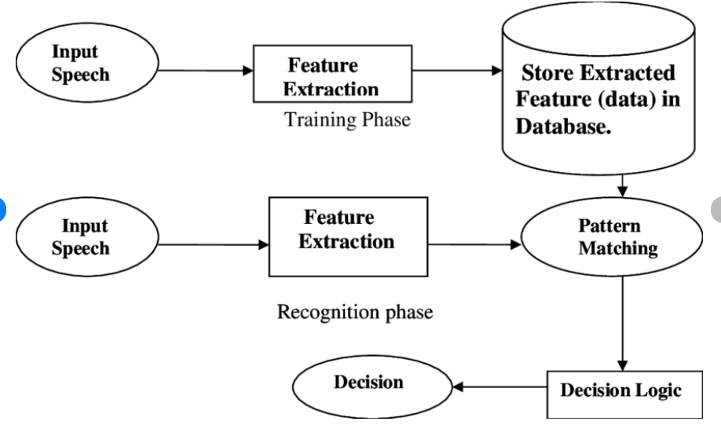

ARCHITECTURE DIAGRAM :
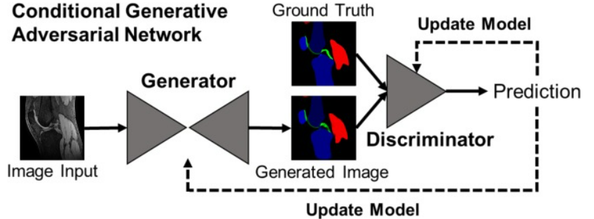

SOFTWARE REQUIREMENTS:
- Operating System : Windows 10
- Platform : python
HARDWARE REQUIREMENTS:
- Keyboard
- Mouse
- Hard disk 500GB
- Ram 4 Gb
CONCLUTION :
- In this study, a novel deep learning architecture - evolving neural network with an adversarial training scheme is presented for a fine-grained learning task - longitudinal KOA grading.
- ENN is devised based on the fact that the disease presents progressive properties from mild to severe.
- It involves the evolving patterns of an input image by comparing it to the template images of different KL grades to formulate evolution traces as the fine-grained domain knowledgeComprehensive experimental results demonstrated the effectiveness of the proposed method on a widely used public dataset - the Osteoarthritis Initiative (OAI) Dataset in terms of an accuracy 62.7%.
- Note that ENN can be introduced to any other tasks and deep architectures, in which the responses present progressive representations.
- For our future work, two major directions can be considered:
1) multi-task learning methods by investigating different progression objectives such as the perspectives from pain and JSN jointly for a robust medical imaging KOA representation
2) multi-modal learning methods by considering other commonly used modalities such as MRI scans and demographics for longitudinal modelling

REFERENCE :
- [1] I. J. Wallace et al., “Knee osteoarthritis has doubled in prevalence since the mid-20th century,” Proc. Nat. Acad. Sci. USA, vol. 114, no. 35, pp. 9332–9336, Aug. 2017.
- [2] J. Kellgren and J. Lawrence, “Radiological assessment of osteoarthrosis,” Ann. Rheumatic Diseases, vol. 16, no. 4, p. 494, 1957.

- [3] M. Cross et al., “The global burden of hip and knee osteoarthritis: Estimates from the global burden of disease 2010 study,” Ann. Rheumatic Diseases, vol. 73, no. 7, pp. 1323–1330, Jul. 2014[4] L. Shamir, S. M. Ling, W. Scott, M. Hochberg, L. Ferrucci, and I. G. Goldberg, “Early detection of radiographic knee osteoarthritis using computer-aided analysis,” Osteoarthritis Cartilage, vol. 17, no. 10, pp. 1307–1312, Oct. 2009.
- [5] K. Simonyan and A. Zisserman, “Very deep convolutional networks for large-scale image recognition,” 2014, arXiv:1409.1556.
- [6] K. He, X. Zhang, S. Ren, and J. Sun, “Deep residual learning for image recognition,” in Proc. IEEE Conf. Comput. Vis. Pattern Recognit. (CVPR), Jun. 2016, pp. 770–778
- [7] A. Dosovitskiy et al., “An image is worth 16×16 words: Transformers for image recognition at scale,” 2020, arXiv:2010.11929.
- [8] P. Chen, L. Gao, X. Shi, K. Allen, and L. Yang, “Fully automatic knee osteoarthritis severity grading using deep neural networks with a novel ordinal loss,” Computerized Med. Imag. Graph., vol. 75, pp. 84–92, Jul. 2019.
- [9] B. Liu, J. Luo, and H. Huang, “Toward automatic quantification of knee osteoarthritis severity using improved faster R-CNN,” Int. J. Comput. Assist. Radiol. Surgery, vol. 15, no. 3, pp. 457–466, Mar. 2020.
- [10] B. Norman, V. Pedoia, A. Noworolski, T. M. Link, and S. Majumdar, “Applying densely connected convolutional neural networks for staging osteoarthritis severity from plain radiographs,” J. Digit. Imag., vol. 32, no. 3, pp. 471–477, 2019.
- [11] E. Halilaj, Y. Le, J. L. Hicks, T. J. Hastie, and S. L. Delp, “Modeling and predicting osteoarthritis progression: Data from the osteoarthritis initiative,” Osteoarthritis Cartilage, vol. 26, no. 12, pp. 1643–1650, Dec. 2018.
- [12] P. Widera et al., “Multi-classifier prediction of knee osteoarthritis progression from incomplete imbalanced longitudinal data,” Sci. Rep., vol. 10, no. 1, p. 8427, Dec. 2020
- [13] Q. Wang, A. Gao, and Y. Hu, ‘‘Joint power and QoE optimization scheme for multi-UAV assisted offloading in mobile computing,’’ IEEE Access, 945 vol. 9, pp. 21206–212110.1109/ACCESS.2021.3055335.
- [14] O. Alagoz, H. Hsu, A. J. Schaefer, and M. S. Roberts, ‘‘Markov deci sion processes: A tool for sequential decision making under uncer tainty,’’ Med. Decis. Making, vol. 30, no. 4, pp. 474–483, Jul. 2010, doi: 949 10.1177/0272989X09353194.
- [15] M. McClellan, C. Cervelló-Pastor, and S. Sallent, ‘‘Deep learning at the mobile edge: Opportunities for 5G networks,’’ Appl. Sci., vol. 10, no. 14, 952 p. 4735, Jul. 2020, doi: 10.3390/app10144735.

