UNSUPERVISED ALGORITHMS TO DETECT ZERO-DAY.ATTACKS STRATEGY AND APPLICATION
ABSTRACT:
- In the last decade, researchers, practitioners and companies struggled for devising mechanisms to detect cyber-security threats. Among others, those efforts originated rule-based, signature-based or supervised Machine Learning (ML) algorithms that were proven effective for detecting those intrusions that have already been encountered and characterized. Instead, new unknown threats, often referred to as zero-day attacks or zero-days, likely go undetected as they are often misclassified by those techniques. In recent years, unsupervised anomaly detection algorithms showed potential to detect zero-days However, dedicated support for quantitative analyses of unsupervised anomaly detection algorithms is still scarce and often does not promote meta-learning, which has potential to improve classification performance. To such extent, this paper introduces the problem of zero-days and reviews unsupervised algorithms for their detection.
- Then, the paper applies a question-answer approach to identify typical issues in conducting quantitative analyses for zero-days detection, and shows how to setup and exercise unsupervised algorithms with appropriate tooling. Using a very recent attack dataset
we debate on
- i) the impact of features on the detection performance of unsupervised algorithms,
- ii) the relevant metrics to evaluate intrusion detectors,
- iii) means to compare multiple unsupervised algorithms,
- iv) the application of meta-learning to reduce misclassifications. Ultimately,
- v) we measure detection performance of unsupervised anomaly detection algorithms with respect to zero-days.
Overall, the paper exemplifies how to practically orchestrate and apply an appropriate methodology, process and tool, providing even non-experts with means to select appropriate strategies to deal with zero-days.
INDEX TERMS Zero-day attacks, intrusion detection, machine learning, anomaly detection, RELOAD, security, unsupervised learning, cyber-attacks
EXISTING SYSTEM:
- Different unsupervised anomaly detectors have been existing throughout years and grouped into families . We describe them with the support . First, depicts various normal data points and four anomalous data points (supposedly, corresponding to attacks).
- The successive to graphically describe the different families, reviewed below. Clustering algorithms partition a dataset by grouping data points in the same cluster if they share similar characteristics. Data points that cannot be assigned to any of the existing clusters, or that do not meet specific inclusion criteria, are anomalous.

DISADVANTAGE OF EXISTING SYSTEM:
- To such extent, this paper introduces the problem of zero-days and reviews unsupervised algorithms for their detection. Then, the paper applies a question-answer approach to identify typical issues in conducting quantitative analyses for zero-days detection, and shows how to setup and exercise unsupervised algorithms with appropriate tooling.
- presents anomaly detection algorithms for unsupervised intrusion detection. Describes best practices and introduces some research questions that drive quantitative analyses of unsupervised algorithms. Reports on tooling tailored to perform such analyses.

PROPOSED SYSTEM :
- Data points that cannot be assigned to any of the proposed clusters, or that do not meet specific inclusion criteria, are anomalous. An example of such behavior is shown in which identifies 3 separate clusters.
In the example, the clustering algorithm identifies two true positives (green tick marks) and two false negatives (red crosses). Similarly, density-based algorithms in estimate the density of a region: data points lying in dense regions of the input space are considered normal, while anomalies are expected in sparse areas
ADVANTAGE:
- when used as the sole or main instrument for intrusion detection. In particular, they are likely to generate a high amount of False Positives (the detector raises a security alert but no attacks are happening) and False Negatives (attacks going undetected), thus lowering correct classifications as True Positives or True Negatives.
- On the other hand, they have shown an discussed superiority in detecting zerodays, therefore a sensible strategy appears to create a synergy between supervised ML algorithms and unsupervised ones to build effective IDSs that deal with both known and zero-day attacks

LITRATURE REVIEW:
TITTLE | AUTHOR | DESCRIPTION
Anomaly detection: A survey,’’ | V. Chandola, A. Banerjee, and V. Kumar, | Anomaly detection is an important problem that has been researched within diverse research areas and application domains.
Experience report: System log analysis for anomaly detection, | S. He, J. Zhu, P. He, and M. R. Lyu, | Anomaly detection plays an important role in management of modern large-scale distributed systems.
A comparative evaluation of unsupervised anomaly detection algorithms for multivariate data | M. Goldstein and S. Uchida, | In contrast to standard classification tasks, anomaly detection is often applied on unlabeled data, taking only the internal structure of the dataset into account
‘Unsupervised anomaly detectors to detect intrusions in the current threat landscape,’’ | T. Zoppi, A. ceccarelli, T. Capecchi, and A. Bondavalli | Ultimately, we digress on capabilities of algorithms in detecting anomalies generated by a wide pool of unknown attacks, showing that achieved metric scores do not vary with respect to identifying single attacks.
INTRODUCTION :
Regardless of their characteristics, attacks should be timely identified to block an ongoing attack or protect critical assets. Different attacks may be crafted against different kinds of systems . Agencies such as ENISA highlight attacks that use web services, whose main vectors are Browser Exploits, Drive-by-Download, malicious URLs or SQL-injection (SQLi). Other attacks are frequently created and delivered through spam or phishing attacks: over 90% of malware infections in organizations originate from phishing attacks
- BLOCK DIAGRAM:
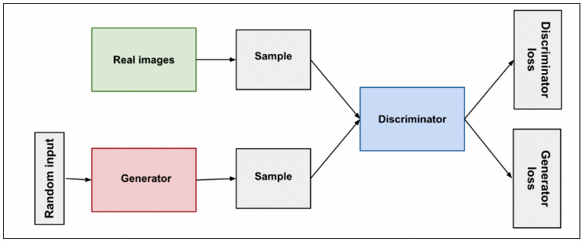

ARCHITECTURE DIAGRAM :
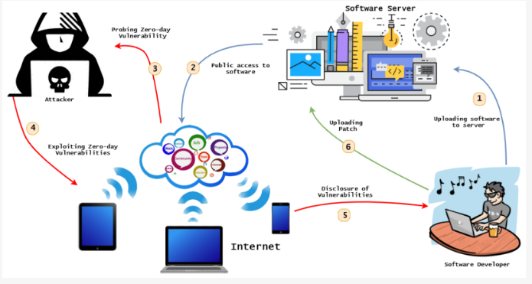

SOFTWARE REQUIREMENTS:
- Operating System : Windows 10
- Platform : python
HARDWARE REQUIREMENTS:
- Keyboard
- Mouse
- Hard disk 500GB
- Ram 4 Gb

CONCLUTION :
This paper motivated the need to adopt unsupervised anomaly detection algorithms as intrusion detectors to deal with zero-day (unknown) attacks. We first elaborated on zero-day attacks, explaining how they differ from known attacks and why intrusion detectors which rely only on rule-based, signature-based and supervised machine learning algorithms may not reliably identify them. Then, we introduced unsupervised anomaly detection algorithms as well as unsupervised meta-learning approaches that can improve their detection performance. We then addressed the need for allowing specific unsupervised anomaly detector to be installed in a given system. Proper tuning and selection has to be derived according to a precise strategy and its application through appropriate tooling and experimental campaigns.
REFERENCE :
- [1] V. Chandola, A. Banerjee, and V. Kumar, ‘‘Anomaly detection: A survey,’’ ACM Comput. Surv., vol. 41, no. 3, pp. 1–58, 2009.
- [2] S. He, J. Zhu, P. He, and M. R. Lyu, ‘‘Experience report: System log analysis for anomaly detection,’’ in Proc. IEEE 27th Int. Symp. Softw. Rel. Eng. (ISSRE), Oct. 2016, pp. 207–218.
- [3] M. Goldstein and S. Uchida, ‘‘A comparative evaluation of unsupervised anomaly detection algorithms for multivariate data,’’ PLoS ONE, vol. 11, no. 4, Apr. 2016, Art. no. e0152173
- , [4] T. Zoppi, A. ceccarelli, T. Capecchi, and A. Bondavalli, ‘‘Unsupervised anomaly detectors to detect intrusions in the current threat landscape,’’ 2020, arXiv:2012.11354. [Online]. Available: http://arxiv.org/ abs/2012.11354
- [5] T. Zoppi, A. Ceccarelli, L. Salani, and A. Bondavalli, ‘‘On the educated selection of unsupervised algorithms via attacks and anomaly classes,’’ J. Inf. Secur. Appl., vol. 52, Jun. 2020, Art. no. 102474.
- [6] M. Hanselmann, T. Strauss, K. Dormann, and H. Ulmer, ‘‘CANet: An unsupervised intrusion detection system for high dimensional CAN bus data,’’ IEEE Access, vol. 8, pp. 58194–58205, 2020.
- [7] G. O. Campos, A. Zimek, J. Sander, R. J. Campello, B. Micenková, E. Schubert, I. Assent, and M. E. Houle, ‘‘On the evaluation of outlier detection: Measures, datasets, and an empirical study,’’ in Proc. CEUR Work-Shop Lernen, Wissen, Daten, Analysen, Sep. 2016, pp. 1–43.
- [8] S. Boughorbel, F. Jarray, and M. El-Anbari, ‘‘Optimal classifier for imbalanced data using matthews correlation coefficient metric,’’ PLoS ONE, vol. 12, no. 6, Jun. 2017, Art. no. e0177678.
- [9] D. Chicco and G. Jurman, ‘‘The advantages of the matthews correlation coefficient (MCC) over f1 score and accuracy in binary classification evaluation,’’ BMC Genomics, vol. 21, no. 1, pp. 1–13, Dec. 2020.
- [10] Y. Chen, Y. Li, X. Q. Cheng, and L. Guo (2006 November), ‘‘Survey and taxonomy of feature selection algorithms in intrusion detection system,’’ in Proc. Int. Conf. Inf. Secur. Cryptol. Berlin, Germany: Springer, Nov. 2006, pp. 153–167.
- [11] M. Al-Qatf, Y. Lasheng, M. Al-Habib, and K. Al-Sabahi, ‘‘Deep learning approach combining sparse autoencoder with SVM for network intrusion detection,’’ IEEE Access, vol. 6, pp. 52843–52856, 2018.
- [12] M. Goldstein and A. Dengel, ‘‘Histogram-based outlier score (hbos): A fast unsupervised anomaly detection algorithm,’’ in KI-2012: Poster and Demo Track, 2012, pp. 59–63
- [13] H.-P. Kriegel, M. S Hubert, and A. Zimek, ‘‘Angle-based outlier detection in high-dimensional data,’’ in Proc. 14th ACM SIGKDD Int. Conf. Knowl. Discovery Data Mining (KDD), 2008, pp. 444–452.
- [14] V. Hautamaki and I. P. K. Franti, ‘‘Outlier detection using k-nearest neighbour graph. Pattern Recognition. ICPR 2004,’’ in Proc. 17th Int. Conf, vol. 3, Aug. 2004, pp. 430–433.
- [15] M. Amer, M. Goldstein, and S. Abdennadher, ‘‘Enhancing one-class support vector machines for unsupervised anomaly detection,’’ in Proc. ACM SIGKDD Workshop Outlier Detection Description (ODD), 2013, pp. 8–15.

