SASDL AND RBATQ: SPARSE AUTOENCODER WITH SWARM BASED DEEP LEARNING AND REINFORCEMENT BASED Q-LEARNING FOR EEG CLASSIFICATION

ABSTRACT:
The most vital information about the electrical activities of the brain can be obtained with the help of Electroencephalography (EEG) signals. It is quite a powerful tool to analyze the neural activities of the brain and various neurological disorders like epilepsy, schizophrenia, sleep related disorders, parkinson disease etc. can be investigated well with the help of EEG signals. Goal: In this paper, two versatile deep learning methods are proposed for the efficient classification of epilepsy and schizophrenia from EEG datasets.The main advantage of using deep learning when compared to other machine learning algorithms is that it has the capability to accomplish feature engineering on its own. It leverages only implicit pairwise labels (weak supervision) when learning the hidden modules. When training the output module, on the other hand, it requires full supervision but achieves high label efficiency, needing as few as ten randomly selected labeled examples (one from each class) to achieve 94.88% accuracy on CIFAR-10 using a ResNet-18 backbone oreover, modular training enables fully modularized DL workflows, which then simplify the design and implementation of pipelines and improve the maintainability and reusability of models Swarm intelligence is also a highly useful technique to solve a wide range of real-world, complex, and non-linear problems. Therefore, taking advantage of these factors, the first method proposed is a Sparse Autoencoder (SAE) with swarm based deep learning method and it is named as (SASDL) using Particle Swarm Optimization (PSO) technique, Cuckoo Search Optimization (CSO) technique and Bat Algorithm (BA) technique; and the second technique proposed is the Reinforcement Learning based on Bidirectional Long-Short Term Memory (BiLSTM), Attention Mechanism, Tree LSTM and Q learning, and it is named as (RBATQ) technique.Both these two novel deep learning techniques are tested on epilepsy and schizophrenia EEG datasets and the results are analyzed comprehensively, and a good classification accuracy of more than 93% is obtained for all the datasets..

EXISTING SYSTEM:
- In this paper, two versatile deep learning methods are proposed for the efficient classification of epilepsy and schizophrenia from EEG datasets. Methods: The main advantage of using deep learning when compared to other machine learning algorithms is that it has the capability to accomplish feature engineering on its own. Swarm intelligence is also a highly useful technique to solve a wide range of real-world, complex, and non-linear problems
- A transfer learning along with semi-supervised learning for seizure classification from EEG signals was proposed by Jiang et al., where the average accuracy was shown to be higher than 95% in most cases

DISADVANTAGE OF EXISTING SYSTEM:
- Swarm intelligence is also a highly useful technique to solve a wide range of real-world, complex, and non-linear problems
- These three approaches produced a high classification accuracy of more than 95% as per the consideration of their problem requirement..
- Schizophrenia is a serious mental disorder where people interpret reality in an abnormal manner Schizophrenia results in a combination of delusion, hallucination, and disordered thinking thereby the daily functions are severely impaired [31]. Therefore, schizophrenia involves a range of problems with cognition, emotion, and behaviour.

PROPOSED SYSTEM :
- This work will review existing computational and digital pathology methods for breast cancer diagnosis with a special focus on deep learning. The paper starts by reviewing public datasets related to breast cancer diagnosis.
- Additionally, existing deep learning methods for breast cancer diagnosis are reviewed. The publicly available code repositories are introduced as well. The paper is closed by highlighting challenges and future works for deep learning-based diagnosis

ADVANTAGE:
- When dealing with CSO, the following tree main rules are used in expressing the cuckoo search process Firstly, one egg is laid by a cuckoo at a particular time and its egg is dropped in a randomly chosen nest.
- In order to sense the distance, echo location is used by the bats and the difference between the prey and the different background barriers are known by the bats
- For an easy implementation, any wavelength can be used depending on the specific problem. By means of adjusting the frequencies the range of the wavelength can be adjusted. While fixing the wavelength λ, the frequency too can be varied as λ and f are closely related.

LITRATURE REVIEW:
TITTLE | AUTHOR | DESCRIPTION
Subject and class specific frequency bands selection for multi-class motor imagery classification, | H.-I. Suk and S.-W. Lee, | We operate the classification process for each frequency band individually
EEG dataset and OpenBMI toolbox for three BCI paradigms: An investigation into BCI illiteracy | M.-H. Lee et al, | In addition, information about the psychological and physiological conditions of BCI users was obtained using a questionnaire, and task-unrelated parameters such as resting state, artifacts, and electromyography of both arms were also recorded.
Optimized deep neural network architecture for robust detection of epileptic seizures using EEG signals,” Clin. Neuriophysiol | R. Hussein, H. Palangi, R. K. Ward, and Z. J. Wang | In this work, a deep neural network architecture is introduced to learn the temporal dependencies in Electroencephalogram (EEG) data for robust detection of epileptic seizures.
EEG signal classification using PCA, ICA, LDA and support vector machines, | A. Subasi and M. Ismail Gursoy | These findings are presented as an example of a method for training, and testing a seizure prediction method on data from individual petit mal epileptic patients
INTRODUCTION :
- An autoencoder model is developed to mitigate the dimensionality of the input .A feedforward neural network is utilized by this form of unsupervised learning and the autoencoder has both encoding and decoding plan An input x is usually trained and x is reconstructed to be quite similar to the input x as much as possible. Many kinds of autoencoders are available in literature such as sparse autoencoder, denoising autoencoder, stacked autoencoder etc.
- The input vector to the PSO/CSO/BA is given from the bottleneck of the sparse autoencoder.

- BLOCK DIAGRAM:
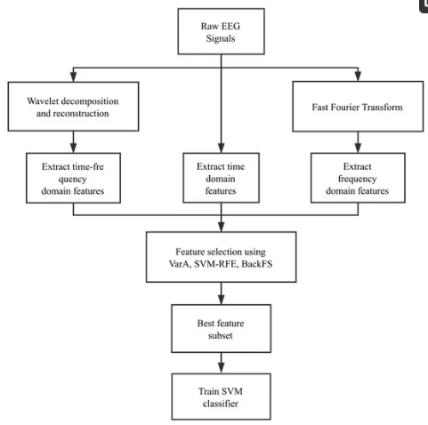

ARCHITECTURE DIAGRAM :
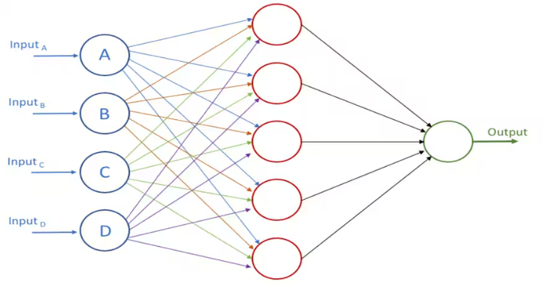

SOFTWARE REQUIREMENTS:
- Operating System : Windows 10
- Platform : python
HARDWARE REQUIREMENTS:
- Keyboard
- Mouse
- Hard disk 500GB
- Ram 4 Gb

CONCLUTION :
To study and analyze the neuronal dynamics within the human brain, the most standard tool utilized by the researchers and clinicians is EEG. For the EEG dependent analysis of various neurological disorders, visual inspection of these huge datasets is very difficult. Therefore, feature extraction techniques and automated classification schemes have been developed in the past. With the advent of deep learning, manual feature extraction is not necessary as it is aided by the deep learning process itself. In this paper, two novel deep learning techniques one with the help of swarm intelligence and another with the help of Reinforcement learning such as SASDL and RBATQ are proposed in this paper and tested for two EEG datasets such as epilepsy dataset and schizophrenia dataset. The highest classification accuracy of 98.55% was obtained with the proposed SASDL-PSO method and 97.75% was obtained with the proposed RBATQ method for epilepsy dataset.

REFERENCE :
- [1] H.-I. Suk and S.-W. Lee, “Subject and class specific frequency bands selection for multi-class motor imagery classification,” Int. J. Imag. Syst. Technol., vol. 21, no 2, pp. 123–130, 2011.
- [2]. M.-H. Lee et al., “EEG dataset and OpenBMI toolbox for three BCI paradigms: An investigation into BCI illiteracy,” Giga Sci., vol. 8, no 5, pp. 1–16, 2019..
- [3] R. Hussein, H. Palangi, R. K. Ward, and Z. J. Wang, “Optimized deep neural network architecture for robust detection of epileptic seizures using EEG signals,” Clin. Neuriophysiol., vol. 130, no. 1, pp. 25–37, 2019
- [4] A. Subasi and M. Ismail Gursoy, “EEG signal classification using PCA, ICA, LDA and support vector machines,”Expert Syst. Appl., vol. 37, no. 12, pp. 8659–8666, 2010.
- [5] N. Zahra, N. Kanwal, N. S. Rehman, S. Ehsan, and K. D. McDonald-Maier, “Seizure detection from EEG signals using multivariate empirical mode decomposition,” Comput. Biol. Med., vol. 88, pp. 132–141, 2017.
- [6] H. Ocak, “Automatic detection of epileptic seizures in EEG using discrete wavelet transform and approximate entropy,” Expert Syst. Appl., vol. 36, no. 2, pp. 2027–2036, 2009
- [7] S. Saminu et al., “A recent investigation on detection and classification of epileptic seizure techniques using EEG signal,” Brain Sci., vol. 11, no. 5, 2021, Art. no. 668.
- [8] A. Shoeibi et al., “Application of deep learning techniques for automated detection of epileptic seizures: A review,” Int. J. Environ. Res. Public Health, vol. 18, no. 11, 2021, Art. no. 5780.
- [9] Y. Jiang et al., “Seizure classification from EEG signals using transfer learning, semi-supervised learning and TSK fuzzy system,” IEEE Trans. Neural Syst. Rehabil. Eng., vol. 25, no. 12, pp. 2270–2284, Dec. 2017, doi: 10.1109/TNSRE.2017.2748388.
- [10] A. Bhattacharyya et al., “Tunable-q wavelet transform based multiscale entropy measure for automated classification of epileptic EEG signals,” Appl. Sci., vol. 7, no. 4, 2017, Art. no. 385.
- [11] T. Zhang and W. Chen, “LMD based features for the automatic seizure detection of EEG signals using SVM,” IEEE Trans. Neural Syst. Rehabil. Eng., vol. 25, no. 8, pp. 1100–1108, Aug. 2017, doi: 10.1109/TNSRE.2016.2611601.
- [12] M. Ullah Hussain, E.-U.-H. Qazi, and H. Aboalsamh, “An automated system for epilepsy detection using EEG brain signals based on deep learning approach,” Expert Syst. Appl., vol. 107, pp. 61–71, 2018.
- [13] X. Wei et al., “Automatic seizure detection using three-dimensional CNN based on multi-channel EEG,” BMC Med. Informat. Decis. Mak., vol. 18, 2018, Art. no. 111. [Online]. Available: https://doi.org/10.1186/s12911- 018-0693-8
- [14] A. G. Mahapatra et al., “Epilepsy EEG classification using morphological component analysis,” EURASIP J. Adv. Signal Process., vol. 2018, 2018, Art. no. 52. [Online]. Available: https://doi.org/10.1186/s13634- 018-0568-2
- [15] Ö. Turk and M. S. Ozerdem, “Epilepsy detection by using scalogram based convolutional neural network from EEG signals,” Brain Sci., vol. 9, no. 5, 2019, Art. no. 115.

