Multi-Agent Deep Reinforcement Learning-Empowered Channel Allocation in Vehicular Networks
ABSTRACT:
With the rapid development of vehicular networks, vehicle-to-everything (V2X) communications have huge number of tasks to be calculated, which brings challenges to the scarce network resources. Cloud servers can alleviate the terrible situation regarding the lack of computing abilities of vehicular user equipment (VUE), but the limited resources, the dynamic environment of vehicles, and the long distances between the cloud servers and VUE induce some potential issues, such as extra communication delay and energy consumptionFortunately, mobile edge computing (MEC), a promising computing paradigm, can ameliorate the above problems by enhancing the computing abilities of VUE through allocating the computational resources to VUEIn this paper, we propose a joint optimization algorithm based on a deep reinforcement learning algorithm named the double deep Q network (double DQN) to minimize the cost constituted of energy consumption, the latency of computation, and communication with the proper policy. The proposed algorithm is more suitable for dynamic scenarios and requires low-latency vehicular scenarios in the real world. Compared with other reinforcement learning algorithms, the algorithm we proposed algorithm improve the performance in terms of convergence, defined cost, and speed by around 30%, 15%, and 17%.

EXISTING SYSTEM:
- The remainder of this paper is organized as follows. In Section 2 we review the related work and explain the motivations of this paper. A detailed introduction to the model system and problem formulation are described in Section 3.
- In Section 4, we introduce some brief background about deep reinforcement learning and present our proposed algorithm.
- Then the parameters, results, and analysis of simulations in this paper are represented in Section 5. In the final section, Section 6, we conclude the entire paper. .

DISADVANTAGE OF EXISTING SYSTEM:
- To solve the dynamic problem caused by the high speed of the vehicular environment, we propose a joint optimization algorithm based on double DQN, which comprehensively considers joint optimization, including offloading strategy, allocation of computational resources, and communication resources. Through building the neural networks to approximate the reward value of the whole system, our algorithm solves the joint optimization problem that traditional methods find hard to solve

PROPOSED SYSTEM :
- With the instruction of the MEC servers, the VUE offload the task to the assigned MEC server with the corresponding transmission power. As displayed in Figure 4, the single gray flash symbol indicates that there is interference produced by VUE reusing the identical radio resources with cellular users.
- Apart from the single flash symbol, the double gray flash symbols represent the coexistence of the interference produced by reusing the same radio resources and the interference produced by the user, who is in thy reusing the same radio resources and the interference produced by the user, who is in the adjacent cell and reuse the identical communication resources
ADVANTAGE:
- Actually, a considerably large number of researchers and papers have paid a lot of attention to this field.
- The two main resources, the computation offloading and communication resources, need to be considered for optimization.
- To read easily and clearly, we classified the papers we refer to into two categories intuitively.
In Table 2, we offer the summary comparison of the references based on some features, such as year, focus on computation offloading and communication resources, and the methods used
LITRATURE REVIEW:
TITTLE | AUTHOR | DESCRIPTION
IEEE Internet Things | Abbas, N.; Zhang, Y.; Taherkordi, A.; Skeie, T. Mobile Edge Computing: | Human breast tumours are diverse in their natural history and in their responsiveness to treatments. Variation in transcriptional programs accounts for much of the biological diversity of human cells and tumours.
Peng, H. Collaborative Energy and Information Transfer in Green Wireless Sensor Networks for Smart Cities | P. St. J. Russell | The purpose of this study was to classify breast carcinomas based on variations in gene expression patterns derived from cDNA microarrays and to correlate tumor characteristics to clinical outcome.
Acosta-Marum, G. Wave: A tutorial | zcategui, R.A.; Sucre, A.J.D.; | The advent of microarrays has led to a new paradigm in deciphering breast cancer heterogeneity, based on which the intrinsisubtyping systemusing prognostic multigene classifiers was developed.
Emerging technology for 5G-enabled vehicular networks | Alahmadi, A.A.; Lawey, A.Q.; El-Gorashi, | To improve on current standards for breast cancer prognosis and prediction of chemotherapy benefit by developing a risk model that incorporates the gene expression-based "

INTRODUCTION :
- Computation offloading denotes the main topic of the current reference is the related work about computation offloading, such as matching the MEC servers and user equipment, for computation offloading decisions.
- Meanwhile, communication resources means the main topic of the reference is work about allocating wireless communication resources, such as selecting channels, assigning the transmission power, etc.
- Actually, a considerably large number of researchers and papers have paid a lot of attention to this field.
- The two main resources, the computation offloading and communication resources, need to be considered for optimization.

- BLOCK DIAGRAM:
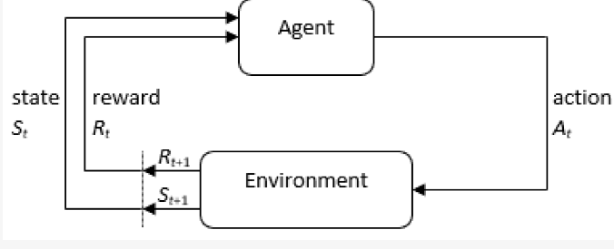

ARCHITECTURE DIAGRAM :
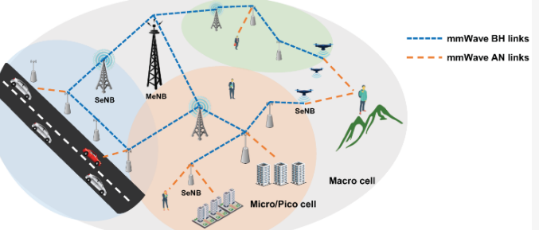

SOFTWARE REQUIREMENTS:
- Operating System : Windows 10
- Platform : python
HARDWARE REQUIREMENTS:
- Keyboard
- Mouse
- Hard disk 500GB
- Ram 4 Gb

CONCLUTION :
- In this paper, we studied a joint optimization problem in a multi-cell scenario with multiple pieces of VUE. This problem is one of the common NP-hard problems, which cannot be solved in the polynomial time. Consequently, we rewrote the origin object with the help of the concept of reinforcement learning. Then we proposed an algorithm based on double DQN to jointly optimize the decision variables, including the task offloading decision and the transmission power policy of VUE, and the computational resources allocation policy of MEC servers. Furthermore, to accelerate the speed of the training neural networks and reduce the latency of the algorithm, we cleaned the action space Sensors by discarding several inefficient actions.

REFERENCE :
- J1. Abbas, N.; Zhang, Y.; Taherkordi, A.; Skeie, T. Mobile Edge Computing: A Survey. IEEE Internet Things J. 2018, 5, 450–465. [CrossRef]
- 2. Lu, W.; Gong, Y.; Liu, X.; Wu, J.; Peng, H. Collaborative Energy and Information Transfer in Green Wireless Sensor Networks for Smart Cities. IEEE Trans. Ind. Inform. 2017, 14, 1585–1593. [CrossRef]
- 3. Uzcategui, R.A.; Sucre, A.J.D.; Acosta-Marum, G. Wave: A tutorial. IEEE Commun. Mag. 2009, 47, 126–133. [CrossRef]
- 4. Vinel, A.; Breu, J.; Luan, T.H.; Hu, H. Emerging technology for 5G-enabled vehicular networks. IEEE Wirel. Commun. 2017, 24, 12. [CrossRef]
- 5. Alahmadi, A.A.; Lawey, A.Q.; El-Gorashi, T.E.; Elmirghani, J.M. Distributed processing in vehicular cloud networks. In Proceedings of the 2017 8th International Conference on the Network of the Future (NOF), London, UK, 22–24 November 2017
- 6. Zhao, J.; Li, Q.; Gong, Y.; Zhang, K. Computation offloading and resources allocation for cloud assisted mobile edge. Computing in vehicular networks. IEEE Trans. Veh. Technol. 2019, 68, 7944–7956. [CrossRef]
- 7. Behbehani, F.S.; Musa, M.; Elgorashi, T.; Elmirghani, J.M. Energy-Efficient Distributed Processing in Vehicular Cloud Architecture. arXiv 2019, arXiv:1903.12451.
- 8. Dayarathna, M.; Wen, Y.; Fan, R. Data Center Energy Consumption Modeling: A Survey. IEEE Commun. Surv. Tutor. 2016, 18, 732–794. [CrossRef]
- 9. Giust, F.; Sciancalepore, V.; Sabella, D.; Filippou, M.C.; Mangiante, S.; Featherstone, W.; Munaretto, D. Multi-access Edge Computing: The driver behind the wheel of 5G-connected cars. IEEE Commun. Stand. Mag. 2018, 2, 66–73. [CrossRef]
- 10. Tao, X.; Ota, K.; Dong, M.; Qi, H.; Li, K. Performance guaranteed computation offloading for mobile-edge cloud computing. IEEE Wirel. Commun. Lett. 2017, 6, 774–777. [CrossRef]

- 11. Sabella, D.; Vaillant, A.; Kuure, P.; Rauschenbach, U.; Giust, F. Mobile-edge computing architecture: The role of MEC in the Internet of Things. IEEE Consum. Electron. Mag. 2016, 5, 84–91. [CrossRef]
- 12. Oliveira, R.; Luísa, M.; Furtadoa, A.; Bernardoa, L.; Dinisa, R.; Pintoa, P. Improving path duration in high mobility vehicular ad hoc networks. Ad Hoc Netw. 2013, 11, 89–103. [CrossRef]
- 13. Watkins, C.J.C.H.; Dayan, P. Technical Note: Q-Learning. Mach. Learn. 1992, 8, 279–292. [CrossRef]
- 14. Sutton, R.; Richard, S. Learning to predict by the methods of temporal differences. Mach. Learn. 1988, 3, 9–44. [CrossRef]
- 15. Thrun, S.; Anton S. Issues in using function approximation for reinforcement learning. In Proceedings of the 1993 Connectionist Models Summer School Hillsdale; Lawrence Erlbaum: Hillsdale, NJ, USA, 1993

