MACHINE LEARNING AND DEEP LEARNING APPROACHES FOR CYBERSECURITY A
ABSTRACT:
The detection and prevention of a network intrusion is a major concern. Machine Learning and Deep Learning methods detect network intrusions by predicting the risk with the help of training the data. Various machine learning and deep learning methods have been proposed over the years which are shown to be more accurate when compared to other network intrusion detecting systems. This survey paper gives a brief introduction about various machine learning and deep learning algorithms.

EXISTING SYSTEM:
- Various machine learning and deep learning methods have been proposed over the years which are shown to be more accurate when compared to other network intrusion detecting systems. This survey paper gives a brief introduction about various machine learning and deep learning algorithms.
DISADVANTAGE OF EXISTING SYSTEM:
- Many problems exist that this conventional neural network cannot solve. The reason that RNN is a recurrent neural network is that the current output of a sequence is also related to the output before it. The concrete manifestation is that the network can remember the information of the previous moment and apply it to the calculation of the current output; that is, the nodes between the hidden layers become connected, and the input of the hidden layer includes both the output of the input layer and the last moment hidden layer output. Theoretically, any length of sequence data RNN can be processed. However, in practice, to reduce the complexity, it is often assumed that the current state is only related to the previous states
PROPOSED SYSTEM :
- This includes even detection of already existing cybersecurity attacks. It requires as much effort to detect already existing type of attack so as to detect a new type of attack
- This is highly impossible task, since there are millions of cybersecurity attacks found among people all over the world. Hence, the detection of cybersecurity threats is of great concern.
- Therefore, the detection of these threats is very important. This can be done by using machine learning and deep learning algorithms in the field of cybersecurity.
ADVANTAGE:
- KNN algorithm is a machine-learning algorithm used for classification, regression. KNN is a non-parametric, lazy learning algorithm. It predicts the classification of a new sample point by using a dataset in which the data points are separated into several classes. KNN is used for classification, the output is a class membership (predicts a class — a discrete value).
- An object is classified by maximum presence of its neighbors, with the object being assigned to the class having maximum number of k nearest neighbors. KNNis used for regression, the output is the value for the object (predicts continuous values). The value predicted is the average of the values of its k nearest neighbors

LITRATURE REVIEW:
TITTLE | AUTHOR | DESCRIPTION
Machine Learning and Deep Learning Methods for Cybersecurity” | Yang Xin, Lingshuang Kong, Zhi Liu, Yuling Chen, Yanmilo Li, Hongliang Zhu, Mingcheng Gao, Haixia Hou, Chunhua Wang, | With the development of the Internet, cyber-attacks are changing rapidly and the cyber security situation is not optimistic
On the Effectiveness of Machine and Deep Learning for Cyber Security | Kehe Wu, Zuge Chen, Wei Li, | Machine learning is adopted in a wide range of domains where it shows its superiority over traditional rule-based algorithms.
“Intrusion Detection System using Support Vector Machine (SVM) and Particle Swarm Optimization (PSO)”,. | , Vitthal Manekar, Kalyani Waghmare,” | Machine learning is adopted in a wide range of domains where it shows its superiority over traditional rule-based algorithms..
Intrusion Detection Using k-Nearest Neighbor | M. Govindarajan, Rlvl. Chandrasekaran | A new approach, based on the k-Nearest Neighbor (kNN) classifier, is used to classify program behavior as normal or intrusive.

INTRODUCTION :
Support Vector Machine (SVM) is a machine learning algorithm which is robust and accurate methods. It includes Support Vector Classification (SVC)and Support Vector Regression (SVR). The SVC is based on the concept of decision boundaries. A decision boundary separates a set of instances having different class values between two groups. The SVC supports both binary and multi-class classifications. The support vector is the closest point to the separation hyperplane, which determines the optimal separation hyperplane
BLOCK DIAGRAM:
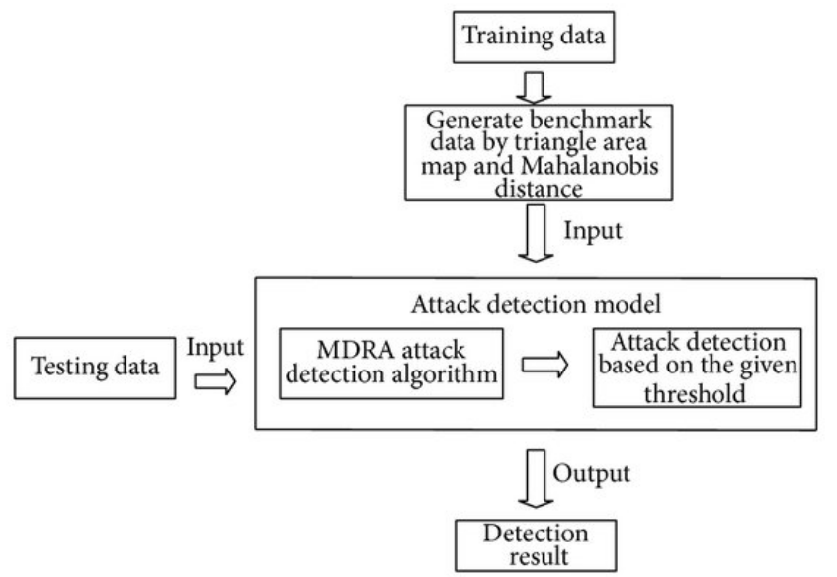

ARCHITECTURE DIAGRAM :
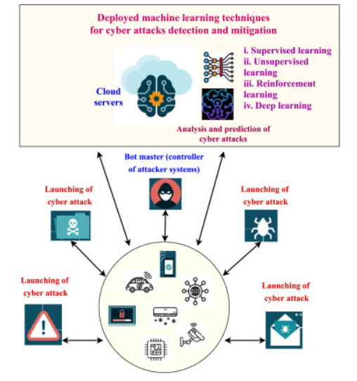

SOFTWARE REQUIREMENTS:
- Operating System : Windows 10
- Platform : python
HARDWARE REQUIREMENTS:
- Keyboard
- Mouse
- Hard disk 500GB
- Ram 4 Gb

CONCLUTION :
This paper presents a survey of ML and DL methods, that can be used for network security. Every method used for implementing an intrusion detection system has its own advantages and disadvantages. In this paper, a comparison is made among the various methods. Therefore, it is not possible to choose only one particular method to implement an intrusion detection system.

REFERENCE :
- [1] Yang Xin, Lingshuang Kong, Zhi Liu, Yuling Chen, Yanmilo Li, Hongliang Zhu, Mingcheng Gao, Haixia Hou, Chunhua Wang,” Machine Learning and Deep Learning Methods for Cybersecurity”, IEEE 2018.
- [2] Giovanni Apruzzese, Luca Ferretti, Mirco Marchetti, Alessandro Guido, Michel Colajanni,” On the Effectiveness of Machine and Deep Learning for Cyber Security”, 2018, 10th International Conference on Cyber Conflict.
- [3] Kehe Wu, Zuge Chen, Wei Li,” A Novel Intrusion Detection Model for a Massive Network Using Convolutional Neural Networks”,IEEE 2018.
- [4] Vitthal Manekar, Kalyani Waghmare,” Intrusion Detection System using Support Vector Machine (SVM) and Particle Swarm Optimization (PSO)”, International Journal of Advanced Computer Research, September-2014.
- [5] M. Govindarajan, Rlvl. Chandrasekaran, “Intrusion Detection Using k-Nearest Neighbor”, IEEE 2009
- [6] M. S. Pervez and D. M. Farid, ‘‘Feature selection and intrusion classification in NSL-KDD CUP 99 dataset employing SVMs,’’ in Proc. 8th Int. Conf. Softw., Knowl., Inf. Manage.Appl. (SKIMA), 2014
- [7] E. G. Dada, ‘‘A hybridized SVM-kNN-pd APSO approach to intrusion detection system,’’ in Proc. Fac. Seminar Ser., 2017.
- [8] N.Gao, L.Gao, Q.Gao, H.Wang, ‘‘An intrusion detection model based on deep belief networks,’’ in Proc. 2nd Int. Conf. Adv. Cloud Big Data, 2014
- [9] C.L.Yin, Y.F.Zhu, J.L.Fei, X.Z.He, ‘‘A deep learning approach for intrusion detection using recurrent neural networks,’’ IEEE 2017
- [10] W. Wang, M. Zhu, X. Zeng, X. Ye, and Y. Sheng, ‘‘Malware traffic classification using convolutional neural network for representation learning,’’ in Proc. Int. Conf. Inf. Netw. 2017.
- [11] C. Azad and V. K. Jha, ‘‘Genetic algorithm to solve the problem of small disjunct in the decision tree-based intrusion detection system,’’ Int. J. Comput. Netw. Inf. Secur. 2015

