LEARNING FROM NOISY DATA AN UNSUPERVISED RANDOM DENOISING METHOD FOR SEISMIC DATA USING MODEL-BASED DEEP LEARNING
ABSTRACT:
For the noise removal problem of noisy seismic data, an improved noise reduction technique based on feedforward denoising neural network (DnCNN) is proposed. The previous DnCNN, which was designed to minimise noise in seismic data, had an issue with a large network depth, which hampered training efficiency. The revised DnCNN technique was previously introduced for noise reduction in natural data sets, and after modifying the essential parameters, this study extends the algorithm to noise reduction in seismic dataThe DUDnCNN algorithm can reduce noise with high efficiency, according to the analysis and comparison of the experimental findings, and the method has certain feasibility and significance for further seismic data noise reduction research.
EXISTING SYSTEM:
A non-diagonal seismic noise reduction technique based on continuous wavelet transform and hybrid block thresholding was proposed by Mousavi et al. The full-variance regularised nonlocal mean approach was used by Li et ato reduce noise in seismic data, which efficiently removed the noise while maintaining the edges. A noise reduction technique based on dynamic clustering with singular value decomposition was suggested by Wang Wei et al[10]. The adaptive thresholding approach based on the shearlet transform was used to reduce seismic data noise by Cheng Hao et al . Although many of the aforementioned algorithms have shown promise in the processing of seismic data noise, further research is needed to increase the efficiency and accuracy of noise reduction
Disadvantage of Existing System
Because it requires the same distribution of test and training data, the former ones have a problem with poor generalisation ability. We present a novel deep learning framework for attenuating random noise in prestack seismic data in an unsupervised manner to avoid constructing noise-free labels. . And the DUDnCNN loss change curve shows that the training loss has basically converged at 20 iterations, and the peak signal-to-noise ratio has also improved significantly before and after iteration, but even though we try to alleviate the problem of effective information being removed by adjusting the learning rate and Batch size several times, the problem of effective information being removed persists.
PROPOSED SYSTEM :
- In contrast to existing DnCNN and other AI-based denoisers, FFCNN has several appealing features: 1) downsampling and upscaling operations, which can significantly reduce runtimes and memory requirements while maintaining denoising performance, and 2) we introduced noised level maps, which can allow a single convolutional neural network (CNN) model to handle noise models with varying parameters. The main work and benefits of this article are focused on the following two components forreal seismic data denoised work
ADVANTAGE:
- The suggested CNN denoising model was tested with synthetic and field data. When compared to two commonly used state-of-the-art denoising approaches, the experimental results show that random noise attenuation while keeping amplitude is more successful. To get around it, several researchers used labels made from realistic-looking synthetic data or denoised results obtained using traditional approaches. . The adaptive thresholding approach based on the shearlet transform was used to reduce seismic data noise by Cheng Hao et

LITRATURE REVIEW:
TITTLE | AUTHOR | DESCRIPTION
"Deep Learning Seismic Random Noise Attenuation via Improved Residual Convolutional Neural Network," | L. Yang, W. Chen, H. Wang and Y. Chen, | Because a high signal-to-noise ratio (SNR) is beneficial to the subsequent processing procedures, the noise attenuation is important.
Deep Learning Prior Model for Unsupervised Seismic Data Random Noise Attenuation," | TK. M. Kitani, B. D. Ziebart, J. A. Bagnell, and M. Hebert,, | Denoising is an indispensable step in seismic data processing...
Anticipating Visual Representations from Un"A Deep Learning Method for Denoising Based on a Fast and Flexible Convolutional Neural Network," | C. Vondrick, H. Pirsiavash, and A. Torralba, | In contrast to other existing neural properties such as faster execution time and smaller memory footprint, and the ability to handle a wide range of noise levels with a single network model.
"A Deep Learning Method for Denoising Based on a Fast and Flexible Convolutional Neural Network," | W. Li, H. Liu and J. Wang, | The quality of the results directly affects the results of subsequent inversion and migration imaging..

INTRODUCTION :
Where x represents the original noise-free seismic data, y represents the noisy seismic data, and n represents the noise, which is commonly additive Gaussian noise with a normal distribution. According to the above equation, the main goal of noise reduction is to recover x from y as much as possible, i.e., the ultimate goal is to remove noise from noisy data using noise reduction processing, so that the obtained seismic data is as close as possible to the original seismic data without noise, and the seismic data used in the subsequent experiments in the paper are all seismic images. The following equation can be derived by using neural networks to improve the denoising model into a learnable process

BLOCK DIAGRAM:
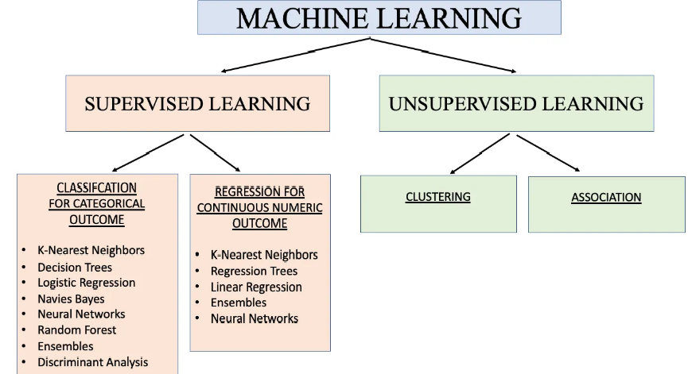
ARCHITECTURE DIAGRAM :
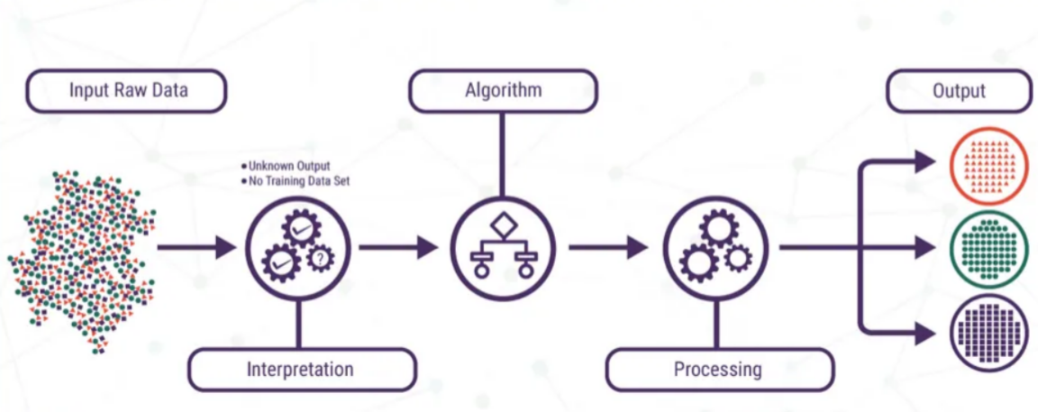

SOFTWARE REQUIREMENTS:
- Operating System : Windows 10
- Platform : python
HARDWARE REQUIREMENTS:
- Keyboard
- Mouse
- Hard disk 500GB
- Ram 4 Gb

CONCLUTION :
To solve the issue of excessive noise reduction network depth affecting training efficiency, this research recommends using a DUDnCNN with a reduced depth to reduce seismic data noise. DUDnCNN combines the benefits of DnCNN batch normalisation with an end-to-end U-Net neural network, and the network's skip-connection operation prevents shallow information from being lost during the feature learning process, allowing it to successfully extract feature information. The dilation convolution operator is introduced to the kernel, allowing the perceptual field to be increased throughout the convolution process.

REFERENCE :
- 1) L. Yang, W. Chen, H. Wang and Y. Chen, "Deep Learning Seismic Random Noise Attenuation via Improved Residual Convolutional Neural Network," in IEEE Transactions on Geoscience and Remote Sensing, vol. 59, no. 9, pp. 7968-7981, Sept. 2021, doi: 10.1109/TGRS.2021.3053399.
- 2) C. Qiu, B. Wu, N. Liu, X. Zhu and H. Ren, "Deep Learning Prior Model for Unsupervised Seismic Data Random Noise Attenuation," in IEEE Geoscience and Remote Sensing Letters, vol. 19, pp. 1-5, 2022, Art no. 7502005, doi: 10.1109/LGRS.2021.3053760.
- 3) W. Li, H. Liu and J. Wang, "A Deep Learning Method for Denoising Based on a Fast and Flexible Convolutional Neural Network," in IEEE Transactions on Geoscience and Remote Sensing, vol. 60, pp. 1- 13, 2022, Art no. 5902813, doi: 10.1109/TGRS.2021.3073001.
- 4) B. Liu et al., "Unsupervised Deep Learning for Random Noise Attenuation of Seismic Data," in IEEE Geoscience and Remote Sensing Letters, vol. 19, pp. 1-5, 2022, Art no. 7501905, doi: 10.1109/LGRS.2021.3057631.
- 5) G. Chen, Y. Liu, M. Zhang and H. Zhang, "Dropout-based robust self-supervised deep learning for seismic data denoising," in IEEE Geoscience and Remote Sensing Letters, doi: 10.1109/LGRS.2022.3167999.
- 6) W. Zhu, S. M. Mousavi and G. C. Beroza, "Seismic Signal Denoising and Decomposition Using Deep Neural Networks," in IEEE Transactions on Geoscience and Remote Sensing, vol. 57, no. 11, pp. 9476- 9488, Nov. 2019, doi: 10.1109/TGRS.2019.2926772.
- 7) D. Liu, Z. Deng, C. Wang, X. Wang and W. Chen, "An Unsupervised Deep Learning Method for Denoising Prestack Random Noise," in IEEE Geoscience and Remote Sensing Letters, vol. 19, pp. 1-5, 2022, Art no. 7500205, doi: 10.1109/LGRS.2020.3019400.
- 8) F. Wang, B. Yang, Y. Wang and M. Wang, "Learning From Noisy Data: An Unsupervised Random Denoising Method for Seismic Data Using Model-Based Deep Learning," in IEEE Transactions on Geoscience and Remote Sensing, vol. 60, pp. 1-14, 2022, Art no. 5913314, doi: 10.1109/TGRS.2022.3165037

