INVESTIGATING DEEP LEARNING BASED BREAST CANCER SUBTYPING USING PAN-CANCER AND MULTI-OMIC DATA
ABSTRACT:
Breast Cancer comprises multiple subtypes implicated in prognosis. Existing stratification methods rely on the expression quantification of small gene sets. Next Generation Sequencing promises large amounts of omic data in the next years. In this scenario, we explore the potential of machine learning and, particularly, deep learning for breast cancer subtyping.a. When multi-omic data types are combined together, performance of deep models shows little (if any) improvement in accuracy, indicating the need for further analysis on larger datasets of multi-omic data as and when they become available. We make use of multi-omic data, including microRNA expressions and copy number alterations, and we provide an in-depth investigation of several supervised and semi-supervised architectures Obtained accuracy results show simpler models to perform at least as well as the deep semi-supervised approaches on our task over gene expression data a. When multi-omic data types are combined together, performance of deep models shows little (if any) improvement in accuracy, indicating the need for further analysis on larger datasets of multi-omic data as and when they become available

EXISTING SYSTEM:
- In Existing system Several multigene prognostic molecular tests have been proposed for BRCA over the last decade, contributing to a better stratification, analysis, and understanding of its prognosisrelated molecular subtypes.
- Notwithstanding their proven predictive power, these tests still use classification models based on gene expression values of only a few genes, leaving much of the additional BRCA traits and heterogeneity unexplained.
PROPOSED SYSTEM :
- This work will review existing computational and digital pathology methods for breast cancer diagnosis with a special focus on deep learning. The paper starts by reviewing public datasets related to breast cancer diagnosis.
- Additionally, existing deep learning methods for breast cancer diagnosis are reviewed. The publicly available code repositories are introduced as well. The paper is closed by highlighting challenges and future works for deep learning-based diagnosis
ADVANTAGE:
- breast cancer diagnosis OR malignant growth OR tumor AND (deep learning OR machine learning)
- Other studies reported that estrogen receptor status (trauma centers) is a fundamental atomic marker used to diagnose and select treatment options
- A limited set of samples with lesion-level annotation was used in the first phase of training.

LITRATURE REVIEW:
TITTLE | AUTHOR | DESCRIPTION
Molecular portraits of human breast tumours | Na Wu , Dewei Li , and Yugeng Xi | Human breast tumours are diverse in their natural history and in their responsiveness to treatments. Variation in transcriptional programs accounts for much of the biological diversity of human cells and tumours.
Gene expression patterns of breast carcinomas distinguish tumor subclasses with clinical implications | T. Sørlie, C. M. Perou, R. Tibshirani, T. Aas, S. Geisler, H. Johnsen, T. Hastie, M. B. Eisen, M. Van De Rijn, S. S. Jeffrey, | The purpose of this study was to classify breast carcinomas based on variations in gene expression patterns derived from cDNA microarrays and to correlate tumor characteristics to clinical outcome.
Breast cancer intrinsic subtype classification, clinical use and future trends | X. Dai, T. Li, Z. Bai, Y. Yang, X. Liu, J. Zhan, and B. Shi | The advent of microarrays has led to a new paradigm in deciphering breast cancer heterogeneity, based on which the intrinsisubtyping systemusing prognostic multigene classifiers was developed.
Supervised risk predictor of breast cancer based on intrinsic sub | J. Parker, M. Mullins, M. Cheang, S. Leung, D. Voduc, T. Vickery, S. Davies, C. Fauron, X. He, Z. Hu, and J. Quackenbush, | To improve on current standards for breast cancer prognosis and prediction of chemotherapy benefit by developing a risk model that incorporates the gene expression-based "intrinsic" subtypes luminal A, luminal B, HER2-enriched, and basal-like.

INTRODUCTION :
- Multi-class Logistic Regression (LR) is the first method we investigated for breast cancer subtyping. LR is a wellestablished linear classification method that has the advantage of producing models that are easier to interpret than the non-linear models discussed shortly.
- To cope with the huge feature set compared to the number of labeled examples, we applied sparsity-inducing L1 regularisation to prevent overfitting. The L1-penalty shrinks the less important feature’s coefficients to zero, removing some features altogether from the model. under- and over-fitting.)

BLOCK DIAGRAM:
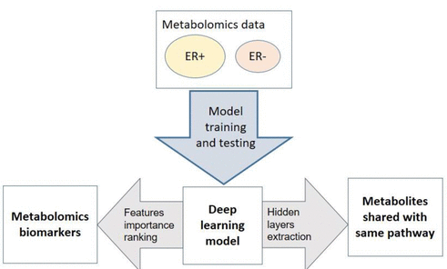
ARCHITECTURE DIAGRAM :
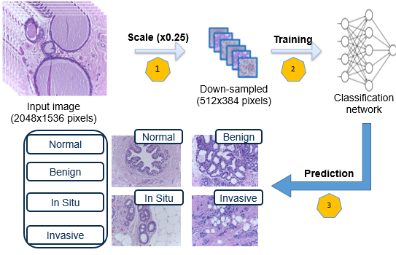

SOFTWARE REQUIREMENTS:
- Operating System : Windows 10
- Platform : python
HARDWARE REQUIREMENTS:
- Keyboard
- Mouse
- Hard disk 500GB
- Ram 4 Gb

CONCLUTION :
In this work we explored a computational approach to leverage the larger datasets provided by high-throughput sequencing technologies for the breast cancer subtyping task. To do so, we developed both supervised and semisupervised machine learning models that could take advantage of this substantial broadening of the variable space to efficiently classify different breast cancer samples accurately

REFERENCE :
- [1] ] C. M. Perou, T. Sørlie, M. Eisen, M. Van de Rijn, S. Jeffrey, C. Rees, and J. Pollack, “Molecular portraits of human breast tumours,” Nature, vol. 406, pp. 747–752, 2000.
- [2]. Gene expression patterns of breast carcinomas distinguish tumor subclasses with clinical implications,” Proceedings of the National Academy of Sciences of the United States of America, vol. 98(19), pp. 10869—-10874, 2001.
- [3] ] intrinsic subtype classification, clinical use and future trends,” American journal of cancer research, vol. 5, no. 10, p. 2929, 2015
- [4] A. F. Vieira and F. Schmitt, “An update on breast cancer multigene prognostic tests-emergent clinical biomarkers,” Frontiers in medicine, vol. 5, p. 248, 2018.
- [15] J. Parker, M. Mullins, M. Cheang, S. Leung, D. Voduc, T. Vickery, S. Davies, C. Fauron, X. He, Z. Hu, and J. Quackenbush, “Supervised risk predictor of breast cancer based on intrinsic subtypes,” J Clin Oncl, vol. 27, pp. 1160—-1167, 2009
- [6] B. Wallden, J. Storhoff, T. Nielsen, N. Dowidar, C. Schaper, S. Ferree, S. Liu, S. Leung, G. Geiss, J. Snider, et al., “Development and verification of the pam50-based prosigna breast cancer gene signature assay,” BMC medical genomics, vol. 8, no. 1, p. 54, 2015.
- [7]. O. Krijgsman, P. Roepman, W. Zwart, J. S. Carroll, S. Tian, F. A. de Snoo, R. A. Bender, R. Bernards, and A. M. Glas, “A diagnostic gene profile for molecular subtyping of breast cancer associated with treatment response,” Breast cancer research and treatment, vol. 133, no. 1, pp. 37–47, 2012.
- [8] Cancer Genome Atlas Network et al., “Comprehensive molecular portraits of human breast tumours,” Nature, vol. 490, no. 7418, p. 61, 2012 .
- [9] A. B. Showkat, M. Sabhiya, and H. Tehseen, “Micrornas and its emerging role as breast cancer diagnostic marker- a review,” Advances in Biomarker Sciences and Technology, vol. 1, pp. 1–8, 2019
- [10] Identification of the copy number variant biomarkers for breast cancer subtypes,” Molecular Genetics and Genomics, vol. 294, no. 1, pp. 95–110, 2019..
- [11] ] S. Cascianelli, I. Molineris, C. Isella, M. Masseroli, and E. Medico, “Machine learning for RNA sequencing-based intrinsic subtyping of breast cancer,” Scientific Reports, vol. 10, no. 1, pp. 1–13, 2020
- [12]. F. A. Spanhol, L. S. Oliveira, C. Petitjean, and L. Heutte, “Breast cancer histopathological image classification using convolutional neural networks,” in 2016 international joint conference on neural networks (IJCNN), pp. 2560–2567, IEEE, 2016
- [13] ] Accurate and reproducible invasive breast cancer detection in whole-slide images: A deep learning approach for quantifying tumor extent,” Scientific reports, vol. 7, p. 46450, 2017.
- [14] Breast cancer histopathological image classification: A deep learning approach,” bioRxiv, p. 242818, 2018.
- [15] Deep learning to distinguish recalled but benign mammography images in breast cancer screening,” Clinical Cancer Research, vol. 24, no. 23, pp. 5902–5909, 2018.

