FEDERATED DEEP LEARNING FOR THE DIAGNOSIS OF CEREBELLAR ATAXIA: PRIVACY PRESERVATION AND AUTO-CRAFTED FEATURE EXTRACTOR
ABSTRACT:
Cerebellar ataxia (CA) is concerned with the incoordination of movement caused by cerebellar dysfunction. Movements of the eyes, speech, trunk, and limbs are affected. Conventional machine learning approaches utilizing centralised databases have been used to objectively diagnose and quantify the severity of CA . Although these approaches achieved high accuracy,large scale deployment will require large clinics and raises privacy concerns. We use motion capture sensors during the performance of a standard neurological balance test obtained from four geographically separated clinics. The recurrence plot, melspectrogram, and poincaré plot are three transformation techniques explored.The recurrence plot, melspectrogram, and poincaré plot are three transformation techniques explored. The proposed scheme provides a practical solution with high diagnosis accuracy, removing the need for feature engineering and preserving data privacy for a large-scale deployment

EXISTING SYSTEM:
- The proposed scheme provides a practical solution with high diagnosis accuracy, removing the need for feature engineering and preserving data privacy for a large-scale deployment.
- we propose an image transformation-based approach to leverage the advantages of state-of-the-art deep learning with federated learning in diagnosing CA. We use motion capture sensors during the performance of a standard neurological balance test obtained from four geographically separated clinics. The recurrence plot, melspectrogram, and poincaré plot are three transformation techniques explored.
DISADVANTAGE OF EXISTING SYSTEM:
Three fundamental problems in assessing ataxia are
- (i) classifying people as ataxics or non-ataxic controls;
- (ii) assessing severity with a regression model or classify the severity into sub-groups of low, moderate, and severe; and,
- (iii) classifying subjects ataxia phenotype to facilitate more specific therapeutic and rehabilitation programs
We evaluate three different image transformation techniques to use with DL and employ transfer learning to overcome the problem of limited datasets.

PROPOSED SYSTEM :
- we propose an image transformation-based approach to leverage the advantages of state-of-the-art deep learning with federated learning in diagnosing CA. We use motion capture sensors during the performance of a standard neurological balance test obtained from four geographically separated clinics. The recurrence plot, melspectrogram, and poincaré plot are three transformation techniques explored.
- The clinician’s experience and the inherent subjectiveness of the human decision-making procedure impact significantly on this assessment method.
ADVANTAGE:
- Researchers also used prism-equipped goggles to assess motor adaptation in ataxia
- In the balance domain, a cloud-based ML implementation operating on data from IMU based wearable sensors were used to quantify the severity of truncal ataxia .
- Interpolating and sliding a fixed-sized window with two second overlapping was used to pre-process the raw data. As recurrence plots are significantly reliable when the data length is longer than 1000 samples
- Most studies in CA have used traditional ML with hand-crafted feature extraction.

LITRATURE REVIEW:
TITTLE | AUTHOR | DESCRIPTION
“Balance deficits due to cerebellar ataxia: A machine learning and cloud-based approach | T. Ngo | It manifests as uncoordinated movement of the limbs, speech, and balance.
A guide to deep learning in healthcare | A. Esteva | we present deep-learning techniques for healthcare, centering our discussion on deep learning in computer vision, natural language processing, reinforcement learning, and generalized methods.
“Deep learning for healthcare: Review, opportunities and challenges,” | R. Miotto, F. Wang, S. Wang, X. Jiang, and J. T. Dudley | Biomedical research, including electronic health records, imaging, -omics, sensor data and text, which are complex, heterogeneous, poorly annotated and generally unstructured.
Federated learning and differential privacy for medical image analysis, | M. Adnan, S. Kalra, J. C. Cresswell, G. W. Taylor, and H. R. Tizhoosh, | The artificial intelligence revolution has been spurred forward by the availability of large-scale datasets

INTRODUCTION :
- Datasets in this study were provided by four clinics, located in three Australian states: Victoria, New South Wales and Western Australia
- Ethics approval was granted by the Human Research and Ethics Committee, Royal Victorian Eye and Ear Hospital, East Melbourne, Australia
- All participants provided informed consent as per the Declaration of Helsinki.

BLOCK DIAGRAM:
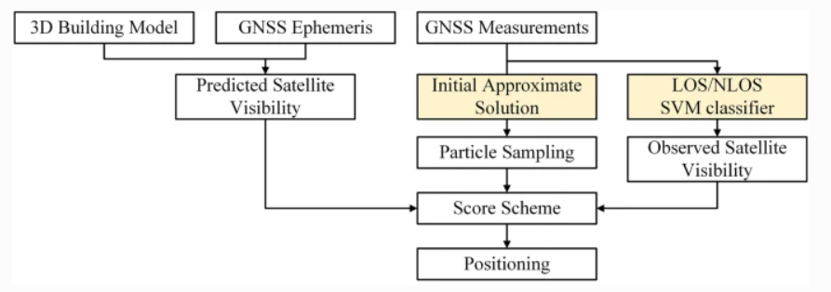
ARCHITECTURE DIAGRAM :
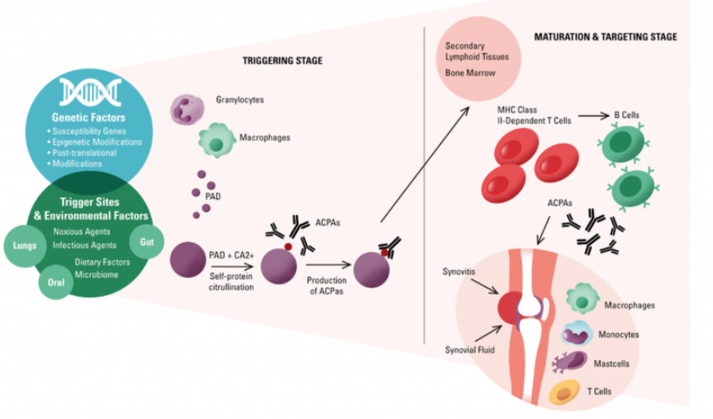

SOFTWARE REQUIREMENTS:
- Operating System : Windows 10
- Platform : python
HARDWARE REQUIREMENTS:
- Keyboard
- Mouse
- Hard disk 500GB
- Ram 4 Gb

CONCLUTION :
This study proposed a novel scheme to utilize image transformation-based approach on DL framework integrated with FL for the CA diagnosis. The results of the analysis indicated the possibility to classify 86.69% accurate using a lightweight convolutional architecture (MobileNetV2) with the recurrence plot transformer. Compared to traditional ML approach, applying DL achieved a better accuracy with higher flexibility to engage with different datasets. It also saved analysis and deployment time by eliminating the laborious work of feature extraction. The FL enables privacy protection for the participant clinics with a deployable and practical scheme for implementation

REFERENCE :
- [1] T. Ngo et al., “Balance deficits due to cerebellar ataxia: A machine learning and cloud-based approach,” IEEE Trans. Biomed. Eng., vol. 68, no. 5, pp. 1507–1517, May 2021.
- [2] A. Esteva et al., “A guide to deep learning in healthcare,” Nature Med., vol. 25, no. 1, pp. 24–29, Jan. 2019.
- [3] R. Miotto, F. Wang, S. Wang, X. Jiang, and J. T. Dudley, “Deep learning for healthcare: Review, opportunities and challenges,” Briefings Bioinf., vol. 19, no. 6, pp. 1236–1246, Nov. 2018
- [4] M. Adnan, S. Kalra, J. C. Cresswell, G. W. Taylor, and H. R. Tizhoosh, “Federated learning and differential privacy for medical image analysis,” Sci. Rep., vol. 12, no. 1, pp. 1–10, Dec. 2022.
- [5] M. Hao, H. Li, X. Luo, G. Xu, H. Yang, and S. Liu, “Efficient and privacy-enhanced federated learning for industrial artificial intelligence,” IEEE Trans. Ind. Informat., vol. 16, no. 10, pp. 6532–6542, Oct. 2020.
- [6] Y. Liu, J. J. Q. Yu, J. Kang, D. Niyato, and S. Zhang, “Privacy-preserving traffic flow prediction: A federated learning approach,” IEEE Internet Things J., vol. 7, no. 8, pp. 7751–7763, Aug. 2020
- [7] Q. Wu, K. He, and X. Chen, “Personalized federated learning for intelligent IoT applications: A cloud-edge based framework,” IEEE Open J. Comput. Soc., vol. 1, pp. 35–44, 2020.
- [8] Y. Zhao, H. Liu, H. Li, P. Barnaghi, and H. Haddadi, “Semi-supervised federated learning for activity recognition,” 2020, arXiv:2011.00851.
- [9] D. C. Nguyen, M. Ding, P. N. Pathirana, A. Seneviratne, J. Li, and H. V. Poor, “Federated learning for Internet of Things: A comprehensive survey,” IEEE Commun. Surveys Tuts., vol. 23, no. 3, pp. 1622–1658, 3rd Quart., 2021.
- 10] Q. Wu, X. Chen, Z. Zhou, and J. Zhang, “FedHome: Cloud-edge based personalized federated learning for in-home health monitoring,” IEEE Trans. Mobile Comput., early access, Dec. 16, 2020, doi: 10.1109/TMC.2020.3045266.
- [11] N. Rieke et al., “The future of digital health with federated learning,” npj Digit. Med., vol. 3, no. 1, pp. 1–7, Dec. 2020.
- [12] R. Kumar et al., “Blockchain-federated-learning and deep learning models for COVID-19 detection using CT imaging,” IEEE Sensors J., vol. 21, no. 14, pp. 16301–16314, Jul. 2021
- [13] S. Warnat-Herresthal et al., “Swarm learning for decentralized and confidential clinical machine learning,” Nature, vol. 594, no. 7862, pp. 265–270, 2021.
- [14] Z. Yang, S. Zhong, A. Carass, S. H. Ying, and J. L. Prince, “Deep learning for cerebellar ataxia classification and functional score regression,” in Machine Learning in Medical Imaging, G. Wu, D. Zhang, and L. Zhou, Eds. Cham, Switzerland: Springer, 2014, pp. 68–76.
- [15] Z. Chang et al., “Accurate detection of cerebellar smooth pursuit eye movement abnormalities via mobile phone video and machine learning,” Sci. Rep., vol. 10, no. 1, pp. 1–10, Dec. 2020.

