FACIAL DEPRESSION RECOGNITION BY DEEP JOINT LABEL DISTRIBUTION AND METRIC LEARNING
ABSTRACT:
In mental health assessment, it is validated that nonverbal cues like facial expressions can be indicative of depressive disorders. Recently, the multimodal fusion of facial appearance and dynamics based on convolutional neural networks has demonstrated encouraging performance in depression analysis. However, correlation and complementarity between different visual modalities have not been well studied in prior methods. In this paper, we propose a sequential fusion method for facial depression recognition. For mining the correlated and complementary depression patterns in multimodal learning, a chained-fusion mechanism is introduced to jointly learn facial appearance and dynamics in a unified framework We show that such sequential fusion can provide a probabilistic perspective of the model correlation and complementarity between two different data modalities for improved depression recognition. Results on a benchmark dataset show the superiority of our method against. several state-of-the-art alternatives

EXISTING SYSTEM:
we propose a sequential fusion method for facial depression recognition. For mining the correlated and complementary depression patterns in multimodal learning, a chained-fusion mechanism is introduced to jointly learn facial appearance and dynamics in a unified framework. We show that such sequential fusion can provide a probabilistic perspective of the model correlation and complementarity between two different data modalities for improved depression recognition. Results on a benchmark dataset show the superiority of our method against several state-of-the-art alternatives

DISADVANTAGE OF EXISTING SYSTEM:
motion features for RGB-D gesture recognition. By imposing the representation learning of associations between different modalities, Zolfaghari et al. designed a chained multi-stream network to fully exploit the pose, motion, and appearance cues for action classification and detection. Feichtenhofer et al. proposed a two-stream CNN architecture to fuse a spatial and temporal network at a convolutional layer instead of at the softmax layer, which boosted performance on action recognition problem with a substantial saving in parameters

PROPOSED SYSTEM :
- While encouraging progress has been made over the past few years, automated depression analysis in videos remains challenging due to the following reasons. On the one hand, unlike those large-scale image datasets for visual recognition the size of most existing depression datasets is relatively small due to the privacy concerns. While representation learning based on convolutional neural network (CNN) has been proved to be more effective than hand-crafted descriptors in visual-based depression recognition the lack of labeled data makes the model training with deep networks prone to over-fitting in practice.

ADVANTAGE:
- we are interested in the visual-based approaches for depression recognition. In the AVEC 2013 competition a facial descriptor named the local phase quantization (LPQ) was used as a baseline for facial depression recognition, where the extracted LPQ features for each video frame are further employed to train a support vector regression (SVR). In, Cummins et al. used the pyramid of histogram of gradients (PHOG) and the space-time interest points (STIPs) for extraction of behavioural cues for depression analysis. Meng et al. proposed to use motion history histogram (MHH) feature to model motion in videos, and then use the partial least squares (PLS) for training regression model.

LITRATURE REVIEW:
TITTLE | AUTHOR | DESCRIPTION
The expression of the emotions in man and animals | C. Darwin and P. Prodger | Initially intended as a chapter in The Descent of Man, The Expression grew in length and was published separately in 1872.
Recognizing action units for facial expression analysis | Y.-I. Tian, T. Kanade, and J. F. Cohn, | Human emotions and intentions are more often communicated by changes in one or a few discrete facial features.
Constants across cultures in the face and emotion. | P. Ekman and W. V. Friesen | Recent studies showing that members of literate cultures associated the same emotion concepts with the same facial behaviors could not demonstrate that at least some facial expressions of emotion are universal; the cultures compared had all been exposed to some of the same mass media presentations
Strong evidence for universals in facial expressions: a reply to russell’s mistaken critique, | P. Ekman, | This article also shows that his many other qualms about other aspects of the design of the studies of literate cultures have no merit.

INTRODUCTION :
- Depression analysis based on various behavioral signals has drawn increasing attention in the affective computing community. Such feasible signals include the vision- and speech-based cues of human communication. While several works in the literature focus on this research topic, we are interested in the visual-based approaches for depression recognition. In the AVEC 2013 competition a facial descriptor named the local phase quantization (LPQ) was used as a baseline for facial depression recognition, where the extracted LPQ features for each video frame are further employed to train a support vector regression (SVR).

BLOCK DIAGRAM:
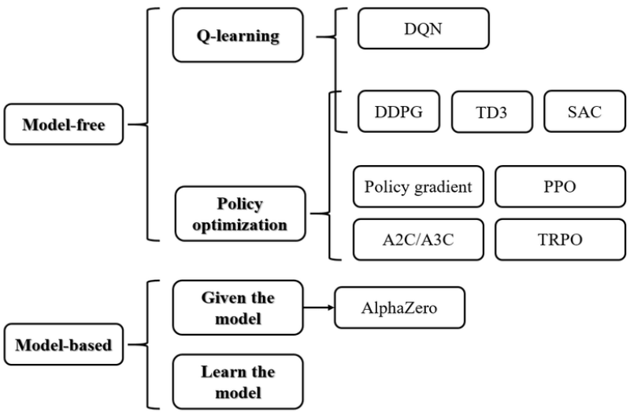

ARCHITECTURE DIAGRAM :
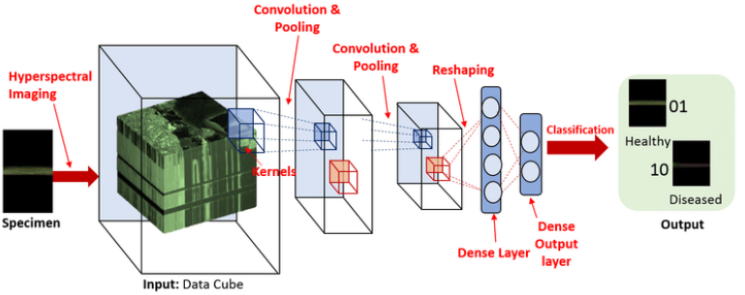

SOFTWARE REQUIREMENTS:
- Operating System : Windows 10
- Platform : python
HARDWARE REQUIREMENTS:
- Keyboard
- Mouse
- Hard disk 500GB
- Ram 4 Gb

CONCLUTION :
In this paper, we proposed a deep multimodal learning method for the representation fusion of facial appearance and dynamics. To model the correlated and complementary depression patterns in multimodal learning, a chained-fusion mechanism is introduced to jointly learn facial appearance and dynamics in a unified framework. We showed that such sequential fusion provides a clear probabilistic perspective of the model correlation and complementarity between two different data modalities for improved depression recognition. Experimental results on a benchmark dataset demonstrated the efficacy of our method when compared to several state-of-the-art alternatives.

REFERENCE :
- [[1] C. Darwin and P. Prodger, The expression of the emotions in man and animals. Oxford University Press, USA, 1998.
- [2] Y.-I. Tian, T. Kanade, and J. F. Cohn, “Recognizing action units for facial expression analysis,” IEEE Transactions on pattern analysis and machine intelligence, vol. 23, no. 2, pp. 97–115, 2001.
- [3] P. Ekman and W. V. Friesen, “Constants across cultures in the face and emotion.” Journal of personality and social psychology, vol. 17, no. 2, pp. 124–129, 1971.
- [4] P. Ekman, “Strong evidence for universals in facial expressions: a reply to russell’s mistaken critique,” Psychological bulletin, vol. 115, no. 2, pp. 268–287, 1994.
- [5] D. Matsumoto, “More evidence for the universality of a contempt expression,” Motivation and Emotion, vol. 16, no. 4, pp. 363–368, 1992.
- [6] R. E. Jack, O. G. Garrod, H. Yu, R. Caldara, and P. G. Schyns, “Facial expressions of emotion are not culturally universal,” Proceedings of the National Academy of Sciences, vol. 109, no. 19, pp. 7241–7244, 2012.
- [7] Z. Zeng, M. Pantic, G. I. Roisman, and T. S. Huang, “A survey of affect recognition methods: Audio, visual, and spontaneous expressions,” IEEE transactions on pattern analysis and machine intelligence, vol. 31, no. 1, pp. 39–58, 2009.
- [8] E. Sariyanidi, H. Gunes, and A. Cavallaro, “Automatic analysis of facial affect: A survey of registration, representation, and recognition,” IEEE transactions on pattern analysis and machine intelligence, vol. 37, no. 6, pp. 1113–1133, 2015.
- [9] B. Martinez and M. F. Valstar, “Advances, challenges, and opportunities in automatic facial expression recognition,” in Advances in Face Detection and Facial Image Analysis. Springer, 2016, pp. 63–100.
- [10] P. Ekman, “Facial action coding system (facs),” A human face, 2002.
- [11] H. Gunes and B. Schuller, “Categorical and dimensional affect analysis in continuous input: Current trends and future directions,” Image and Vision Computing, vol. 31, no. 2, pp. 120–136, 2013.
- [12] C. Shan, S. Gong, and P. W. McOwan, “Facial expression recognition based on local binary patterns: A comprehensive study,” Image and Vision Computing, vol. 27, no. 6, pp. 803–816, 2009.
- [13] P. Liu, S. Han, Z. Meng, and Y. Tong, “Facial expression recognition via a boosted deep belief network,” in Proceedings of the IEEE Conference on Computer Vision and Pattern Recognition, 2014, pp. 1805–1812.
- [14] A. Mollahosseini, D. Chan, and M. H. Mahoor, “Going deeper in facial expression recognition using deep neural networks,” in Applications of Computer Vision (WACV), 2016 IEEE Winter Conference on. IEEE, 2016, pp. 1–10.
- [15] G. Zhao and M. Pietikainen, “Dynamic texture recognition using local binary patterns with an application to facial expressions,” IEEE transactions on pattern analysis and machine intelligence, vol. 29, no. 6, pp. 915–928, 2007

