DEPTH SELECTION FOR DEEP RELU NETS IN FEATURE EXTRACTION AND GENERALIZATION
ABSTRACT:
Deep learning is recognized to be capable of discovering deep features for representation learning and pattern recognition without requiring elegant feature engineering techniques by taking advantage of human ingenuity and prior knowledge. Thus it has triggered enormous research activities in machine learning and pattern recognition. One of the most important challenge of deep learning is to figure out relations between a feature and the depth of deep neural networks (deep nets for short) to reflect the necessity of depth. Our purpose is to quantify this feature-depth correspondence in feature extraction and generalization. We present the adaptivity of features to depths and vice-verse via showing a depth-parameter trade-off in extracting both single feature and composite features. Based on these results, we prove that implementing the classical empirical risk minimization on deep nets can achieve the optimal generalization performance for numerous learning tasks. Our theoretical results are verified by a series of numerical experiments including toy simulations and a real application of earthquake seismic intensity prediction.

EXISTING SYSTEM:
The former focuses on designing preprocessing pipelines and data transformations that result in a tractable representation of data, while the latter utilizes learning algorithms related to specific targets, such as regression, classification and clustering on the data representation to finish the learning task. Studies in the second step abound in machine learning and numerous learning schemes such as kernel methods neural networks and boosting have been proposed. However, feature extraction in the first step is usually labor intensive, which requires elegant feature engineering techniques by taking advantages of human ingenuity and prior knowledge

DISADVANTAGE OF EXISTING SYSTEM:
The first problem refers to the representation performance of deep nets, needing tools from information theory like coding theory and entropy theory The second one concerns approximation abilities of deep nets with different depth, requiring approximation theory techniques such as local polynomial approximations covering number estimates and wavelets analysis to quantify powers and limitations of deep nets. The last one focuses on the generalization capability of deep learning algorithms in machine learning, for which statistical learning theory as well as empirical processing should be utilized
PROPOSED SYSTEM :
- Furthermore, from an optimization viewpoint, large depth requires to solve a highly nonconvex optimization problem involving the ill-conditioning of the Hessian, the existence of many local minima, saddle points, plateau and even some flat regions, making it difficult to design optimization algorithms for such deep nets with convergence guarantees.
- Based on these, we provide a theoretical guidance for depth selection to extract data features by showing that deep nets with various depths, larger than a specified value, are capable of extracting the smoothness and other data features.

ADVANTAGE:
- The third way is that the weight matrix is generated jointly by both the above ways.
- Like the most widely used deep convolutional neural networks, we count the number of free parameters according to the third way by considering both sparse connections and weight-sharing .
It should be mentioned that such a way to count free parameter is different from which considers deep fully connected neural networks
LITRATURE REVIEW:
TITTLE | AUTHOR | DESCRIPTION
A convergence theory for deep learning via over-parameterization. | Z. Allen-Zhu, Y. Li, and Z. Song. | Deep neural networks (DNNs) have demonstrated dominating performance in many fields since AlexNet, networks used in practice are going wider and deeper
A review and new perspectives. | Y. Bengio, A. Courville, and P. Vincent. Representation learning | The success of machine learning algorithms generally depends on data representation, and we hypothesize that this is because different representations
On the complexity of neural network classifiers: a comparison between shallow and deep architectures. | M. Bianchini and F. Scarselli. | Recently, deep networks were proved to be more effective than shallow architectures to face complex real–world applications. However, theoretical results supporting this claim are still few and incomplete.
Pattern Recognition and Machine Learning, | C. M. Bishop | In particular, Bayesian methods have grown from a specialist niche to become mainstream, while graphical models have emerged as a general framework for describing and applying probabilistic models.

INTRODUCTION :
- The study of approximation capability of shallow nets is a classical topic in neural networks. We refer the readers to a fruitful review paper for details on this topic. Compared with the classical linear approaches like polynomials, shallow nets with sigmoidal activation function possess better approximation ability and are capable of conducting dimensionindependent error estimates under certain restrictions on the target functions . More importantly, the universality showed that shallow nets can extract any data feature as long as the network is sufficiently wide

BLOCK DIAGRAM:
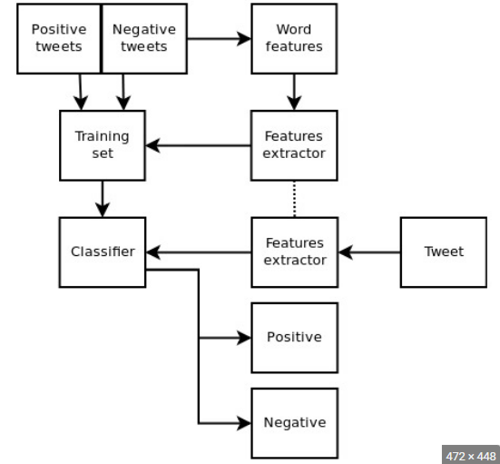

ARCHITECTURE DIAGRAM :
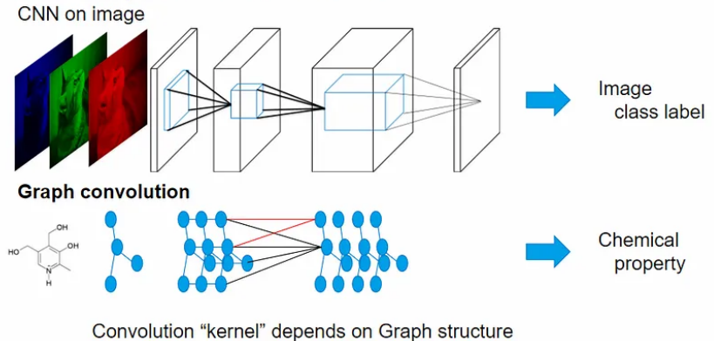

SOFTWARE REQUIREMENTS:
- Operating System : Windows 10
- Platform : python
HARDWARE REQUIREMENTS:
- Keyboard
- Mouse
- Hard disk 500GB
- Ram 4 Gb

CONCLUTION :
In this paper, we studied theoretical advantages of deep nets via considering the role of depth in feature extraction and generalization. The main contributions are four folds. Firstly, under the same capacity costs (via covering numbers), we proved that deep nets are better than shallow nets in extracting the group structure features. Secondly, we proved that deep ReLU nets are one of the optimal tools in extracting the smoothness feature. Thirdly, we rigorously proved the adaptivity of features to depths and vice verse, which was adopted to derive the optimal learning rate for implementing empirical risk minimization on deep nets.

REFERENCE :
- [1] Z. Allen-Zhu, Y. Li, and Z. Song. A convergence theory for deep learning via over-parameterization. arXiv preprint arXiv:1811.03962, 2018.
- [2] A. Barron. Universal approximation bounds for superpositions of a sigmoidal function. IEEE Trans. Inform. Theory, 1993, 39(3): 930-945.
- [3] Y. Bengio, A. Courville, and P. Vincent. Representation learning: A review and new perspectives. IEEE Trans. Pattern Anal. Mach. Intel., 3, 1798-1828, 2013.
- [4] M. Bianchini and F. Scarselli. On the complexity of neural network classifiers: a comparison between shallow and deep architectures. IEEE. Trans. Neural Netw. & Learn. Sys., 25: 1553-1565, 2014.
- [5] C. M. Bishop. Pattern Recognition and Machine Learning. Springer, 2006.
- [6] J. Bruna and S. Mallat. Invariant scattering convolution networks. IEEE Trans. Pattern Anal. Mach. Intel., 35: 1872-1886, 2013.
- [7] C. K. Chui, X. Li, and H. N. Mhaskar. Neural networks for lozalized approximation. Math. Comput., 63: 607-623, 1994.
- [8] C. K. Chui, S. B. Lin, and D. X. Zhou. Construction of neural networks for realization of localized deep learning. Front. Appl. Math. Statis., 4: 14, 2018.
- [9] C. K. Chui, S. B. Lin, and D. X. Zhou, Deep neural networks for rotation-invariance approximation and learning. Anal. Appl., 17: 737- 772, 2019.
- [10] F. Cucker and D. X. Zhou. Learning Theory: An Approximation Theory Viewpoint, Cambridge University Press, Cambridge, 2007.
- [11] G. Cybenko. Approximation by superpositions of sigmoidal function. Math. Control Signals Syst., 2: 303-314, 1989.
- [12] O. Delalleau and Y. Bengio. Shallow vs. deep sum-product networks. NIPs, 666-674, 2011.
- [13] D. L. Donoho. Unconditional bases are optimal bases for data compression and for statistical estimation. Appl. Comput. Harmonic. Anal., 1(1):100-115, 1993.
- [14] R. Eldan and O. Shamir. The power of depth for feedforward neural networks. arXiv preprint arXiv:1512.03965, 2015.
- [15] T. Evgeniou, M. Pontil, and T. Poggio. Regularization networks and support vector machines. Adv. Comput. Math., 13: 1-50, 2000.

