DEEPKEYGEN: A DEEP LEARNING-BASED STREAM CIPHER GENERATOR FOR MEDICAL IMAGE ENCRYPTION AND DECRYPTION
ABSTRACT:
The need for medical image encryption is increasingly pronounced, for example to safeguard the privacy of the patients’ medical imaging data. In this paper, a novel deep learningbased key generation network (DeepKeyGen) is proposed as a stream cipher generator to generate the private key, which can then be used for encrypting and decrypting of medical images. In DeepKeyGen, the generative adversarial network (GAN) is adopted as the learning network to generate the private key. Furthermore, the transformation domain (that represents the “style” of the private key to be generated) is designed to guide the learning network to realize the private key generation processThe goal of DeepKeyGen is to learn the mapping relationship of how to transfer the initial image to the private key. We evaluate DeepKeyGen using three datasets, namely: the Montgomery County chest X-ray dataset, the Ultrasonic Brachial Plexus dataset, and the BraTS18 dataset. The evaluation findings and security analysis show that the proposed key generation network can achieve a high-level security in generating the private key.
Index Terms—Key generator, deep learning, generative adversarial network, image-to-image translation

EXISTING SYSTEM:
- The discriminator is used to distinguish between the key generated by the generator and the data from the transformation domain. Due to the randomness of the training process for deep learning, the generated private keys differ even under the same training conditions. In other words, the proposed DeepKeyGen can be considered as a one-time pad. Moreover, DeepGenKey utilizes unlabeled and unpaired images to train the learning network; thus, overcoming data availability issue in training the GAN.
- In the next section, we will introduce the related literature, prior to presenting our proposed DeepKeyGen in the third section. We then describe our security and performance evaluations in the next two sections, before concluding this paper in the last section.

DISADVANTAGE OF EXISTING SYSTEM:
- Inspired by the concept of cycle consistency, Zhu et al. proposed the CycleGAN model to solve the problem of special training dataset for style transfer tasks. It can be trained by adopting the unpaired and unlabeled data, so as to facilitate the application of GAN in image-to-image transformation. Kim et al.
- proposed DiscoGAN to ensure that certain features of the image are preserved when the image is transferred to another domain. Inspired by the original dual learning method of natural language processing, Yi et al. proposed the DualGAN model, which can be used to translate images between two domains with different characteristics by using unlabeled and unpaired data.
PROPOSED SYSTEM :
- These existing key generation algorithms require the generators to be manually designed, and the generator realizing process is then repeated several times and the underlying mathematical formulas constantly refined to achieve or approach the desired style. This is clearly time- and resource-expensive.
- The value ranges of pi , x and y are from 0 to 255, and the value range of c is from 0 to 2. The private key differs from that of existing stream ciphers, which is actually a four-dimensional key. The key values (which contain the pixel value information and the three-dimensional space position information) ensure the private key is complex and the key space is sufficiently large; thus, significantly enhancing the key’s security level.
ADVANTAGE:
- The generator network G is used to transfer the initial image from source domain onto the transformation domain. The output of the generator network G is the private key which holds the same security characteristics as the encrypted performance in the transformation domain.
- The generator network G is composed of three downsample layers, six residual blocks, two transposed convolutional layers and an ordinary convolutional layer. The initial image is firstly processed with three downsample layers. These layers are aimed at extracting the features from the initial image

LITRATURE REVIEW:
TITTLE | AUTHOR | DESCRIPTION
Trivium: A stream cipher construction inspired by block ` cipher design principles, | C. D. Canniere | In this paper, we propose a new stream cipher construction based on block cipher design principles. The main idea is to replace the building blocks used in block ciphers by equivalent stream cipher components.
A survey of lightweight stream ciphers for embedded systems | C. Manifavas, G. Hatzivasilis, K. Fysarakis, and Y. Papaefstathiou | Pervasive computing constitutes a growing trend, aiming to embed smart devices into everyday objects
“A new stream cipher based on nonlinear dynamic system,”,” | O. Mannai, R. Becheikh, and R. Rhouma, | The core of the cipher is the Ikeda system which can be seen as a Nonlinear Feedback Shift Register (NLFSR) of length 7 plus one memory.
Implementation of pseudo linear feedback shift register physical unclonable function on silicon,, | Y. Ogasahara, Y. Hori, and H. Koike, | we demonstrate the first implementation of a pseudo linear feedback shift register physical unclonable function (PL-PUF) on silicon, and a proposal of the power supply design to obtain fine reproducibility.

INTRODUCTION :
- This method uses Fibonacci linear feedback shift registers and AES algorithms as pseudo-random number generators to achieve a high security level. Liu et al. proposed an authentication and dynamic encryption method based on state estimation, which selects the metrics of the power system to generate the key. As the value of power measurement used to generate the key is constantly changing and unpredictable, the key is challenging to guess. Kalsi et al. demonstrated the possibility of hiding data based on the combination of DNA sequences and deep learning, where their proposed key generation approach uses the natural selection theory, Needleman-Wunsch algorithm, and genetic algorithm.

BLOCK DIAGRAM:
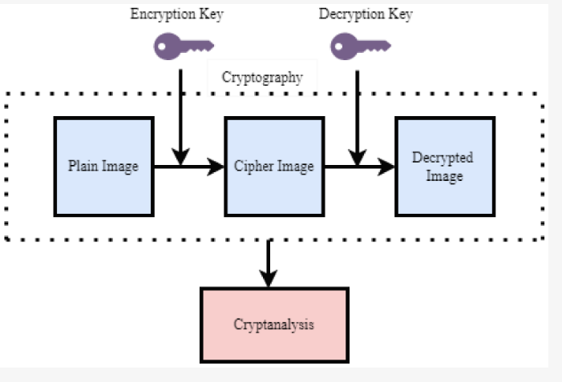

ARCHITECTURE DIAGRAM :
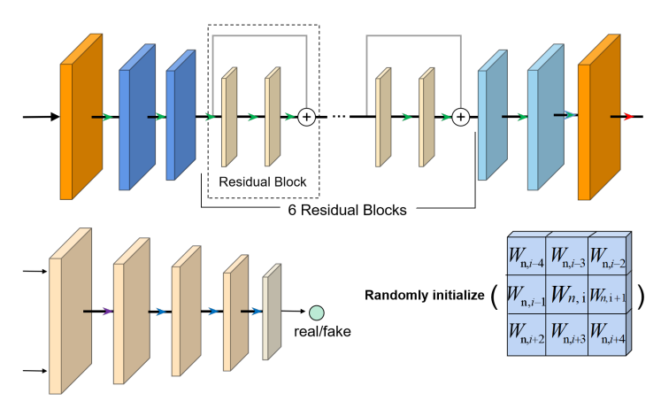

SOFTWARE REQUIREMENTS:
- Operating System : Windows 10
- Platform : python
HARDWARE REQUIREMENTS:
- Keyboard
- Mouse
- Hard disk 500GB
- Ram 4 Gb

CONCLUTION :
In this paper, we proposed a novel deep learning-based stream cipher generator, DeepKeyGen, which is designed to automatically generate the private key by directly learning the desirable “style”. The proposed DeepKeyGen uses the images in the transformation domain as the desired “style” of the private key, and adopts the learning network to translate the initial image (“seed”) in the source domain onto the transformation domain, in order to generate the private key. The generated private key is then used to encrypt/decrypt medical image(s), by employing the XOR algorithm. DeepKeyGen was evaluated using the Montgomery County chest X-ray dataset, the Ultrasonic Brachial Plexus dataset, and the BraTS18 dataset.

REFERENCE :
- [1] C. D. Canniere, “Trivium: A stream cipher construction inspired by block ` cipher design principles,” in International Conference on Information Security, 2006.
- [2] C. Manifavas, G. Hatzivasilis, K. Fysarakis, and Y. Papaefstathiou, “A survey of lightweight stream ciphers for embedded systems,” Security and Communication Networks, vol. 9, no. 10, pp. 1226–1246, 2016.
- [3] O. Mannai, R. Becheikh, and R. Rhouma, “A new stream cipher based on nonlinear dynamic system,” in 2018 26th European Signal Processing Conference (EUSIPCO). IEEE, 2018, pp. 316–320.
- [4] Y. Ogasahara, Y. Hori, and H. Koike, “Implementation of pseudo linear feedback shift register physical unclonable function on silicon,” in 2016 IEEE International Symposium on Circuits and Systems (ISCAS). IEEE, 2016, pp. 758–761.
- [5] M. Hemattil, A. Ahmadi, S. V. Makkil, and M. Ahmadi, “Hardware design of chaotic pseudo-random number generator based on nonlinear feedback shift register,” in 2018 IEEE 61st International Midwest Symposium on Circuits and Systems (MWSCAS). IEEE, 2018, pp. 980–983.
- [6] M. Miroschnyk, Y. Pakhomov, E. German, A. Shkil, E. Kulak, and D. Kucherenko, “Design automation of testable finite state machines,” in 2017 IEEE East-West Design & Test Symposium (EWDTS). IEEE, 2017, pp. 1–6.
- [7] G. Cao and X. Wang, “Image encryption based on the combination of roulette wheel selection with linear congruence pixel transformation,” Multimedia Tools and Applications, vol. 78, no. 8, pp. 10 625–10 647, 2019.
- [8] Z. Hua, B. Zhou, and Y. Zhou, “Sine-transform-based chaotic system with fpga implementation,” IEEE Transactions on Industrial Electronics, vol. 65, no. 3, pp. 2557–2566, 2017
- [9] W. Luo, J. Li, J. Yang, W. Xu, and J. Zhang, “Convolutional sparse autoencoders for image classification,” IEEE transactions on neural networks and learning systems, vol. 29, no. 7, pp. 3289–3294, 2017.
- [10] P. Tang, X. Wang, B. Shi, X. Bai, W. Liu, and Z. Tu, “Deep fishernet for image classification,” IEEE transactions on neural networks and learning systems, vol. 30, no. 7, pp. 2244–2250, 2018
- [11] G. Li and Y. Yu, “Contrast-oriented deep neural networks for salient object detection,” IEEE transactions on neural networks and learning systems, vol. 29, no. 12, pp. 6038–6051, 2018.
- [12] Y. Ding, C. Luo, et.al., “High-order correlation detecting in features for diagnosis of Alzheimer’s disease and mild cognitive impairment,” Biomedical Signal Processing and Control, vol. 53, Sept. 2019.
- [13] W. Guo and P. Aarabi, “Hair segmentation using heuristically-trained neural networks,” IEEE transactions on neural networks and learning systems, vol. 29, no. 1, pp. 25–36, 2016.
- [14] H. Chen, Z. Qin, Y. Ding, et.al., “Brain tumor segmentation with deep convolutional symmetric neural networ,” Neurocomputing, DOI:10.1016/j.neucom.2019.01.111.
- [15] S. Jaeger, S. Candemir, S. Antani, et.al. “Two public chest X-ray datasets for computer-aided screening of pulmonary diseases,” Quantitative imaging in medicine and surgery, vol. 4, pp. 475-7, Dec. 20

