Bitcoin Transaction Forecasting with Deep.Network Representation Learning
ABSTRACT:
Bitcoin and its decentralized computing paradigm for digital currency trading are one of the most disruptive technology in the 21st century. This paper presents a novel approach to developing a Bitcoin transaction forecast model, DLForecast, by leveraging deep neural networks for learning Bitcoin transaction network representations. DLForecast makes three original contributions. First, we explore three interesting properties between Bitcoin transaction accounts: topological connectivity pattern of Bitcoin accounts, transaction amount pattern, and transaction dynamics. Second, we construct a time-decaying reachability graph and a time-decaying transaction pattern graph, aiming at capturing different types of spatial-temporal Bitcoin transaction patterns. Third, we employ node embedding on both graphs and develop a Bitcoin transaction forecasting system between user accounts based on historical transactions with built-in time-decaying factor. To maintain an effective transaction forecasting performance, we leverage the multiplicative model update (MMU) ensemble to combine prediction models built on different transaction features extracted from each corresponding Bitcoin transaction graph. Evaluated on real-world Bitcoin transaction data, we show that our spatial-temporal forecasting model is efficient with fast runtime and effective with forecasting accuracy over 60% and improves the prediction performance by 50% when compared to forecasting model built on the static graph baseline.

EXISTING SYSTEM:
The proposed system evolves on-the-fly and is capable of predicting how likely the two accounts will make transactions in the near future. Third but not the last, we apply the Multiplicative Model Updates (MMU) ensemble to combine prediction models trained over different transaction features extracted from the bitcoin transaction graph. The ensemble ensures the stable yet competitive performance of the proposed Bitcoin transaction forecasting system. We achieve accuracy of over 60% on the future transaction forecasting and improve the performance by more than 50% when compared to the forecast model built on the static graph baseline
DISADVANTAGE OF EXISTING SYSTEM:
A straightforward way to construct the Bitcoin transaction graph is considering sender addresses and receiver addresses as nodes, sender-receiver pairs as edges, and Bitcoin amount as weight. Since one address may involve in multiple transactions, there can be multiple single-direction edges from the sender vertex to the receiver vertex over time. Besides, the role of the sender and the receiver can also switch. As no graph mining algorithm can process such complicate repeated, weighted and directed connectivity between nodes, it is natural to simplify the problem.
PROPOSED SYSTEM :
Most of the existing work on the statistical analysis of Bitcoin transaction data falls into this category.
In recent years, utilize the Bitcoin transaction graph data to make Bitcoin price prediction. However, none of the existing work, to the best of our knowledge, has developed a DNN-model-based transaction forecasting system. Example predictions include the likelihood of making a transaction between two accounts, or which account is the most likely to conduct a transaction with a given account.

ADVANTAGE:
These features are either focused only on the (spatial) graph scale or on the (temporal) time-changing scale.
Different from these papers, we combine different spatial and temporal features to capture the dynamics in Bitcoin transactions.
Due to the high dynamics of the Bitcoin transaction and the changing transaction pattern, which embedding feature has the best ability to capture transaction pattern varies over time.
In a dynamic environment, we iteratively choose transaction forecasting models constructed from embedding from different Bitcoin transaction features without knowledge of the future
LITRATURE REVIEW:
TITTLE | AUTHOR | DESCRIPTION
A peer-to-peer electronic cash system | S. Nakamoto and A. Bitcoin | A purely peer-to-peer version of electronic cash would allow online payments to be sent directly from one party to another without going through a financial institution. .
Security and privacy on blockchain | PR. Zhang, R. Xue, and L. Liu, | Blockchain offers an innovative approach to storing information, executing transactions, performing functions, and establishing trust in an open environment
“Bitter to better—how to make bitcoin a better currency,, | S. Barber, X. Boyen, E. Shi, and E. Uzun, “ | We perform an in-depth investigation to understand what made Bitcoin so successful, while decades of research on cryptographic e-cash has not lead to a large-scale deployment.
Majority is not enough: Bitcoin mining is vulnerable, | I. Eyal and E. G. Sirer | We present an attack with which colluding miners obtain a revenue larger than their fair share.

INTRODUCTION :
- Most of the existing work on the statistical analysis of Bitcoin transaction data falls into this category. [6] analyzed Bitcoin transactions carried out until May 2012 and discovers that a massive number of transactions only involve a small number of Bitcoins and only a few transactions move a large amount of money. [7] analyzed the transaction graph until May 2013, identified an initial phase of growth of the Bitcoin network, and measured network characteristics, temporal patterns, and the wealth accumulation over time

BLOCK DIAGRAM:
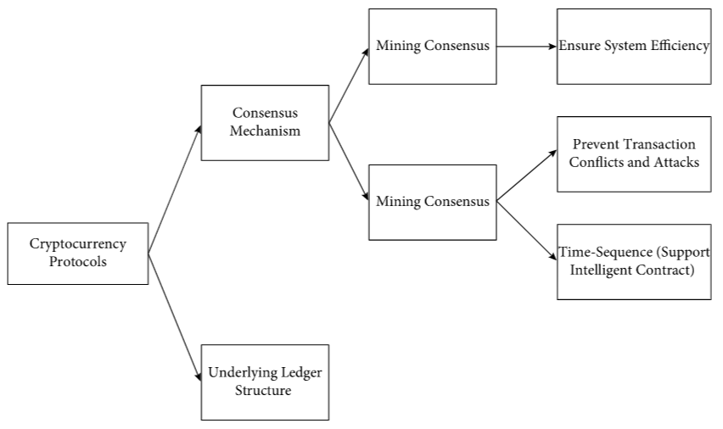

ARCHITECTURE DIAGRAM :
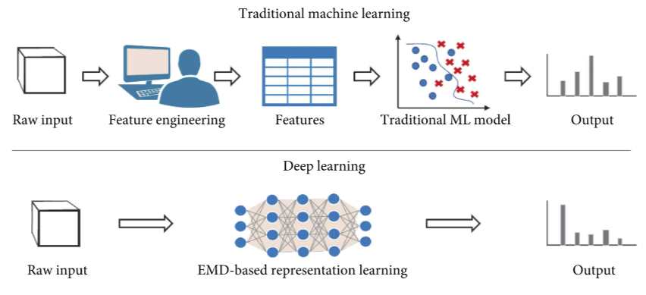

SOFTWARE REQUIREMENTS:
- Operating System : Windows 10
- Platform : python
HARDWARE REQUIREMENTS:
- Keyboard
- Mouse
- Hard disk 500GB
- Ram 4 Gb

CONCLUTION :
We have presented DLForecast − a Bitcoin transaction forecast system, which leverages deep neural networks to learn Bitcoin transaction network representations. This paper makes three unique contributions. First, we analyzed the Bitcoin transaction data by exploring their transaction-based connectivity patterns and their transaction amount patterns. Second, we constructed a time-decayed reachability graph and a time-decayed transaction pattern graph to extract spatial and temporal features of Bitcoin transaction dynamics. Third but not the least, we learn Bitcoin transaction patterns through node embedding by mapping each of the constructed graphs into a low-dimension representation vector space.

REFERENCE :
- [1] S. Nakamoto and A. Bitcoin, “A peer-to-peer electronic cash system,” Bitcoin.–URL: https://bitcoin. org/bitcoin. pdf, 2008.
- [2] R. Zhang, R. Xue, and L. Liu, “Security and privacy on blockchain,” ACM Computing Surveys (CSUR), vol. 52, no. 3, pp. 1–34, 2019.
- [3] S. Barber, X. Boyen, E. Shi, and E. Uzun, “Bitter to better—how to make bitcoin a better currency,” in International Conference on Financial Cryptography and Data Security. Springer, 2012, pp. 399– 414.
- [4] I. Eyal and E. G. Sirer, “Majority is not enough: Bitcoin mining is vulnerable,” Communications of the ACM, vol. 61, no. 7, pp. 95–102, 2018.
- [5] B. Perozzi, R. Al-Rfou, and S. Skiena, “Deepwalk: Online learning of social representations,” in Proceedings of the 20th ACM SIGKDD international conference on Knowledge discovery and data mining. ACM, 2014, pp. 701–710.
- [6] D. Ron and A. Shamir, “Quantitative analysis of the full bitcoin transaction graph,” in International Conference on Financial Cryptography and Data Security. Springer, 2013, pp. 6–24
- [7] M. Lischke and B. Fabian, “Analyzing the bitcoin network: The first four years,” Future Internet, vol. 8, no. 1, p. 7, 2016.
- [8] D. D. F. Maesa, A. Marino, and L. Ricci, “Uncovering the bitcoin blockchain: an analysis of the full users graph,” in 2016 IEEE International Conference on Data Science and Advanced Analytics (DSAA). IEEE, 2016, pp. 537–546.
- [9] A. Pareja, G. Domeniconi, J. Chen, T. Ma, T. Suzumura, H. Kanezashi, T. Kaler, and C. E. Leisersen, “Evolvegcn: Evolving graph convolutional networks for dynamic graphs,” in Thirty-Four AAAI Conference on Artificial Intelligence, 2020
- [10] A. Greaves and B. Au, “Using the bitcoin transaction graph to predict the price of bitcoin,” technical report, 2015.
- [11] C. G. Akcora, A. K. Dey, Y. R. Gel, and M. Kantarcioglu, “Forecasting bitcoin price with graph chainlets,” in Pacific-Asia Conference on Knowledge Discovery and Data Mining. Springer, 2018, pp. 765–776.
- [12] S. McNally, J. Roche, and S. Caton, “Predicting the price of bitcoin using machine learning,” in 2018 26th Euromicro International Conference on Parallel, Distributed and Network-based Processing (PDP). IEEE, 2018, pp. 339–343.
- [13] A. Grover and J. Leskovec, “node2vec: Scalable feature learning for networks,” in Proceedings of the 22nd ACM SIGKDD international conference on Knowledge discovery and data mining. ACM, 2016, pp. 855–864.
- [14] S. Cao, W. Lu, and Q. Xu, “Grarep: Learning graph representations with global structural information,” in Proceedings of the 24th ACM international on conference on information and knowledge management. ACM, 2015, pp. 891–900.
- [15] J. Tang, M. Qu, M. Wang, M. Zhang, J. Yan, and Q. Mei, “Line: Large-scale information network embedding,” in Proceedings of the 24th international conference on world wide web. International World Wide Web Conferences Steering Committee, 2015, pp. 1067–1077..

