A DEEP LEARNING APPROACH FOR TASK OFFLOADING IN MULTI-UAV AIDED MOBILE EDGE COMPUTING
ABSTRACT:
A number of electric devices in buildings can be considered as important demand response (DR) resources, for instance, the battery energy storage system (BESS) and the heat, ventilation, and air conditioning (HVAC) systems. The conventional model-based DR methods rely on efficient ondemand computing resources. However, the current buildings suffer from the high cost of computing resources and lack a costeffective automation system, which becomes the main obstacle to the popularization and implementation of the DR program. Therefore, in this paper, we present a hybrid cloud and edge control strategy for BESS and HVAC based on deep reinforcement learning (DRL). On the cloud infrastructure, the agent learns the control strategy online based on the proposed continuous dueling deep Q-learning (C-DDQN) algorithm, and the learned strategy is distributed to the edge devices for execution. Under this framework, the data-intensive application of cloud computing in real-time DR shows advantages in high processing speed, unlimited data aggregation, fault-tolerant, cost-saving, security, and confidentiality. However, if every controller is trained from the beginning, the cloud resources are wasted to a large extent

EXISTING SYSTEM:
- A hybrid cloud and edge framework is presented for the control of DR resources, including BESS and HVAC units.
- The problem that the training of the DRL-based method requires power computing resources can be solved. The proposed framework saves the high cost of local computing resources.
With this framework commissioned, the learning in the cloud and the real-time control in the edge can be fully automated, and the DR resources can respond to the DR plan actively and timely with limited human participation
DISADVANTAGE OF EXISTING SYSTEM:
- The optimization process is usually timeconsuming, especially when the dimension of the decision variables is very large. To solve the optimization problem efficiently, a powerful computing resource is required. However, the current buildings suffer from the high cost of computing resources and lack a cost-effective automation system, which becomes the main obstacle to the popularization of the DR program.

PROPOSED SYSTEM :
- The same finding can be concluded for the slight illegal action percentage in the first 500 episodes. The gap becomes smaller after 500 episodes. It shows the significance of transfer learning in online training. From the perspective of average daily cost, it can be concluded in Table III that both training a new model ($12.1) and transferring from the existing model ($11.7) are very close to the optimization result ($11.1). But directly using the existing model ($18.2) will cause a 63.96% higher cost than the optimal solution.
ADVANTAGE:
- Luo at el. pointed out that cloud-based information infrastructure will be widely used in the next-generation power grid. Customer-oriented energy management as a service (EMaaS) under the cloud framework is put forward . The cloud can provide energy management service through solving the optimization for various types of load, such as electric vehicles (EVs) and air-conditioners . With the aid of the cloud, end-users only need to pay-on-demand and largely reduce the local investment cost and operation cost on local hardware

LITRATURE REVIEW:
TITTLE | AUTHOR | DESCRIPTION
An overview of demand response: Key-elements and international experience,”, | N. G. Paterakis, O. Erdinç, and J. P. S. Catalão, | The increasing penetration of (RES) in power systems intensifies the need of enhancing the flexibility in grid operations in order.
Application of DR and co-simulation approach for renewable integrated HEMS: a review | P. Rajendhar and B. E. Jeyaraj, | The evolvement of sustainable smart grid (SG) technology, advanced metering infrastructure, bidirectional communication
“Optimal household appliances scheduling under day-ahead pricing and loadshaping demand response strategies, | N. G. Paterakis, O. Erdinc, A. G. Bakirtzis, and J. P. S. Catalão, | In this paper, a detailed home energy management system structure is developed to determine the optimal day-ahead appliance scheduling of a smart household under hourly pricing
“Peak-aware online economic dispatching for microgrids,” | Y. Zhang, M. H. Hajiesmaili, S. Cai, M. Chen, and Q. Zhu, “ | By employing local renewable energy sources and power generation units while connected to the central grid, microgrid

INTRODUCTION :
- A hybrid cloud and edge framework is presented for the control of DR resources, including BESS and HVAC units.
- The problem that the training of the DRL-based method requires power computing resources can be solved.
- The proposed framework saves the high cost of local computing resources. With this framework commissioned, the learning in the cloud and the real-time control in the edge can be fully automated, and the DR resources can respond to the DR plan actively and timely with limited human participation.
BLOCK DIAGRAM:
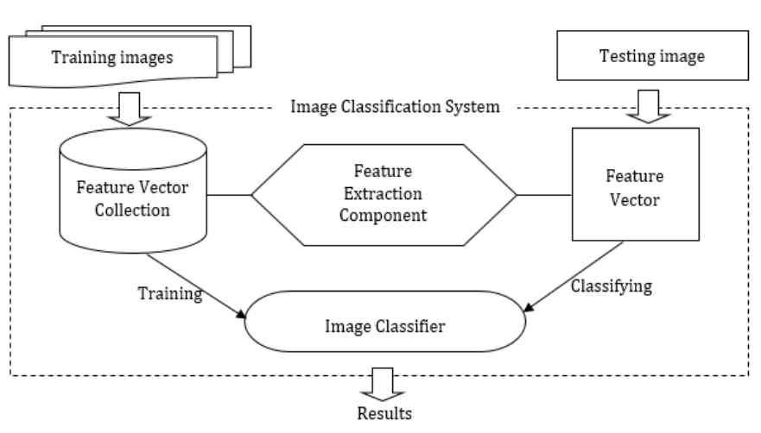ARCHITECTURE DIAGRAM :
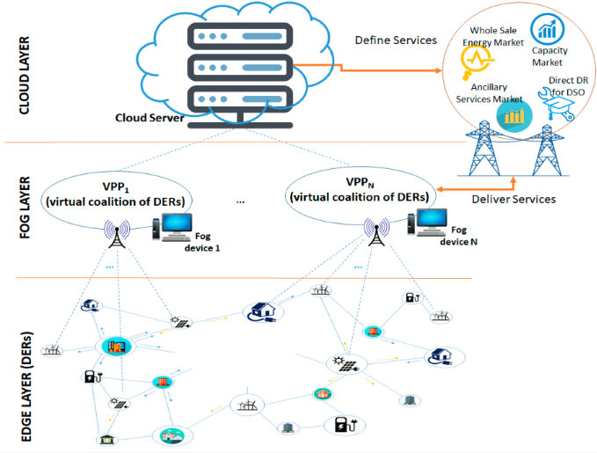

SOFTWARE REQUIREMENTS:
- Operating System : Windows 10
- Platform : python
HARDWARE REQUIREMENTS:
- Keyboard
- Mouse
- Hard disk 500GB
- Ram 4 G
CONCLUTION :
In this paper, we have presented a hybrid cloud and edge control strategy of DR using DRL and transfer learning. BESS and HVAC units are utilized as main DR resources. The neural network, which represents the control strategy of BESS, is trained in the cloud according to the proposed C-DDQN algorithm. After the control strategy is trained, the network is saved in edge, and the real-time control is realized through edge computing. Applying cloud computing shows the advantage of high processing speed and cost-saving. To further save the cloud computing resources, the methodology of transfer learning between BESS and HVAC units is proposed based on fine-tuning and domain adaption.

REFERENCE :
- [1] N. G. Paterakis, O. Erdinç, and J. P. S. Catalão, “An overview of demand response: Key-elements and international experience,” Renewable and Sustainable Energy Reviews, vol. 69, pp. 871-891, 2017.
- [2] P. Rajendhar and B. E. Jeyaraj, “Application of DR and co-simulation approach for renewable integrated HEMS: a review,” IET Generation, Transmission & Distribution, vol. 13, no. 16, pp. 3501-3512, 2019.
- [3] N. G. Paterakis, O. Erdinc, A. G. Bakirtzis, and J. P. S. Catalão, “Optimal household appliances scheduling under day-ahead pricing and loadshaping demand response strategies,” IEEE Transactions on Industrial Informatics, vol. 11, no. 6, pp. 1509-1519, 2015
- [4] Y. Zhang, M. H. Hajiesmaili, S. Cai, M. Chen, and Q. Zhu, “Peak-aware online economic dispatching for microgrids,” IEEE Transactions on Smart Grid, vol. 9, no. 1, pp. 323-335, 2016.
- [5] K. M. Tsui and S.-C. Chan, “Demand response optimization for smart home scheduling under real-time pricing,” IEEE Transactions on Smart Grid, vol. 3, no. 4, pp. 1812-1821, 2012.
- [6] J. H. Yoon, R. Baldick, and A. Novoselac, “Dynamic demand response controller based on real-time retail price for residential buildings,” IEEE Transactions on Smart Grid, vol. 5, no. 1, pp. 121-129, 2014.
- [[7] B. Wang, C. Zhang, and Z. Dong, “Interval optimization based coordination of demand response and battery energy storage system considering SoC management in a microgrid,” IEEE Transactions on Sustainable Energy, vol. 11, no. 4, pp. 2922 - 2931, 2020.
- [8] H. Shareef, M. S. Ahmed, A. Mohamed, and E. Al Hassan, “Review on home energy management system considering demand responses, smart technologies, and intelligent controllers,” IEEE Access, vol. 6, pp. 24498- 24509, 2018.
- [9] A. Taşcıkaraoğlu, N. G. Paterakis, O. Erdinç, and J. P. S. Catalao, “Combining the flexibility from shared energy storage systems and DLCbased demand response of HVAC units for distribution system operation enhancement,” IEEE Transactions on Sustainable Energy, vol. 10, no. 1, pp. 137-148, 2018.
- [10] S. Zheng, Y. Sun, B. Li, B. Qi, K. Shi, Y. Li, and X. Tu, “Incentive-based integrated demand response for multiple energy carriers considering behavioral coupling effect of consumers,” IEEE Transactions on Smart Grid, vol. 11, no. 4, pp. 3231 - 3245, 2020.
- [11] B. Qela and H. T. Mouftah, “Peak load curtailment in a smart grid via fuzzy system approach,” IEEE Transactions on Smart Grid, vol. 5, no. 2, pp. 761-768, 2014.
- [12] P. Tarasak, C. C. Chai, Y. S. Kwok, and S. W. Oh, “Demand bidding program and its application in hotel energy management,” IEEE Transactions on Smart Grid, vol. 5, no. 2, pp. 821-828, 2014.
- [13] L. Yao and W. H. Lim, “Optimal purchase strategy for demand bidding,” IEEE Transactions on Power Systems, vol. 33, no. 3, pp. 2754-2762, 2017.
- [14] H. Xu, H. Sun, D. Nikovski, S. Kitamura, K. Mori, and H. Hashimoto, “Deep reinforcement learning for joint bidding and pricing of load serving entity,” IEEE Transactions on Smart Grid, vol. 10, no. 6, pp. 6366-6375, 2019.
- [15] Y. Ye, D. Qiu, M. Sun, D. Papadaskalopoulos, and G. Strbac, “Deep reinforcement learning for strategic bidding in electricity markets,” IEEE Transactions on Smart Grid, vol. 11, no. 2, pp. 1343-1355, 2019.

