A SURVEY ON MATHEMATICAL, MACHINE LEARNING AND DEEP LEARNING MODELS FOR COVID-19 TRANSMISSION AND DIAGNOSIS

ABSTRACT:
COVID-19 is a life threatening disease which has a enormous global impact. As the cause of the disease is a novel coronavirus whose gene information is unknown, drugs and vaccines are yet to be found. For the present situation, disease spread analysis and prediction with the help of mathematical and data driven model will be of great help to initiate prevention and control action, namely lockdown and qurantine. There are various mathematical and machine-learning models proposed for analyzing the spread and prediction. . Each model has its own limitations and advantages for a particluar scenario. This article reviews the state-of-the art mathematical models for COVID19, including compartment models, statistical models and machine learning models to provide more insight, so that an appropriate model can be well adopted for the disease spread analysis. Furthermore, accurate diagnose of COVID19 is another essential process to identify the infected person and control further spreading. . As the spreading is fast, there is a need for quick auotomated diagnosis mechanism to handle large population. Deep-learning and machinelearning based diagnostic mechanism will be more appropriate for this purpose. In this aspect, a comprehensive review on the deep learning models for the diagnosis of the disease is also provided in this article.

EXISTING SYSTEM:
- There are various mathematical and machine-learning models proposed for analyzing the spread and prediction. Each model has its own limitations and advantages for a particluar scenario. This article reviews the state-of-the art mathematical models for COVID19, including compartment models, statistical models and machine learning models to provide more insight, so that an appropriate model can be well adopted for the disease spread analysis. Considering the countries as individuals, a model describing spread between the countries and within the country is proposed in . The name of this model is BeCoDis, which characterize disease initiation, epidemic strength, and spread per country
DISADVANTAGE OF EXISTING SYSTEM:
- Considering the countries as individuals, a model describing spread between the countries and within the country is proposed in . The name of this model is BeCoDis, which characterize disease initiation, epidemic strength, and spread per country.
- The variation of BeCoDis model was employed by authors to find the international spread of the novel coronavirus outbreak.
- A method to estimate the parameters of epidemiological models, through multi objective problem formulation and its optimization is proposed

PROPOSED SYSTEM :
- Chinese government has informed the world health organization (WHO) about severe acute cases of pneumonia with unfamiliar etiology . This outbreak originates from the seafood market in the city of Wuhan, China and started infecting more than 50 people.
- The live animals, namely, frogs, snakes, marmots, rabbits and bats are usually sold at the Hunan sea market. On 12 January 2020, an order was released from the National Health Commission of China stating that there is an epidemic of viral Pneumonia. Using sequence-based analysis, the Government has identified that the cause of the disease is due to a novel coronavirus.

ADVANTAGE:
- The bayesian SEIR epidemiological model is used to perform a parametric regression on the COVID-19 outbreak data . A compartmental SEIR model for epidemic in India is reported by modeling the flow of individuals using a set of differential equations
- To solve the multi objective function, authors have used Achievement Scalarizing Function Genetic AlgorithmThis number is used to assess alternative interventions to control an outbreak .
- The work models the dynamics of COVID-19. The details about the transmission of infection among bats and people is briefly described in the work. In this work, bats are considered as the hosts, while the seafood market is assumed to be the source for which the mathematical results are presented followed by a formulation of the fractional model.

LITRATURE REVIEW:
TITTLE | AUTHOR | DESCRIPTION
“Deep learning enables accurate diagnosis of novel coronavirus (covid-19) with Ct images | Y. Song et al., | A novel coronavirus (COVID-19) recently emerged as an acute respiratory syndrome, and has caused a pneumonia outbreak world-widely
Mathematical modeling of the spread of the coronavirus disease 2019 (covid-19) considering its particular characteristics. the case of china, | B. Ivorra, M. Ferrández, M. Vela-Pérez, and A. Ramos, | In this paper we develop a mathematical model for the spread of the coronavirus disease 2019 (COVID-19).
“Early dynamics of transmission and control of covid-19: A mathematical modelling study,” | , A. J. Kucharski et al., | Based on these estimates, we then calculated the probability that newly introduced cases might generate outbreaks in other areas.
“Transmission dynamics of 2019 novel coronavirus (2019-ncov),” | T. Liu et al., | Data of severe acute respiratory syndrome (SARS) cases in Guangdong Province during 2002-2003 were obtained from Guangdong Provincial Center for Disease Control and Prevention (GDCDC).

INTRODUCTION :
- Chinese government has informed the world health organization (WHO) about severe acute cases of pneumonia with unfamiliar etiology. This outbreak originates from the seafood market in the city of Wuhan, China and started infecting more than 50 people. The live animals, namely, frogs, snakes, marmots, rabbits and bats are usually sold at the Hunan sea market. On 12 January 2020, an order was released from the National Health Commission of China stating that there is an epidemic of viral Pneumonia. Using sequence-based analysis, the Government has identified that the cause of the disease is due to a novel coronavirus

BLOCK DIAGRAM:
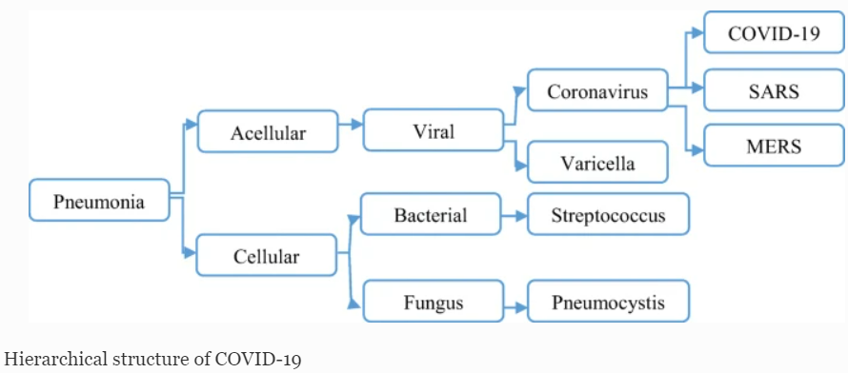

ARCHITECTURE DIAGRAM :
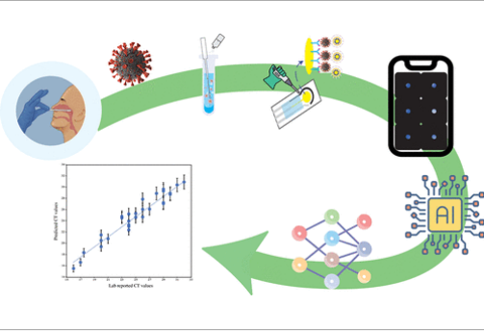

SOFTWARE REQUIREMENTS:
- Operating System : Windows 10
- Platform : python
HARDWARE REQUIREMENTS:
- Keyboard
- Mouse
- Hard disk 500GB
- Ram 4 Gb

CONCLUTION :
A comprehensive review of available mathematical models for the transmission of COVID-19 is presented in this article. The review was carried out on the various models namely, differential equation based, statistical based, prediction based, mixed model, machine learning and deep learning based. In addition, machine learning and deep learning based models for the diagnosis of COVID-19 using radiological images are also reviewed in this article. Furthermore, the usage of natural language processinfor the analysis of mental illness and feeling of the public based on the comments posted in the social media is also reviewed in the article
REFERENCE :
- [1] Y. Song et al., “Deep learning enables accurate diagnosis of novel coronavirus (covid-19) with Ct images,” IEEE/ACM Trans. Comput. Biol. Bioinf., Mar. 11, 2021.
- [2] B. Ivorra, M. Ferrández, M. Vela-Pérez, and A. Ramos, “Mathematical modeling of the spread of the coronavirus disease 2019 (covid-19) considering its particular characteristics. the case of china,” Tech. Rep., MOMAT, Mar. 2020. [Online]. Available: https://doi-org.usm.idm.oclc.org
- [3] A. J. Kucharski et al., “Early dynamics of transmission and control of covid-19: A mathematical modelling study,” Lancet Infect. Dis., vol. 20, no. 5, pp. 553–558, 2020
- [4] T. Liu et al., “Transmission dynamics of 2019 novel coronavirus (2019-ncov),” bioRxiv, 2020. [Online]. Available: https://www.biorxivorg/content/early/2020/01/26/2020.01.25.919787
- [5] G. Chowell, L. Sattenspiel, S. Bansal, and C. Viboud, “Mathematical models to characterize early epidemic growth: A review,” Phys. Life Rev., vol. 18, pp. 66–97, 2016.
- [6] F. Brauer, C. Castillo-Chavez, and C. Castillo-Chavez, Mathematical Models in Population Biology and Epidemiology. Berlin, Germany: Springer, 2012
- [7] M. Miller, “2019 novel coronavirus covid-19 (2019-Ncov) data repository,” Bull.-Assoc. Can. Map Libraries Arch., vol. 1, no. 164, pp. 47–51, 2020.
- [8] “Who coronavirus (covid-19) dashboard,” Accessed: Jan. 5, 2021. [Online]. Available: https://covid19.who.int/
- [9] W. C. Roda, M. B. Varughese, D. Han, and M. Y. Li, “Why is it difficult to accurately predict the covid-19 epidemic?,” Infect. Dis. Model., vol. 5, pp. 271–281, 2020.
- [10] K. Liang, “Mathematical model of infection kinetics and its analysis for covid-19, SARS and MERS,” Infect., Genet. Evol., vol. 82, 2020, Art. no. 104306.
- [11] R. Dandekar and G. Barbastathis, “Neural network aided quarantine control model estimation of global covid-19 spread,” 2020. [Online]. Available: https://arxiv.org/abs/2004.02752
- [12] P. E. Lekone and B. F. Finkenstädt, “Statistical inference in a stochastic epidemic seir model with control intervention: Ebola as a case study,” Biometrics, vol. 62, no. 4, pp. 1170–1177, 2006.

- [13] E. De Brouwer, D. Raimondi, and Y. Moreau, “Modeling the covid-19 outbreaks and the effectiveness of the containment measures adopted across countries,” medRxiv, 2020. [Online]. Available: https://www.medrxiv.orcontent/early/2020/04/19/2020.04.02.20046375
- [14] K. Chatterjee, K. Chatterjee, A. Kumar, and S. Shankar, “Healthcare impact of covid-19 epidemic in india: A stochastic mathematical model,” Med. J. Armed Forces India, vol. 76, no. 2, pp. 147–155, 2020.
- [15] M. R. Ferrándeza, B. Ivorrab, P. M. Ortigosaa, A. M. Ramosb, and J. L. Redondoa, “Application of the be-codis model to the 2018-19 ebola virus disease outbreak in the democratic republic of congo,” ResearchGate Preprint, vol. 23, pp. 1–17, 2019..

