QUANTIFYING THE ALIGNMENT OF GRAPH AND FEATURES IN DEEP LEARNING
ABSTRACT:
We show that the classification performance of graph convolutional networks (GCNs) is related to the alignment between features, graph, and ground truth, which we quantify using a subspace alignment measure (SAM) corresponding to the Frobenius norm of the matrix of pairwise chordal distances between three subspaces associated with features, graph, and ground truth. The proposed measure is based on the principal angles between subspaces and has both spectral and geometrical interpretations We showcase the relationship between the SAM and the classification performance through the study of limiting cases of GCNs and systematic randomizations of both features and graph structure applied to a constructive example and several examples of citation networks of different origins. The analysis also reveals the relative importance of the graph and features for classification purposes

EXISTING SYSTEM:
The proposed measure is based on the principal angles between subspaces and has both spectral and geometrical interpretations. We showcase the relationship between the SAM and the classification performance through the study of limiting cases of GCNs and systematic randomizations of both features and graph structure applied to a constructive example and several examples of citation networks of different origins. The analysis also reveals the relative importance of the graph and features for classification purposes.

DISADVANTAGE OF EXISTING SYSTEM:
- The pairwise chordal distances Di j in are computed from a number of minimal angles, corresponding to the smaller of the two dimensions of the subspaces being compared. Hence, the dimensions of the subspaces (kX , kA , kY ) need to be defined to compute the distance matrix D. Here, we are interested in finding low dimensional subspaces of features, graph, and ground truth with dimensions (k∗ X , k∗ A , k∗ Y ) such that they provide maximum discriminatory power between the original problem and the fully randomized (null) model. To do this, we propose the following criterion
PROPOSED SYSTEM :
However, existing deep models are supervised which require a large dataset with ground truth alpha mattes for training. To avoid the cost of data collection and possible bias in training data, this paper proposes a datasetfree unsupervised deep learning-based approach for background matting. Observing that the local smoothness of alpha matte can be well characterized by the untrained network prior called deep matte prior, we model the foreground and alpha matte using the priors encoded by two generative convolutional neural networks. To avoid possible overfitting during unsupervised learning, a twostage learning scheme is developed which contains projectionbased training and Bayesian post refinement.
ADVANTAGE:

LITRATURE REVIEW:
TITTLE | AUTHOR | DESCRIPTION
Deep learning | Y. LeCun, Y. Bengio, and G. Hinton | These neural networks attempt to simulate the behavior of the human brainalbeit far from matching its abilityallowing it to “learn” from large amounts of data..
An overview,” Neural Netw | J. Schmidhuber, “ | Neural Networks are a key piece of some of the most successful machine learning algorithms.
“Cambridge, MA. | , I. Goodfellow, Y. Bengio, and A. Courville, | People age 5 and older can receive their first dose, second dose, or bivalent booster of Pfizer COVID-19 vaccine.
“Going beyond Euclidean data,” | M. M. Bronstein, J. Bruna, Y. LeCun, A. Szlam, and P. Vandergheynst, | Many scientific fields study data with an underlying structure that is a non-Euclidean space

INTRODUCTION :
The first attempt to generalize neural networks on graphs can be traced back to Gori et al. who proposed a scheme combining recurrent neural networks (RNNs) and random walk models. Their method requires the repeated application of contraction maps as propagation functions until the node representations reach a stable fixed point.
This method, however, did not attract much attention when it was proposed.

BLOCK DIAGRAM:
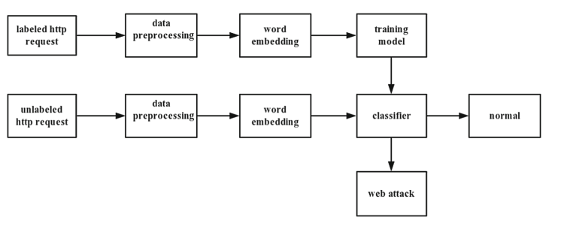

ARCHITECTURE DIAGRAM :
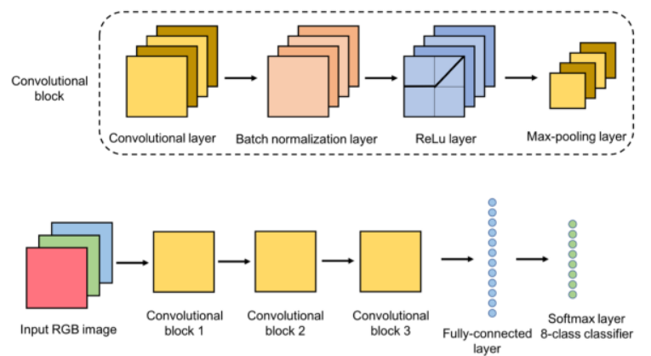

SOFTWARE REQUIREMENTS:
- Operating System : Windows 10
- Platform : python
HARDWARE REQUIREMENTS:
- Keyboard
- Mouse
- Hard disk 500GB
- Ram 4 Gb

CONCLUTION :
In this article, we have introduced SAM (12), a measure that quantifies the consistency between the feature and graph ingredients of data sets, and we showed that it correlates well with the classification performance of GCNs. Our experiments show that a degree of alignment is needed for a GCN approach to be beneficial, and using a GCN can actually be detrimental to the classification performance if the feature and graph subspaces associated with the data are not constructively aligned (e.g., Wikipedia and Wikipedia II).
REFERENCE :
- [1] Y. LeCun, Y. Bengio, and G. Hinton, “Deep learning,” Nature, vol. 521, no. 7553, p. 436, 2015.
- [2] I. Goodfellow, Y. Bengio, and A. Courville, Deep Learning. Cambridge, MA, USA: MIT Press, 2016.
[3] J. Schmidhuber, “Deep learning in neural networks: An overview,” Neural Netw., vol. 61, pp. 85–117, Jan. 2015.
- [4] M. M. Bronstein, J. Bruna, Y. LeCun, A. Szlam, and P. Vandergheynst, “Geometric deep learning: Going beyond Euclidean data,” IEEE Signal Process. Mag., vol. 34, no. 4, pp. 18–42, Jul. 2017
- [5] L. Deng and D. Yu, “Deep learning: Methods and applications,” Found. Trends Signal Process., vol. 7, nos. 3–4, pp. 197–387, Jun. 2014.
- [6] E. P. Simoncelli and B. A. Olshausen, “Natural image statistics and neural representation,” Annu. Rev. Neurosci., vol. 24, no. 1, pp. 1193–1216, Mar. 2001.
- [7] D. J. Field, “What the statistics of natural images tell us about visual coding,” Hum. Vis., Visual Process., Digit. Display, vol. 1077, pp. 269–277, Aug. 1989.
- [8] Y. Lecun, L. Bottou, Y. Bengio, and P. Haffner, “Gradient-based learning applied to document recognition,” Proc. IEEE, vol. 86, no. 11, pp. 2278–2324, Nov. 1998.
- [9] Y. LeCun et al., “Handwritten digit recognition with a back-propagation network,” in Proc. Adv. Neural Inf. Process. Syst., 1990, pp. 396–404.
- [10] J. Bruna and S. Mallat, “Invariant scattering convolution networks,” IEEE Trans. Pattern Anal. Mach. Intell., vol. 35, no. 8, pp. 1872–1886, Aug. 2013.
- [11] D. Lazer et al., “Life in the network: The coming age of computational social science,” Science, vol. 323, no. 5915, p. 721, 2009.
- [12] K. Xu, W. Hu, J. Leskovec, and S. Jegelka, “How powerful are graph neural networks?” in Proc. Int. Conf. Learn. Represent., 2019, pp. 1–17.
- [13] W. Hamilton, Z. Ying, and J. Leskovec, “Inductive representation learning on large graphs,” in Proc. Adv. Neural Inf. Process. Syst., 2017, pp. 1024–1034.
- [14] Z. Wu, S. Pan, F. Chen, G. Long, C. Zhang, and S. Y. Philip, “A comprehensive survey on graph neural networks,” IEEE Trans. Neural Netw. Learn. Syst., early access, Mar. 24, 2020, doi: 10.1109/ TNNLS.2020.2978386.
- [15] M. Defferrard, X. Bresson, and P. Vandergheynst, “Convolutional neural networks on graphs with fast localized spectral filtering,” in Proc. Adv. Neural Inf. Process. Syst., 2016, pp. 3844–3852s

