HUMAN-IN-THE-LOOP EXTRACTION OF INTERPRETABLE CONCEPTS IN DEEP LEARNING MODELS
ABSTRACT:
The interpretation of deep neural networks (DNNs) has become a key topic as more and more people apply them to solve various problems and making critical decisions. Concept-based explanations have recently become a popular approach for post-hoc interpretation of DNNs. However, identifying human-understandable visual concepts that affect model decisions is a challenging task that is not easily addressed with automatic approaches. We present a novel human-in-the-loop approach to generate user-defined concepts for model interpretation and diagnostics. Central to our proposal is the use of active learning, where human knowledge and feedback are combined to train a concept extractor with very little human labeling effort. We integrate this process into an interactive system, ConceptExtract. Through two case studies, we show how our approach helps analyze model behavior and extract human-friendly concepts for different machine learning tasks and datasets and how to use these concepts to understand the predictions, compare model performance and make suggestions for model refinementQuantitative experiments show that our active learning approach can accurately extract meaningful visual concepts
EXISTING SYSTEM:
- To tackle the issue of interpretability in neural networks, many techniques have been proposed to help people understand model predictions. TCAV (Testing with Concept Activation Vectors) and the follow-up work ACE aim to understand what signals the model uses for predicting different image labels They generate a measure of importance of a visual concept (e.g. wheel, glass) for a prediction (e.g. predicted as a car) in a trained model. However, the concepts generated by automatic clustering methods may not match human concepts. A prototype system implementing our proposed human-in-theloop workflow, featuring scalable image patch exploration, visual cues and interactive filters for active learning and a rich set of model diagnostics and comparative analysis visualizations
- To solve this problem, we use deep embeddings as a representation of the image patches. As an image is passed as an input through a DNN model, the output after each hidden layer is an embedding in that latent space. These deep embeddings provide hints for the model to distinguish different images. Previous work shows that euclidean distance1 in the latent space is an effective perceptual similarity metric .
Model developers encounter different problems while diagnosing their model to make improvements
Disadvantage of Existing System
- To solve this problem, we use deep embeddings as a representation of the image patches. As an image is passed as an input through a DNN model, the output after each hidden layer is an embedding in that latent space. These deep embeddings provide hints for the model to distinguish different images. Previous work shows that euclidean distance1 in the latent space is an effective perceptual similarity metric
- Model developers encounter different problems while diagnosing their model to make improvements.

PROPOSED SYSTEM :
- In this view, each image patch could be treated as a multivariate data sample, including variables like prediction accuracy and concept confidence scores for the existing concept extractors. A barchart is displayed for each of these variables. To help the user quickly identify an interesting target and generate new facts, the crossfilter view is also connected with the image patch view. Only the selected image patches in the crossfilter will be plotted in the image patch view. These concept filters can help the user quickly identify confident or confused image patches for different concepts. It is particularly useful when the user has trained multiple visual concepts and would like to study how the learned concepts correlate with each other.
ADVANTAGE:
- The lost cargo has two types of pixel annotations: the coarse ones including lost cargo (obstacle), road, and background; the fine ones for distinguishing specific lost cargo objects/obstacles in the images like boxes, balls, and so on. The coarse annotations are used by DenseNetFCN for training and prediction. To quantitatively evaluate our concept extraction model, we use the fine annotations as groundtruth visual concepts.
- The coarse annotations are used by DenseNetFCN for training and prediction. To quantitatively evaluate our concept extraction model, we use the fine annotations as groundtruth visual concepts. We pick a concept — dogs and trained the concept classifier for 4 iterations

LITRATURE REVIEW:
TITTLE | AUTHOR | DESCRIPTION
“Sanity checks for saliency maps. In Proceedings of the 32Nd International Conference on Neural Information Processing Systems, | J. Adebayo, J. Gilmer, M. Muelly, I. Goodfellow, M. Hardt, and B. Kim. | Saliency methods have emerged as a popular tool to highlight features in an input deemed relevant for the prediction of a learned model.
M. Welling, C. Cortes, N. Lawrence, and K. Q. Weinberger, eds., Advances in Neural Information Processing Systems,,” | Z. Pei, X. Chen, and Y.-H. Yang | Scene representation-the process of converting visual sensory data into concise descriptions-is a requirement for intelligent behavior
“On pixel-wise explanations for non-linear classifier decisions by layer-wise relevance propagation. | , S. Bach, A. Binder, G. Montavon, F. Klauschen, K.-R. Mu¨ller, and W. Samek | systems is of high value in many applications, as it allows to verify the reasoning of the system and provides additional information to the human expert.
Understanding and addressing the performancecompatibility tradeoff. Proceedings of the AAAI Conference on Artificial Intelligence, | S. Lin, A. Ryabtsev, S. Sengupta, B. L. Curless, S. M. Seitz, and I. Kemelmacher-Shlizerman | systems are being deployed to support human decision making in high-stakes domains such as healthcare and criminal justice

INTRODUCTION :
- In this paper, we use neural networks whose first layer has as many units as there are pixels in the input image. To exploit spatial locality, current deep neural networks (DNNs) use convolutional layers, typically followed by nonlinear activation functions. After a sequence of such layers, a fully-connected layer is usually present before the model output. This basic setup can be used in various tasks by assembling different layers; each potential configuration is called an architecture.

BLOCK DIAGRAM:
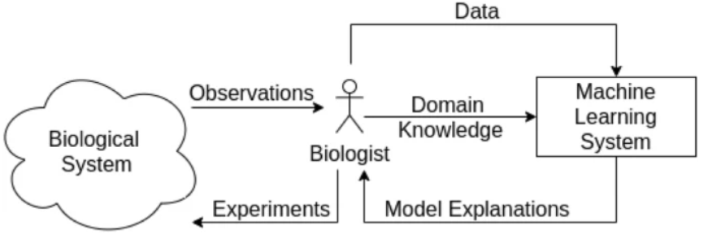
ARCHITECTURE DIAGRAM :
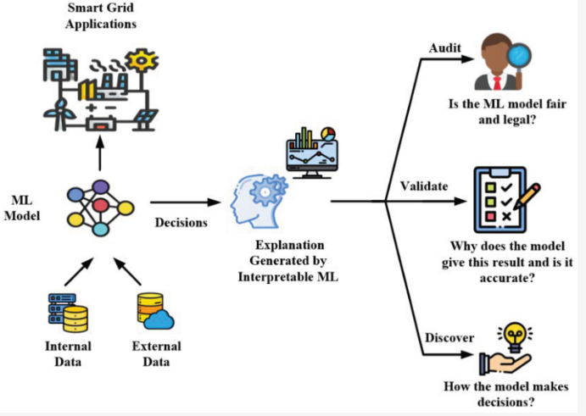

SOFTWARE REQUIREMENTS:
- Operating System : Windows 10
- Platform : python
HARDWARE REQUIREMENTS:
- Keyboard
- Mouse
- Hard disk 500GB
- Ram 4 Gb

CONCLUTION :
we presented a novel approach for extracting concepts to help interpret neural networks, and contributed the use of a visualization-assisted active learning loop to extract interpretable concepts. We integrate the full pipeline into an interactive visualization system, ConceptExtract. Through case studies and experimental validations, we show our approach can extract concepts that are both human understandable and customizable based on the user’s interest

REFERENCE :
- [1] J. Adebayo, J. Gilmer, M. Muelly, I. Goodfellow, M. Hardt, and B. Kim. Sanity checks for saliency maps. In Proceedings of the 32Nd International Conference on Neural Information Processing Systems, NIPS’18, pp. 9525– 9536. Curran Associates Inc., USA, 2018.
- [2] J. Ba and R. Caruana. Do deep nets really need to be deep? In Z. Ghahramani, M. Welling, C. Cortes, N. Lawrence, and K. Q. Weinberger, eds., Advances in Neural Information Processing Systems, vol. 27. Curran Associates, Inc., 2014.
- [[3] S. Bach, A. Binder, G. Montavon, F. Klauschen, K.-R. Mu¨ller, and W. Samek. On pixel-wise explanations for non-linear classifier decisions by layer-wise relevance propagation. PLOS ONE, 10(7):1–46, 07 2015. doi: 10.1371/journal.pone.0130140
- [4] G. Bansal, B. Nushi, E. Kamar, D. S. Weld, W. S. Lasecki, and E. Horvitz. Updates in human-ai teams: Understanding and addressing the performance/compatibility tradeoff. Proceedings of the AAAI Conference on Artificial Intelligence, 33(01):2429–2437, Jul. 2019. doi: 10.1609/aaai. v33i01.33012429
- [5] M. Bojarski, A. Choromanska, K. Choromanski, B. Firner, L. J. Ackel, U. Muller, P. Yeres, and K. Zieba. Visualbackprop: Efficient visualization of cnns for autonomous driving. In 2018 IEEE International Conference on Robotics and Automation (ICRA), pp. 4701–4708, 2018. doi: 10.1109/ ICRA.2018.8461053

- [6] M. Bostock, V. Ogievetsky, and J. Heer. D3 data-driven documents. IEEE Transactions on Visualization and Computer Graphics, 17(12):2301–2309, Dec. 2011. doi: 10.1109/TVCG.2011.185
- [7] C. J. Cai, E. Reif, N. Hegde, J. D. Hipp, B. Kim, D. Smilkov, M. Wattenberg, F. B. Vie´gas, G. S. Corrado, M. C. Stumpe, and M. Terry. Human-centered tools for coping with imperfect algorithms during medical decision-making. CoRR, abs/1902.02960, 2019.
- [8] C. Chen, O. Li, A. Barnett, J. Su, and C. Rudin. This looks like that: deep learning for interpretable image recognition. ArXiv, abs/1806.10574, 2018.
- [9] L.-C. Chen, G. Papandreou, F. Schroff, and H. Adam. Rethinking atrous convolution for semantic image segmentation. arXiv preprint arXiv:1706.05587, 2017
- [10] E. Choi, M. T. Bahadori, J. Sun, J. A. Kulas, A. Schuetz, and W. F. Stewart. Retain: An interpretable predictive model for healthcare using reverse time attention mechanism. In NIPS, 2016.
- [11] J. Deng, W. Dong, R. Socher, L.-J. Li, K. Li, and L. Fei-Fei. Imagenet: A large-scale hierarchical image database. In 2009 IEEE Conference on Computer Vision and Pattern Recognition, pp. 248–255, 2009. doi: 10. 1109/CVPR.2009.5206848
- [12] R. Fong and A. Vedaldi. Interpretable explanations of black boxes by meaningful perturbation. CoRR, abs/1704.03296, 2017..
- [13] A. Ghorbani, J. Wexler, J. Y. Zou, and B. Kim. Towards automatic concept-based explanations. In Advances in Neural Information Processing Systems, pp. 9273–9282, 2019.
- [14] M. Grinberg. Flask web development: developing web applications with python. ” O’Reilly Media, Inc.”, 2018.
- [15] K. He, X. Zhang, S. Ren, and J. Sun. Deep residual learning for image recognition. In 2016 IEEE Conference on Computer Vision and Pattern Recognition (CVPR), pp. 770–778, 2016. doi: 10.1109/CVPR.2016.90

