SCALABLE AND PRACTICAL NATURAL GRADIENT FOR LARGE-SCALE DEEP LEARNING
ABSTRACT:
large-scale distributed training of deep neural networks results in models with worse generalization performance as a result of the increase in the effective mini-batch size. previous approaches attempt to address this problem by varying the learning rate and batch size over epochs and layers, or ad hoc modifications of batch normalization we propose scalable and practical natural gradient descent (sp-ngd), a principled approach for training models that allows them to attain similar generalization performance to models trained with first-order optimization methods, but with accelerated convergence. furthermore, sp-ngd scales to large mini-batch sizes with a negligible computational overhead as compared to first-order methods. we evaluated sp-ngd on a benchmark task where highly optimized first-order methods are available as references: training a resnet-50 model for image classification on imagenet. we demonstrate convergence to a top-1 validation accuracy of 75.4% in 5.5 minutes using a mini-batch size of 32,768 with 1,024 gpus, as well as an accuracy of 74.9% with an extremely large mini-batch size of 131,072 in 873 steps of sp-ngd
EXISTING SYSTEM:
- More complex approaches for manipulating the learning rate were proposed, such as LARS [8], where a different learning rate is used for each layer by normalizing them with the ratio between the layer-wise norms of the weights and gradients.
- This enabled the training with a mini-batch size of 32K without the use of ad hoc modifications, which achieved 74.9% accuracy in 14 minutes (64 epochs) [8]. It has been reported that combining LARS with counter intuitive modifications to the batch normalization, can yield 75.8% accuracy even for a mini-batch size of 65K
- The hierarchical synchronization of minibatches have also been proposed but such methods have not been tested at scale to the extent of the authors’ knowledge.
DISADVANTAGE OF EXISTING SYSTEM:
- Our implementation uses a decentralized approach using MPI/NCCL1 collective communications among the processes. The decentralized approach has been used in high performance computing for a long time, and is known to scale to thousands of GPUs without modification. Although, software like Horovod2 can alleviate the problems with parameter servers by working as a TensorFlow wrapper for NCCL, a workable realization of K-FAC requires solving many engineering and modeling challenges, and our solution is the first one that succeeds on a large scale task.

PROPOSED SYSTEM :

ADVANTAGE:
- More complex approaches for manipulating the learning rate were proposed, such as LARS [8], where a different learning rate is used for each layer by normalizing them with the ratio between the layer-wise norms of the weights and gradients. This enabled the training with a mini-batch size of 32K without the use of ad hoc modifications, which achieved 74.9% accuracy in 14 minutes (64 epochs). It has been reported that combining LARS with counter intuitive modifications to the batch normalization, can yield 75.8% accuracy even for a mini-batch size of 65K
LITRATURE REVIEW:
TITTLE | AUTHOR | DESCRIPTION
“Measuring the Effects of Data Parallelism on Neural Network Training,” | N. G. Paterakis, O. Erdinç, and J. P. S. Catalão, | Recent hardware developments have dramatically increased the scale of data parallelism available for neural network training..
Norm matters: Efficient and accurate normalization schemes in deep networks | E. Hoffer, R. Banner, I. Golan, and D. Soudry, | Over the past few years, Batch-Normalization has been commonly used in deep networks, allowing faster training and high performance for a wide variety of applications.
“Don’t Decay the Learning Rate, Increase the Batch Size,” , | S. L. Smith, P.-J. Kindermans, C. Ying, and Q. V. Le, | This procedure is successful for stochastic gradient descent (SGD), SGD with momentum, Nesterov momentum, and Adam.
“ImageNet: A Large-Scale Hierarchical Image Database,” | J. Deng, W. Dong, R. Socher, L.-J. Li, K. Li, and L. Fei-Fei | The explosion of image data on the Internet has the potential to foster more sophisticated and robust models and algorithms to index, retrieve, organize and interact with images and multimedia data.

INTRODUCTION :
- A hybrid cloud and edge framework is presented for the control of DR resources, including BESS and HVAC units.
- The problem that the training of the DRL-based method requires power computing resources can be solved.
- The proposed framework saves the high cost of local computing resources. With this framework commissioned, the learning in the cloud and the real-time control in the edge can be fully automated, and the DR resources can respond to the DR plan actively and timely with limited human participation.

BLOCK DIAGRAM:
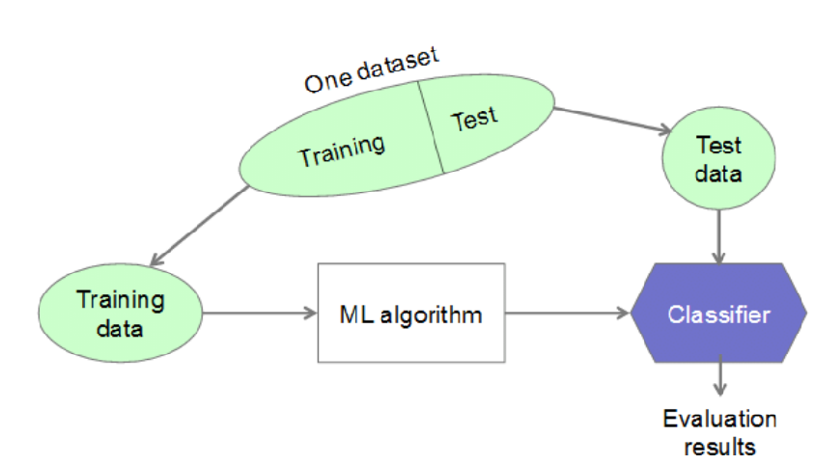
ARCHITECTURE DIAGRAM :


SOFTWARE REQUIREMENTS:
- Operating System : Windows 10
- Platform : python
HARDWARE REQUIREMENTS:
- Keyboard
- Mouse
- Hard disk 500GB
- Ram 4 Gb

CONCLUTION :
More complex approaches for manipulating the learning rate were proposed, such as LARS , where a different learning rate is used for each layer by normalizing them with the ratio between the layer-wise norms of the weights and gradients. This enabled the training with a mini-batch size of 32K without the use of ad hoc modifications, which achieved 74.9% accuracy in 14 minutes (64 epochs). It has been reported that combining LARS with counter intuitive modifications to the batch normalization, can yield 75.8% accuracy even for a mini-batch size of 65K

REFERENCE :
- [1] C. J. Shallue, J. Lee, J. Antognini, J. Sohl-Dickstein, R. Frostig, and G. E. Dahl, “Measuring the Effects of Data Parallelism on Neural Network Training,” Journal of Machine Learning Research, vol. 20, no. 112, pp. 1–49, 2019.
- [2] E. Hoffer, R. Banner, I. Golan, and D. Soudry, “Norm matters: Efficient and accurate normalization schemes in deep networks,” in Advances in Neural Information Processing Systems, 2018, pp. 2160–2170.
- [3] S. L. Smith, P.-J. Kindermans, C. Ying, and Q. V. Le, “Don’t Decay the Learning Rate, Increase the Batch Size,” in International Conference on Learning Representations, 2018.
- [4] J. Deng, W. Dong, R. Socher, L.-J. Li, K. Li, and L. Fei-Fei, “ImageNet: A Large-Scale Hierarchical Image Database,” in IEEE Conference on Computer Vision and Pattern Recognition, 2009, pp. 248–255.
- [5] K. He, X. Zhang, S. Ren, and J. Sun, “Deep Residual Learning for Image Recognition,” in IEEE Conference on Computer Vision and Pattern Recognition, 2016, pp. 770–778
- [6] P. Goyal, P. Dollar, R. Girshick, P. Noordhuis, L. Wesolowski, ´ A. Kyrola, A. Tulloch, Y. Jia, and K. He, “Accurate, Large Minibatch SGD: Training ImageNet in 1 Hour,” arXiv preprint arXiv:1706.02677, 2017.
- [ 7] T. Akiba, S. Suzuki, and K. Fukuda, “Extremely Large Minibatch SGD: Training ResNet-50 on ImageNet in 15 Minutes,” arXiv preprint arXiv:1711.04325, 2017.
- [8] Y. You, I. Gitman, and B. Ginsburg, “Large Batch Training of Convolutional Networks,” arXiv preprint arXiv:1708.03888, 2017.
- 9] X. Jia, S. Song, W. He, Y. Wang, H. Rong, F. Zhou, L. Xie, Z. Guo, Y. Yang, L. Yu, T. Chen, G. Hu, S. Shi, and X. Chu, “Highly Scalable Deep Learning Training System with Mixed-Precision: Training ImageNet in Four Minutes,” arXiv preprint arXiv:1807.11205, 2018
- [10] H. Mikami, H. Suganuma, P. U-chupala, Y. Tanaka, and Y. Kageyama, “Massively Distributed SGD: ImageNet/ResNet-50 Training in a Flash,” arXiv preprint arXiv:1811.05233, 2018.
- [11] M. Yamazaki, A. Kasagi, A. Tabuchi, T. Honda, M. Miwa, N. Fukumoto, T. Tabaru, A. Ike, and K. Nakashima, “Yet Another Accelerated SGD: ResNet-50 Training on ImageNet in 74.7 seconds,” arXiv preprint arXiv:1903.12650, 2019.
- [12] T. Lin, S. U. Stich, and M. Jaggi, “Don’t Use Large Mini-Batches, Use Local SGD,” arXiv preprint arXiv:1808.07217, 2018.
- [13] C. Ying, S. Kumar, D. Chen, T. Wang, and Y. Cheng, “Image Classification at Supercomputer Scale,” arXiv preprint arXiv:1811.06992, 2018.
- [14] S.-i. Amari, “Natural Gradient Works Efficiently in Learning,” Neural Computation, vol. 10, pp. 251–276, 1998.
- [15] N. L. Roux, P.-a. Manzagol, and Y. Bengio, “Topmoumoute Online Natural Gradient Algorithm,” in Advances in Neural Information Processing Systems 20, 2008, pp. 849–856

