A SYSTEMATIC REVIEW ON RECENT ADVANCEMENTS IN DEEP AND MACHINE LEARNING BASED DETECTION AND CLASSIFICATION OF ACUTE LYMPHOBLASTIC LEUKEMIA
ABSTRACT:
Automatic Leukemia or blood cancer detection is a challenging job and is very much required in healthcare centers. It has a significant role in early diagnosis and treatment planning. Leukemia is a hematological disorder that starts from the bone marrow and affects white blood cells (WBCs). Microscopic analysis of WBCs is a preferred approach for an early detection of Leukemia since it is cost-effective and less painful. Very few literature reviews have been done to demonstrate a comprehensive analysis of deep and machine learning-based Acute Lymphoblastic Leukemia (ALL) detection. This article presents a systematic review of the recent advancements in this knowledge domain. Here, various artificial intelligence-based ALL detection approaches are in a systematic manner with merits and demits. The review of these schemes is conducted in a structured manner. For this purpose, segmentation schemes are broadly categorized into signal and image processing-based techniques, conventional machine learning-based techniques, and deep learning-based techniquesConventional machine learning-based ALL classification approaches are categorized into supervised and unsupervised machine learning is presented.

EXISTING SYSTEM:
- The dropout layer is used to avoid overfitting. In 2020, Jha and Dutta presented a Chronological Sine Cosine Algorithm (SCA)-based deep CNN model to classify ALL successfully. Shahin et al. have proposed a new CNN-based framework (WBCsNet) to classify WBC efficiently. Claro et al. have suggested a deep-learning network (Alert-Net). It consists of 5 convolution layers, two fully connected layers, and a softmax layer. Conventional CNN needs a huge dataset to achieve outstanding performance. Since publicly available standard medical datasets are in small size, it is unable to properly fine-tune the weights to extract more important target-specific features efficiently. Thus, it yields relatively poor performance.

DISADVANTAGE OF EXISTING SYSTEM:
- Various researchers have employed the Watershed algorithm to segment overlapped and touched cells However, it faces an over-segmentation problem due to cells’ irregular shape. Some researchers have applied a marker-based watershed algorithm to segment overlapped and touched cells more effectively and solve the above problem . In this technique, we have first extracted the marker, and then the marker is imposed on the gradient to get the segmented cells They treat the segmentation as a pixel classification problem and segment the nucleus, cytoplasm, and background quite effectively

PROPOSED SYSTEM :
This article presents a brief analysis of recent advancements in deep and machine learning-based detection and classification of ALL. We have analyzed various existing methods of segmentation, feature extraction, and classification, which are employed to detect ALL efficiently. From this review, we also observed that among classical machine learning schemes, unsupervised schemes are preferred for segmentation tasks, whereas supervised schemes are preferred for classification tasks. More advanced deep learning or transfer learning-based systems can be designed by modifying the existing efficient models to make the system more accurate and faster as well

ADVANTAGE:
- The ALL classification performance can be improved by employing an efficient ensemble transfer learning classifier that combines the benefits of all the transfer learning schemes used in this classifier. Hence, it enhances the diversity ability of feature learning, resulting in the extraction of more significant features. In addition, the combined benefits also improve the overall classification performances. In both these review works, the authors have emphasized the discussion of several segmentation approaches, whereas they have not focused on classification schemes.

LITRATURE REVIEW:
TITTLE | AUTHOR | DESCRIPTION
‘An efficient blood-cell segmentation for the detection of hematological disorders,,. | P. K. Das, S. Meher, R. Panda, and A. Abraham, | Theautomatic segmentation of blood cells for detecting hematological disorders is a crucial job. It has a vital role in diagnosis, treatment planning, and output evaluation. ..
An efficient deep convolutional neural network based detection and classification of acute lymphoblastic leukemia, | P. K. Das and S. Meher | This paper proposes an efficient deep CNNs framework to mitigate this issue and yield more accurate ALL detection.
An automatic nucleus segmentation and CNN model based classification method of white blood cell. | P. P. Banik, R. Saha, and K.-D. Kim | The characteristics of WBC can be defined based on the morphological properties of WBC nucleus.
Leukemia diagnosis in blood slides using transfer learning in CNNsand SV for classification,’’ | L. H. Vogado, R. M. S. Veras, F. H. D. Araujo, R. R. V. Silva, and K. R. T. Aires, | Computer-aided systems can be used to reduce the possibility of prescribing inappropriate treatments and assist specialists in the diagnosis of this disease.

INTRODUCTION :
- The quality of acquired microscopic images relies on camera type, microscope type, light source, capturing camera angle, illumination variation, and noise. Hence, stain normalization is a crucial preprocessing step that normalizes all stain slides to deal with variations in capturing environments, particularly lighting condition variations. It minimizes the illumination and color variations due to different capturing environments of microscopic images taken from different laboratories and thus improving the segmentation and classification performances

- BLOCK DIAGRAM:
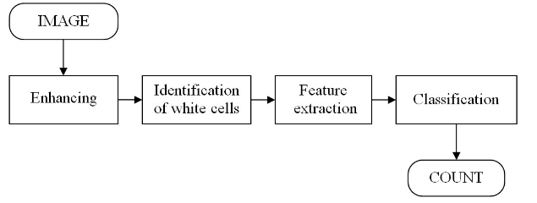

ARCHITECTURE DIAGRAM :
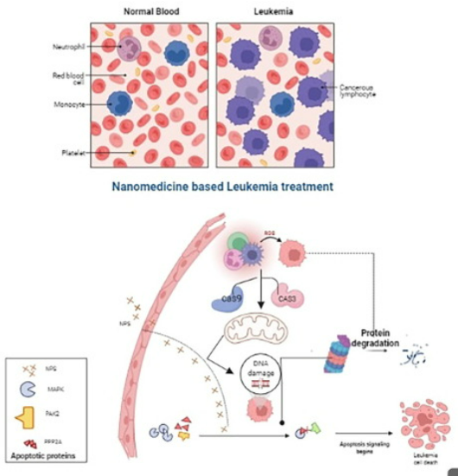

SOFTWARE REQUIREMENTS:
- Operating System : Windows 10
- Platform : python
HARDWARE REQUIREMENTS:
- Keyboard
- Mouse
- Hard disk 500GB
- Ram 4 Gb

CONCLUTION :
This article presents a brief analysis of recent advancements in deep and machine learning-based detection and classification of ALL. We have analyzed various existing methods of segmentation, feature extraction, and classification, which are employed to detect ALL efficiently However, Deep learning, particularly transfer learning, has emerged as a preferred approach for automatic and more robust detection and classification of ALL since it yields excellent performance even in small datasets we have also observed that the MobileNetV2- ResNet18 architecture yields the best ALL detection performance in ALLIDB1 dataset due to the combined benefits of both schemes.

REFERENCE :
- [1] P. K. Das, S. Meher, R. Panda, and A. Abraham, ‘‘An efficient blood-cell segmentation for the detection of hematological disorders,’’ IEEE Trans. Cybern., early access, Mar. 18, 2021, doi: 10.1109/TCYB.2021.3062152.
- [2] P. K. Das and S. Meher, ‘‘An efficient deep convolutional neural network based detection and classification of acute lymphoblastic leukemia,’’ Expert Syst. Appl., vol. 183, Nov. 2021, Art. no. 115311.
- [3] P. P. Banik, R. Saha, and K.-D. Kim, ‘‘An automatic nucleus segmentation and CNN model based classification method of white blood cell,’’ Expert Syst. Appl., vol. 149, Jul. 2020, Art. no. 113211.
- [4] L. H. Vogado, R. M. S. Veras, F. H. D. Araujo, R. R. V. Silva, and K. R. T. Aires, ‘‘Leukemia diagnosis in blood slides using transfer learning in CNNs and SVM for classification,’’ Eng. Appl. Artif. Intell., vol. 72, pp. 415–422, Jun. 2018.
- [5] P. K. Das, B. Nayak, and S. Meher, ‘‘A lightweight deep learning system for automatic detection of blood cancer,’’ Measurement, vol. 191, Mar. 2022, Art. no. 110762.
- [6] P. K. Das, A. Pradhan, and S. Meher, ‘‘Detection of acute lymphoblastic leukemia using machine learning techniques,’’ in Machine Learning, Deep Learning and Computational Intelligence for Wireless Communication. Singapore: Springer, 2021, pp. 425–437.
- [7] P. K. Das and S. Meher, ‘‘Transfer learning-based automatic detection of acute lymphocytic leukemia,’’ in Proc. Nat. Conf. Commun. (NCC), Jul. 2021, pp. 1–6.
- [8] S. Mishra, B. Majhi, and P. K. Sa, ‘‘Texture feature based classification on microscopic blood smear for acute lymphoblastic leukemia detection,’’ Biomed. Signal Process. Control, vol. 47, pp. 303–311, Jan. 2019.
- [9] P. K. Das, S. Meher, R. Panda, and A. Abraham, ‘‘A review of automated methods for the detection of sickle cell disease,’’ IEEE Rev. Biomed. Eng., vol. 13, pp. 309–324, 2020.
- [10] P. K. Das, P. Jadoun, and S. Meher, ‘‘Detection and classification of acute lymphocytic leukemia,’’ in Proc. IEEE-HYDCON, Sep. 2020, pp. 15.
- [11] N. Patel and A. Mishra, ‘‘Automated leukaemia detection using microscopic images,’’ Proc. Comput. Sci., vol. 58, pp. 635–642, Jan. 2015.
- [12] J. M. Bennett, D. Catovsky, M.-T. Daniel, G. Flandrin, D. A. G. Galton, H. R. Gralnick, and C. Sultan, ‘‘Proposals for the classification of the acute leukaemias French-American-British (FAB) co-operative group,’’ Brit. J. Haematol., vol. 33, no. 4, pp. 451–458, Aug. 1976.
- [13] T. Terwilliger and M. Abdul-Hay, ‘‘Acute lymphoblastic leukemia: A comprehensive review and 2017 update,’’ Blood Cancer J., vol. 7, no. 6, p. e577, Jun. 2017.
- [14] K. AL-Dulaimi, J. Banks, K. Nugyen, A. Al-Sabaawi, I. Tomeo-Reyes, and V. Chandran, ‘‘Segmentation of white blood cell, nucleus and cytoplasm in digital haematology microscope images: A review–challenges, current and future potential techniques,’’ IEEE Rev. Biomed. Eng., vol. 14, pp. 290–306, 2021.
- [15] S. Shafique and S. Tehsin, ‘‘Acute lymphoblastic leukemia detection and classification of its subtypes using pretrained deep convolutional neural networks,’’ Technol. Cancer Res. Treatment, vol. 17, Sep. 2018, Art. no. 1533033818802789

