A REVIEW ON DEEP LEARNING TECHNIQUES FOR VIDEO PREDICTION

ABSTRACT:
The ability to predict, anticipate and reason about future outcomes is a key component of intelligent decision-making systems. In light of the success of deep learning in computer vision, deep-learning-based video prediction emerged as a promising research direction. Defined as a self-supervised learning task, video prediction represents a suitable framework for representation learning, as it demonstrated potential capabilities for extracting meaningful representations of the underlying patterns in natural videos. Motivated by the increasing interest in this task, we provide a review on the deep learning methods for prediction in video sequences. We firstly define the video prediction fundamentals, as well as mandatory background concepts and the most used datasets. we carefully analyze existing video prediction models organized according to a proposed taxonomy, highlighting their contributions and their significance in the field.The summary of the datasets and methods is accompanied with experimental results that facilitate the assessment of the state of the art on a quantitative basis. The paper is summarized by drawing some general conclusions, identifying open research challenges and by pointing out future research directions.

EXISTING SYSTEM:
- proposed the conditional Generative Adversarial Network (cGAN), a conditional version where the generator and discriminator are conditioned on some extra information, e.g. class labels, previous predictions, and multimodal data, among others. CGANs are suitable for video prediction, since the spatiotemporal coherence between the generated frames and the input sequence is guaranteed.
- With that purpose, the challenge provided a dataset that extends UCF101 [115] (trimmed videos with one action) with 2100 untrimmed videos where one or more actions take place (with the correspondent temporal annotations) and almost 3000 relevant videos without any of the 101 proposed actions.
- A problem was that TCGA and ARCHS4 preprocess the data (from the sequencer output) using slightly different pipelines.
- The cross-entropy loss, which is standard for classification problems.
- Leveraging on that additional information can offer the chance to extract features useful to overcome the lack of labeled samples and tackle the subtyping problem more efficiently.

DISADVANTAGE OF EXISTING SYSTEM:
- A problem was that TCGA and ARCHS4 preprocess the data (from the sequencer output) using slightly different pipelines.
- The cross-entropy loss, which is standard for classification problems.
- Leveraging on that additional information can offer the chance to extract features useful to overcome the lack of labeled samples and tackle the subtyping problem more efficiently.

PROPOSED SYSTEM :
- we carefully analyze existing video prediction models organized according to a proposed taxonomy, highlighting their contributions and their significance in the field.
- Most of the existing deep learning-based models in the literature are deterministic. Although the future is uncertain, a deterministic prediction would suffice some easily predictable situations
- While great strides have been made to mitigate blurriness, most of the existing approaches still rely on distance-based loss functions.
- This has further encouraged authors to reformulate existing deterministic models in a probabilistic fashion.

ADVANTAGE:
- The most widely used evaluation protocols for video prediction rely on image similarity-based metrics such as, Mean-Squared Error (MSE), Structural Similarity Index Measure (SSIM) [229], and Peak Signal to Noise Ratio (PSNR). However, evaluating a prediction according to the mismatch between its visual appearance and the ground truth is not always reliable
- Finally, the lack of reliable and fair evaluation models makes the qualitative evaluation of video prediction challenging and represents another potential open problem.

LITRATURE REVIEW:
TITTLE | AUTHOR | DESCRIPTION
Max-margin early event detectors, | M. H. Nguyen and F. D. la Torre | we simulate the sequential frame-by-framedata arrival for training time series and learn an event de-tector that correctly classiﬁes partially observed sequences
Activity Forecasting | TK. M. Kitani, B. D. Ziebart, J. A. Bagnell, and M. Hebert,, | To achieve accurate activity forecasting, the approach modeled the effect of the physical environment on the choice of human actions..
TITTLE | AUTHOR | DESCRIPTION
Anticipating Visual Representations from Unlabeled Video,” | C. Vondrick, H. Pirsiavash, and A. Torralba, | This work presents a framework that capitalizes on temporal structure in unlabeled video to learn to anticipatehuman actions and objects and applies recognition algorithms onthe authors'predicted representationto anticipateobjectsand actions
Visual Forecasting by Imitating Dynamics in Natural Sequences, | K. Zeng, W. B. Shen, D. Huang, M. Sun, and J. C. Niebles, | The key challenge is the high-dimensional and continuous state-action space that prohibits the application of previous IRL algorithms.

INTRODUCTION :
- The ability to predict, anticipate and reason about future events is the essence of intelligence [21] and one of the main goals of decision-making systems.
- This idea has biological roots, and also draws inspiration from the predictive coding paradigm borrowed
- From the cognitive neuroscience field From a neuroscience perspective, the human brain builds complex mental representations of the physical and causal rules that govern the world. This is primarily through observation and interaction

BLOCK DIAGRAM:
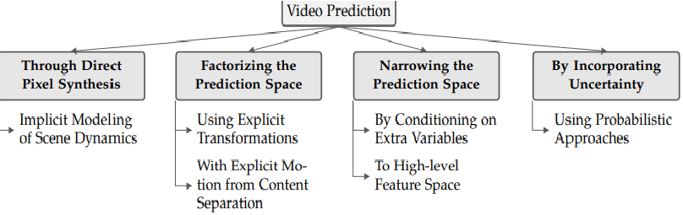

ARCHITECTURE DIAGRAM :
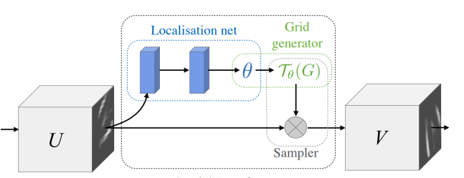

SOFTWARE REQUIREMENTS:
- Operating System : Windows 10
- Platform : python
HARDWARE REQUIREMENTS:
- Keyboard
- Mouse
- Hard disk 500GB
- Ram 4 Gb
CONCLUTION :
- In this review, after reformulating the predictive learning paradigm in the context of video prediction, we have closely reviewed the fundamentals on which it is based: exploiting the time dimension of videos, dealing with stochasticity, and the importance of the loss functions in the learning process. Moreover, an analysis of the backbone deep learningbased architectures for this task was performed in order to provide the reader the necessary background knowledge. The core of this study encompasses the analysis and classification of more than 50 methods and the datasets they have used.

REFERENCE :
- [1] M. H. Nguyen and F. D. la Torre, “Max-margin early event detectors,” in CVPR, 2012.
- [2] K. M. Kitani, B. D. Ziebart, J. A. Bagnell, and M. Hebert, “Activity Forecasting,” in ECCV, 2012.
- [3] C. Vondrick, H. Pirsiavash, and A. Torralba, “Anticipating Visual Representations from Unlabeled Video,” in CVPR, 2016.
- [4] K. Zeng, W. B. Shen, D. Huang, M. Sun, and J. C. Niebles, “Visual Forecasting by Imitating Dynamics in Natural Sequences,” in ICCV, 2017.
- [5] S. Shalev-Shwartz, N. Ben-Zrihem, A. Cohen, and A. Shashua, “Long-term planning by short-term prediction,” arXiv:1602.01580, 2016.
- [6] O. Makansi, E. Ilg, O. Cicek, and T. Brox, “Overcoming limitations of mixture density networks: A sampling and fitting framework for multimodal future prediction,” in CVPR, 2019.
- [7] Z. Liu, R. A. Yeh, X. Tang, Y. Liu, and A. Agarwala, “Video frame synthesis using deep voxel flow,” in ICCV, 2017.
- [8] P. Luc, C. Couprie, Y. LeCun, and J. Verbeek, “Predicting Future Instance Segmentation by Forecasting Convolutional Features,” in ECCV, 2018, pp. 593–608.
- [9] A. Bhattacharyya, M. Fritz, and B. Schiele, “Bayesian prediction of future street scenes using synthetic likelihoods,” in ICLR, 2019.
- [10] A. Terwilliger, G. Brazil, and X. Liu, “Recurrent flow-guided semantic forecasting,” in WACV, 2019.
- [11] A. Bhattacharyya, M. Fritz, and B. Schiele, “Long-Term On-Board Prediction of People in Traffic Scenes Under Uncertainty,” in CVPR, 2018.
- [12] W. Liu, W. Luo, D. Lian, and S. Gao, “Future frame prediction for anomaly detection - A new baseline,” in CVPR. IEEE, 2018.
- [13] X. Shi, Z. Chen, H. Wang, D. Yeung, W. Wong, and W. Woo, “Convolutional LSTM network: A machine learning approach for precipitation nowcasting,” in NeurIPS, 2015.
- [14] X. Shi, Z. Gao, L. Lausen, H. Wang, D.-Y. Yeung, W.-k. Wong, and W.-c. WOO, “Deep learning for precipitation nowcasting: A benchmark and a new model,” in NeurIPS, 2017.
- [15] A. Hu, F. Cotter, N. Mohan, C. Gurau, and A. Kendall, “Probabilistic future prediction for video scene understanding,” arXiv:2003.06409, 2020.

