A SYSTEMATIC REVIEW TOWARDS BIG DATA ANALYTICS IN SOCIAL MEDIA

ABSTRACT:
The recent advancement in internet 2.0 creates a scope to connect people worldwide using society 2.0 and web 2.0 technologies. This new era allows the consumer to directly connect with other individuals, business corporations, and the governmentPeople are open to sharing opinions, views, and ideas on any topic in different formats out loud. This creates the opportunity to make the “Big Social Data” handy by implementing machine learning approaches and social data analyticsThis study offers an overview of recent works in social media, data science, and machine learning to gain a wide perspective on social media big data analytics. We explain why social media data are significant elements of the improved data-driven decision-making process. We propose and build the “Sunflower Model of Big Data” to define big data and bring it up to date with technology by combining 5 V’s and 10 Bigs. We discover the top ten social data analytics to work in the domain of social media platforms. A comprehensive list of relevant statistical/machine learning methods to implement each of these big data analytics is discussed in this work. Text Analytics” is the most used analytics in social data analysis to date. We create a taxonomy on social media analytics to meet the need and provide a clear understandingTools, techniques, and supporting data type are also discussed in this research workAs a result, researchers will have an easier time deciding which social data analytics would best suit their needs..

EXISTING SYSTEM:
- We propose and build the Sunflower Model of Big Data to define big data and bring it up to date with technology by combining 5 V’s and 10 Bigs. We discover the top ten social data analytics to work in the domain of social media platforms.
- This section investigates the concept of big data and proposes a new dynamic approach to defining big data.
- To reflect the combination of 5 V’s and 10 Bigs in big data, we develop and propose the “Sunflower Model of Big Data
- We propose this as a flexible and dynamic model.

DISADVANTAGE OF EXISTING SYSTEM:
- The series of tasks from the SMS is mostly used to collect and scrutinize scientific articles from a certain topic area to answer some predetermined questions. The strategy behind this is to find and assess all applicable articles to address specific problems
- Sequential activities by following a series of independent tasks lead to the ultimate goal in this system
- Adjustability and variety in big social data require data analytics, machine learning, and data science in the domain of social media data analysis.

PROPOSED SYSTEM :
- This work will review existing computational and digital pathology methods for breast cancer diagnosis with a special focus on deep learning. The paper starts by reviewing public datasets related to breast cancer diagnosis.
Additionally, existing deep learning methods for breast cancer diagnosis are reviewed. The publicly available code repositories are introduced as well. The paper is closed by highlighting challenges and future works for deep learning-based diagnosis
ADVANTAGE:
- We use the advance search and filter option provided by each of these databases.
- Video analytics shows the recent advancement of technology in social data analysis
- social media, big data, and mental health Current advances and ethical implications
- Many disciplines and sectors have advanced as a result of the widespread use of social media data and big data analytics. There are numerous hurdles and limitations to working in this field.

LITRATURE REVIEW:
TITTLE | AUTHOR | DESCRIPTION
Big data and social media analytics | V. Dhawan and N. Zanini | The use of big data in various fields and industries is a closely debated and observed topic that social media experts are actively engaged in.
amazing social media statistics and facts | TK. Smith | We come across all sorts of interesting stats about social media platforms and users, so we’ve collated the best of them in this bumper facts list..
Big data concepts, methods, and analytics | A. Gandomi and M. Haider | This paper attempts to offer a broader definition of big data that captures its other unique and defining characteristics.
A survey, Comput. Human Behav | N. A. Ghani, S. Hamid, I. A. Targio Hashem, and E. Ahmed | If this prediction is to come true, then next generation computing should be about anticipatory user interfaces that should be human-centered, built for humans based on human models

INTRODUCTION :
- Technological advancements produce numerous sorts of structured data, but the majority is semi-structured or unstructured data, which is mostly big data. Big data refer to large, complex data collections that necessitate sophisticated and cost-effective data administration and analysis tools to extract insights and make decisions
- Unstructured data include online text, photographs, audio, and video, all of which lack structural organization and need special analytics/tools for data analysis

- BLOCK DIAGRAM:
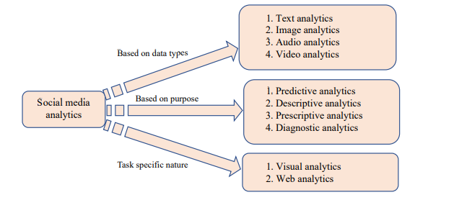

ARCHITECTURE DIAGRAM :
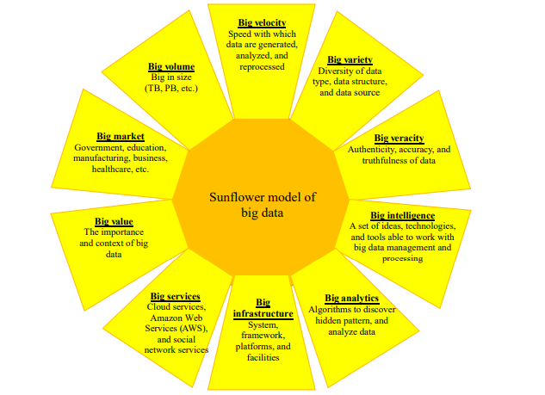

SOFTWARE REQUIREMENTS:
- Operating System : Windows 10
- Platform : python
HARDWARE REQUIREMENTS:
- Keyboard
- Mouse
- Hard disk 500GB
- Ram 4 Gb
CONCLUTION :
- Big data, along with advances in computing tools, have evolved as a significant data analytics for understanding human behavior by analyzing data from social media. All types of organizations, from industry to government, can be benefitted using social data, data science, and social data analytics. This study fills in the research gap by identifying the ten most widely accepted and used big data analytics for analyzing social data and making decisions. Considering the overlap among the approaches of social media analytics, we design a taxonomy of big data analytics in the social media domain. We create three main categories and then assign these ten analytics to each one depending on the purpose, nature of usage, and working area. Data analysis in social media is aided by machine learning techniques. Each of these social data analytics has a long list of machine learning or statistical methodologies associated with it. We present social data analytics along with the methodologies.

REFERENCE :
- [1] V. Dhawan and N. Zanini, Big data and social media analytics, Res. Matters A Cambridge Assess. Publ., no. 18, pp. 36–41, 2014
- [2]. K. Smith, 126 amazing social media statistics and facts, https://www.brandwatch.com/blog/amazing-socialmedia-statistics-and-facts/, 2019..
- [3] A. Gandomi and M. Haider, Beyond the hype: Big data concepts, methods, and analytics, Int. J. Inf. Manage., vol. 35, no. 2, pp. 137–144, 2015
- [5] P. V. Paul, K. Monica, and M. Trishanka, A survey on big data analytics using social media data, in Proc. 2017 Innov. Power Adv. Comput. Technol. (i-PACT), Vellore, India, 2017, pp. 1–4.
- [6] F. Shaikh, F. Rangrez, A. Khan, and U. Shaikh, Social media analytics based on big data, in Proc. 2017 Int. Conf. Intell. Comput. Control. (I2C2), Coimbatore, India, 2017, pp. 1–6
- [7] V. Nunavath and M. Goodwin, The role of artificial intelligence in social media big data analytics for disaster management–initial results of a systematic literature review, in Proc. 2018 5th Int. Conf. Inf. Commun. Technol. Disaster Manag. (ICT-DM), Sendai, Japan, 2018, pp. 1–4.
- [8] F. Piccialli and J. E. Jung, Understanding customer experience diffusion on social networking services by big data analytics, Mob. Networks Appl., vol. 22, no. 4, pp. 605–612, 2017..
- [[9] P. Ducange, R. Pecori, and P. Mezzina, A glimpse on big data analytics in the framework of marketing strategies, Soft Comput., vol. 22, no. 1, pp. 325–342, 2018
- [10] P. Grover and A. K. Kar, Big data analytics: A review on theoretical contributions and tools used in literature, Glob. J. Flex. Syst. Manag., vol. 18, no. 3, pp. 203–229, 2017.
- [11] J. Amudhavel, V. Padmapriya, V. Gowri, K. Lakshmipriya, K. P. Kumar, and B. Thiyagarajan, Perspectives, motivations, and implications of big data analytics, in Proc. 2015 International Conference on Advanced Research in Computer Science Engineering & Technology (ICARCSET), Unnao, India, 2015, pp. 1–5.
- [12] M. Gupta and J. F. George, Toward the development of a big data analytics capability, Inf. Manag., vol. 53, no. 8, pp. 1049–1064, 2016.
- [13] L. Cao, Data science: Challenges and directions, Communicati
on of the ACM, vol. 60, no. 8, pp. 59–68, 2017.
- [14] Z. Sun, K. Strang, and R. Li, Big data with ten big characteristics, 0.13140/RG.2.2.21798.98886.
- [15] B. Sena, A. P. Allian, and E. Y. Nakagawa, Characterizing A systematic mapping study, in Proc. 11th Brazilian Symposium on Software Components, Architectures, and Reuse, New York, NY, USA, 2017, pp. 1–10.

