AI EMPOWERED RIS-ASSISTED NOMA NETWORKS: DEEP LEARNING OR REINFORCEMENT LEARNING
ABSTRACT:
A novel reconfigurable intelligent surfaces (RISs)- based transmission framework is proposed for downlink nonorthogonal multiple access (NOMA) networks. We propose a quality-of-service (QoS)-based clustering scheme to improve the resource efficiency and formulate a sum rate maximization problem by jointly optimizing the phase shift of the RIS and the power allocation at the base station (BS). A model-agnostic meta-learning (MAML)-based learning algorithm is proposed to solve the joint optimization problem with a fast convergence rate and low model complexity. Extensive simulation results demonstrate that the proposed QoS-based NOMA network achieves significantly higher transmission throughput compared to the conventional orthogonal multiple access (OMA) networkIt can also be observed that substantial throughput gain can be achieved by integrating RISs in NOMA and OMA networks. Moreover, simulation results of the proposed QoS-based clustering method demonstrate observable throughput gain against the conventional channel condition-based schemes

EXISTING SYSTEM:
- A novel reconfigurable intelligent surfaces (RISs)- based transmission framework is proposed for downlink nonorthogonal multiple access (NOMA) networks.

- Simulation results indicate that the implementation of RIS can induce approximately 5% to 25% throughput gain as the number of RIS elements increases from 8 to 64, in both NOMA and OMA networks. Results also show that the proposed QoS-based clustering method achieves higher throughput than the conventional channel condition-based approach

- Hence, we proposed to tackle the joint optimization problem utilizing machine learning techniques

DISADVANTAGE OF EXISTING SYSTEM:
- A model-agnostic meta-learning (MAML)-based learning algorithm is proposed to solve the joint optimization problem with a fast convergence rate and low model complexity.
- To maximize sum rate while ensuring user fairness, the authors of formulated a max-min problem for RIS-enhanced NOMA networks by jointly optimizing the power allocation and the RIS phase shift
- The sum rate maximization problem of RIS-aided NOMA systems was investigated in , where the passive beamforming at the RIS was jointly optimized with the active beamforming at the base station (BS) under both the ideal and non-ideal RIS elements

PROPOSED SYSTEM :
- To the best of our knowledge, there does not exist a DL-based solution for RIS-aided NOMA networks, which motivates this study. In this paper, we investigate the sum rate optimization problem in RIS-aided downlink MISO-NOMA networks, where both the RIS phase shift and the BS power allocation are optimized to maximize the total transmission sum rate. We adopt the zero-forcing (ZF) precoding method and the successive interference cancellation (SIC) decoding method to eliminate the effect of multi-user interference on the strong users.

ADVANTAGE:
- where the passive beamforming at the RIS was jointly optimized with the active beamforming at the base station (BS) under both the ideal and non-ideal RIS elements. To maximize sum rate while ensuring user fairness, the authors of formulated a max-min problem for RIS-enhanced NOMA networks by jointly optimizing the power allocation and the RIS phase shift
- We adopt the zero-forcing (ZF) precoding method and the successive interference cancellation (SIC) decoding method to eliminate the effect of multi-user interference on the strong users. However, this approach causes the weak users to suffer from both inter-cluster and intra-cluster interference, leading to poor achievable rates.
LITRATURE REVIEW:
TITTLE | AUTHOR | DESCRIPTION
“Toward massive MIMO ¨ 2.0: Understanding spatial correlation | L. Sanguinetti, E. Bjornson, and J. Hoydis | There is a thin line of papers that avoided these caveats, but the results are easily missed
“Reconfigurable intelligent surfaces: Principles and opportunities | Y. Liu, X. Liu, X. Mu, T. Hou, J. Xu, M. Di Renzo, and N. AlDhahir | In addition, we systematically survey existing designs for RIS-enhanced wireless networks encompassing performance analysis, information theory, and performance optimization perspectives.
Machine learning empowered trajectory and passive beamforming design in UAV-RIS wireless networks | X. Liu, Y. Liu, and Y. Chen | A novel framework is proposed for integrating reconfigurable intelligent surfaces (RIS) in unmanned aerial vehicle (UAV) enabled wireless networks, where an RIS is deployed for enhancing the service quality of the UAV.
a, “Paleoecología y Cronoestratigrafía de las Diatomeas del Miembro Los Indios en la Mesa La Misión, del Mioceno de Baja California, México,” | X. Liu, Y. Liu, Y. Chen, and H. V. Poor | The Mesa La Misión in Baja California is an outcrop of the Member Los Indios, part of the Rosarito Beach Formation.

INTRODUCTION :
- we consider a downlink MISO system with one BS and K mobile users (MUs). The BS is equipped with M antenna elements and each MU is equipped with one single antenna.
- The communication between the BS and the MUs is assisted by a RIS of N reflecting elements, whose phase shift and amplitude absorption can be adjusted by a controller.
- The channels between the BS and the RIS are modelled as Rician fading channels. The BS-MU channels and the RIS-MU channels are modelled as Rayleigh fading channels.

BLOCK DIAGRAM:
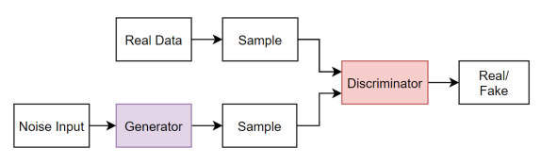

ARCHITECTURE DIAGRAM :
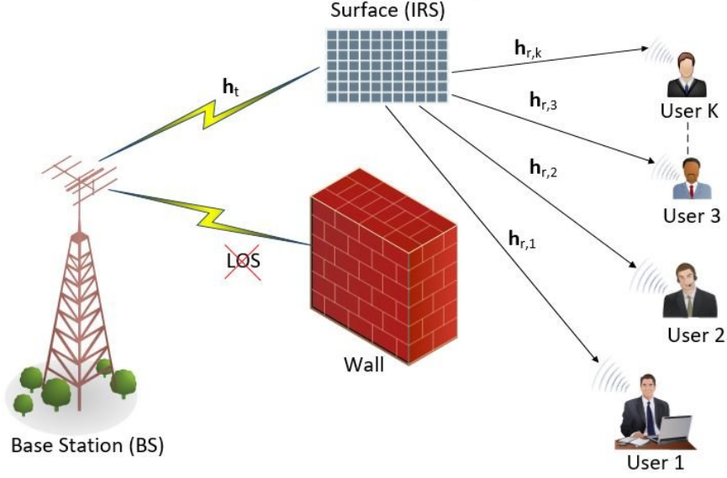

SOFTWARE REQUIREMENTS:
- Operating System : Windows 10
- Platform : python
HARDWARE REQUIREMENTS:
- Keyboard
- Mouse
- Hard disk 500GB
- Ram 4 Gb

CONCLUTION :
In this article, we proposed a QoS-based clustering method to improve the resource efficiency in RIS-assisted NOMA networks. We formulated the sum rate maximization problem by jointly optimizing the RIS phase shift and the BS power allocation. The proposed DL solution utilized a low-complexity network architecture and employed MAML to improve the convergence rate. Simulation results demonstrated that higher transmission throughput was achieved by the proposed QoSbased clustering method than the baseline method. Results also illustrated that the proposed QoS-based NOMA model achieved higher throughput compared to the conventional OMA models for a wide range of values of the BS transmit power and the RLS elements.

sREFERENCE :
- [1] L. Sanguinetti, E. Bjornson, and J. Hoydis, “Toward massive MIMO ¨ 2.0: Understanding spatial correlation, interference supp6 reflecting elements. contamination,” IEEE Trans. Commun., vol. 68, no. 1,
- [2] Y. Liu, X. Liu, X. Mu, T. Hou, J. Xu, M. Di Renzo, and N. AlDhahir, “Reconfigurable intelligent surfaces: Principles and opportunities,” IEEE Commun. Surv. & Tut., May 2021, accepted to appear, doi:10.1109/COMST.2021.3077737.
- [3] X. Liu, Y. Liu, and Y. Chen, “Machine learning empowered trajectory and passive beamforming design in UAV-RIS wireless networks,” IEEE J. Sel. Areas Commun., Dec. 2020, doi:10.1109/JSAC.2020.3041401.
- [1[4] X. Liu, Y. Liu, Y. Chen, and H. V. Poor, “RIS enhanced massive nonorthogonal multiple access networks: Deployment and passive beamforming design,” IEEE J. Sel. Areas Commun., vol. 39, no. 4, pp. 1057–1071, Apr. 2021.
- [5] Y. Liu, Z. Qin, M. Elkashlan, Z. Ding, A. Nallanathan, and L. Hanzo, “Nonorthogonal multiple access for 5G and beyond,” Proc. IEEE, vol. 105, no. 12, pp. 2347–2381, Dec. 2017.
- [6] Y. Liu, X. Mu, X. Liu, M. Di Renzo, Z. Ding, and R. Schober, “Reconfigurable intelligent surface (RIS) aided multi-user networks: Interplay between NOMA and RIS,” arXi
- [7] T. Hou, Y. Liu, Z. Song, X. Sun, Y. Chen, and L. Hanzo, “Reconfigurable intelligent surface aided NOMA networks,” IEEE J. Sel. Areas Commun., vol. 38, no. 11, pp. 2575–2588, Jul. 2020.
- [8] X. Mu, Y. Liu, L. Guo, J. Lin, and N. Al-Dhahir, “Exploiting intelligent reflecting surfaces in NOMA networks: Joint beamforming optimization,” IEEE Trans. Wireless Commun., vol. 19, no. 10, pp. 6884–6898, Jul. 2020.
- [9] G. Yang, X. Xu, and Y.-C. Liang, “Intelligent reflecting surface assisted non-orthogonal multiple access,” in IEEE Wireless Commun. Netw. Conf. (WCNC 2020), May 2020, pp. 1–6.
- [10] S. Sun, Z. Cao, H. Zhu, and J. Zhao, “A survey of optimization methods from a machine learning perspective,” IEEE Trans. Cybern., vol. 50, no. 8, pp. 3668–3681, Nov. 2020.
- [11] Y. Ge and J. Fan, “Beamforming optimization for intelligent reflecting surface assisted MISO: A deep transfer learning approach,” IEEE Trans. Veh. Technol., pp. 1–1, Mar. 2021.
- [12] C. Huang, G. C. Alexandropoulos, C. Yuen, and M. Debbah, “Indoor signal focusing with deep learning designed reconfigurable intelligent surfaces,” in IEEE Int. Workshop Signal Process. Adv. Wireless Commun. (SPAWC), Jul. 2019, pp. 1–5.
- [13] B. Sheen, J. Yang, X. Feng, and M. M. U. Chowdhury, “A deep learning based modeling of reconfigurable intelligent surface assisted wireless communications for phase shift configuration,” IEEE Open J. Commun. Soc., vol. 2,
- [14] C. Finn, P. Abbeel, and S. Levine, “Model-agnostic meta-learning for fast adaptation of deep networks,” Proc. Int. Conf. Mach. Learn. (ICML 2017), pp. 1126–1135, Jul. 2017.
- [15] Y. Wu, M. Rosca, and T. Lillicrap, “Deep compressed sensing,” Proc. Int. Conf. Mach. Learn., vol. 97,

