DEEP LEARNING FOR PERSON RE-IDENTIFICATION: A SURVEY AND OUTLOOK
ABSTRACT:
Person re-identification (Re-ID) aims at retrieving a person of interest across multiple non-overlapping cameras. With the advancement of deep neural networks and increasing demand of intelligent video surveillance, it has gained significantly increased interest in the computer vision community. By dissecting the involved components in developing a person Re-ID system, we categorize it into the closed-world and open-world settings. The widely studied closed-world setting is usually applied under various research-oriented assumptions, and has achieved inspiring success using deep learning techniques on a number of datasetsWe first conduct a comprehensive overview with in-depth analysis for closed-world person Re-ID from three different perspectives, including deep feature representation learning, deep metric learning and ranking optimization. With the performance saturation under closed-world setting, the research focus for person Re-ID has recently shifted to the open-world setting, facing more challenging issues. This setting is closer to practical applications under specific scenarios. We summarize the open-world Re-ID in terms of five different aspects. By analyzing the advantages of existing methods, we design a powerful AGW baseline, achieving state-of-the-art or at least comparable performance on twelve datasets for FOUR different Re-ID tasks.

EXISTING SYSTEM:
- A context-aware attentive feature learning method is proposed in incorporating both an intra-sequence and inter-sequence attention for pair-wise feature alignment and refinement. The attention consistency property is added in Group similarity is another popular approach to leverage the cross-image attention, which involves multiple images for local and global similarity modeling. The first group mainly enhances the robustness against misalignment/imperfect detection, and the second improves the feature learning by mining the relations across multiple images.
- A similar random erasing strategy is proposed in adding random noise to the input images.
DISADVANTAGE OF EXISTING SYSTEM:
- P ERSON re-identification (Re-ID) has been widely studied as a specific person retrieval problem across non-overlapping cameras Given a query person-of-interest, the goal of Re-ID is to determine whether this person has appeared in another place at a distinct time captured by a different camera, or even the same camera at a different time instant.
- The query person can be represented by an image a video sequence , and even a text description
- Due to the urgent demand of public safety and increasing number of surveillance cameras, person Re-ID is imperative in intelligent surveillance systems with significant research impact and practical importance.
PROPOSED SYSTEM :
- By analyzing the advantages of existing methods, we design a powerful AGW baseline, achieving state-of-the-art or at least comparable performance on twelve datasets for FOUR different Re-ID tasks. Meanwhile, we introduce a new evaluation metric (mINP) for person Re-ID, indicating the cost for finding all the correct matches, which provides an additional criteria to evaluate the Re-ID system for real applications. Finally, some important yet under-investigated open issues are discussed.

ADVANTAGE:
- The most commonly used training strategy for handling the imbalanced issue is identity sampling . For each training batch, a certain number of identities are randomly selected, and then several images are sampled from each selected identity. This batch sampling strategy guarantees the informative positive and negative mining
- The widely-used k-reciprocal reranking mines the contextual information. Similar idea for contextual information modeling is applied in Bai et al. utilize the geometric structure of the underlying manifold. An expanded cross neighborhood re-ranking method is introduced by integrating the cross neighborhood distance. A local blurring re-ranking employs the clustering structure to improve neighborhood similarity measurement.

LITRATURE REVIEW:
TITTLE | AUTHOR | DESCRIPTION
Person reidentification by camera correlation aware feature augmentation, | Y.-C. Chen, X. Zhu, W.-S. Zheng, and J.-H. Lai | The challenge of person re-identification (re-id) is to match individual images of the same person captured by different nonoverlapping camera views against significant and unknown cross-view feature distortion.
Person reidentification: Past, present and future,” | L. Zheng, Y. Yang, and A. G. Hauptmann | Person re-identification (re-ID) has become increasingly popular in the community due to its application and research significance.
Person reidentification using spatiotemporal appearance, | N. Gheissari, T. B. Sebastian, and R. Hartley | In many surveillance applications it is desirable to determine if a given individual has been previously observed over a network of cameras. This is the person reidentification problem.
Re-id done right: towards good practices for person re-identification,” | J. Almazan, B. Gajic, N. Murray, and D. Larlus, | Training a deep architecture using a ranking loss has become standard for the person re-identification task.

INTRODUCTION :
- This section provides an overview for closed-world person Re-ID. As discussed in 1, this setting usually has the following assumptions:
- person appearances are captured by single-modality visible cameras, either by image or video;The persons are represented by bounding boxes, where most of the bounding box area belongs the same identity; The training has enough annotated training data for supervised discriminative Re-ID model learning; The annotations are generally correct; The query person must appear in the gallery set. Typically, a standard closed-world Re-ID system contains three main components: Feature Representation Learning

BLOCK DIAGRAM:
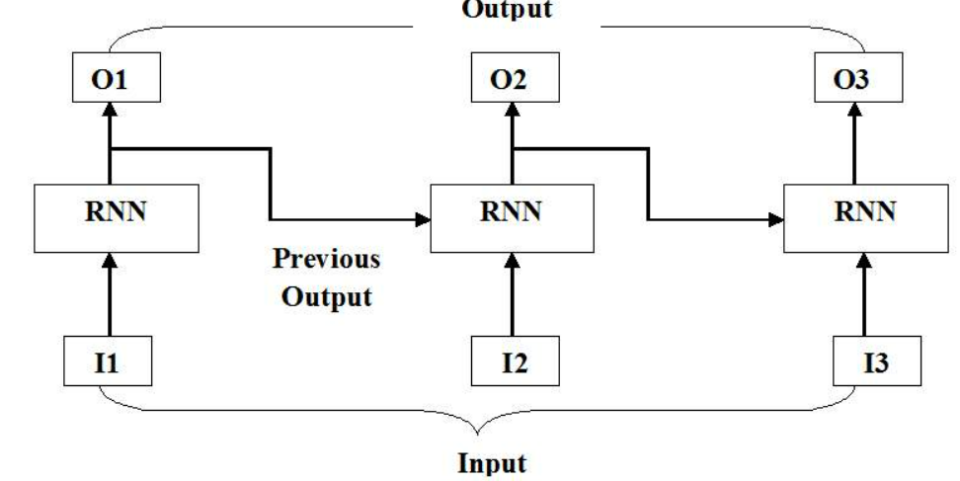
ARCHITECTURE DIAGRAM :
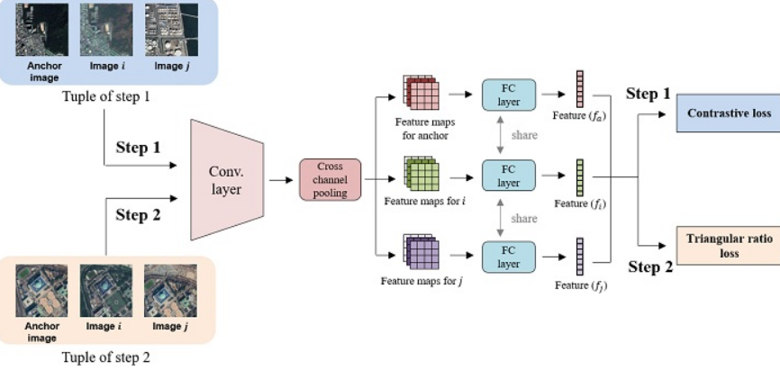

SOFTWARE REQUIREMENTS:
- Operating System : Windows 10
- Platform : python
HARDWARE REQUIREMENTS:
- Keyboard
- Mouse
- Hard disk 500GB
- Ram 4 Gb

CONCLUTION :
This paper presents a comprehensive survey with in-depth analysis from a both closed-world and open-world perspectives. We first introduce the widely studied person Re-ID under the closed-world setting from three aspects: feature representation learning, deep metric learning and ranking optimization. With powerful deep learning, the closedworld person Re-ID has achieved performance saturation on several datasets. Correspondingly, the open-world setting has recently gained increasing attention, with efforts to address various practical challenges. This survey also introduces a new evaluation metric to measure the cost of finding all the correct matches. We believe this survey will provide important guidance for future Re-ID research
. REFERENCE :
- [1] Y.-C. Chen, X. Zhu, W.-S. Zheng, and J.-H. Lai, “Person reidentification by camera correlation aware feature augmentation,” IEEE TPAMI, vol. 40, no. 2, pp. 392–408, 2018.
- [2] L. Zheng, Y. Yang, and A. G. Hauptmann, “Person reidentification: Past, present and future,” arXiv preprint arXiv:1610.02984, 2016.
- [3] N. Gheissari, T. B. Sebastian, and R. Hartley, “Person reidentification using spatiotemporal appearance,” in CVPR, 2006, pp. 1528–1535
- [4] J. Almazan, B. Gajic, N. Murray, and D. Larlus, “Re-id done right: towards good practices for person re-identification,” arXiv preprint arXiv:1801.05339, 2018.
- [5] L. Zheng, L. Shen, L. Tian, S. Wang, J. Wang, and Q. Tian, “Scalable person re-identification: A benchmark,” in ICCV, 2015, pp. 1116–1124.
- [6] N. Martinel, G. Luca Foresti, and C. Micheloni, “Aggregating deep pyramidal representations for person re-identification,” in CVPR Workshops, 2019, pp. 0–0.
- [7] T. Wang, S. Gong, X. Zhu, and S. Wang, “Person re-identification by video ranking,” in ECCV, 2014, pp. 688–703.
- [8] L. Zheng, Z. Bie, Y. Sun, J. Wang, C. Su, S. Wang, and Q. Tian, “Mars: A video benchmark for large-scale person reidentification,” in ECCV, 2016.
- [9] M. Ye, C. Liang, Z. Wang, Q. Leng, J. Chen, and J. Liu, “Specific person retrieval via incomplete text description,” in ACM ICMR, 2015, pp. 547–550.
- [10] S. Li, T. Xiao, H. Li, W. Yang, and X. Wang, “Identity-aware textual-visual matching with latent co-attention,” in ICCV, 2017, pp. 1890–1899.
- [11] S. Karanam, Y. Li, and R. J. Radke, “Person re-identification with discriminatively trained viewpoint invariant dictionaries,” in ICCV, 2015, pp. 4516–4524.
- [12] S. Bak, S. Zaidenberg, B. Boulay, and F. Bremond, “Improving person re-identification by viewpoint cues,” in AVSS, 2014, pp. 175–180.
- [13] X. Li, W.-S. Zheng, X. Wang, T. Xiang, and S. Gong, “Multi-scale learning for low-resolution person re-identification,” in ICCV, 2015, pp. 3765–3773.
- [14] Y. Wang, L. Wang, Y. You, X. Zou, V. Chen, S. Li, G. Huang, B. Hariharan, and K. Q. Weinberger, “Resource aware person reidentification across multiple resolutions,” in CVPR, 2018, pp. 8042–8051.
- [15] Y. Huang, Z.-J. Zha, X. Fu, and W. Zhang, “Illumination-invariant person re-identification,” in ACM MM, 2019, pp. 365–373.

