DEEP LEARNING IN NUCLEAR INDUSTRY: A SURVEY
ABSTRACT:
As a high-tech strategic emerging comprehensive industry, the nuclear industry is committed to the research, production, and processing of nuclear fuel, as well as the development and utilization of nuclear energy. Nowadays, the nuclear industry has made remarkable progress in the application fields of nuclear weapons, nuclear power, nuclear medical treatment, radiation processing, and so on. With the development of artificial intelligence and the proposal of “Industry 4.0”, more and more artificial intelligence technologies are introduced into the nuclear industry chain to improve production efficiency, reduce operation cost, improve operation safety, and realize risk avoidance. As a high-tech strategic emerging comprehensive industry, the nuclear industry is committed to the research, production, and processing of nuclear fuel, as well as the development and utilization of nuclear energy. Nowadays, the nuclear industry has made remarkable progress in the application fields of nuclear weapons, nuclear power, nuclear medical treatment, radiation processing, and so on. With the development of artificial intelligence and the proposal of “Industry 4.0”, more and more artificial intelligence technologies are introduced into the nuclear industry chain to improve production efficiency, reduce operation cost, improve operation safety, and realize risk avoidance

EXISTING SYSTEM:
- At the same time, more and more deep neural networks used to analyze different data types (e.g., image, video, text, speech, and multi-modal data) have been proposed with the deepening of deep learning research

- With the expansion of problem scale, more and more variants of CNNs
(e.g., VGGNet, GoogLeNet, ResNet, DenseNet) have been proposed and successfully applied to object detection, semantic segmentation, image caption, and other complex CV application scenarios[36, 75, 76]. Applying CNNs-based models in the nuclear industry are able to quickly and effectively analyze the graphics, images, and videos, which can strengthen the automatic operation monitoring of key equipment and improve the safety of operation

DISADVANTAGE OF EXISTING SYSTEM:
- It is worth mentioning that Tsinghua University defines the “industrial intelligence” as the use of AI and other theories and methods to solve the technical problems of operation, management, research and development, production, and service in the process of industrial manufacturing .
- The low efficiency and subjective problem of feature engineering in traditional ML methods, as well as the generalization dilemma of the single static model are solved well by DL methods[
- so as to improve the security of management, as well as solve the problems of multi-level access control and industrial robot authentication.
PROPOSED SYSTEM :
- In the nuclear equipment manufacturing of midstream segment, DL methods can be used to analyze and process the massive structured, unstructured, and semi-structured data generated by design, production, and operation of the nuclear island, conventional island, auxiliary system, and instrument control equipment, so as to provide intelligent analysis and decision-making system . Moreover, in nuclear equipment manufacturing, high labor costs and low labor productivity exist side by side, and the working and operation environments of equipment production are difficult to control.
- The simulation of NPPs in the personnel training plan must reproduce the situation faced by operators in the actual operation. One purpose of the simulation is to support the design of new control systems or ergonomic evaluation of existing control systems, so as to improve man-machine interaction and operation safety[

ADVANTAGE:
- In the field of nuclear medicine, nuclear technology can be used to diagnose and treat diseases by the common imagining equipment
- The United States, Germany, China, and other countries have used AI technologies to realize industrial intelligence, in order to improve the competitiveness of national industry through industrial intelligence, so as to take the lead in the new round of the industrial revolution, i.e., the “Industry 4.0
- . As an important technical means of AI, DL methods have also been widely used in the nuclear industry with the upsurge of industrial intelligence concept recently
- Furthermore, DL methods based on multi-objective optimization can be used to optimize the parameters of the processing operation for improving the yield and quality of nuclear fuel elements, as well as the manufacturing efficiency

LITRATURE REVIEW:
TITTLE | AUTHOR | DESCRIPTION
Chinese views on nuclear weapons: Evidence from an online survey, Res. Polit., | N. Egel and R. L. Hines, | Although scholars have studied Chinese elites’ views on nuclear weapons, surprisingly little is known about the views of China’s public
Geneva, Switzerland: FCCC, 2015 | FCCC, | Italian Ginevra, city, capital of Genève canton, in the far southwestern corner of Switzerland that juts into France. One of Europe’s most cosmopolitan cities
Research on the development path of carbon peak and carbon neutrality in China’s power industry | F. H. Zhu, Y. S. Wang, Z. Xu, J. Z. Li, Y. H. Dong, H. Li, X. L. Li, Y. Hu, X. L. Sun, and Y. Ding | The Chinese government promises to peak carbon dioxide emissions by 2030 and strives to achieve carbon neutralization by 2060.
Applied Radiation Chemistry: Radiation Processing | R. J. Woods and A. K. Pikaev, | Deals with radiation processing as a whole using a chemical perspective.

INTRODUCTION :
- As the most common and complete nuclear industry system in the nuclear industry, the nuclear power industry chain involves all segments, such as mining, manufacturing, development, research, and processing, as well as requires a certain degree of supervision and capital investment in all segments[58]. Thus, deep learning can be applied to many segments of the nuclear power industry chain and generalized to other nuclear industries, so as to promote the development of the nuclear industry intelligence
- The midstream segment is mainly the manufacturing of nuclear power core components, mainly including nuclear island equipment, conventional island equipment, and auxiliary systems, as well as the manufacturing of corresponding instrument control
BLOCK DIAGRAM:
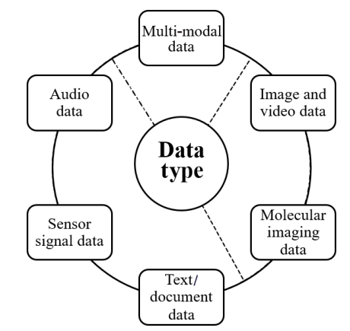

ARCHITECTURE DIAGRAM :
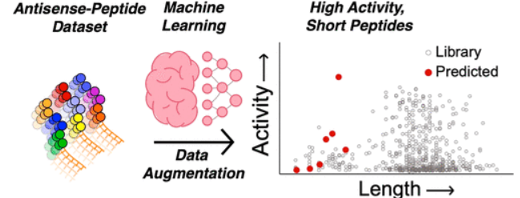

SOFTWARE REQUIREMENTS:
- Operating System : Windows 10
- Platform : python
HARDWARE REQUIREMENTS:
- Keyboard
- Mouse
- Hard disk 500GB
- Ram 4 Gb

CONCLUTION :
The fourth generation industrial revolution (Industry 4.0) with the application of a new generation of information technology in the industrial field as the core technology driving force is quietly coming. With the development and progress of the nuclear industry in recent years, as well as the development of AI, big data, cloud computing, IoT, and 5G technologies, the development of digitization, informatization, networking, and intelligence of the nuclear industry has become an inevitable trend. Based on the most common and 154 complete nuclear power industry chain in the nuclear industry, this paper excavates the application scenarios of intelligent demand in the upstream, middle, and downstream links of the whole nuclear industry chain, and further analyzes the data types in these demand scenarios

REFERENCE :
- [[1] N. Egel and R. L. Hines, Chinese views on nuclear weapons: Evidence from an online survey, Res. Polit., vol. 8, no. 3, p. 20531680211032840, 2021.
- [2] FCCC, Report of the Conference of the Parties to the United Nations Framework Convention on Climate Change (21st Session, 2015: Paris). Geneva, Switzerland: FCCC, 2015.
- [3] F. H. Zhu, Y. S. Wang, Z. Xu, J. Z. Li, Y. H. Dong, H. Li, X. L. Li, Y. Hu, X. L. Sun, and Y. Ding, Research on the development path of carbon peak and carbon neutrality in China’s power industry, (in Chinese), Electric Power Technol. Environ. Prot., vol. 37, no. 3, pp. 9–16, 202
- [4] R. J. Woods and A. K. Pikaev, Applied Radiation Chemistry: Radiation Processing. New York, NY, USA:
- [5]Z. Zimek, G. Przybytniak, and I. Kaluska, Radiation processing of polymers and semiconductors at the institute of nuclear chemistry and technology, Nukleonika, vol. 51, no. S1, pp. S129–S132, 2006.
- [6] P. E. Christian and K. M. Waterstram-Rich, Nuclear Medicine and PET/CT: Technology and Techniques. St. Louis, MO, USA: Mosby, 2007
- [7] W. W. Lie, B. Jiang, and W. J. Zhao, Obstetric imaging diagnostic platform based on cloud computing technology under the background of smart medical big data and deep learning, IEEE Access, vol. 8, pp. 78265–78278, 2020.
- [8] C. Aktolun, Artificial intelligence and radiomics in nuclear medicine: Potentials and challenges, Eur. J. Nucl. Med. Mol. Imaging, vol. 46, no. 13, pp. 2731–2736, 2019
- [9] S. Russell, Artificial intelligence: The future is superintelligent, Nature, vol. 548, no. 7669, pp. 520–521, 2017.
- [10] X. Q. Yang, J. Guo, H. Tang, and Z. Liao, Application prospect analysis of big data and artificial intelligence in the field of nuclear industry, (in Chinese), Inf. Commun., vol. 2, pp. 266–268, 2020.
- [11] Z. Y. Kong, Development trend of robot application in nuclear industry, (in Chinese), At. Energy Sci. Technol., vol. 14, no. 5, pp. 645–649&625, 1980
- [12] K. Zhang, J. B. Ni, K. Yang, X. H. Liang, J. Ren, and X. S. Shen, Security and privacy in smart city applications: Challenges and solutions, IEEE Commun. Mag., vol. 55, no. 1, pp. 122–129, 2017..
- [13] J. Mabrouki, M. Azrour, D. Dhiba, Y. Farhaoui, and S. El Hajjaji, IoT-based data logger for weather monitoring using arduino-based wireless sensor networks with remote graphical application and alerts, Big Data Mining and Analytics, vol. 4, no. 1, pp. 25–32, 2021.

- [14] A. Guezzaz, Y. Asimi, M. Azrour, and A. Asimi, Mathematical validation of proposed machine learning classifier for heterogeneous traffic and anomaly detection, Big Data Mining and Analytics, vol. 4, no. 1, pp. 18–24, 2021.
- [15] J. P. Zhang, F. Y. Wang, K. F. Wang, W. H. Lin, X. Xu, and C. Chen, Data-driven intelligent transportation systems: A survey, IEEE Trans. Intell. T

