INFERENCE OF BRAIN STATES UNDER ANESTHESIA WITH META LEARNING BASED DEEP LEARNING MODELS
ABSTRACT:
Monitoringthe depth of unconsciousnessduring anesthesia is beneficial in both clinical settings and neuroscience investigations to understand brain mechanisms. Electroencephalogram(EEG) has been used as an objective means of characterizing brain altered arousal and/or cognition states induced by anesthetics in real-time. Different general anesthetics affect cerebral electrical activities in different ways. However, the performance of conventional machine learning models on EEG data is unsatisfactory due to the low Signal to Noise Ratio (SNR) in the EEG signals, especially in the office-based anesthesia EEG setting. Deep learning models have been used widely in the field of Brain Computer Interface (BCI) to perform classificationand pattern recognition tasks due to their capability of good generalization and handling noisesCompared to other BCI applications, where deep learning has demonstrated encouraging results, the deep learning approach for classifying different brain consciousnessstates under anesthesia has been much less investigated. In this paper, we propose a new framework based on meta-learning using deep neural networks, named Anes-MetaNet, to classify brain states under anesthetics The Anes-MetaNet is composed of ConvolutionalNeural Networks (CNN) to extract power spectrum features, and a time consequence model based on Long Short-Term Memory (LSTM) networks to capture the temporal dependencies, and a meta-learning framework to handle large cross-subject variability We use a multi-stage training paradigm to improve the performance, which is justified by visualizing the high-level feature mapping. Experiments on the office-based anesthesia EEG dataset demonstrate the effectivenessof our proposedAnes-MetaNet by comparison of existing methods. Index Terms—Brain state estimation, meta learning, anesthesia EEG, deep learning

EXISTING SYSTEM:
- Experiments on the office-based anesthesia EEG dataset demonstrate the effectivenessof our proposedAnes-MetaNet by comparison of existing methods.
- As for the DoA task, only a few researches based on deep learning have been conducted. For instance, Park et al. proposed a real-time DoA monitoring system based on a convolutional neural network framework
- Although deep learning frameworks proposed in the previous literature typically outperform the existing classical machine learning algorithms, these studies are designed to analyze the anesthetic EEG data collected from the hospital-based environment.

DISADVANTAGE OF EXISTING SYSTEM:
- EEG signals vary significantly from subject to subject. The classification function f obtained using CNN training from EEG data of some subjects may not be applicable to other subjects. Meta-learning is used in this paper to address this problem.
- LSTM network is a special instance of RNN which mitigates the problems of gradient vanishing and gradient explosion in long sequence training of RNN.
- we randomly extract the same amount of data for training, which can effectively prevent the overfitting problem caused by the problem of class imbalance

PROPOSED SYSTEM :
- Experiments on the office-based anesthesia EEG dataset demonstrate the effectivenessof our proposedAnes-MetaNet by comparison of existing methods.
- Although deep learning frameworks proposed in the previous literature typically outperform the existing classical machine learning algorithms, these studies are designed to analyze the anesthetic EEG data collected from the hospital-based environment.
- Even though the CLA model performs much better than the other existing models in when applying it to an HBA dataset, such results indicate this model is not suitable for the OBA condition
ADVANTAGE:
- Electroencephalogram(EEG) has been used as an objective means of characterizing brain altered arousal and/or cognition states induced by anesthetics in real-time
- Measurements through the observation of heart rate, breathing pattern, blood pressure and other factors, have been used to measure DoA
- Currently, the Bispectral Index (BIS, Aspect Medical Systems, USA) is the most widely used DoA monitor index in clinical practice; however, previous researchers have reported a poor connection between the DoA and the BIS

LITRATURE REVIEW:
TITTLE | AUTHOR | DESCRIPTION
General anesthesia and altered states of arousal: A systems neuroscience analysis | E. N. Brown, P. L. Purdon, and C. J. Van Dort | Each altered arousal state results from the anesthetic drugs acting at multiple targets in the central nervous system.
Intraoperative electroencephalogram suppression predicts postoperative delirium | B. A. Fritz | Postoperative delirium is a common complication associated with increased morbidity and mortality, longer hospital stays, and greater health care expenditures
Electroencephalogram signatures of loss and recovery of consciousness from propofol | P. L. Purdon | he subjects executed an auditory task at 4-s intervals consisting of interleaved verbal and click stimuli to identify loss and recovery of consciousness.
Closed-loop control of anesthetic state in nonhuman primates | S. Chakravarty | The United States FDA acknowledges the potential benefits of such automatic physiological closed-loop control devices for patient care.

INTRODUCTION :
- The dataset provides EEG recordings of patients during general anesthesia. The induction and maintenance of sedation is done by administering low-dose propofol ramp, intermitted by boluses of propofol, ketamine, dexmedetomidine and lidocaine.
- it is difficult to classify the OBA data into multiple states as conducted in the previous works. Despite this, the transitioned state between CON and LOC states is critically important for the anesthetists to control the doses of drugs. We then determine to classify the DoA into LOC, CON and the transitioning states in this study.

- BLOCK DIAGRAM:
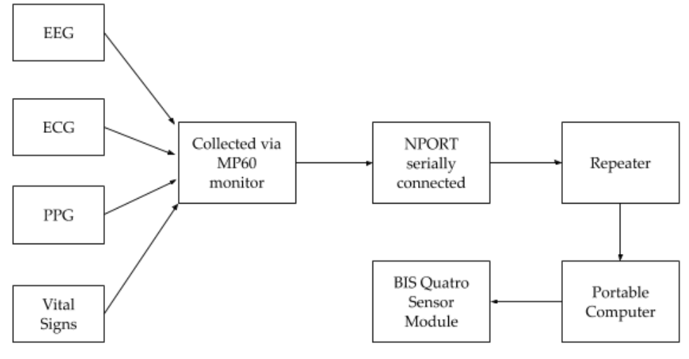

ARCHITECTURE DIAGRAM :
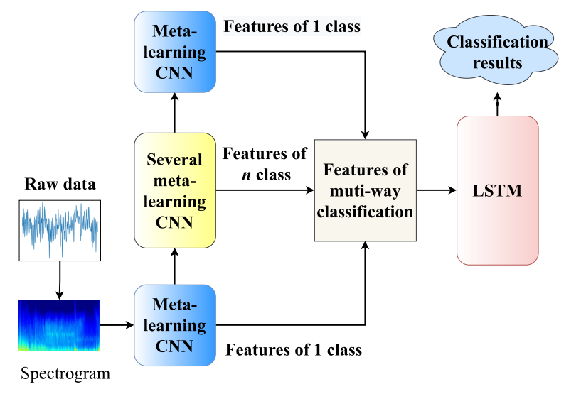

SOFTWARE REQUIREMENTS:
- Operating System : Windows 10
- Platform : python
HARDWARE REQUIREMENTS:
- Keyboard
- Mouse
- Hard disk 500GB
- Ram 4 Gb

CONCLUTION :
In this study, we propose an Anes-MetaNet to solve the DoA classification problem in office-based environments, in which, studies on the classification of anesthesia EEG data have not been well investigated. The model we develop, provides good performance for the classification of brain states using anesthesia EEG data. The proposed Anes-MetaNet can mitigate the individual differences among subjects. We train the model in a sequential way to reach a better classification accuracy. The t-SNE visualization validates our two-stage training mechanism. The comparison results using an HBA dataset and an OBA dataset, showcase how complex the OBA data is and the necessity of developing the Anes-MetaNet. In the future, a systematic comparison of OBA EEG data and HBA EEG data under different anesthetics need to be conducted with regards to model accuracy and interpretability

REFERENCE :
- [1] E. N. Brown, P. L. Purdon, and C. J. Van Dort, “General anesthesia and altered states of arousal: A systems neuroscience analysis,” Annu. Rev. Neurosci., vol. 34, no. 1, pp. 601–628, Jul. 2011.
- [2] B. A. Fritz et al., “Intraoperative electroencephalogram suppression predicts postoperative delirium,” Anesthesia Analgesia, vol. 122, no. 1, p. 234, 2016.
- [3] P. L. Purdon et al., “Electroencephalogram signatures of loss and recovery of consciousness from propofol,” Proc. Nat. Acad. Sci. USA, vol. 110, no. 12, pp. E1142–E1151, 2013
- [4] S. Chakravarty et al., “Closed-loop control of anesthetic state in nonhuman primates,” bioRxiv, 2021, doi: 10.1101/2021.09.12.459958.
- [5] C. N. Sessler et al., “The Richmond agitation–sedation scale: Validity and reliability in adult intensive care unit patients,” Amer. J. Respiratory Crit. Care Med., vol. 166, no. 10, pp. 1338–1344, 2002.
- [6] T. A. Bowdle, “Depth of anesthesia monitoring,” Anesthesiol. Clinics North Amer., vol. 24, no. 4, pp. 793–822, 2006.
- [7] X.-S. Zhang, R. J. Roy, and E. W. Jensen, “EEG complexity as a measure of depth of anesthesia for patients,” IEEE Trans. Biomed. Eng., vol. 48, no. 12, pp. 1424–1433, Dec. 2001
- [8] F. L. da Silva, “EEG and MEG: Relevance to neuroscience,” Neuron, vol. 80, no. 5, pp. 1112–1128, 2013.
- [9] O. Akeju et al., “Electroencephalogram signatures of ketamine anesthesia-induced unconsciousness,” Clin. Neurophysiol., vol. 127, no. 6, pp. 2414–2422, Jun. 2016.
- [10] H. W. Shin et al., “Monitoring of anesthetic depth and EEG band power using phase lag entropy during propofol anesthesia,” BMC Anesthesiol., vol. 20, no. 1, pp. 1–10, Dec. 2020.
- [11] R. Shalbaf, H. Behnam, and H. J. Moghadam, “Monitoring depth of anesthesia using combination of EEG measure and hemodynamic variables,” Cognit. Neurodyn., vol. 9, no. 1, pp. 41–51, 2015
- [12] M. Jospin et al., “Detrended fluctuation analysis of EEG as a measure of depth of anesthesia,” IEEE Trans. Biomed. Eng., vol. 54, no. 5, pp. 840–846, May 2007.
- [13] T. Nguyen-Ky, P. F. Wen, and Y. Li, “Consciousness and depth of anesthesia assessment based on Bayesian analysis of EEG signals,” IEEE Trans. Biomed. Eng., vol. 60, no. 6, pp. 1488–1498, Jun. 2013.
- [14] R. Shalbaf, H. Behnam, J. W. Sleigh, A. Steyn-Ross, and L. J. Voss, “Monitoring the depth of anesthesia using entropy features and an artificial neural network,” J. Neurosci. Methods, vol. 218, no. 1, pp. 17–24, 2013.
- [15] M. Peker, A. Arslan, B. ¸Sen, F. V. Çelebi, and A. But, “A novel hybrid method for determining the depth of anesthesia level: Combining ReliefF feature selection and random forest algorithm (ReliefF+ RF),” in Proc. Int. Symp. Innov. Intell. Syst. Appl. (INISTA), 2015, pp. 1–8.

