MODULARIZING DEEP LEARNING VIA PAIRWISE LEARNING WITH KERNELS
ABSTRACT:
By redefining the conventional notions of layers, we present an alternative view on finitely wide, fully trainable deep neural networks as stacked linear models in feature spaces, leading to a kernel machine interpretation. Based on this construction, we then propose a provably optimal modular learning framework for classification that does not require between-module backpropagation This modular approach brings new insights into the label requirement of deep learning (DL). It leverages only implicit pairwise labels (weak supervision) when learning the hidden modules. When training the output module, on the other hand, it requires full supervision but achieves high label efficiency, needing as few as ten randomly selected labeled examples (one from each class) to achieve 94.88% accuracy on CIFAR-10 using a ResNet-18 backbone. oreover, modular training enables fully modularized DL workflows, which then simplify the design and implementation of pipelines and improve the maintainability and reusability of models. To showcase the advantages of such a modularized workflow, we describe a simple yet reliable method for estimating reusability of pretrained modules as well as task transferability in a transfer learning setting At practically no computation overhead, it precisely described the task space structure of 15 binary classification tasks from CIFAR-10

EXISTING SYSTEM:
- In Existing system we extended their theoretical framework, explicitly established the connections between NNs and KMs, and proposed a fully modular training approach with proven strong optimality guarantee.
- kernels to imitate the computations performed by infinitely wide networks in expectation. Shankar et al. [4] proposed kernels that are equivaleent to expectations of finite-widths random networks.
- proposed an a posteriori method that analyzes a trained network as modules in order to extract useful information. Most works in this direction, however, achieved only partial

DISADVANTAGE OF EXISTING SYSTEM:
- When performance is unsatisfying, it is practically impossible to trace the source of the problem to a particular design choice.
- Moreover, this method can be extended to measure task transferability, a central problem in transfer learning, continual/lifelong learning, and multitask learning Unlike many existing methods, our approach requires no training, is task agnostic, flexible, and completely data-driven. .
- Underlying this practical problem is a theoretical issue that is central to many important research domains, including transfer learning, continual/lifelong learning, metalearning, and multitask learning: .

PROPOSED SYSTEM :
we then propose a provably optimal modular learning framework for classification that does not require between-module backpropagation.
This modular approach brings new insights into the label requirement of deep learning (DL). It leverages only implicit pairwise labels (weak supervision) when learning the hidden modules. When training the output module, on the other hand, it requires full supervision but achieves high label efficiency, needing as few as ten randomly selected labeled examples (one from each class) to achieve 94.88% accuracy on CIFAR-10 using a ResNet-18 backbone
ADVANTAGE:
- This definition is often used as an identity and is referred to as the “kernel trick” in some more modern taxe
- Along this line of research, some more recent methods include H-score [51] and the Bregman-correntropy conditional divergence [52], the latter of which used the correntropy functional [53] and the Bregman matrix divergence [54] to quantify divergence between mappings.
- To facilitate fair comparisons, end-to-end and modular training operate on the same backbone network. For all results, we used stochastic gradient descent as the optimizer with batch size 128. For each module in the modular method as well as the end-to-end baseline, we trained with annealing 3This type of results is reminiscent of the “ideal bounds” for representati
- The momentum was set to 0.9 throughout. For data preprocessing, we used simple mean subtraction followed by division by standard deviation.
LITRATURE REVIEW:
TITTLE | AUTHOR | DESCRIPTION
Bayesian learning for neural networks | R. M. Neal | This book demonstrates how Bayesian methods allow complex neural network models to be used without fear of the "overfitting" that can occur with traditional training methods.
Deep neural networks as Gaussian processes | J. Lee, Y. Bahri, R. Novak, S. S. Schoenholz, J. Pennington, and J. Sohl-Dickstein, | It has long been known that a single-layer fully-connected neural network with an i.i.d.
Neural tangent kerne | A. Jacot, F. Gabriel, and C. Hongler, | This enables simple closed form statements to be made about neural network predictions, training dynamics, generalization, and loss surfaces.
Neural kernels without tangents | V. Shankar | kernels from bags of features. We show that these operations correspond to many of the building blocks of “neural tangent kernels” (NTK).

INTRODUCTION :
- The idea is simple. Instead of considering the nonlinearity to be the last component of a layer or a module (call it the ith layer or module here for convenience), we consider it to be the first component of the next layer. After potentially repeating this process for layer i +1 to get rid of its trailing nonlinearity, we turned layer i +1 into a layer of linear models in feature spaces..
- These linear models can be shown to be KMs (see Fig. 1). We first present the method for fully connected networks and then extend to CNNs [16]. Contrasting existing works (see [7]), the extension requires minimal adjustments only.

- BLOCK DIAGRAM:
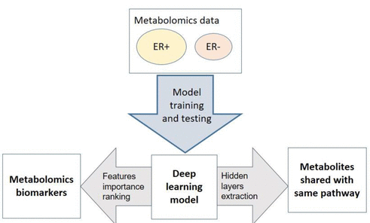

ARCHITECTURE DIAGRAM :
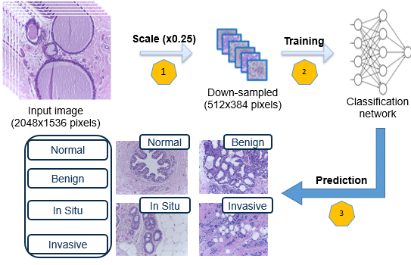

SOFTWARE REQUIREMENTS:
- Operating System : Windows 10
- Platform : python
HARDWARE REQUIREMENTS:
- Keyboard
- Mouse
- Hard disk 500GB
- Ram 4 Gb

CONCLUTION :
In this article, we proposed a simple, alternative view on NNs that turns layers into linear models in feature spaces and showed that they are KMs. Based on this construction, we presented a modular learning framework for classification that does not require between-module propagation. Focusing on the two-module instantiation, we proved its optimality, demonstrated that it matches state-of-the-art performance from end-to-end backpropagation on MNIST and CIFAR-10, and showed that it learns powerful classifiers using almost only implicit, more efficient pairwise labels. This modular learning framework enables fully modularized DL workflows. We then demonstrated the benefit of such a workflow in a transfer learning setting, where the transferability among 15 binary classification tasks from CIFAR-10 was to be estimated. Our simple approach accurately described the task space structure using a fraction of target task training data with practically no computation overhead.

REFERENCE :
- [1] R. M. Neal, “Bayesian learning for neural networks,” Ph.D. dissertation, Graduate Dept. Comput. Sci., Univ. Toronto, Toronto, ON, Canada, 1995
- [2]. J. Lee, Y. Bahri, R. Novak, S. S. Schoenholz, J. Pennington, and J. Sohl-Dickstein, “Deep neural networks as Gaussian processes,” 2017, arXiv:1711.00165. [Online]. Available: http://arxiv.org/abs/1711.00165
- [3] A. Jacot, F. Gabriel, and C. Hongler, “Neural tangent kernel: Convergence and generalization in neural networks,” in Proc. Adv. Neural Inf. Process. Syst., 2018, pp. 8571–8580
- [4] V. Shankar et al., “Neural kernels without tangents,” 2020, arXiv:2003.02237.
- [5] Y. Cho and L. K. Saul, “Kernel methods for deep learning,” in Proc. Adv. Neural Inf. Process. Syst., 2009, pp. 342–350 [6] S. Arora, S. S. Du, Z. Li, R. Salakhutdinov, R. Wang, and D. Yu, “Harnessing the power of infinitely wide deep nets on small-data tasks,” 2019, arXiv:1910.01663
- [7]. S. Arora, S. S. Du, W. Hu, Z. Li, R. R. Salakhutdinov, and R. Wang, “On exact computation with an infinitely wide neural net,” in Proc. Adv. Neural Inf. Process. .
- [8] Z. Li et al., “Enhanced convolutional neural tangent kernels
- [9] K. He, X. Zhang, S. Ren, and J. Sun, “Deep residual learning for image recognition,” in Proc. IEEE Conf. Comput. Vis. Pattern Recognit. (CVPR), Jun. 2016, pp. 770–778.
- [10] A. Tran, C. Nguyen, and T. Hassner, “Transferability and hardness of supervised classification tasks,” . Conf. Comput. Vis. ..
- [11] S. Shalev-Shwartz and S. Ben-David, Understanding Machine Learning: From Theory to Algorithms. Cambridge, U.K.: Cambridge Univ. Press, 2014.
- [12]. N. Aronszajn, “Theory of reproducing kernels,” Trans. Amer. Math. Soc., vol. 68, no. 3, pp. 337–404, 1950.
- [13] J. H. Manton et al., “A primer on reproducing Kernel Hilbert spaces,” Found. Trends Signal Process., vol. 8, nos. 1–2, pp. 1–126, 2015.
- [14] B. Scholkopf and A. J. Smola, Learning With Kernels: Support Vector Machines, Regularization, Optimization, and Beyond. Cambridge, MA, USA: MIT Press, 2001.
- [15] A. Rahimi and B. Recht, “Random features for large-scale kernel machines,” in Proc. Adv. Neural Inf. Process. Syst., vol. 2008, pp. 1177–1184

