PREDICTION OF 12 PHOTONIC CRYSTAL FIBER OPTICAL PROPERTIES USING MLP IN DEEP LEARNING
ABSTRACT:
Photonic crystal fibers (PCFs) are the specialized optical waveguides that led to many interesting applications ranging from nonlinear optical signal processing to high-power fiber amplifiers. In this paper, machine learning techniques are used to compute various optical properties including effective index, effective mode area, dispersion and confinement loss for a solid-core PCF. These machine learning algorithms based on artificial neural networks are able to make accurate predictions of above mentioned optical properties for usual parameter space of wavelength ranging from 0.5-1.8 μm, pitch from 0.8-2.0 μm, diameter by pitch from 0.6-0.9 and number of rings as 4 or 5 in a silica solid-core PCF. We demonstrate the use of simple and fast-training feed-forward artificial neural networks that predicts the output for unknown device parameters faster than conventional numerical simulation techniques Computation runtimes required with neural networks (for training and testing) and Lumerical Mode Solutions are also compared.

EXISTING SYSTEM:
- Photonic crystal fiber was first proposed by Knight et al.
- in 1996, which consists of a core with the periodic arrangement of air holes running along the length of the fiber. The core of the PCF can be solid or hollow
- proposed a deep learning-based algorithm using the dimensionality reduction technique to understand the properties of electromagnetic wave-matter interaction in nanostructures.
- A geometric deep learning approach has also been reported to study nanophotonics structures In 2018, extreme learning machine and deep learning were used for computing dispersion relations and optimization of Q-factors for photonic crystals

DISADVANTAGE OF EXISTING SYSTEM:
- The accuracy of the model depends upon how well the dataset is aligned to the problem to be solved. Variant PCFs were simulated by changing some geometric property values and their optical properties were calculated.
- Choosing the above-mentioned parameters are based on our prior experience of similar problems and a thorough study has been carried out in our previous work
- We could increase the epochs to a higher value but this would increase the simulation time, and may also lead to the overfitting problem

PROPOSED SYSTEM :
- We demonstrate the use of simple and fast-training feed-forward artificial neural networks that predicts the output for unknown device parameters faster than conventional numerical simulation techniques. Computation runtimes required with neural networks (for training and testing) and Lumerical MODE solutions are also compared.
- this paper, machine learning techniques are used to compute various opticalproperties including eﬀective index, eﬀective mode area, dispersion and conﬁnement loss for asolid-core PCF.
ADVANTAGE:
- In 2018, extreme learning machine and deep learning were used for computing dispersionrelations and optimization of Q-factors for photonic crystals.
- The ANN/MLP architecture parameters are introduced in this section along with the PCF typethat is used for generating the dataset. The ﬁrst step of the training procedure of an ANN model is to have a ﬁnite and appropriate labeled dataset.
- An ANN/MLP model with 3 hidden layers and 50 nodes/neurons in each layer was usedthroughout this paper, as shown in Fig. 2. These hidden layers were fully interconnected, whichmeans each node/neuron of a layer is connected to each node/neuron in the following layer.

LITRATURE REVIEW:
TITTLE | AUTHOR | DESCRIPTION
All-silica single-mode optical ﬁber with photonic crystal  cladding | C. Knight, T. A. Birks, P. St. J. Russell, and D. M. Atkin | Human breast tumours are diverse in their natural history and in their responsiveness to treatments. Variation in transcriptional programs accounts for much of the biological diversity of human cells and tumours.
Photonic crystal ﬁbers: Basics and applications | P. St. J. Russell | The purpose of this study was to classify breast carcinomas based on variations in gene expression patterns derived from cDNA microarrays and to correlate tumor characteristics to clinical outcome.
Supercontinuum  generation in photonic crystal ﬁbers and optical ﬁber tapers: a novel light source, | W. J. Wadsworth, A. Ortigosa-Blanch, J. C. Knight, T. A. Birks, T.-P. M. Man, and P. St. J. Russell | The advent of microarrays has led to a new paradigm in deciphering breast cancer heterogeneity, based on which the intrinsisubtyping systemusing prognostic multigene classifiers was developed.
All-normal dispersion chalcogenide PCF for ultraﬂat mid-infrared  supercontinuum generation | JM. R. Karim, H. Ahmad, and B. M. A. Rahman | To improve on current standards for breast cancer prognosis and prediction of chemotherapy benefit by developing a risk model that incorporates the gene expression-based "

INTRODUCTION :
- The ANN/MLP architecture parameters are introduced in this section along with the PCF typethat is used for generating the dataset.
- The ﬁrst step of the training procedure of an ANN model is to have a ﬁnite and appropriate labeled dataset.
- His initially generated dataset plays a crucialrole for any ANN model.
- The accuracy of the model depends upon how well the dataset isaligned to the problem to be solved.

BLOCK DIAGRAM:
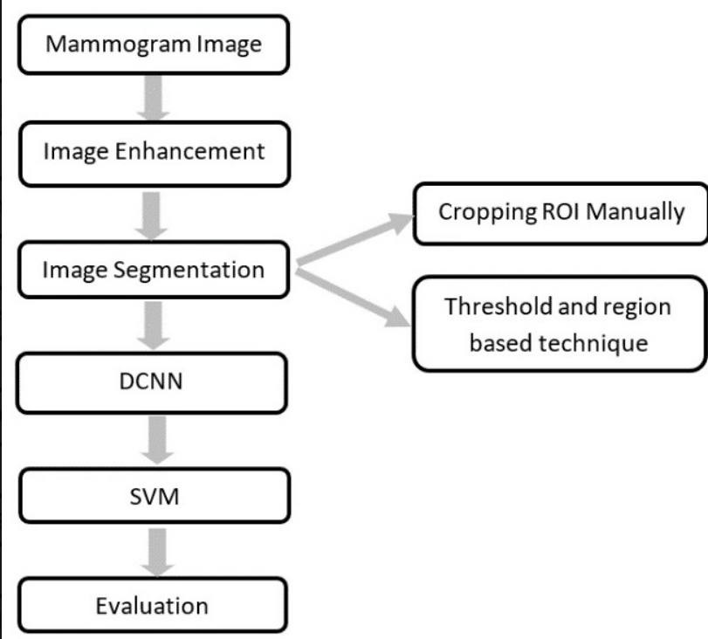

ARCHITECTURE DIAGRAM :
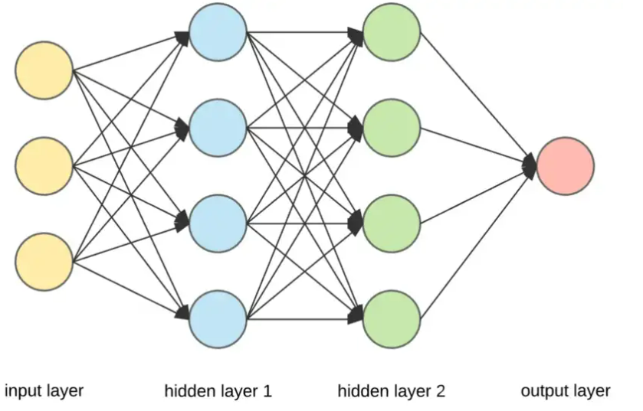

SOFTWARE REQUIREMENTS:
- Operating System : Windows 10
- Platform : python
HARDWARE REQUIREMENTS:
- Keyboard
- Mouse
- Hard disk 500GB
- Ram 4 Gb

CONCLUTION :
machine learning techniques have been employed to accurately predict the importantproperties for a silica core photonic crystal ﬁber design. This paper has shown that how we can predict the eﬀective index, eﬀective mode area, dispersion and conﬁnement loss of a photoniccrystal ﬁber within milliseconds, in contrast of needing few minutes with numerical simulations.Three hidden layers with 50 neurons in each layer were used throughout the code, which oﬀer rapidconvergence and suﬃcient accuracy in predicting outputs for unknown geometric dimension

REFERENCE :
- [1] J. C. Knight, T. A. Birks, P. St. J. Russell, and D. M. Atkin, “All-silica single-mode optical ﬁber with photonic crystalcladding,” Opt. Lett. 21(19), 1547–1549 (1996).
- [2.]P. St. J. Russell, “Photonic crystal ﬁbers: Basics and applications,” in Optical Fiber Telecommunications VA, (Elsevier,2008), pp. 485–522.
- [3.] W. J. Wadsworth, A. Ortigosa-Blanch, J. C. Knight, T. A. Birks, T.-P. M. Man, and P. St. J. Russell, “Supercontinuum generation in photonic crystal ﬁbers and optical ﬁber tapers: a novel light source,” J. Opt. Soc. Am.19(9),2148–2155 (2002).
- [4.]M. R. Karim, H. Ahmad, and B. M. A. Rahman, “All-normal dispersion chalcogenide PCF for ultraﬂat mid-infraredsupercontinuum generation,” IEEE Photonics Technol. Lett. 29(21), 1792–1795 (2017).
- [5.] F. Benabid, J. C. Knight, G. Antonopoulos, and P. St. J. Russell, “Stimulated Raman scattering in hydrogen-ﬁlled hollow-core photonic crystal ﬁber,” Science 298(5592), 399–402 (2002)
- [6.]F. Benabid, G. Bouwmans, J. C. Knight, P. St. J. Russell, and F. Couny, “Ultrahigh eﬃciency laser wavelengthconversion in a gas-ﬁlled hollow core photonic crystal ﬁber by pure stimulated rotational Raman scattering inmolecular hydrogen,” Phys. Rev. Lett. 93(12), 123903 (2004).
- [7].P. K. Cheo, A. Liu, and G. G. King, “A high-brightness laser beam from a phase-locked multicore Yb-doped ﬁberlaser array,” IEEE Photonics Technol. Lett. 13(5), 439–441 (2001).
- [8.]M. De, T. K. Gangopadhyay, and V. K. Singh, “Prospects of photonic crystal ﬁber as physical sensor: An overview,”Sensors 19(3), 464 (2019).
- [9.]T. M. Monro, W. Belardi, K. Furusawa, J. C. Baggett, N. G. R. Broderick, and D. J. Richardson, “Sensing with microstructured optical ﬁbres,” Meas. Sci. Technol. 12(7), 854–858 (2001).
- [10.]R. Holzwarth, Th. Udem, T. W. Hänsch, J. C. Knight, W. J. Wadsworth, and P. St. J. Russell, “Optical frequencysynthesizer for precision spectroscopy,” Phys. Rev. Lett. 85(11), 2264–2267 (2000
- [11.]C.-P. Yu and H.-C. Chang, “Applications of the ﬁnite diﬀerence mode solution method to photonic crystal structures,”Opt. Quantum Electron. 36(1-3), 145–163 (2004).
- [12.]A. Cucinotta, S. Selleri, L. Vincetti, and M. Zoboli, “Holey ﬁber analysis through the ﬁnite-element method,” IEEEPhotonics Technol. Lett. 14(11), 1530–1532 (2002).
- [13.]S. G. Johnson and J. D. Joannopoulos, “Block-iterative frequency-domain methods for Maxwell’s equations in aplanewave basis,” Opt. Express 8(3), 173–190 (2001).
- [14.]S. Shi, C. Chen, and D. W. Prather, “Plane-wave expansion method for calculating band structure of photonic crystal slabs with perfectly matched layers,” J. Opt. Soc. Am. A 21(9), 1769–1775 (2004).
- [15.]R. A. Norton and R. Scheichl, “Planewave expansion methods for photonic crystal ﬁbres,” Appl. Numer. Math.6388–104 (2013

