UNSUPERVISED DEEP BACKGROUND MATTING USING DEEP MATTE PRIOR
ABSTRACT:
Background matting is a recently developed image matting approach, with applications to image and video editing. It refers to estimating both the alpha matte and foreground from a pair of images with and without foreground objects. Recent work has applied deep learning to background matting, with very promising performance achieved. However, existing deep models are supervised which require a large dataset with ground truth alpha mattes for training. To avoid the cost of data collection and possible bias in training data, this paper proposes a datasetfree unsupervised deep learning-based approach for background mattingObserving that the local smoothness of alpha matte can be well characterized by the untrained network prior called deep matte prior, we model the foreground and alpha matte using the priors encoded by two generative convolutional neural networks. To avoid possible overfitting during unsupervised learning, a twostage learning scheme is developed which contains projectionbased training and Bayesian post refinement. An alpha-mattedriven initialization scheme is also developed for performance boost.. Even without calling external training data, the proposed approach provides competitive performance to recent supervised learning-based methods in the experiments.

EXISTING SYSTEM:
Motivated by the cost and possible bias introduced by the prerequisite on training datasets of a supervised deep learningbased method, this paper aims at developing an unsupervised deep learning-based approach for background matting which does not require any external training sample. In other words, no ground truth alpha matte will be called for training, and the proposed approach only takes an image pair ( ¯I, B¯) as the input and directly learns to estimate the corresponding F and α. Such a training-data-free approach has its great benefits in practice. In addition, it can also be used for generating foreground objects and alpha mattes that are close to the ground truths for boosting the supervised training.
DISADVANTAGE OF EXISTING SYSTEM:
Notice that for each image pixel, there are three unknowns in the matting problem (1). Therefore, it is a highly ill-posed problem, and the main concern in image matting is about how to resolve the solution ambiguity. Most existing methods introduce additional external information (e.g. a trimap input by the user) or constraints (e.g. a green-screen environment) for reducing the solution ambiguity. The trimap-based methods require manual annotations from users, which can be laborintensive in the batch processing of many images. The methods assuming a green-screen environment has quite limited applicability, as such an assumption does not hold true for many scenarios, especially in urban areas

PROPOSED SYSTEM :
- However, existing deep models are supervised which require a large dataset with ground truth alpha mattes for training. To avoid the cost of data collection and possible bias in training data, this paper proposes a datasetfree unsupervised deep learning-based approach for background matting. Observing that the local smoothness of alpha matte can be well characterized by the untrained network prior called deep matte prior, we model the foreground and alpha matte using the priors encoded by two generative convolutional neural networks. To avoid possible overfitting during unsupervised learning, a twostage learning scheme is developed which contains projectionbased training and Bayesian post refinement.

ADVANTAGE:
- Based on the deep image prior and deep matte prior, we adopt two generative CNNs to model the foreground and alpha matte respectively, and the predictions from these two CNNs will then be used to reconstruct the background given by the input image pair. While the deep image/matte priors partially addressed the possible overfitting arising from the solution ambiguity, a straightforward training by the standard procedure will still suffer from the overfitting to undesired solutions,. In addition, it can also be used for generating foreground objects and alpha mattes that are close to the ground truths for boosting the supervised training.

LITRATURE REVIEW:
TITTLE | AUTHOR | DESCRIPTION
“Matting-based residual optimization for structurally consistent image color correction,. | Y. Niu, P. Liu, T. Zhao, and Y. Fan | Image color correction aims to eliminate color differences between images, especially for color consistency in panoramic or stereoscopic images..
All-in-focus synthetic aperture imaging using image matting,” | Z. Pei, X. Chen, and Y.-H. Yang | As well, the occlusion problem, a challenging task for many computer vision applications, can be easily handled..
“Most existing matting methods require a green screen background or a manually created trimap to produce a good matte. | , V. Jayaram, B. Curless, S. M. Seitz, and I. Kemelmacher Shlizerman, “ | Membrane proteins execute significant roles in cellular processes of living organisms, ranging from cell signaling to cell adhesion.
“Real-time high-resolution background matting | S. Lin, A. Ryabtsev, S. Sengupta, B. L. Curless, S. M. Seitz, and I. Kemelmacher-Shlizerman | We introduce a real-time, high-resolution background replacement technique which operates at 30fps in 4K resolution, and 60fps for HD on a modern GPU

INTRODUCTION :
- Background matting is also a challenging ill-posed problem, as there are two unknowns for each image pixel. In [3], [4], supervised deep learning methods are developed for background matting. These studies collected large datasets with image triplets: images with foreground objects, images without foreground objects, and manually-crafted alpha mattes. Then deep networks are trained over such datasets, with state-ofthe-art results achieved.

BLOCK DIAGRAM:
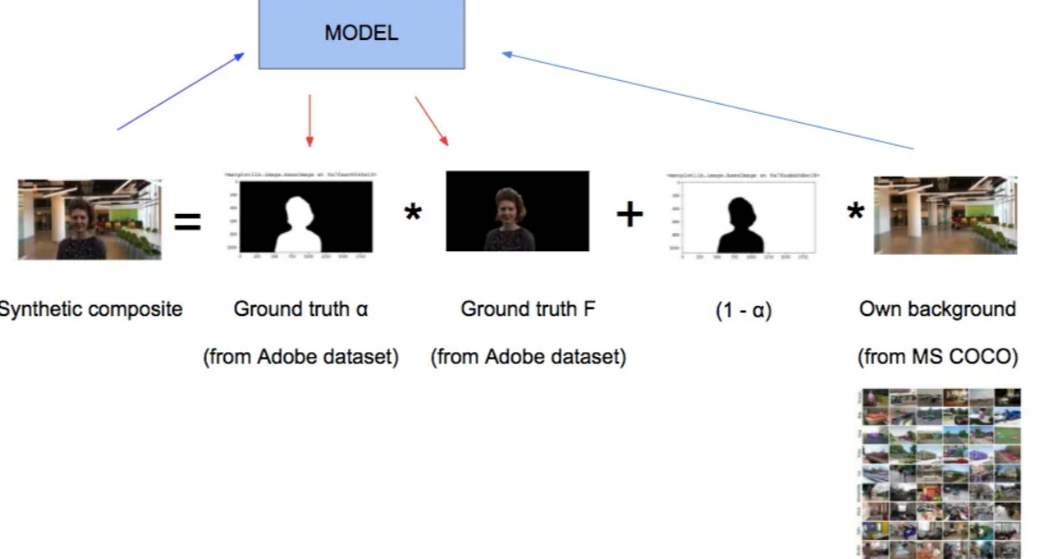

ARCHITECTURE DIAGRAM :
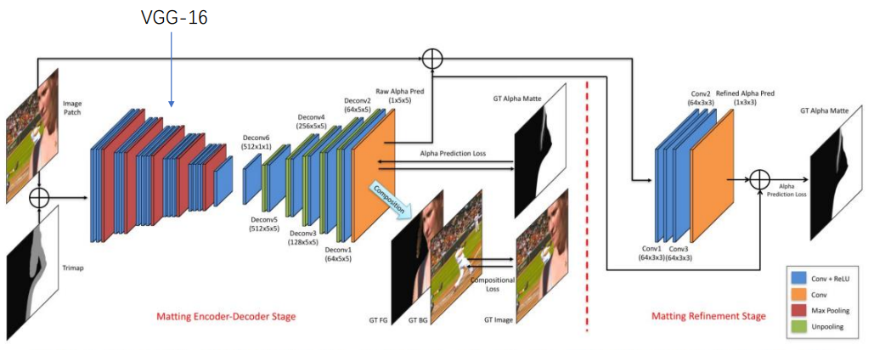

SOFTWARE REQUIREMENTS:
- Operating System : Windows 10
- Platform : python
HARDWARE REQUIREMENTS:
- Keyboard
- Mouse
- Hard disk 500GB
- Ram 4 Gb

CONCLUTION :
As a newly developed approach for image matting, background matting has attractive features over traditional trimapbased methods. Its task is about estimating the alpha matte and foreground from a pair of observed image and background image. This work showed that background matting can be done effectively using unsupervised deep learning without any prerequisite on training data, which provides a complementary approach to existing supervised learning-based methods. There are two key parts in the proposed approach: deep image and matte priors for modeling the foreground and alpha matte respectively, and a well-designed two-stage unsupervised learning scheme for overcoming overfitting.

REFERENCE :
- [1] Y. Niu, P. Liu, T. Zhao, and Y. Fan, “Matting-based residual optimization for structurally consistent image color correction,” IEEE Transactions on Circuits and Systems for Video Technology, vol. 30, no. 10, pp. 3624– 3636, 2020.
- [2] Z. Pei, X. Chen, and Y.-H. Yang, “All-in-focus synthetic aperture imaging using image matting,” IEEE Transactions on Circuits and Systems for Video Technology, vol. 28, no. 2, pp. 288–301, 2018.
- [3] S. Sengupta, V. Jayaram, B. Curless, S. M. Seitz, and I. KemelmacherShlizerman, “Background matting: The world is your green screen,” in Proceedings of IEEE/CVF Conference on Computer Vision and Pattern Recognition, 2020, pp. 2291–2300
- [4] S. Lin, A. Ryabtsev, S. Sengupta, B. L. Curless, S. M. Seitz, and I. Kemelmacher-Shlizerman, “Real-time high-resolution background matting,” in Proceedings of IEEE/CVF Conference on Computer Vision and Pattern Recognition, 2021, pp. 8762–8771.
- [5] D. Ulyanov, A. Vedaldi, and V. Lempitsky, “Deep image prior,” in Proceedings of IEEE Conference on Computer Vision and Pattern Recognition, 2018, pp. 9446–9454.
- [6] J. Sun, J. Jia, C.-K. Tang, and H.-Y. Shum, “Poisson matting,” in ACM SIGGRAPH, 2004, pp. 315–321.
- [7] Y.-Y. Chuang, B. Curless, D. H. Salesin, and R. Szeliski, “A bayesian approach to digital matting,” in Proceedings of IEEE Conference on Computer Vision and Pattern Recognition, vol. 2. IEEE, 2001, pp. II–II.
- [8] M. Jin, B.-K. Kim, and W.-J. Song, “Adaptive propagation-based colorsampling for alpha matting,” IEEE Transactions on Circuits and Systems for Video Technology, vol. 24, no. 7, pp. 1101–1110, 2014.
- [9] Y. Aksoy, T. Ozan Aydin, and M. Pollefeys, “Designing effective interpixel information flow for natural image matting,” in Proceedings of IEEE Conference on Computer Vision and Pattern Recognition, 2017, pp. 29–37. .
- [10] J. Wang and M. F. Cohen, “Optimized color sampling for robust matting,” in Proceedings of IEEE Conference on Computer Vision and Pattern Recognition. IEEE, 2007, pp. 1–8.
- [11] E. S. Gastal and M. M. Oliveira, “Shared sampling for real-time alpha matting,” in Computer Graphics Forum, vol. 29, no. 2. Wiley Online Library, 2010, pp. 575–584.
- [12] E. Shahrian, D. Rajan, B. Price, and S. Cohen, “Improving image matting using comprehensive sampling sets,” in Proceedings of IEEE Conference on Computer Vision and Pattern Recognition, 2013, pp. 636– 643.
- [13] C. Xiao, M. Liu, D. Xiao, Z. Dong, and K.-L. Ma, “Fast closedform matting using a hierarchical data structure,” IEEE Transactions on Circuits and Systems for Video Technology, vol. 24, no. 1, pp. 49–62, 2014.
- [14] X. Li, K. Liu, Y. Dong, and D. Tao, “Patch alignment manifold matting,” IEEE Transactions on Neural Networks and Learning Systems, vol. 29, no. 7, pp. 3214–3226, 2018.
- [15] A. Levin, D. Lischinski, and Y. Weiss, “A closed-form solution to natural image matting,” IEEE Transactions on Pattern Analysis and Machine Intelligence, vol. 30, no. 2, pp. 228–242, 2007

