IMAGE PIXEL BASED GRAPHICAL AUTHENTICATION SYSTEM

ABSTRACT
In three level graphical, text and color file security system the authentication is done by image representation password. Data sharing is an important functionality in cloud storage. In this article, we show how to securely, efficiently, and flexibly share data with others in cloud storage. We describe new public-key cryptosystems which produce constant-size cipher texts such that efficient delegation of decryption rights for any set of cipher texts are possible. The novelty is that one can aggregate any set of secret keys and make them as compact as a single key, but encompassing the power of all the keys being aggregated. In other words, the secret key holder can release a constant-size aggregate key for flexible choices of cipher text set in cloud storage, but the other encrypted files outside the set remain confidential.

TABLE OF CONTENTS

CHAPTER NO |  | TITLES | PAGE NO
 |  | ABSTRACT | ii
1 | 1.1 | INTRODUCTION | 1
 | 1.2 | PROBLEM DEFINITION | 6
 | 1.3 | SCOPE | 7
 | 1.4 | DESCRIPTION OF THE PROJECT | 7
 | 1.5 | OBJECTIVES | 7
 | 1.6 | GRAPHICAL PASSWORD SCHEMES | 8
 |  | 1.6.1 Type of Graphical Password Schemes | 10
 |  | 1.6.2 Recall Base Graphical Password Scheme | 10
 |  | 1.6.3 Recognition Base Graphical Password Scheme | 12
 | 1.7 | SOFTWARE SPECIFICATION | 15
 |  | 1.7.1 Features Of .Net | 15
 |  | 1.7.2 Overview Of Technologies Used | 15
 |  | 1.7.3 Client Application Development | 19
 |  | 1.7.4 Server Application Development | 20
 |  | 1.7.5 Code-Behind Web Forms | 25
 |  | 1.7.6 Introduction To ASP.NET Server Controls | 25
 |  | 1.7.7 Back End Technology | 26
 |  | 1.7.8 Single Tier | 32
 |  | 1.7.9 Two Tier (Client-Server) | 33
 |  | 1.7.10 Three Tier And N-Tier | 33
 |  | 1.7.11 Common Type System | 36
 |  | LITERATURE SURVEY | 37
2 |  | SYSTEM ANALYSIS | 40
 | 2.1 | EXISTING SYSTEM | 41
 | 2.2 | PROPOSED SYSTEM | 41
 | 2.3 | FEASIBILITY STUDY | 42
 |  | 2.3.1 Economical feasibility | 42
 |  | 2.3.2 Technical feasibility | 42
 |  | 2.3.3 Operational feasibility | 42
 |  | 2.3.4 Environmental Feasibility | 42
 | 2.4 | SYSTEM REQUIREMENTS | 42
 |  | 2.4.1 Hardware Requirement | 43
 |  | 2.4.2 Software Requirement | 43
 | 2.5 | MODULE DESCRIPTION | 44
 |  | 2.5.1. Graphical Password | 44
 |  | 2.5.2 Encrypt phase | 44
 |  | 2.5.3. key gen phase | 44
 |  | 2.5.4. Decrypt phase | 44
 |  | 2.5.5 REPORTS | 44
3 |  | SYSTEM DESIGN AND DEVELOPMENT | 46
 | 3.1 | LOGICAL DESIGN | 46
 |  | 3.1.1 Data Flow Diagram | 46
 |  | 3.1.2 Case Diagram | 48
 |  | 3.1.3 Uml Diagram | 49
 | 3.2 | PHYSICAL DESIGN | 50
 | 3.3 | INPUT DESIGN | 50
 | 3.4 | OUTPUT DESIGN | 50
4 |  | TESTING AND IMPLEMENTATION | 52
 | 4.1 | TESTING | 52
 |  | 4.1.1 Black Box Testin | 52
 |  | 4.1.2 White Box Testing | 52
 |  | 4.1.3 Unit Testing | 52
 | 4.2 | SYSTEM IMPLEMENTATION | 52
5 | 5.1 | CONCLUSION | 54
 | 5.2 | FUTURE ENHANCEMENTS | 54
 | 5.3 | REFERENCES | 55

INTRODUCTION

CHAPTER 1
INTRODUCTION
CLOUD storage is gaining popularity recently. In enterprise settings, we see the rise in demand for data outsourcing, which assists in the strategic management of corporate data. It is also used as a core technology behind many online services for personal applications. Nowadays, it is easy to apply for free accounts for email, photo album, file sharing and/or remote access, with storage size more than 25 GB (or a few dollars for more than 1 TB). Together with the current wireless technology, users can access almost all of their files and emails by a mobile phone in any corner of the world. Considering data privacy, a traditional way to ensure it is to rely on the server to enforce the access control after authentication, which means any unexpected privilege escalation will expose all data. In a shared-tenancy cloud computing environment, things become even worse. Data from different clients can be hosted on separate virtual machines (VMs) but reside on a single physical machine. Data in a target VM could be stolen by instantiating another VM co resident with the target one. Regarding availability of files, there are a series of cryptographic schemes which go as far as allowing a third-party auditor to check the availability of files on behalf of the data owner without leaking anything about the data, or without compromising the data owners anonymity. Likewise, cloud users probably will not hold the strong belief that the cloud server is doing a good job in terms of confidentiality. A cryptographic solution, for example, with proven security relied on number-theoretic assumptions is more desirable, whenever the user is not perfectly happy with trusting the security of the VM or the honesty of the technical staff. These users are motivated to encrypt their data with their own keys before uploading them to the server. Data sharing is an important functionality in cloud storage. For example, bloggers can let their friends view a subset of their private pictures; an enterprise may grant her employees access to a portion of sensitive data. The challenging problem is how to effectively share encrypted data. Of course users can download the encrypted data from the storage, decrypt them, then send them to others for sharing, but it loses the value of cloud storage. Users should be able to delegate the access rights of the sharing data to others so that they can access these data from the server directly. However, finding an efficient and secure way to share partial data in cloud storage is not trivial. Below we will take Dropbox 1 as an example for illustration.
Assume that Alice puts all her private photos on Dropbox, and she does not want to expose her photos to everyone. Due to various data leakage possibility Alice cannot feel relieved by just relying on the privacy protection mechanisms provided by Dropbox, so she encrypts all the photos using her own keys before uploading. One day, Alice’s friend, Bob, asks her to share the photos taken over all these years which Bob appeared in. Alice can then use the share function of Dropbox, but the problem now is how to delegate the decryption rights for thes e photos to Bob. A possible option Alice can choose is to securely send Bob the secret keys involved. Naturally, there are two extreme ways for her under the traditional encryption paradigm:
- Alice encrypts all files with a single encryption key and gives Bob the corresponding secret key directly.
- Alice encrypts files with distinct keys and sends Bob the corresponding secret keys. Obviously, the first method is inadequate since all unchosen data may be also leaked to Bob. For the second method, there are practical concerns on efficiency.
The number of such keys is as many as the number of the shared photos, say, a thousand. Transferring these secret keys inherently requires a secure channel, and storing these keys requires rather expensive secure storage. The costs and complexities involved generally increase with the number of the decryption keys to be shared. In short, it is very heavy and costly to do that. Encryption keys also come with two flavors—symmetric key or asymmetric (public) key. Using symmetric encryp- tion, when Alice wants the data to be originated from a third party, she has to give the encryptor her secret key; obviously, this is not always desirable. By contrast, the encryption key and decryption key are different in public key encryption. The use of public-key encryption gives more flexibility for our applications. For example, in enterprise settings, every employee can upload encrypted data on the cloud storage server without the knowledge of the company’s master-secret key. Therefore, the best solution for the above problem is that Alice encrypts files with distinct public-keys, but only sends Bob a single (constant-size) decryption key. Since the decryption key should be sent via a secure channel and kept secret, small key size is always desirable. For example, we cannot expect large storage for encryption keys in the resource-constraint devices like smart phones, smart cards, or wireless sensor nodes. Especially, these secret keys are usually stored in the tamper-proof memory, which is relatively expensive. The present research efforts mainly focus on minimizing the communication requirements (such as bandwidth, rounds of communication) like aggregate signature. However, not much has been done about the key itself.
One of the things you need to protect your information is the security of information devices. The most commonly used scheme for the security of information devices, is the password. Password use numbers only, or use combinations of numbers and letters also. This authentication technique is called textbased authentication. There is a problem with text-based authentication that is the numbers should be easy to remember, but others should be impossible to predict. However, In order to remember the password, the password should be short and meaningful. But short and meaningful password can be easily stolen. Moreover, users want to enter a password quickly and long passwords are hard to remember, so they often use the same password for different accounts. Therefore, when a password for one account is revealed, it becomes difficult to keep the security of other accounts. It is further improved by applying a small threshold for failed login attempts from unknown machines but a large threshold for failed attempts from known machines with a previous successful login within a given time frame. Captcha was also used with recognition-based graphical passwords to address spyware wherein a text Captcha is displayed below each image; a user locates her own pass-images from decoy images, and enters the characters at specific locations of the Captcha below each pass-image as her password during authentication.
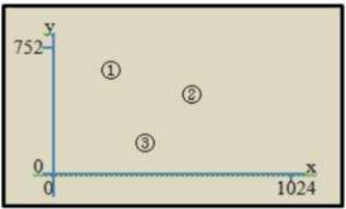
For example, if the Pass Positions is applied with an image size of 1024 x 752 (roughly the full screen), and three points are chosen (i.e. (150, 650), (530, 330), (370, 70)), as shown in, then Pass Positions generates R-String (RD, LD) in the registration phase.

Authentication is the process of determining whether a user should be allowed to access a particular system or resource. Users can’t remember strong passwords easily and the passwords that can be remembered are easy to guess. A password authentication system should encourage strong and less predictable passwords while maintaining memorability and security. People are access their mobiles, TABs and laptops anywhere like coffee shops, mall, railway station, banks and those areas which are already in CCTV. They are totally aware about this environment where their devices are easily access and recorded in video footage. that time login information and other personal information recorded. For any hacker this kind of information is enough to hack their devices and miss use it easily without any extra efforts by using CCTV video footage. The purpose of this paper is to avoid this kind of unlike attacks. Here we are giving a login functionality with using image pixels and there are set of images we are used for login process. This process is based on optical image processing techniques. Where system read the image pixels’ location and stored into the database. While user access their devices that time all that pixels location should be identify and match. So there will be no chance to hack the devices and personal information’s. In this paper, we propose a Cued Click Points (CCP) for image password authentication. A password consists of one click-point per image for a sequence of images. The next image displayed is based on the previous click-point so users receive immediate implicit feedback as to whether they are on the correct path when logging in. CCP offers both improved security and usability. Authentication based on passwords is used largely in applications for computer security and privacy. Comprised of numbers and upper- and lowercase letters, textual passwords are considered strong enough to resist against brute force attacks. They are versatile and easy to implement. Alphanumeric passwords are required to satisfy two contradictory requirements. They should be easy to remember while at the same time they should be hard to guess. Various graphical password authentication schemes were developed to address the problems and weaknesses associated with textual passwords. Humans have a better ability to memorize images with long-term memory (LTM) than verbal representations. However, most of these image based passwords are vulnerable to shoulder surfing attacks. A secure graphical authentication system named PassMatrix is used that protects users from becoming victims of shoulder surfing attacks when inputting passwords in public through the usage of one-time login indicators. A login indicator is randomly generated for each pass-image and will be useless after the session terminates. The login indicator provides better security against shoulder surfing attacks, since users use a dynamic pointer to point out the position of their passwords rather than clicking on the password object directly .If a passimage is faintly printed on a cover image, the legitimate user who is close to the PC screen can see the pass-image but someone who is far from the screen cannot recognize the pass-image. Generic Visible Watermark Embedding technique is used to blend a cover image and a pass-image. Moreover, because images with less independent objects usually suffer more on the hot-spot problem, carefully selecting images with rich objects can alleviate the hot-spot based random guess attacks. This method can also be extended to secure login of web applications in computers by using QR code and user behavior service. The user behaviors act as a service in android platform and check the call details and locations which we traveled. At the time of authentication frequent questions are asked based on user behavior. If we answered currectly the authentication done successfully. Pixel Value Graphical Password Scheme is a knowledge base password scheme that requires an image file pixel value extraction as authentication subject. Through this graphical password scheme, users need to determine an image file and username during enrolment stage as authentication key to a system. Then, on log in procedure, user once again input a username and feed image file on log in page. System will extract pixel value from fed image file, and validate the username and pixel value to authenticate a user to a system. Pixel value graphical password scheme is not click-based graphical password which widely applied to existing graphical password scheme method. This scheme gives a freedom to user to determine an image file, based on certain requirements, to be use on this access control system. However, pixel-value graphical password scheme can be implemented on a system where others graphical password scheme rationally implemented such as online banking system, internet mail system, operating system logon, and more. This paper presents a literature review of graphical password and negative aspect discussion on current graphical password scheme. Topic covered here includes Graphical Password Scheme discussion including techniques, types, and method in section two (2), section three (3) will discuss on current graphical password scheme in negative aspects and the impact of pixel value graphical password solution implementation. Section four (4), will conclude all discussion and findings of this study.
1.2 PROBLEM DEFINITION :
Password-based authentication is one of the simplest and most common authentication mechanisms used to provide computer security. However, people prefer to create short and simple passwords as it can recognize easily. This type of password is usually lead to password guessing easily and caused malicious activities. In addition, traditional authentications like passwords are the unwillingness of the users to remember long, challenging combination of numbers, letters and symbols that can be easily copy or guess. Therefore, users are restricted to add numbers or special characters in their passwords but such policies make the passwords hard to remember. Lastly, password thefts can and do happen on a daily basis because the password is not secure and allows attackers to steal or crack data easily. This may reduce the level security of the system. So, users need to choose a strong password like combine the alphabets, number and symbol together.
1.3 Scope:
A key-aggregate encryption scheme consists of five polynomial-time algorithms as follows. The data owner establishes the public system parameter via Setup and generates a public/master-secret key pair via KeyGen. Messages can be encrypted via Encrypt by anyone who also decides what ciphertext lass is associated with the plaintext message to be encrypted. The data owner can use the master-secret to generate an aggregate decryption key for a set of cipher text classes via Extract. The generated keys can be passed to delegates securely (via secure e-mails or secure devices)
1.4 DESCRIPTION OF THE PROJECT
The problem of Knowledge based authentication mechanism (KBAM) typically text based password are well known. The goal of an authentication system is to support users in selecting the superior password. An alternative to alphanumeric password is the graphical password. Graphical password uses images or representation of an image as a password. Human brains easily recognize pictures than the text. Most of the time user create memorable password which is easy to guess but strong system assigned password are difficult to remember. An authentication system should allow user choice while influencing user towards stronger passwords.
1.5 OBJECTIVES
The main objective of this project is to develop a web based application to protect data from server using graphical password authentication system which can be used to manage the contents hosted on a web site.

1.6 Graphical Password Schemes:
Graphical password scheme were introduced to reduce the human memory burden on text-based password. Research in the psychology discipline suggests that humans are better at recognizing visual information than recalling meaningless text-based strings (Dhamija, R. and A. Perrig, 2000), whether for authentication or otherwise (Pierce, J.D., 2004). This natural ability in humans can be use for authentication in a similar way to recalling passwords. A graphical authentication technique where users enter their login to a text box and then select screen artifacts, appearing among other control artifacts, is considered as a part of the graphical password (Pierce, J.D., 2004). In 1999, a technique where users identify previously seen RandomArt is proposed by Perrig and Song. RandomArt hashes users’ passwords and root keys in public key infrastructures and creates a visual representation of that hash. Later, this technique is enhanced by R.Dhamija that assembling the RandomArt images into a sequence of images that users identify in sequence before they are authenticated. Dhamija and Perrig called their suite Déjà Vu (2000) and validated it as a viable alternative paradigm using images. Blonder patented a graphical password that required users to touch predetermined areas or known as clickpoints grids of an image in sequence for authentication in 1996. Blonder method was later being an inspirational idea for graphical password scheme development. His technique was designed to suited computer based application. Passlogix Inc. distribute v-go, an authentication application that requires users to do such things as enter the time on a clock, draw cards from a deck, and entering phone numbers. Real User (formerly IDArts, 1999) distributes Passfaces, an authentication system based on recognising previously seen images of faces (Pierce, J.D., 2004). Most of reproducing a drawing graphical password scheme was developed that initially for mobile handheld devices. In year 1999 Jermyn, Mayer, Monrose, Reiter and Rubin proposed a graphical password scheme that consisted of simple pictures drawn on a grid. This graphical password scheme category require a precise and accurate drawing that also require a specified input tools such as stylus did not bring a huge impact for graphical password scheme development competition.
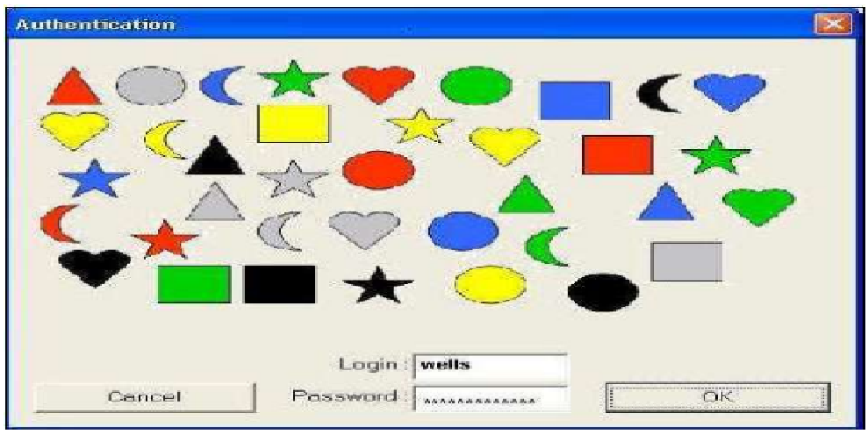
Coloured shape authentication dialogue
1.6.1 Type of Graphical Password Schemes:
Knowledge based techniques are the most widely used authentication techniques and include both textbased and picture-based passwords (Suo, X., 2006). The picture based techniques can be categorized into two:
- Recall Base Graphical Password Schemes.
- Recognition Base Graphical Password Schemes.
1.8.2 Recall Base Graphical Password Scheme: In recall based techniques user is asked to reproduce something that user created or selected earlier during the enrolment stage.
Two types of Recall based password techniques:
- Reproducing a drawing.
- Repeating a selection.
Reproducing a Drawing: There are three methods under this category which are:
A. DAS (Draw-a-secret): This method is proposed by Jermyn, Mayer, Monrose, Reiter and Rubin in 1999, which allows user to draw their unique password as in Figure 2. A user is required to draw a simple picture on a grid. The coordinates of the grids occupied by the picture are stored in the order of the drawing. During authentication, the user is asked to re-draw the picture. If the drawing touches the same grids in the same sequence, then the user is authenticated. Jermyn, et al. suggested that given reasonable-length passwords in a 5 X 5 grid, the full password space of DAS is larger than that of the full text password space (Suo, X., 2006).
B. Passdoodle Method: This is developed by J.Goldberg. This is a graphical password comprised of handwritten designs or text, usually drawn with a stylus onto a touch sensitive screen. Their study concluded that users were able to remember complete doodle images as accurately as alphanumeric passwords (Suo, X., 2006).
C. Syukri Method: This method is a system where authentication is conducted by having user drawing their signature using mouse. Their technique included two stages, enrolment and verification. On enrolment stage: user will first be asked to draw their signature with mouse, and then the system will extract the signature area and either enlarges or scale-down signatures, rotates if needed, (also known as normalizing). The information will later be saved into the database. The verification stage first takes the user input, and does the normalization again, and then extracts the parameters of the signature. After that, the system conducts verification using geometric average means and a dynamic update of database. According to the paper, the rate of successful verification was satisfying (Suo, X., 2006). The biggest advantage of this approach is that there is no need to memorize one’s signature and signatures are hard to fake.
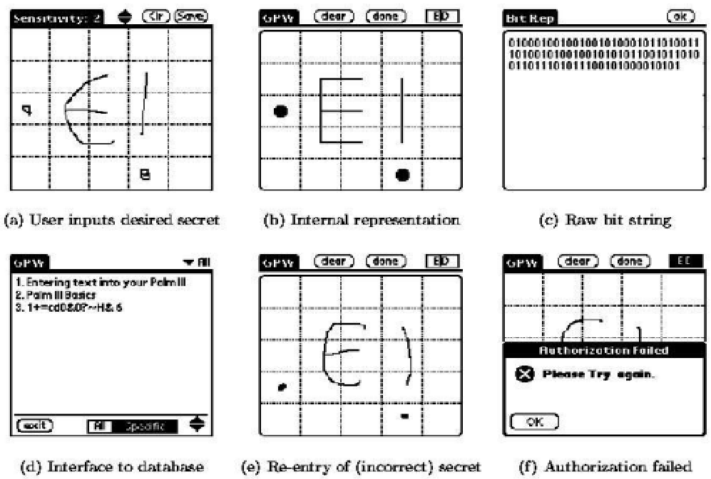
Draw-a-Secret (DAS) method
Repeating a Selection:
In this group of authentication algorithms, a user is asked to repeat sequences of actions originally conducted by the user during the registration stage. There are four methods is review under this category which is:
A. Blonder Method: In this method Blonder designed a graphical password scheme in which a password is created by having the user click on several locations on an image. During authentication, the user must click on the approximate areas of those locations (Blonder, G., 1996). The image can assist users to recall their passwords and therefore this method is considered more convenient than unassisted recall (as in text-based password).
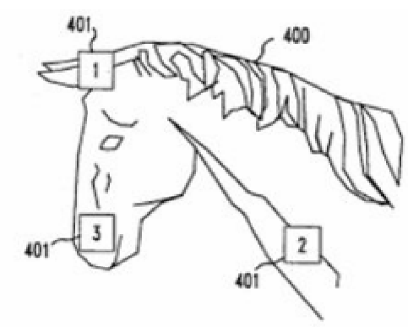
Clickpoints on Blonder method
B. PassGo Method: Based on predetermined clickpoint grids graphical password scheme, an improvement on DAS (in term of grids) techniques was developed by Hai Tao in 2006. This technique was known as PassGo. It design based on old Chinese board game known as GO. PassGo was design to suite computer based used and can be implement on bigger grids that increase password space for DAS-type graphical password scheme. This method however does not show any similarity with DAS technique where there is no free move drawing work requires on authentication process. This method is better suite repeating a selection technique. In this technique, user is requiring to touch on grid intersection instead of grids cells symmetry drawing (Tao, H., 2006) on authentication process. The touch grid is determined by user during enrolment process. This method was also designed with graphical referencing aided which look like a checker board for each 9 by 9 grids.
C. Passpoint Method: This system proposed by Wiedenbeck, and Wiedenbeck, extended Blonder’s idea by eliminating the predefined boundaries and allowing arbitrary images to be used (Wiedenbeck, S., 2005). As a result, a user can click on any place on an image (as opposed to some pre-defined areas) to create a password. A tolerance around each chosen pixel is calculated. In order to be authenticated, the user must click within the tolerance of their chosen pixels and also in the correct sequence. This technique is based on the discretization method proposed by Birget, because any picture can be used and because a picture may contain hundreds to thousands of memorable points, the possible password space is quite large. Wiedenbeck conducted a user study, in which one group of participants was asked to use alphanumerical password, while the other group was asked to use the graphical password. The result showed that graphical password took fewer attempts for the user than alphanumerical passwords (Wiedenbeck, S., 2005).
D. Passlogix Method: Passlogix, Google has developed a graphical password system based on blonder idea. In their implementation, users must click on various items in the image in the correct sequence in order to be authenticated. Invisible boundaries are defined for each item in order to detect whether an item is clicked by mouse. It has also developed several graphical password techniques based on repeating a sequence of actions (Suo, X., 2006). For example, its v-Go includes a graphical password scheme where users can mix up a virtual cocktail and use the combination of ingredients as password. Other password options include picking a hard at cards or putting together a “meal” in the virtual kitchen.
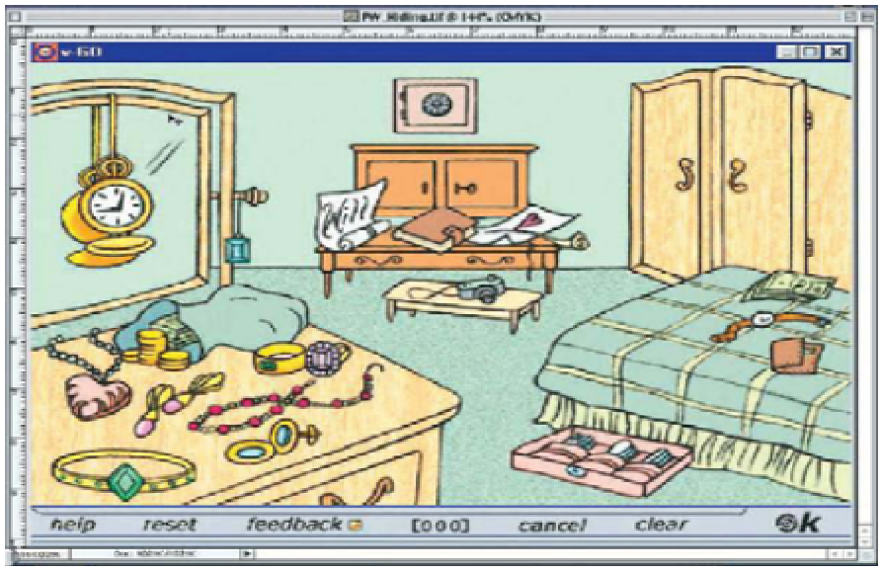
Pass Logix dialogue
1.6.3 Recognition Base Graphical Password Scheme:
In recognition based techniques, users are given a set of pictures and they pick and memorize some of them. During authentication, the users need to recognize and identify the pictures they have picked earlier. There are six methods for this category which are:
A. Dhamija and Perrig Algorithm: This method is proposed a graphical authentication scheme based on Hash Visualization technique. In their system, user will be asked to select certain number of images from a set of random pictures generated by a program. Later, user will be required to identify the pre-selected images to be authenticated. The results showed that 90% of all participants succeeded in the authentication using their technique, while only 70% succeeded using text-based passwords and PINS (Dhamija, R. and A. Perrig, 2000). The average log-in time, however, is longer than the traditional approach, but has a much smaller failure rate (Dhamija, R. and A. Perrig, 2000; Pierce, J.D., 2004).
B. Sobrado and Birget Algorithm: They developed a graphical password technique that deals with shouldersurfing problem. In the first scheme, the system will display a number of pass-objects (pre-selected by user) among many other objects. To be authenticated, a user needs to recognize pass-objects and click inside the convex hull formed by all the passobjects.
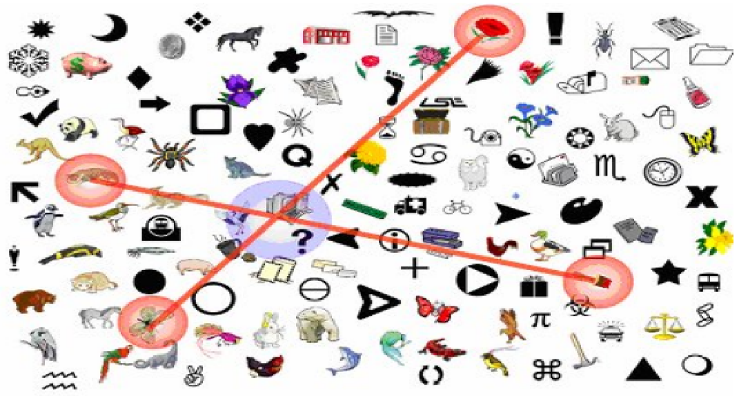
Shoulder surfing resistance scheme
In their second algorithm, a user moves a frame (and the objects within it) until the pass object on the frame lines up with the other two pass-objects. With this method, it is suggested repeating the process for a few more times to minimize the likelihood of logging in by randomly clicking or rotating.
C. Man, et al. Algorithm: In this algorithm, a user selects a number of pictures as pass-objects. Each pass-object has several variants and each variant is assigned a unique code. During authentication, the user is challenged with several scenes. Each scene contains several pass-objects (each in the form of a randomly chosen variant) and many decoyobjects. The user has to type in a string with the unique codes corresponding to the pass-object variants present in the 24 scene as well as a code indicating the relative location of the pass-objects in reference to a pair of eyes. The argument is that it is very hard to crack this kind of password even if the whole authentication process is recorded on video because where is no mouse click to give away the pass-object information (Man, S., 2004).
D. Jansen Algorithm: This algorithm graphical password mechanism proposed for mobile devices. During enrolment stage, a user selects a theme (e.g. sea, cat, etc.) which consists of thumbnail photos and then registers a sequence of images as a password. During the authentication, the user must enter the registered images in the correct sequence. After a successful authentication, the user may change the password, selecting a new sequence, or possibly change the theme. One drawback of this technique is that while the amount of thumbnail image is limited to 30, the password space is small. Each thumbnail image is assigned a numerical value, and the sequence of selection will essentially generate a numerical password (Jansen, W., 2004).
E. Takada and Koike: Discuss a similar graphical password technique for mobile devices. This technique allows users to use their favourite image for authentication. The users first register their favourite images (pass-images) with the server. During authentication, a user has to go through several rounds of verification. At each round, the user either selects a pass-image among several decoy-images or chooses nothing if no pass-image is present. The program would authorize a user only if all verifications are successful. Allowing users to register their own images makes it easier for user to remember their pass-images. A notification mechanism is also implemented to notify users when new images are registered in order to prevent unauthorized image registration since it is viewable to the public (Takada, T. and H. Koike, 2003).
F. Passface Algorithm: Which is a technique developed by Real User Corporation, Google RealUser. The basic idea is as follows. The user will be asked to choose four images of human faces from a face database as their future password. In the authentication stage, the user sees a grid of nine faces, consisting of one face previously chosen by the user and eight decoy faces. The user recognizes and clicks anywhere on the known face. This procedure is repeated for several rounds. The user is authenticated if he or she correctly identifies the four faces. The technique is based on the assumption that people can recall human faces easier than other pictures (Passface Corporation, 2005). User studies by Valentine have shown that Passfaces are very memorable over long intervals (Valentine, T., 1999). Comparative studies conducted by Brostoff showed that Passfaces had only a third of the login failure rate of text-based passwords, despite with about a third the frequency of use. Their study also showed that Passface-based log–in process took longer than text passwords and therefore were used less frequently by users.

1.7 SOFTWARE SPECIFICATION
1.7.1 FEATURES OF .NET
Microsoft .NET is a set of Microsoft software technologies for rapidly building and integrating XML Web services, Microsoft Windows-based applications, and Web solutions. The .NET Framework is a language-neutral platform for writing programs that can easily and securely interoperate. There’s no language barrier with .NET: there are numerous languages available to the developer including Managed C++, C#, Visual Basic and Java Script. The .NET framework provides the foundation for components to interact seamlessly, whether locally or remotely on different platforms. It standardizes common data types and communications protocols so that components created in different languages can easily interoperate.
“.NET” is also the collective name given to various software components built upon the .NET platform. These will be both products (Visual Studio.NET and Windows.NET Server, for instance) and services (like Passport, .NET My Services, and so on).
1.7.2 OVERVIEW OF TECHNOLOGIES USED
Front End Technology
Microsoft .NET Framework
The .NET Framework is a new computing platform that simplifies application development in the highly distributed environment of the Internet. The .NET Framework is designed to fulfill the following objectives:
- To provide a consistent object-oriented programming environment whether object code is stored and executed locally, executed locally but Internet-distributed, or executed remotely.
- To provide a code-execution environment that minimizes software deployment and versioning conflicts.
- To provide a code-execution environment that guarantees safe execution of code, including code created by an unknown or semi-trusted third party.
- To provide a code-execution environment that eliminates the performance problems of scripted or interpreted environments.
- To make the developer experience consistent across widely varying types of applications, such as Windows-based applications and Web-based applications.
- To build all communication on industry standards to ensure that code based on the .NET Framework can integrate with any other code.
The .NET Framework has two main components: the common language runtime and the .NET Framework class library. The common language runtime is the foundation of the .NET Framework. You can think of the runtime as an agent that manages code at execution time, providing core services such as memory management, thread management, and remoting, while also enforcing strict type safety and other forms of code accuracy that ensure security and robustness. In fact, the concept of code management is a fundamental principle of the runtime. Code that targets the runtime is known as managed code, while code that does not target the runtime is known as unmanaged code. The class library, the other main component of the .NET Framework, is a comprehensive, object-oriented collection of reusable types that you can use to develop applications ranging from traditional command-line or graphical user interface (GUI) applications to applications based on the latest innovations provided by ASP.NET, such as Web Forms and XML Web services.
The .NET Framework can be hosted by unmanaged components that load the common language runtime into their processes and initiate the execution of managed code, thereby creating a software environment that can exploit both managed and unmanaged features. The .NET Framework not only provides several runtime hosts, but also supports the development of third-party runtime hosts.
For example, ASP.NET hosts the runtime to provide a scalable, server-side environment for managed code. ASP.NET works directly with the runtime to enable Web Forms applications and XML Web services, both of which are discussed later in this topic.
Internet Explorer is an example of an unmanaged application that hosts the runtime (in the form of a MIME type extension). Using Internet Explorer to host the runtime enables you to embed managed components or Windows Forms controls in HTML documents. Hosting the runtime in this way makes managed mobile code (similar to Microsoft® ActiveX® controls) possible, but with significant improvements that only managed code can offer, such as semi-trusted execution and secure isolated file storage.
The following illustration shows the relationship of the common language runtime and the class library to your applications and to the overall system. The illustration also shows how managed code operates within a larger architecture.
Features of the Common Language Runtime
The common language runtime manages memory, thread execution, code execution, code safety verification, compilation, and other system services. These features are intrinsic to the managed code that runs on the common language runtime.
With regards to security, managed components are awarded varying degrees of trust, depending on a number of factors that include their origin (such as the Internet, enterprise network, or local computer). This means that a managed component might or might not be able to perform file-access operations, registry-access operations, or other sensitive functions, even if it is being used in the same active application.
The runtime enforces code access security. For example, users can trust that an executable embedded in a Web page can play an animation on screen or sing a song, but cannot access their personal data, file system, or network. The security features of the runtime thus enable legitimate Internet-deployed software to be exceptionally featuring rich.
The runtime also enforces code robustness by implementing a strict type- and code-verification infrastructure called the common type system (CTS). The CTS ensures that all managed code is self-describing. The various Microsoft and third-party language compilers generate managed code that conforms to the CTS. This means that managed code can consume other managed types and instances, while strictly enforcing type fidelity and type safety.
In addition, the managed environment of the runtime eliminates many common software issues. For example, the runtime automatically handles object layout and manages references to objects, releasing them when they are no longer being used. This automatic memory management resolves the two most common application errors, memory leaks and invalid memory references.
The runtime also accelerates developer productivity. For example, programmers can write applications in their development language of choice, yet take full advantage of the runtime, the class library, and components written in other languages by other developers. Any compiler vendor who chooses to target the runtime can do so. Language compilers that target the .NET Framework make the features of the .NET Framework available to existing code written in that language, greatly easing the migration process for existing applications.
While the runtime is designed for the software of the future, it also supports software of today and yesterday. Interoperability between managed and unmanaged code enables developers to continue to use necessary COM components and DLLs.
The runtime is designed to enhance performance. Although the common language runtime provides many standard runtime services, managed code is never interpreted. A feature called just-in-time (JIT) compiling enables all managed code to run in the native machine language of the system on which it is executing. Meanwhile, the memory manager removes the possibilities of fragmented memory and increases memory locality-of-reference to further increase performance.
Finally, the runtime can be hosted by high-performance, server-side applications, such as Microsoft® SQL Server™ and Internet Information Services (IIS). This infrastructure enables you to use managed code to write your business logic, while still enjoying the superior performance of the industry's best enterprise servers that support runtime hosting.
.NET Framework Class Library
The .NET Framework class library is a collection of reusable types that tightly integrate with the common language runtime. The class library is object oriented, providing types from which your own managed code can derive functionality. This not only makes the .NET Framework types easy to use, but also reduces the time associated with learning new features of the .NET Framework. In addition, third-party components can integrate seamlessly with classes in the .NET Framework.
For example, the .NET Framework collection classes implement a set of interfaces that you can use to develop your own collection classes. Your collection classes will blend seamlessly with the classes in the .NET Framework.
As you would expect from an object-oriented class library, the .NET Framework types enable you to accomplish a range of common programming tasks, including tasks such as string management, data collection, database connectivity, and file access. In addition to these common tasks, the class library includes types that support a variety of specialized development scenarios. For example, you can use the .NET Framework to develop the following types of applications and services:
- Console applications.
- Scripted or hosted applications.
- Windows GUI applications (Windows Forms).
- ASP.NET applications.
- XML Web services.
- Windows services.
For example, the Windows Forms classes are a comprehensive set of reusable types that vastly simplify Windows GUI development. If you write an ASP.NET Web Form application, you can use the Web Forms classes.
1.7.3 Client Application Development
Client applications are the closest to a traditional style of application in Windows-based programming. These are the types of applications that display windows or forms on the desktop, enabling a user to perform a task. Client applications include applications such as
word processors and spreadsheets, as well as custom business applications such as data-entry tools, reporting tools, and so on. Client applications usually employ windows, menus, buttons, and other GUI elements, and they likely access local resources such as the file system and peripherals such as printers.
Another kind of client application is the traditional ActiveX control (now replaced by the managed Windows Forms control) deployed over the Internet as a Web page. This application is much like other client applications: it is executed natively, has access to local resources, and includes graphical elements.
In the past, developers created such applications using C/C++ in conjunction with the Microsoft Foundation Classes (MFC) or with a rapid application development (RAD) environment such as Microsoft® Visual Basic®. The .NET Framework incorporates aspects of these existing products into a single, consistent development environment that drastically simplifies the development of client applications. The Windows Forms classes contained in the .NET Framework are designed to be used for GUI development. You can easily create command windows, buttons, menus, toolbars, and other screen elements with the flexibility necessary to accommodate shifting business needs.
For example, the .NET Framework provides simple properties to adjust visual attributes associated with forms. In some cases the underlying operating system does not support changing these attributes directly, and in these cases the .NET Framework automatically recreates the forms. This is one of many ways in which the .NET Framework integrates the developer interface, making coding simpler and more consistent.
Unlike ActiveX controls, Windows Forms controls have semi-trusted access to a user's computer. This means that binary or natively executing code can access some of the resources on the user's system (such as GUI elements and limited file access) without being able to access or compromise other resources. Because of code access security, many applications that once needed to be installed on a user's system can now be safely deployed through the Web. Your applications can implement the features of a local application while being deployed like a Web page.
1.7.4 Server Application Development
Server-side applications in the managed world are implemented through runtime hosts. Unmanaged applications host the common language runtime, which allows your custom managed code to control the behavior of the server. This model provides you with all the features of the common language runtime and class library while gaining the performance and scalability of the host server.
The following illustration shows a basic network schema with managed code running in different server environments. Servers such as IIS and SQL Server can perform standard operations while your application logic executes through the managed code.
Server-side managed code
ASP.NET is the hosting environment that enables developers to use the .NET Framework to target Web-based applications. However, ASP.NET is more than just a runtime host; it is a complete architecture for developing Web sites and Internet-distributed objects using managed code. Both Web Forms and XML Web services use IIS and ASP.NET as the publishing mechanism for applications, and both have a collection of supporting classes in the .NET Framework.
XML Web services, an important evolution in Web-based technology, are distributed, server-side application components similar to common Web sites. However, unlike Web-based applications, XML Web services components have no UI and are not targeted for browsers such as Internet Explorer and Netscape Navigator. Instead, XML Web services consist of reusable software components designed to be consumed by other applications, such as traditional client applications, Web-based applications, or even other XML Web services. As a result, XML Web services technology is rapidly moving application development and deployment into the highly distributed environment of the Internet.
If you have used earlier versions of ASP technology, you will immediately notice the improvements that ASP.NET and Web Forms offers. For example, you can develop Web Forms pages in any language that supports the .NET Framework. In addition, your code no longer needs to share the same file with your HTTP text (although it can continue to do so if you prefer). Web Forms pages execute in native machine language because, like any other managed application, they take full advantage of the runtime. In contrast, unmanaged ASP pages are always scripted and interpreted. ASP.NET pages are faster, more functional, and easier to develop than unmanaged ASP pages because they interact with the runtime like any managed application.
The .NET Framework also provides a collection of classes and tools to aid in development and consumption of XML Web services applications. XML Web services are built on standards such as SOAP (a remote procedure-call protocol), XML (an extensible data format), and WSDL ( the Web Services Description Language). The .NET Framework is built on these standards to promote interoperability with non-Microsoft solutions.
For example, the Web Services Description Language tool included with the .NET Framework SDK can query an XML Web service published on the Web, parse its WSDL description, and produce C# or Visual Basic source code that your application can use to become a client of the XML Web service. The source code can create classes derived from classes in the class library that handle all the underlying communication using SOAP and XML parsing. Although you can use the class library to consume XML Web services directly, the Web Services Description Language tool and the other tools contained in the SDK facilitate your development efforts with the .NET Framework.
If you develop and publish your own XML Web service, the .NET Framework provides a set of classes that conform to all the underlying communication standards, such as SOAP, WSDL, and XML. Using those classes enables you to focus on the logic of your service, without concerning yourself with the communications infrastructure required by distributed software development.
Finally, like Web Forms pages in the managed environment, your XML Web service will run with the speed of native machine language using the scalable communication of IIS.
Active Server Pages.NET
ASP.NET is a programming framework built on the common language runtime that can be used on a server to build powerful Web applications. ASP.NET offers several important advantages over previous Web development models:
- Enhanced Performance. ASP.NET is compiled common language runtime code running on the server. Unlike its interpreted predecessors, ASP.NET can take advantage of early binding, just-in-time compilation, native optimization, and caching services right out of the box. This amounts to dramatically better performance before you ever write a line of code.
- World-Class Tool Support. The ASP.NET framework is complemented by a rich toolbox and designer in the Visual Studio integrated development environment. WYSIWYG editing, drag-and-drop server controls, and automatic deployment are just a few of the features this powerful tool provides.
- Power and Flexibility. Because ASP.NET is based on the common language runtime, the power and flexibility of that entire platform is available to Web application developers. The .NET Framework class library, Messaging, and Data Access solutions are all seamlessly accessible from the Web. ASP.NET is also language-independent, so you can choose the language that best applies to your application or partition your application across many languages. Further, common language runtime interoperability guarantees that your existing investment in COM-based development is preserved when migrating to ASP.NET.
- Simplicity. ASP.NET makes it easy to perform common tasks, from simple form submission and client authentication to deployment and site configuration. For example, the ASP.NET page framework allows you to build user interfaces that cleanly separate application logic from presentation code and to handle events in a simple, Visual Basic - like forms processing model. Additionally, the common language runtime simplifies development, with managed code services such as automatic reference counting and garbage collection.
- Manageability. ASP.NET employs a text-based, hierarchical configuration system, which simplifies applying settings to your server environment and Web applications. Because configuration information is stored as plain text, new settings may be applied without the aid of local administration tools. This "zero local administration" philosophy extends to deploying ASP.NET Framework applications as well. An ASP.NET Framework application is deployed to a server simply by copying the necessary files to the server. No server restart is required, even to deploy or replace running compiled code.
- Scalability and Availability. ASP.NET has been designed with scalability in mind, with features specifically tailored to improve performance in clustered and multiprocessor environments. Further, processes are closely monitored and managed by the ASP.NET runtime, so that if one misbehaves (leaks, deadlocks), a new process can be created in its place, which helps keep your application constantly available to handle requests.
- Customizability and Extensibility. ASP.NET delivers a well-factored architecture that allows developers to "plug-in" their code at the appropriate level. In fact, it is possible to extend or replace any subcomponent of the ASP.NET runtime with your own custom-written component. Implementing custom authentication or state services has never been easier.
- Security. With built in Windows authentication and per-application configuration, you can be assured that your applications are secure.
Language Support
The Microsoft .NET Platform currently offers built-in support for three languages: C#, Visual Basic, and JScript.
What is ASP.NET Web Forms?
The ASP.NET Web Forms page framework is a scalable common language runtime programming model that can be used on the server to dynamically generate Web pages.
Intended as a logical evolution of ASP (ASP.NET provides syntax compatibility with existing pages), the ASP.NET Web Forms framework has been specifically designed to address a number of key deficiencies in the previous model. In particular, it provides:
• The ability to create and use reusable UI controls that can encapsulate common functionality and thus reduce the amount of code that a page developer has to write.
• The ability for developers to cleanly structure their page logic in an orderly fashion (not "spaghetti code").
• The ability for development tools to provide strong WYSIWYG design support for pages (existing ASP code is opaque to tools).
ASP.NET Web Forms pages are text files with an .aspx file name extension. They can be deployed throughout an IIS virtual root directory tree. When a browser client requests .aspx resources, the ASP.NET runtime parses and compiles the target file into a .NET Framework class. This class can then be used to dynamically process incoming requests. (Note that the .aspx file is compiled only the first time it is accessed; the compiled type instance is then reused across multiple requests).
An ASP.NET page can be created simply by taking an existing HTML file and changing its file name extension to .aspx (no modification of code is required). For example, the following sample demonstrates a simple HTML page that collects a user's name and category preference and then performs a form post back to the originating page when a button is clicked:
ASP.NET provides syntax compatibility with existing ASP pages. This includes support for <% %> code render blocks that can be intermixed with HTML content within an .aspx file. These code blocks execute in a top-down manner at page render time.
1.7.5 Code-Behind Web Forms
ASP.NET supports two methods of authoring dynamic pages. The first is the method shown in the preceding samples, where the page code is physically declared within the originating .aspx file. An alternative approach--known as the code-behind method--enables the page code to be more cleanly separated from the HTML content into an entirely separate file.
1.7.6 Introduction to ASP.NET Server Controls
In addition to (or instead of) using <% %> code blocks to program dynamic content, ASP.NET page developers can use ASP.NET server controls to program Web pages. Server controls are declared within an .aspx file using custom tags or intrinsic HTML tags that contain a runat="server" attributes value. Intrinsic HTML tags are handled by one of the controls in the System.Web.UI.Html Controls namespace. Any tag that doesn't explicitly map to one of the controls is assigned the type of System. Web.UI.HtmlControls.HtmlGenericControl.
Server controls automatically maintain any client-entered values between round trips to the server. This control state is not stored on the server (it is instead stored within an <input type="hidden"> form field that is round-tripped between requests). Note also that no client-side script is required.
In addition to supporting standard HTML input controls, ASP.NET enables developers to utilize richer custom controls on their pages. For example, the following sample demonstrates how the <asp:adrotator> control can be used to dynamically display rotating ads on a page.
1. ASP.NET Web Forms provide an easy and powerful way to build dynamic Web UI.
2. ASP.NET Web Forms pages can target any browser client (there are no script library or cookie requirements).
3. ASP.NET Web Forms pages provide syntax compatibility with existing ASP pages.
4. ASP.NET server controls provide an easy way to encapsulate common functionality.
5. ASP.NET ships with 45 built-in server controls. Developers can also use controls built by third parties.
6. ASP.NET server controls can automatically project both up level and down level HTML.
7. ASP.NET templates provide an easy way to customize the look and feel of list server controls.
8. ASP.NET validation controls provide an easy way to do declarative client or server data validation.
1.7.7 BACK END TECHNOLOGY:
About Microsoft SQL Server 2000
Microsoft SQL Server is a Structured Query Language (SQL) based, client/server relational database. Each of these terms describes a fundamental part of the architecture of SQL Server.
Database
A database is similar to a data file in that it is a storage place for data. Like a data file, a database does not present information directly to a user; the user runs an application that accesses data from the database and presents it to the user in an understandable format.
A database typically has two components: the files holding the physical database and the database management system (DBMS) software that applications use to access data. The DBMS is responsible for enforcing the database structure, including:
• Maintaining the relationships between data in the database.
• Ensuring that data is stored correctly and that the rules defining data relationships are not violated.
• Recovering all data to a point of known consistency in case of system failures.
Relational Database
There are different ways to organize data in a database but relational databases are one of the most effective. Relational database systems are an application of mathematical set theory to the problem of effectively organizing data. In a relational database, data is collected into tables (called relations in relational theory).
When organizing data into tables, you can usually find many different ways to define tables. Relational database theory defines a process, normalization, which ensures that the set of tables you define will organize your data effectively.
Client/Server:-
In a client/server system, the server is a relatively large computer in a central location that manages a resource used by many people. When individuals need to use the resource, they connect over the network from their computers, or clients, to the server.
Examples of servers are: In a client/server database architecture, the database files and DBMS software reside on a server. A communications component is provided so applications can run on separate clients and communicate to the database server over a network. The SQL Server communication component also allows communication between an application running on the server and SQL Server.
Server applications are usually capable of working with several clients at the same time. SQL Server can work with thousands of client applications simultaneously. The server has features to prevent the logical problems that occur if a user tries to read or modify data currently being used by others.
While SQL Server is designed to work as a server in a client/server network, it is also capable of working as a stand-alone database directly on the client. The scalability and ease-of-use features of SQL Server allow it to work efficiently on a client without consuming too many resources.
Structured Query Language (SQL)
To work with data in a database, you must use a set of commands and statements (language) defined by the DBMS software. There are several different languages that can be used with relational databases; the most common is SQL. Both the American National Standards Institute (ANSI) and the International Standards Organization (ISO) have defined standards for SQL. Most modern DBMS products support the Entry Level of SQL-92, the latest SQL standard (published in 1992).
SQL Server Features
Microsoft SQL Server supports a set of features that result in the following benefits:
- Ease of installation, deployment, and use
- SQL Server includes a set of administrative and development tools that improve your ability to install, deploy, manage, and use SQL Server across several sites.
Scalability
The same database engine can be used across platforms ranging from laptop computers running Microsoft Windows® 95/98 to large, multiprocessor servers running Microsoft Windows NT®, Enterprise Edition.
Data warehousing
SQL Server includes tools for extracting and analyzing summary data for online analytical processing (OLAP). SQL Server also includes tools for visually designing databases and analyzing data using English-based questions.
System integration with other server software
SQL Server integrates with e-mail, the Internet, and Windows.

Databases
A database in Microsoft SQL Server consists of a collection of tables that contain data, and other objects, such as views, indexes, stored procedures, and triggers, defined to support activities performed with the data. The data stored in a database is usually related to a particular subject or process, such as inventory information for a manufacturing warehouse.
SQL Server can support many databases, and each database can store either interrelated data or data unrelated to that in the other databases. For example, a server can have one database that stores personnel data and another that stores product-related data. Alternatively, one database can store current customer order data, and another; related database can store historical customer orders that are used for yearly reporting. Before you create a database, it is important to understand the parts of a database and how to design these parts to ensure that the database performs well after it is implemented.
Middleware Technology
Activex Data Objects.Net Overview
ADO.NET is an evolution of the ADO data access model that directly addresses user requirements for developing scalable applications. It was designed specifically for the web with scalability, statelessness, and XML in mind.
ADO.NET uses some ADO objects, such as the Connection and Command objects, and also introduces new objects. Key new ADO.NET objects include the Dataset, Data Reader, and Data Adapter.
The important distinction between this evolved stage of ADO.NET and previous data architectures is that there exists an object -- the Dataset -- that is separate and distinct from any data stores. Because of that, the Dataset functions as a standalone entity. You can think of the Dataset as an always disconnected record set that knows nothing about the source or destination of the data it contains. Inside a Dataset, much like in a database, there are tables, columns, relationships, constraints, views, and so forth.
A Data Adapter is the object that connects to the database to fill the Dataset. Then, it connects back to the database to update the data there, based on operations performed while the Dataset held the data. In the past, data processing has been primarily connection-based. Now, in an effort to make multi-tiered apps more efficient, data processing is turning to a message-based approach that revolves around chunks of information. At the center of this approach is the Data Adapter, which provides a bridge to retrieve and save data between a Dataset and its source data store. It accomplishes this by means of requests to the appropriate SQL commands made against the data store.
The XML-based Dataset object provides a consistent programming model that works with all models of data storage: flat, relational, and hierarchical. It does this by having no 'knowledge' of the source of its data, and by representing the data that it holds as collections and data types. No matter what the source of the data within the Dataset is, it is manipulated through the same set of standard APIs exposed through the Dataset and its subordinate objects.
While the Dataset has no knowledge of the source of its data, the managed provider has detailed and specific information. The role of the managed provider is to connect, fill, and persist the Dataset to and from data stores. The OLE DB and SQL Server .NET Data Providers (System.Data.OleDb and System.Data.SqlClient) that are part of the .Net Framework provide four basic objects: the Command, Connection, Data Reader and Data Adapter. In the remaining sections of this document, we'll walk through each part of the Dataset and the OLE DB/SQL Server .NET Data Providers explaining what they are, and how to program against them. The following sections will introduce you to some objects that have evolved, and some that are new. These objects are:
• Connections. For connection to and managing transactions against a database.
• Commands. For issuing SQL commands against a database.
• Data Readers. For reading a forward-only stream of data records from a SQL Server data source.
• Datasets. For storing, removing and programming against flat data, XML data and relational data.
• Data Adapters. For pushing data into a Dataset, and reconciling data against a database.
When dealing with connections to a database, there are two different options: SQL Server .NET Data Provider (System.Data.SqlClient) and OLE DB .NET Data Provider (System.Data.OleDb). In these samples we will use the SQL Server .NET Data Provider. These are written to talk directly to Microsoft SQL Server. The OLE DB .NET Data Provider is used to talk to any OLE DB provider (as it uses OLE DB underneath).
Connections
Connections are used to 'talk to' databases, and are represented by provider-specific classes such as SQLConnection. Commands travel over connections and result sets are returned in the form of streams which can be read by a Data Reader object, or pushed into a Dataset object.
Commands
Commands contain the information that is submitted to a database, and are represented by provider-specific classes such as SQLCommand. A command can be a stored procedure call, an UPDATE statement, or a statement that returns results. You can also use input and output parameters, and return values as part of your command syntax. The example below shows how to issue an INSERT statement against the North wind database.
Data Readers
The Data Reader object is somewhat synonymous with a read-only/forward-only cursor over data. The Data Reader API supports flat as well as hierarchical data. A Data Reader object is returned after executing a command against a database. The format of the returned Data Reader object is different from a record set. For example, you might use the Data Reader to show the results of a search list in a web page.
Datasets
The Dataset object is similar to the ADO Record set object, but more powerful, and with one other important distinction: the Dataset is always disconnected. The Dataset object represents a cache of data, with database-like structures such as tables, columns, relationships, and constraints. However, though a Dataset can and does behave much like a database, it is important to remember that Dataset objects do not interact directly with databases, or other source data. This allows the developer to work with a programming model that is always consistent, regardless of where the source data resides. Data coming from a database, an XML file, from code, or user input can all be placed into Dataset objects. Then, as changes are made to the Dataset they can be tracked and verified before updating the source data. The Get Changes method of the Dataset object actually creates a second Dataset that contains only the changes to the data. This Dataset is then used by a Data Adapter (or other objects) to update the original data source. The Dataset has many XML characteristics, including the ability to produce and consume XML data and XML schemas. XML schemas can be used to describe schemas interchanged via Web Services. In fact, a Dataset with a schema can actually be compiled for type safety and statement completion.
Data Adapters (OLEDB/SQL)
The Data Adapter object works as a bridge between the Dataset and the source data. Using the provider-specific SqlDataAdapter (along with its associated SqlCommand and SqlConnection) can increase overall performance when working with a Microsoft SQL Server databases. For other OLE DB-supported databases, you would use the OleDbDataAdapter object and its associated OleDbCommand and OleDbConnection objects. The Data Adapter object uses commands to update the data source after changes have been made to the Dataset. Using the Fill method of the Data Adapter calls the SELECT command; using the Update method calls the INSERT, UPDATE or DELETE command for each changed row. You can explicitly set these commands in order to control the statements used at runtime to resolve changes, including the use of stored procedures. For ad-hoc scenarios, a Command Builder object can generate these at run-time based upon a select statement. However, this run-time generation requires an extra round-trip to the server in order to gather required metadata, so explicitly providing the INSERT, UPDATE, and DELETE commands at design time will result in better run-time performance.
1. ADO.NET is the next evolution of ADO for the .Net Framework.
2. ADO.NET was created with n-Tier, statelessness and XML in the forefront. Two new objects, the Dataset and Data Adapter, are provided for these scenarios. ADO.NET can be used to get data from a stream, or to store data in a cache for updates.
3. There is a lot more information about ADO.NET in the documentation.
4. Remember, you can execute a command directly against the database in order to do inserts, updates, and deletes. You don't need to first put data into a Dataset in order to insert, update, or delete it.
5. Also, you can use a Dataset to bind to the data, move through the data, and navigate data relationships ass is contained in the aggregate key via Decrypt
1.7.8 Single Tier
In a single tier the server and client are the same in the sense that a client program that needs information (client) and the source of this type of architecture is also possible in java, in case flat files are used to store the data. However this is useful only in case of small applications. The advantage with this is the simplicity and portability of the application developed.

Server and client

Database

1.7.9 Two Tier (client-server)
In two tier architecture the database resides in one machine and client in different machine they are connected through the network. In this type of architecture a database management takes control of the database and provides access to clients in a network. This software bundle is also called as the server. Software in different machines, requesting for information are called as the Clients.
1.7.10 Three Tier and N-Tier
In the three-tier architecture, any number servers can access the database that resides on server. Which in turn serve clients in a network. For example, you want to access the database using java applets, the applet running in some other machine, can send request only to the server from which it is down loaded. For this reason we will need to have a intermediate server which will accept the requests from applets and them to the actual database server. This intermediate server acts as a two-way communication channel also. This is the information or data from the database is passed on to the applet that is requesting it. This can be extended to make n tiers of servers, each server carrying to specific type of request from clients, however in practice only 3 tiers architecture is popular.
C# Language
C# (pronounced C Sharp) is a multi-paradigm programming language that encompasses functional, imperative, generic, object-oriented (class-based), and component-oriented programming disciplines. It was developed by Microsoft as part of the .NET initiative and later approved as a standard by ECMA (ECMA-334) and ISO (ISO/IEC 23270). C# is one of the 44 programming languages supported by the .NET Framework's Common Language Runtime.
C# is intended to be a simple, modern, general-purpose, object-oriented programming language. Anders Hejlsberg, the designer of Delphi, leads the team which is developing C#. It has an object-oriented syntax based on C++ and is heavily influenced by other programming languages such as Delphi and Java. It was initially named Cool, which stood for "C like Object Oriented Language". However, in July 2000, when Microsoft made the project public, the name of the programming language was given as C#. The most recent version of the language is C# 3.0 which was released in conjunction with the .NET Framework 3.5 in 2007. The next proposed version, C# 4.0, is in development.
Features of C#:-
By design, C# is the programming language that most directly reflects the underlying Common Language Infrastructure (CLI). Most of C#'s intrinsic types correspond to value-types implemented by the CLI framework. However, the C# language specification does not state the code generation requirements of the compiler: that is, it does not state that a C# compiler must target a Common Language Runtime (CLR), or generate Common Intermediate Language (CIL), or generate any other specific format. Theoretically, a C# compiler could generate machine code like traditional compilers of C++ or FORTRAN; in practice, all existing C# implementations target CIL.
Some notable C# distinguishing features are:
- There are no global variables or functions. All methods and members must be declared within classes. It is possible, however, to use static methods/variables within public classes instead of global variables/functions.
- Local variables cannot shadow variables of the enclosing block, unlike C and C++. Variable shadowing is often considered confusing by C++ texts.
- C# supports a strict Boolean data type, bool. Statements that take conditions, such as while and if, require an expression of a boolean type. While C++ also has a boolean type, it can be freely converted to and from integers, and expressions such as if(a) require only that a is convertible to bool, allowing a to be an int, or a pointer. C# disallows this "integer meaning true or false" approach on the grounds that forcing programmers to use expressions that return exactly bool can prevent certain types of programming mistakes such as if (a = b) (use of = instead of ==).
- In C#, memory address pointers can only be used within blocks specifically marked as unsafe, and programs with unsafe code need appropriate permissions to run. Most object access is done through safe object references, which are always either pointing to a valid, existing object, or have the well-defined null value; a reference to a garbage-collected object, or to random block of memory, is impossible to obtain. An unsafe pointer can point to an instance of a value-type, array, string, or a block of memory allocated on a stack. Code that is not marked as unsafe can still store and manipulate pointers through the System.IntPtr type, but cannot dereference them.
- Managed memory cannot be explicitly freed, but is automatically garbage collected. Garbage collection addresses memory leaks. C# also provides direct support for deterministic finalization with the using statement (supporting the Resource Acquisition Is Initialization idiom).
- Multiple inheritance is not supported, although a class can implement any number of interfaces. This was a design decision by the language's lead architect to avoid complication, avoid dependency hell and simplify architectural requirements throughout CLI.
- C# is more type safe than C++. The only implicit conversions by default are those which are considered safe, such as widening of integers and conversion from a derived type to a base type. This is enforced at compile-time, during JIT, and, in some cases, at runtime. There are no implicit conversions between booleans and integers, nor between enumeration members and integers (except for literal 0, which can be implicitly converted to any enumerated type). Any user-defined conversion must be explicitly marked as explicit or implicit, unlike C++ copy constructors (which are implicit by default) and conversion operators (which are always implicit).
- Enumeration members are placed in their own scope.
- C# provides syntactic sugar for a common pattern of a pair of methods, accessor (getter) and mutator (setter) encapsulating operations on a single attribute of a class, in form of properties.
- Full type reflection and discovery is available.
- C# currently (as of 3 June 2008) has 77 reserved words.

1.7.11 Common Type system (CTS)
C# has a unified type system. This unified type system is called Common Type System (CTS).
A unified type system implies that all types, including primitives such as integers, are subclasses of the System.Object class. For example, every type inherits a ToString() method. For performance reasons, primitive types

Literature Survey

1. SIDDA REDDY, M.NARENDRA AND K.HELINI, “KNOWLEDGE DISCOVERY FROM STATIC DATASETS TO EVOLVING DATA STREAMS AND CHALLENGES”, INTERNATIONAL JOURNAL OF COMPUTER APPLICATIONS, VOLUME 87, NO.15, PP 22-25, 2014.

From this project, we researched a novel approach for mining the frequent itemsets from a data stream. We have implemented an efficient tree based incremental frequent itemsets mining model in our previous analysis document, further here we developed an approach for mining frequent itemsets using variable window size by context variation analysis (MFI-VWS-CVA) over data streams. Due to the factor of fixing window size dynamically by concept variation analysis, the said model is identified as optimal and scalable. A parallel process that determines frequent itemsets from the concept of cached bush structures, which is our earlier proposal, performs frequent itemsets mining over data streams. We extended this incremental frequent itemset mining algorithm by introducing windowing the streaming transaction with variable window size technique in regard to achieve efficient memory usage and execution time. The experiment results confirm that the MFI-VWS-CVA is scalable under divergent streaming data size and coverage values. In future this model can be extended to perform utility based frequent itemset mining over data streams.

2. YULAI YUAN, YONGWEI WU_, XIAO FENG, JING LI, GUANGWEN YANG, WEIMIN ZHENG, (2010) “VDBMR: MAPREDUCE- BASED DISTRIBUTED DATA INTEGRATION USING VIRTUAL DATABASE”, FUTURE GENERATION COMPUTER SYSTEMS, VOL. 26, PP. 1418-1425.

In order to have a summarized data results for a particular web application, we need to do log analysis which will help to improve the business strategies as well as to generate statistical reports. Hadoop – MR log file analysis tool will provide us graphical reports showing hits for web pages, user’s activity, in which part of website users are interested, traffic sources, etc. From these reports business communities can evaluate which parts of the website need to be improved, which are the potential customers, from which geographical region website is getting maximum hits, etc, which will help in designing future marketing plans. Log analysis can be done by various methods but what matters is response time. Hadoop MapReduce framework provides parallel distributed processing and reliable data storage for large volumes of log files. Firstly, data get stored in the hierarchy on several nodes in a cluster so that access time required can be reduced which saves much of the processing time. Here hadoop’s characteristic of moving computation to the data rather moving data to computation helps to improve response time. Secondly, MapReduce successfully works for large datasets giving the efficient results.

3. YANFENG ZHANG, QIXIN GAO, LIXIN GAO, AND CUIRONG WANG, PRITER: A DISTRIBUTED FRAMEWORK FOR PRIORITIZING ITERATIVE COMPUTATIONS, IEEE TRANSACTIONS ON PARALLEL AND DISTRIBUTED SYSTEMS, VOL. 24, NO. 9, SEPTEMBER 2013
Hadoop framework gives flexibility to the programmer to choose the feature that he is comfortable to code with. Since writing a lot many lines of code in Java would be too difficult to work on the relational database model and so we have chosen the Hive and the Pig models to work on the datasets and Pig has the advantage of creating MapReduce code for us. We have executed business logic on a 2GB dataset and could achieve a better performance when we have executed it in Hadoop and on a centralized system. In future we will execute the same execution on different virtual machines and would analyze the behavior of the execution.

4. XIN-SHE YANG, "SWARM-BASED METAHEURISTIC ALGORITHMS AND NO-FREE- LUNCH THEOREMS", BOOK CHAPTER OF THEORY AND NEW APPLICATIONS OF SWARM INTELLIGENCE, EDITED BY RAFAEL PARPINELLI AND HEITOR S. LOPES, ISBN 978-953-51-0364-6, 2012.
Big data may not only large in volume but they can be structured in many columns giving rise to high dimensionality in feature space, which is a well-known problem in data mining. In constructing a classification model, original feature space is mapped onto a new space of reduced dimensions. Identification of relevant features is extremely important for classification tasks (improving accuracy and reducing computational costs). Given the high dimensionality in the data, selecting a right subset of useful features from all the original features is difficult and may be even computationally intractable. There is no golden rule of thumbs how this should be done albeit a lot of research efforts have been going on, advocating different feature selection methods. However, to the best of the authors’ knowledge, no universal method is being claimed, though recently a high surge in hybrid modes of integrating meta-heuristics into wrapper-based feature selection method is seen in the literature. The designs of the proposed feature selection models in most of those works focus on either a single classification algorithms or a single meta-heuristic method. Also in some works, the feature selection is limited to a specific feature set length that has to be inputted manually by the user.

SYSTEM ANALYSIS

CHAPTER 2
2. SYSTEM ANALYSIS
2.1 EXISTING SYSTEM
There exist several expressive ABE schemes where the decryption algorithm only requires a constant number of pairing computations. Recently, Green et al. proposed a remedy to this problem by introducing the notion of ABE with outsourced decryption, which largely eliminates the decryption overhead for users. Based on the existing ABE schemes, Green et al. also presented concrete ABE schemes with outsourced decryption. In these existing schemes, a user provides an untrusted server, say a proxy operated by a cloud service provider, with a transformation key TK that allows the latter to translate any ABE ciphertext CT satisfied by that user’s attributes or access policy into a simple ciphertext CT’, and it only incurs a small overhead for the user to recover the plaintext from the transformed ciphertext CT’. The security property of the ABE scheme with outsourced decryption guarantees that an adversary (including the malicious cloud server) be not able to learn anything about the encrypted message; however, the scheme provides no guarantee on the correctness of the transformation done by the cloud server. In the cloud computing setting, cloud service providers may have strong financial incentives to return incorrect answers, if such answers require less work and are unlikely to be detected by users.
2.2. PROPOSED SYSTEM
In the proposed System, Graphical Password Security system is defined as the creation and proliferation of the personal computer, the globalization of ideas and other human acts, and the use of technology in exchanging files and providing access to more people. Important communication files and documents via other related documents are often combined to create a multifaceted instructional delivery system. The fundamental method to unite the admin will check the user's id then only it will allowed to access the system. we proposed in our system even we have the existing system because the new system is very simplicity, easy to access, attractive web page, and includes user friendly, can log in anyway/anytime, user can easily learn the functions of its buttons, student not in IT field also can use the this easily without any problem and so on. We included these kind elements because the student will enjoy and interest to using the system.
2.3 FEASIBILITY STUDY
The feasibility Analysis is an analytical program through project manager determines the project success ratio and through feasibility study project manager able to see either project . The key considerations involved in the feasibility analysis are:
- Economic Feasibility
- Technical Feasibility
- Operational Feasibility
- Environmental Feasibility
2.3.1 ECONOMICAL FEASIBILITY
Hence this project is economically feasible there is no need to involve any cost for this project.
2.3.2 TECHNICAL FEASIBILITY
Software Technologies used are PHP and MySql. In the educational institutions, it is possible to update the system in future. No special hardware is required for the purpose of using this system. Hence it is declared that this project is technically feasible.
2.3.3 OPERATIONAL FEASIBILITY
As the admin work mainly to maintain the Patient and Doctor .Doctor will predict patient cancer disease. Hence it is easy to operate with training. Therefore it is operationally feasible for implementation.
2.3.4 ENVIRONMENTAL FEASIBILITY
This project environment is correct as a admin has developed this system and no expenditure is involved under any head and this process is part of admin document management, this project environment is accessible.
2.4 SYSTEM REQUIREMENTS
- System : Pentium IV 2.4 GHz.
- Hard Disk : 40 GB.
- Monitor : 15 inch VGA Color.
- Mouse : Logitech Mouse.
- Ram : 512 MB
- Keyboard : Standard Keyboard
2.4.1 HARDWARE REQUIREMENTS
The Hardware of the computer consists of physical component such as Input Devices, Storage Devices, Processing & Control units and Output Devices. Computer includes external storage unit to store data in programs.
The Hardware Configuration involved in this project
- System : Pentium IV 2.4 GHz.
- Hard Disk : 40 GB.
- Monitor : 15 inch VGA Color.
- Mouse : Logitech Mouse.
- Ram : 512 MB
- Keyboard : Standard Keyboard
2.4.2 SOFTWARE REQUIREMENTS
Software is a group of programs that computers need to do a particular task. It is an essential requirement of Computer System. The Software used to develop the project is
- Operating System : Windows XP.
- Platform : DOT NET TECHNOLOGY
- Front End : ASP.Net 3.5
- Back End : SQL SERVER 2005

2.5 MODULE DESCRIPTION
2.5.1. Graphical Password
Graphical pixel password pattern gives high security to data .user can select or click their password in image ,each pixel as saved as password. if user forgot their password we send change password link to mail ,then user can click that link and provide their new graphical password.
2.5.2 Encrypt phase
Encrypt(PK,M, A). The encryption algorithm takes as input the public parameters PK, a message M, and an access structure A over the universe of attributes. The algorithm will encrypt M and produce a cipher text CT such that only a user that possesses a set of attributes that stases the access structure will be able to decrypt the message. We will assume that the cipher text implicitly contains A.
2.5.3. key gen phase
Key Generation (MK,S). The key generation algorithm takes as input the master key MK and a set of attributes S that describe the key.
2.5.4. Decrypt phase
Decrypt(PK, CT, SK). The decryption algorithm takes as input the public parameters PK, a cipher text CT, which contains an access policy A, and a private key SK, which is a private key for a set S of attributes. If the set S of attributes satisﬁes the access structure A then the algorithm will decrypt the cipher text and return a message M
2.5.5 REPORTS
The output of the entire module was displays in the report window.

SYSTEM DESIGN AND DEVELOPEMENT

CHAPTER 3

3. SYSTEM DESIGN
3.1 LOGICAL DESIGN
3.1.1 DATA FLOW DIAGRAM
The Data Flow Diagram is a way of expressing the system requirements in a graphical form. Based upon the System Flow and the Table Design the Data Flow Diagram is generated. Diagram shows how data is transformed as it moves from one system component to another. This diagram can be used as an aid in checking for duplication and discrepancies and as an index for more detailed documentation.
- It can help as in identifying the flow of data in a system without specifying the media or hardware involved.
- It uses a few simple symbols connected by arrow represents among data, flows, external entities source and destinations stores.
- It is simple to draw and easily depict the basic components and flow of the system
- It can be drawn in a increasing level of details starting with the summary high-level view and proceeding to more detailed lower level views.
- This supports a modular structured, top-down view of the system component and flows.
- It can also be used to represent physical viewpoints.

DATA FLOW DIAGRAM

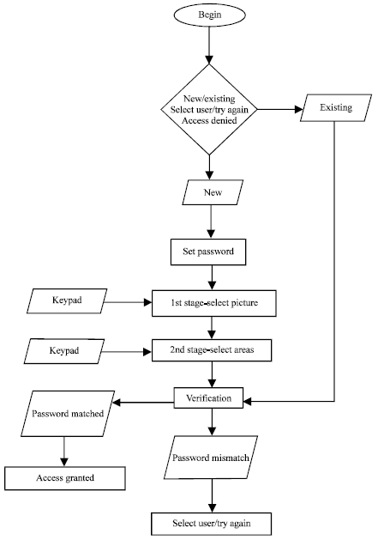

3.1.2 CASE DIAGRAM

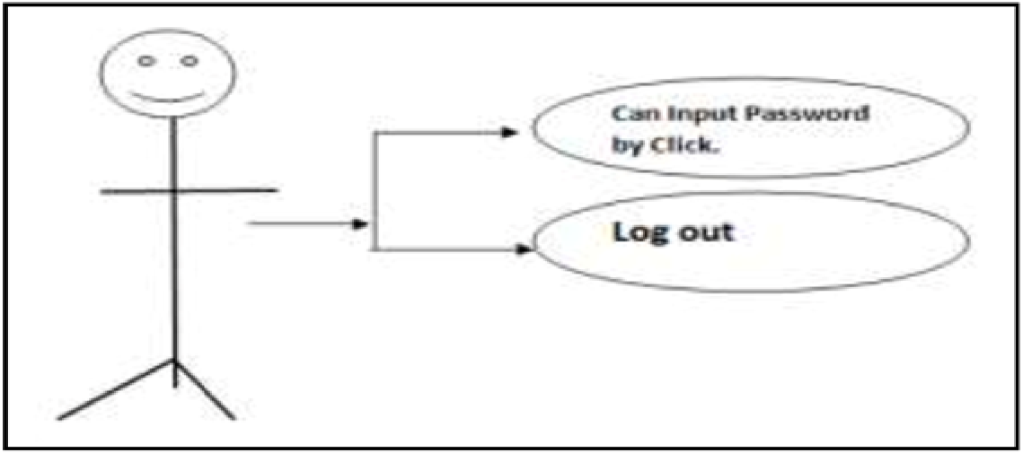

3.1.3 UML DIAGRAM

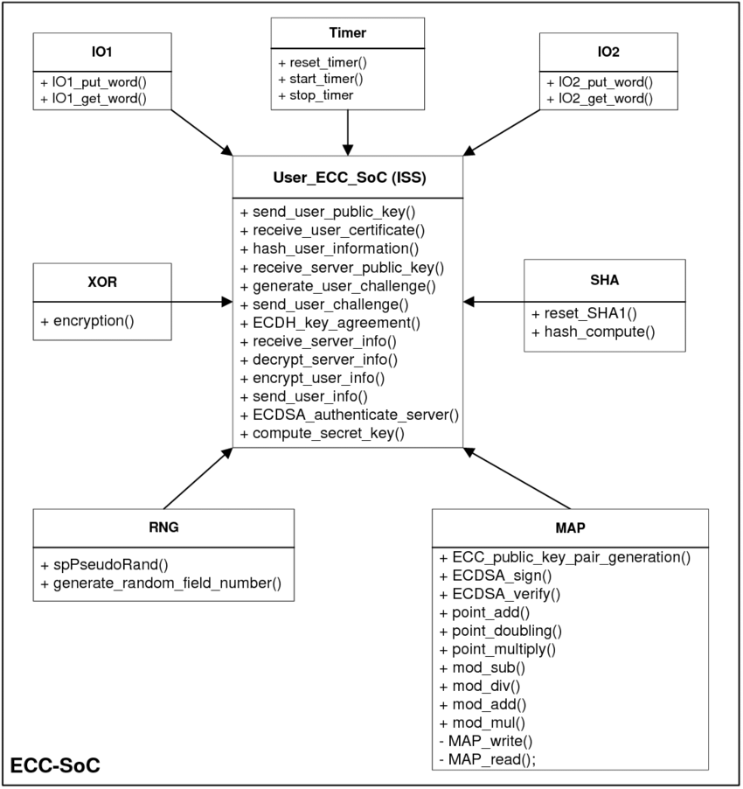

3.2 PHYSICAL DESIGN
3.2.1 DATABASE DESIGN

ADO.NET and accessing the database through applets and ADO.NET API via an intermediate server resulted server resulted in a new type of database model which is different from the client-server model. Based on number of intermediate server through the request should go it is named as single tire, two tire and multi tire architecture
3.3 INPUT DESIGN
Input of the application is uploading image file for graphical image authentication .
3.4 OUTPUT DESIGN
Using Image we extract the pixel as password and stored in server based on username. Based on the registration login will happen with pixel based password authentication. If authentication success user will allow to store the value in server in secure manner.

TESTING AND IMPLEMENTATION

CHAPTER 4
TESTING AND IMPLEMENTATION
  - TESTING
4.1.1 BLACK BOX TESTING
Black box testing is defined as a testing technique in which functionality of the Application under Test (AUT) is tested without looking at the internal code structure, implementation details and knowledge of internal paths of the software. This type of testing is based entirely on software requirements and specifications. In Black Box Testing we just focus on inputs and output of the software system without bothering about internal knowledge of the software program.
4.1.2 WHITE BOX TESTING
White box testing is a software testing method in which the internal structure/design/implementation of the item being tested is known to the tester. The tester chooses inputs to exercise paths through the code and determines the appropriate outputs. Programming know-how and the implementation knowledge is essential. White box testing is testing beyond the user interface and into the nitty-gritty of a system.
4.1.3 UNIT TESTING
The goal of unit testing to separate each part of the program and test that the individual parts are working correctly and as intended. While performing unit tests, application code functions are executed in a test environment with sample input. The output obtained is then compared with the expected output for that input. If they match the test passes. If not it is a failure. Unit tests are great for confirming the correctness of the code. Let’s take a look at a sample algorithm that illustrates the concept.
.4.2 SYSTEM IMPLEMENTATION
Implementation is the stage of the project when the theoretical design is turned into a working system. This is the final and important phase in the system life cycle It is actually the process of converting the new system into a operational one.

CONCLUSION

CHAPTER 5
CONCLUSION AND FUTURE ENHANCEMENT
5.1 CONCLUSION
In this abstract we are trying to make our authentication system more user friendly and also we have tried to implement mature & fast Shoulder Surfing Resistant Mechanism. We have considered graphical based systems and tried to reduce the efforts required by end-user to remember passwords. A look at the advancement in technology over the past few years tells us that the next era will have system security at its core. Thus Graphical Password may be accepted in future as a major authentication system.
5.2 FUTURE ENHANCEMENTS
In the pictures examination found that there were not many critical contrasts among a few pictures of ordinary scenes. Utilizing direction from brain science just as instinct one might probably pick pictures that are adequately great secret key pictures and maintain a strategic distance from even from a pessimistic standpoint pictures that meddle with memo ability. In any case, further work on secret key pictures is expected to decide to what degree pictures have "problem areas" that pull in numerous clients to pick secret phrase focuses in a similar little regions. In the event that problem areas happen regularly, at that point they diminish entropy of the framework. This wonder has been appeared in face acknowledgment graphical passwords, yet the threat might be less in our framework with great selection of pictures to keep away from problem areas. We intend to start concentrating problem areas by gathering countless secret key focuses on different pictures.

5.3 REFERENCE BOOKS

[1] "Fundamentals of information systems security/access con-trol systems -Wikibooks, open books for an open world,” [Online]. Available: https://en.wikibooks.org/wiki/Fundamentals_of_Information_Systems_Security/Access_Control_Systems. Accessed: Jan. 22, 2017.

[2] X. Suo, Y. Zhu, and G. S. Owen, "Graphical passwords: A survey," 21st Annual Computer Security Applications Conference (ACSAC’05).

[3] M. S. B. Sahu, and A. Singh, "Survey on various techniques of user authentication and graphical Password," International Journal of Computer Trends and Technology, vol. 16, no. 3, pp. 98–102, Oct. 2014.

[4] "Password," in Wikipedia, Wikimedia Foundation, 2017. [Online]. Available: https://en.wikipedia.org/wiki/Password. Accessed: Jan. 24, 2017.

[5] S. Ramanan, and B. J S, "A Survey on Different Graphical Password Authentication Techniques," International Journal of Innovative Research in Computer and Communication Engineering, vol. 2, issue 12, pp. 7594–7602, Dec. 2014.

[6] M. Burnett, and D. Kleimann, “Perfect passwords: Selection, protection, authentication,” United States: Syngress Media, U.S., 2005.

[7] H. A. Kute, and D. N. Rewadkar, "Continuous User Identity Verification Using Biometric Traits for Secure Internet Services," International Journal of Innovative Research in Computer and Communication Engineering, vol. 3, issue. 8, pp. 7352–7357, Aug.2015.

[8] A. H. Lashkari, A. Gani, L. G. Sabet, and S. Farmand, "A new algorithm on Graphical User Authentication (GUA) based on multi-line grids," Scientific Research and Essays, vol. 5(24), pp. 3865–3875, Dec. 2010.

