Development of business models for collection and utilization of single use plastics and various other industrial wastes

ABSTRACT
This study reviews the scientific literature for business models contributing to sustainable plastic management and suggests avenues for future research. We define sustainable plastic management (SPM) as any technique along the waste hierarchy seeking to minimize the environmental damage of plastic material. Limited cases were found during the literature review, whereas many more SPM business models exist in practice, signaling a research gap. Forty-four scientifically documented business models were identified and analyzed on the basis of business model component, sustainability, level of waste hierarchy and sustainable business model archetype. Our results suggest that business models focus on recycling and creating value from waste, as well as the development of bioplastic. Few cases qualified as triple bottom line businesses, as many reported environmental and economic, but not social, benefits. Circular economy business models were found in a quarter of all cases. Finally, we present a synthesis of the barriers and opportunities for sustainable plastic management by the private sector. Drivers include maintaining competitive advantage, accessing green customers, collaboration with stakeholders, and achieving efficiency improvements. Barriers frequently mentioned were high costs, complexity of new systems, supply chain lock-in and low customer buy-in. Further research should expand the scale of SPM research, identify the enabling conditions for sustainable plastic management, and determine environmental impact.
CHAPTER 2
2. SYSTEM ANALYSIS
  - EXISTING SYSTEM

- This highlights the urgent need to restructure existing recycling systems and policies on the production of plastic and its disposal.
- A variety of regulatory and legislative tools exists, aimed at controlling, reducing and managing the use of plastics, with a particular emphasis on single-use plastics.
- Existing legislation consists mainly of levies, bans, and voluntary efforts through the 3R rule: reduce, reuse and recycle. The features that are essential to biota are identical, as many organisms thrive in small bodies of water that exist at or just below the surface, rendering them essentially aquatic organisms.
2.1.1 DRAWBACKS OF EXISTING SYSTEM :
- The problem of plastics is situated in the global challenge of waste management which now confronts humanity.
- This development has since motivated greater global efforts into examining and exploring new technologies and innovative solutions to the problem.
- It is useful to noted that these same application advantages which have lend to the generation of massive waste and pollution issues at the global level .
2.2. PROPOSED SYSTEM
- The proposed approach aims mostly at educating the public to the dangers posed by plastic debris, especially in aquatic systems.
- In the proposed scenario, the use of intentionally added microplastics in consumer or professional products of any kind would be severely restricted.
- Multiple technologies exist for this purpose, such as thermochemical and catalytic conversion approaches. The non-profit company was closed but no other dedicated purpose was identified for the levy’s revenues.
2.2.1. ADVANTAGES OF PROPOSED SYSTEM
- The recovered plastic is made into goods with similar performance to those from virgin plastics. However, the quality of the scrap reintroduced has a bearing on the performance of the resulting product.
- Plastic recycling processes are largely focused on primary and secondary recycling methods thereby calling for growth in adoption of other recycling processes to improve the recycling capacity and efficiency.
- There are several techniques that can be applied to separate and sort plastic solid waste and these should be applied in the most efficient way during a short period of time so as to be cost effective.
2.3 FEASIBILITY STUDY
The feasibility Analysis is an analytical program through project manager determines the project success ratio and through feasibility study project manager able to see either project. The key considerations involved in the feasibility analysis are:
- Economic Feasibility
- Technical Feasibility
- Operational Feasibility
- Environmental Feasibility
2.3.1 ECONOMICAL FEASIBILITY
Hence this project is economically feasible there is no need to involve any cost for this project.
2.3.2 TECHNICAL FEASIBILITY
Software Technologies used are PHP and MySql. In the educational institutions, it is possible to update the system in future. No special hardware is required for the purpose of using this system. Hence it is declared that this project is technically feasible.
2.3.3 OPERATIONAL FEASIBILITY
As the admin work mainly to maintain the Patient and Doctor .Doctor will predict patient cancer disease. Hence it is easy to operate with training. Therefore it is operationally feasible for implementation.

2.3.4 ENVIRONMENTAL FEASIBILITY
This project environment is correct as a admin has developed this system and no expenditure is involved under any head and this process is part of admin document management, this project environment is accessible.
2.4 SYSTEM REQUIREMENTS
- System : Pentium IV 2.4 GHz.
- Hard Disk : 40 GB.
- Monitor : 15 inch VGA Color.
- Mouse : Logitech Mouse.
- Ram : 512 MB
- Keyboard : Standard Keyboard

2.4.1 HARDWARE REQUIREMENTS
The Hardware of the computer consists of physical component such as Input Devices, Storage Devices, Processing & Control units and Output Devices. Computer includes external storage unit to store data in programs.
The Hardware Configuration involved in this project
- System : Pentium IV 2.4 GHz.
- Hard Disk : 40 GB.
- Monitor : 15 inch VGA Color.
- Mouse : Logitech Mouse.
- Ram : 512 MB
- Keyboard : Standard Keyboard

2.4.2 SOFTWARE REQUIREMENTS
Software is a group of programs that computers need to do a particular task. It is an essential requirement of Computer System. The Software used to develop the project is
- Operating System : Windows XP.
- Platform : DOT NET TECHNOLOGY
- Front End : ASP.Net 3.5
- Back End : SQL SERVER 2005

CHAPTER 3
SYSTEM DESIGN AND DEVELOPEMENT
SYSTEM ARCHICTURE

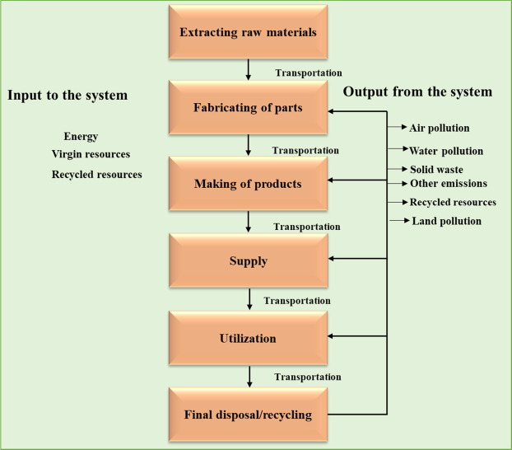

CHAPTER 4
TESTING AND IMPLEMENTATION

  - TESTING
Implementation is the stage of the project when the theoretical design is turned into a working system. This is the final and important phase in the system life cycle It is actually the process of converting the new system into a operational one.

4.1.1Unit Testing
Unit testing comprises the set of tests performed by an individual programmer prior to integration of the unit into a larger system. The module interface is tested to ensure that information properly flows into and out of the program unit. The local data structure is examined to ensure that data stored temporarily maintains its integrity during all steps in an algorithm’s execution. Boundary conditions are tested to ensure that the module operates properly at boundaries established to limit or restrict processing. All independent paths through the control structure are tested. All error-handling paths are tested.

4.1.2 Block Box Testing
Black-box testing is a method of software testing that examines the functionality of an application without peering into its internal structures or workings. This method of test can be applied virtually to every level of software testing: unit, integration, system and acceptance. It is sometimes referred to as specification-based testing.

4.2 SYSTEM IMPLEMENTATION
Implementation is the stage of the project when the theoretical design is turned into a working system. This is the final and important phase in the system life cycle It is actually the process of converting the new system into a operational one.

CHAPTER 5
CONCLUSION:
This study has synthesized the current scientific literature regarding business models for sustainable plastic management, or SPM, which we defined as an activity that minimizes the environmental damage of plastic material. The review found 20 academic articles referencing 44 unique SPM business models. The business models were coded and analyzed on the basis of the business model components, sustainability indicators, their position in the waste hierarchy, and categorized into sustainable archetypes. Additionally, drivers and barriers were identified and larger trends were addressed that promote or hinder SPM.

CHAPTER-6
REFERENCE
- Abdelkafi, N., Hansen, E.G., 2018. Ecopreneurs’ creation of user business models for green tech: an exploratory study in e-mobility. Int. J. Entrepreneurial Ventur. 10, 32e55.
- Alaerts, L., Augustinus, M., Van Acker, K., Alaerts, L., Augustinus, M., Van Acker, K., 2018. Impact of bio-based plastics on current recycling of plastics. Sustainability 10, 1487.
- Bergmann, M., Klages, M., Bergmann, M., Klages, M., 2015. Marine anthropogenic litter. https://doi.org/10.1007/978-3-319-16510-3.
- Betts, K., 2008. Why small plastic particles may pose a big problem in the oceans. Environ. Sci. Technol. 42.
- Chesbrough, H., 2010. Business model innovation: opportunities and barriers. Long. Range Plan. 43, 354e363.
- Engler, R.E., 2012. The complex interaction between marine debris and toxic chemicals in the ocean. Environ. Sci. Technol. 46, 12302e12315.
- Galloway, T.S., Cole, M., Lewis, C., 2017. Interactions of microplastic debris throughout the marine ecosystem. Nat. Ecol. Evol. 1 https://doi.org/10.1038/ s41559-017-0116, 0116.
- Geissdoerfer, M., Vladimirova, D., Evans, S., 2018. Sustainable business model innovation: a review. J. Clean. Prod. 198, 401e416.
- Høgevold, N.M., 2011. A corporate effort towards a sustainable business model. Eur. Bus. Rev. 23, 392e400.
- Hoon, C., 2013. Meta-synthesis of qualitative case studies: an approach to theory building. Organ. Res. Methods 16, 522e556.

