Using food waste as consumable organic resource

ABSTRACT
Food wastage and its accumulation are becoming a critical problem around the globe due to continuous increase of the world population. The exponential growth in food waste is imposing serious threats to our society like environmental pollution, health risk, and scarcity of dumping land. There is an urgent need to take appropriate measures to reduce food waste burden by adopting standard management practices. Currently, various kinds of approaches are investigated in waste food processing and management for societal benefits and applications. Anaerobic digestion approach has appeared as one of the most ecofriendly and promising solutions for food wastes management, energy, and nutrient production, which can contribute to world’s ever-increasing energy requirements. Here, we have briefly described and explored the different aspects of anaerobic biodegrading approaches for food waste, effects of cosubstrates, effect of environmental factors, contribution of microbial population, and available computational resources for food waste management researches.

CHAPTER 2
2. SYSTEM ANALYSIS
  - EXISTING SYSTEM

- In contrast, interventions designed to prevent waste focus on the utility of existing goods as a way to improve resource efficiency.
- Waste management-exempt activities would impose the obligation on a smaller number of businesses, and could be introduced as part of the existing regulatory framework.
- It must promote the uptake of existing mainstream technologies and best practices, but also harness and guide the resource saving potential of disruptive innovations.
2.1.1 DRAWBACKS OF EXISTING SYSTEM :
- Incineration of food waste consisting high moisture content results in the release of dioxins which may further lead to several environmental problems.
- This food waste, which is a component of municipal solid waste, is incinerated or dumped in open area which may cause severe health and environmental issues.
- It would be useful to pay more attention to recovery processes for new and emerging materials and technologies, and there is a continued need to support research on problematic legacy wastes, especially from the nuclear industry.
2.2. PROPOSED SYSTEM
- We received showed a widespread concern about the proposed absence of planning at a level between the national and the local.
- The proposed actions were based on local resources, skills and infrastructure, the analysis produced a bespoke, sustainable solution that was grounded in the local context.
- This too will influence the balance of system maps because a failure to acknowledge the views of citizens can compromise the effectiveness of proposed interventions.
2.2.1. ADVANTAGES OF PROPOSED SYSTEM
- It was reported that the use of goat rumen fluid as inoculum at the rate of 8% (v/v) is very efficient for biogas production.
- The pH of bioreactor affects the microbial activity in anaerobic digestion and its efficiency.
- It has been reported that two-stage anaerobic digestion is providing more efficient operation as compared to single stage.
- Microbial community analysis, investigating the composition and behaviour of microbial communities, can be helpful to optimize stable and efficient process operation.

2.3 FEASIBILITY STUDY
The feasibility Analysis is an analytical program through project manager determines the project success ratio and through feasibility study project manager able to see either project. The key considerations involved in the feasibility analysis are:
- Economic Feasibility
- Technical Feasibility
- Operational Feasibility
- Environmental Feasibility
2.3.1 ECONOMICAL FEASIBILITY
Hence this project is economically feasible there is no need to involve any cost for this project.
2.3.2 TECHNICAL FEASIBILITY
Software Technologies used are PHP and MySql. In the educational institutions, it is possible to update the system in future. No special hardware is required for the purpose of using this system. Hence it is declared that this project is technically feasible.
2.3.3 OPERATIONAL FEASIBILITY
As the admin work mainly to maintain the Patient and Doctor .Doctor will predict patient cancer disease. Hence it is easy to operate with training. Therefore it is operationally feasible for implementation.
2.3.4 ENVIRONMENTAL FEASIBILITY
This project environment is correct as a admin has developed this system and no expenditure is involved under any head and this process is part of admin document management, this project environment is accessible.

2.4 SYSTEM REQUIREMENTS
- System : Pentium IV 2.4 GHz.
- Hard Disk : 40 GB.
- Monitor : 15 inch VGA Color.
- Mouse : Logitech Mouse.
- Ram : 512 MB
- Keyboard : Standard Keyboard

2.4.1 HARDWARE REQUIREMENTS
The Hardware of the computer consists of physical component such as Input Devices, Storage Devices, Processing & Control units and Output Devices. Computer includes external storage unit to store data in programs.
The Hardware Configuration involved in this project
- System : Pentium IV 2.4 GHz.
- Hard Disk : 40 GB.
- Monitor : 15 inch VGA Color.
- Mouse : Logitech Mouse.
- Ram : 512 MB
- Keyboard : Standard Keyboard

2.4.2 SOFTWARE REQUIREMENTS
Software is a group of programs that computers need to do a particular task. It is an essential requirement of Computer System. The Software used to develop the project is
- Operating System : Windows XP.
- Platform : DOT NET TECHNOLOGY
- Front End : ASP.Net 3.5
- Back End : SQL SERVER 2005

CHAPTER 3
SYSTEM DESIGN AND DEVELOPEMENT
SYSTEM ARCHICTURE

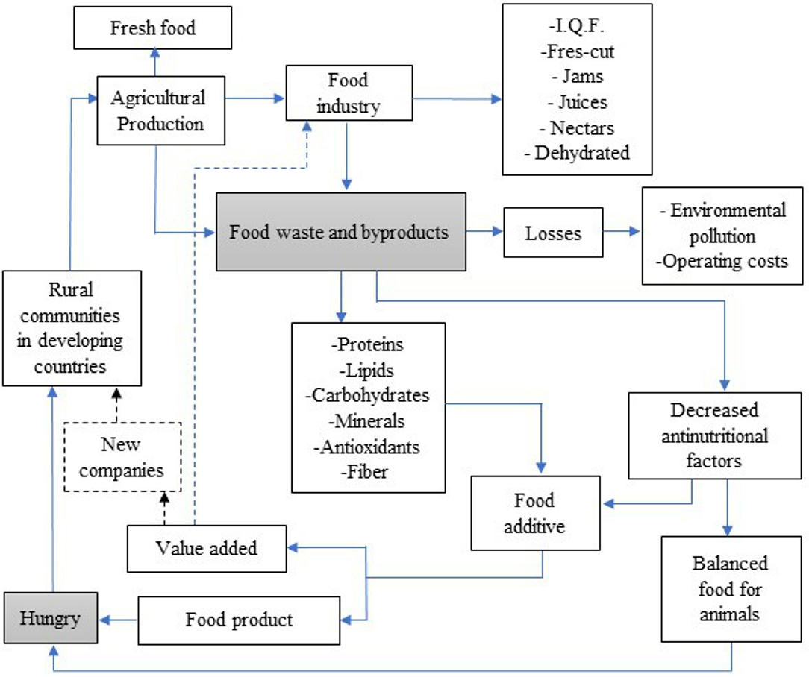

CHAPTER 4
TESTING AND IMPLEMENTATION

  - TESTING
Implementation is the stage of the project when the theoretical design is turned into a working system. This is the final and important phase in the system life cycle It is actually the process of converting the new system into a operational one.

4.1.1Unit Testing
Unit testing comprises the set of tests performed by an individual programmer prior to integration of the unit into a larger system. The module interface is tested to ensure that information properly flows into and out of the program unit. The local data structure is examined to ensure that data stored temporarily maintains its integrity during all steps in an algorithm’s execution. Boundary conditions are tested to ensure that the module operates properly at boundaries established to limit or restrict processing. All independent paths through the control structure are tested. All error-handling paths are tested.

4.1.2 Block Box Testing
Black-box testing is a method of software testing that examines the functionality of an application without peering into its internal structures or workings. This method of test can be applied virtually to every level of software testing: unit, integration, system and acceptance. It is sometimes referred to as specification-based testing.

4.2 SYSTEM IMPLEMENTATION
Implementation is the stage of the project when the theoretical design is turned into a working system. This is the final and important phase in the system life cycle It is actually the process of converting the new system into a operational one.

CHAPTER 5
CONCLUSION:
Proper disposal of food waste has posed a stern pecuniary and environmental concern. It appears that conversion of food waste into energy via anaerobic processes in terms of methane is economically viable. However, difficulties accompanying the collection as well as transportation of food waste should also be considered. Nevertheless, the stumpy or no cost of food waste along with the environmental aids considering the waste discarding would balance the initial high investment costs of the biorefineries. Moreover, the efficacy and cost base of the generation could be upgraded by intensifying research and optimization studies on assimilating different value-added product manufacturing processes.

CHAPTER-6
REFERENCE
- [1] FAO, Towards the Future we Want: End Hunger and Make the Transition to Sustainable Agricultural and Food Systems, Food and Agriculture Organization of the United Nations Rome, 2012.
- [2] M. Melikoglu, C. S. K. Lin, and C. Webb, “Analysing global food waste problem: pinpointing the facts and estimating the energy content,” Central European Journal of Engineering, vol. 3, no. 2, pp. 157–164, 2013.
- [3] A. Agarwal, A. Singhmar, M. Kulshrestha, and A. K. Mittal, “Municipal solid waste recycling and associated markets in Delhi, India,” Resources, Conservation and Recycling, vol. 44, no. 1, pp. 73–90, 2005.
- [4] FAO, FAOSTAT: World Food and Agriculture Statistical Yearbook, FAO-Food & Agriculture Organization of the United Nation, Rome, Italy, 2013.
- [5] I. M. Nasir, T. I. M. Ghazi, and R. Omar, “Production of biogas from solid organic wastes through anaerobic digestion: a review,” Applied Microbiology and Biotechnology, vol. 95, no. 2, pp. 321–329, 2012.
- [6] S. Pattnaik and M. V. Reddy, “Assessment of municipal solid waste management in Puducherry (Pondicherry), India,” Resources, Conservation and Recycling, vol. 54, no. 8, pp. 512– 520, 2010.
- [7] V. Talyan, R. P. Dahiya, and T. R. Sreekrishnan, “State of municipal solid waste management in Delhi, the capital of India,” Waste Management, vol. 28, no. 7, pp. 1276–1287, 2008.
- [8] T. Katami, A. Yasuhara, and T. Shibamoto, “Formation of dioxins from incineration of foods found in domestic garbage,” Environmental Science and Technology, vol. 38, no. 4, pp. 1062– 1065, 2004.
- [9] H. Ma, Q. Wang, D. Qian, L. Gong, and W. Zhang, “The utilization of acid-tolerant bacteria on ethanol production from kitchen garbage,” Renewable Energy, vol. 34, no. 6, pp. 1466– 1470, 2009.
- [10] T. N. B. Dung, B. Sen, C. C. Chen, G. Kumar, and C. Y. Lin, “Food waste to bioenergy via anaerobic processes,” Energy Procedia, vol. 61, pp. 307–312, 2014

