Tracking, reducing and reusing of plastic waste

ABSTRACT
The quantities of plastic wastes discarded and the fate of various plastics in the environment. Our Interactive Qualifying Project was concerned with researching the possible alternatives to plastics, mainly biodegradable plastics that have been claimed to biodegrade and help environment. Moreover, it was also required to evaluate the best methods to deal with our plastic wastes that are environmentally, economically, and energywise viable.

CHAPTER 2
2. SYSTEM ANALYSIS
  - EXISTING SYSTEM

- Within a game-like context, pupils can experience in-person in the simulation of certain existing systems.
- Waste collection systems are seemingly failing to deal with waste resulting from this culture. Poor waste management systems also compound to this problem or nonexistence of enforcements or absence of substitute materials.
- To achieve the closed-loop use of resources of a circular economy in plastic waste management, there should exist genuine cooperation between all sectors of a society.
2.1.1 DRAWBACKS OF EXISTING SYSTEM :
- Their recycling is a challenge in itself, and the fact that used plastics tossed into land never degrade adds to the problem.
- Long-term lead poisoning has many severe health impacts like a decrease in bone growth and muscle development, damaged nervous system, speech and language problems, unconsciousness etc.
- It has the potential to cause reproductive and developmental problems in women, nervous system disorders.
2.2. PROPOSED SYSTEM
- Recycling is the process of converting the old and used materials/components/items/parts for a new use, for the same purpose or for some other purpose.
- After plastic packaging materials have served their purpose, the bulk of them are disposed and become post-consumer waste. A wholistic approach to waste management will need to involve all stakeholders working to achieve a circular economy.
- Food packaging has evolved to be a key aspect to successful food industries serving fast foods, ready meals, on-the-go beverages and snacks among others.
2.2.1. ADVANTAGES OF PROPOSED SYSTEM
- These plastics can be programmed to degrade in the desired amount of time while being manufactured which gives them advantage from conventional plastics.
- A major advantage that can result from this would be that the food wasted in these areas can be directly diverted to commercial composting facilities.
- It has been involved in raising awareness in people about adverse effects of traditional plastics and advantages of biodegradable plastics.

2.3 FEASIBILITY STUDY
The feasibility Analysis is an analytical program through project manager determines the project success ratio and through feasibility study project manager able to see either project. The key considerations involved in the feasibility analysis are:
- Economic Feasibility
- Technical Feasibility
- Operational Feasibility
- Environmental Feasibility
2.3.1 ECONOMICAL FEASIBILITY
Hence this project is economically feasible there is no need to involve any cost for this project.
2.3.2 TECHNICAL FEASIBILITY
Software Technologies used are PHP and MySql. In the educational institutions, it is possible to update the system in future. No special hardware is required for the purpose of using this system. Hence it is declared that this project is technically feasible.
2.3.3 OPERATIONAL FEASIBILITY
As the admin work mainly to maintain the Patient and Doctor .Doctor will predict patient cancer disease. Hence it is easy to operate with training. Therefore it is operationally feasible for implementation.
2.3.4 ENVIRONMENTAL FEASIBILITY
This project environment is correct as a admin has developed this system and no expenditure is involved under any head and this process is part of admin document management, this project environment is accessible.

2.4 SYSTEM REQUIREMENTS
- System : Pentium IV 2.4 GHz.
- Hard Disk : 40 GB.
- Monitor : 15 inch VGA Color.
- Mouse : Logitech Mouse.
- Ram : 512 MB
- Keyboard : Standard Keyboard

2.4.1 HARDWARE REQUIREMENTS
The Hardware of the computer consists of physical component such as Input Devices, Storage Devices, Processing & Control units and Output Devices. Computer includes external storage unit to store data in programs.
The Hardware Configuration involved in this project
- System : Pentium IV 2.4 GHz.
- Hard Disk : 40 GB.
- Monitor : 15 inch VGA Color.
- Mouse : Logitech Mouse.
- Ram : 512 MB
- Keyboard : Standard Keyboard

2.4.2 SOFTWARE REQUIREMENTS
Software is a group of programs that computers need to do a particular task. It is an essential requirement of Computer System. The Software used to develop the project is
- Operating System : Windows XP.
- Platform : DOT NET TECHNOLOGY
- Front End : ASP.Net 3.5
- Back End : SQL SERVER 2005

CHAPTER 3
SYSTEM DESIGN AND DEVELOPEMENT
SYSTEM ARCHICTURE

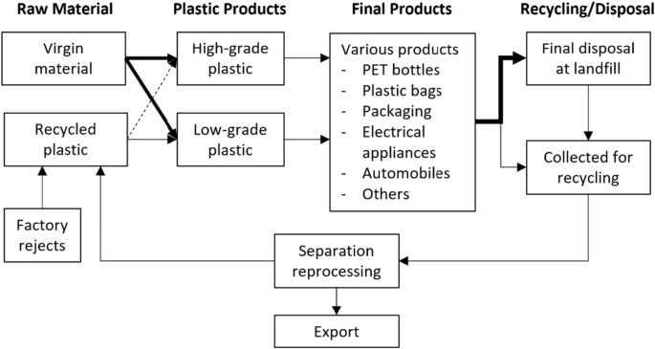

CHAPTER 4
TESTING AND IMPLEMENTATION

  - TESTING
Implementation is the stage of the project when the theoretical design is turned into a working system. This is the final and important phase in the system life cycle It is actually the process of converting the new system into a operational one.

4.1.1Unit Testing
Unit testing comprises the set of tests performed by an individual programmer prior to integration of the unit into a larger system. The module interface is tested to ensure that information properly flows into and out of the program unit. The local data structure is examined to ensure that data stored temporarily maintains its integrity during all steps in an algorithm’s execution. Boundary conditions are tested to ensure that the module operates properly at boundaries established to limit or restrict processing. All independent paths through the control structure are tested. All error-handling paths are tested.

4.1.2 Block Box Testing
Black-box testing is a method of software testing that examines the functionality of an application without peering into its internal structures or workings. This method of test can be applied virtually to every level of software testing: unit, integration, system and acceptance. It is sometimes referred to as specification-based testing.

4.2 SYSTEM IMPLEMENTATION
Implementation is the stage of the project when the theoretical design is turned into a working system. This is the final and important phase in the system life cycle It is actually the process of converting the new system into a operational one.

CHAPTER 5
CONCLUSION:
Plastic takes up large part of society, from plastics used for furniture, electronics, to small households needs like containers and grocery bags. Since plastic first became available to consumers, it became widely used, due to the advantages it provides, such as lightweight, durability and its ability to mold into any products with chemicals and additives. However, there are also a number of disadvantages that plastic poses, including health problems starting from manufacturing to consumption and negative environmental impacts created by accumulation of plastic wastes.

CHAPTER-6
REFERENCE
- AggRegain. Terminology. 2009. http://www.aggregain.org.uk/terminology/recyclate.html (accessed April 2009).
- Bottle Bill Resource Guide. 2007. http://www.bottlebill.org/ (accessed September 9, 2008).
- Burns, Loree Griffin. Tracking Trash: Flotsam, Jetsam, and the Science of Ocean Motion. Boston: Houghton Mifflin Company, 2007.
- Callister and David G. Rethwisch, 553. Hoboken, NJ: John Wiley & Sons, 2008.
- Choi, Charles Q. "New Biodegradable Plastics Could Be Tossed into the Sea." LIVESCIENCE. march 27, 2007.
- Environmental Protection Agency. "Municipal Solid Waste in the United States." 2007 Facts and Figures. November 2008.
- EPA. 2006 MSW Characterization Data Tables. Washington, DC, November 2007.
- Kissell, Joe. Biodegradable Plastic-The Quest of Impermanence. Paris, May 5, 2005. Marshall, Jessica. Discovery. August 21, 2008.
- Nolan-ITU Pty Ltd. Biodegradable Plastics - Developments and Environmental Impacts. october 2002.
- Szabo, Liz. Heat causes chemical to leach from plastic. Virginia: USA Today, 2008.

