Suggest an improvised of tackling the issue of creating a consistent supply chain to augment the use of Bio fuels

ABSTRACT
The rapidly growing biofuel industry poses considerable challenges to its supply chain network design and operations. In this chapter, we introduce key characteristics of the biofuel supply chain that comprises of feedstock production, biomass logistics, biofuel production and distribution. We then discuss the recent literature on biofuel supply chain models. Using an illustrative biofuel supply chain model to facilitate the understanding of the core trade-offs in this context, we discuss various issues including logistics network optimization, transportation and inventory management, uncertainty management, land use competition, governmental policies, and the resulting environmental and social impacts.

CHAPTER 2
2. SYSTEM ANALYSIS
  - EXISTING SYSTEM

- In addition, first generation biofuels require changes in the existing transportation infrastructure such as modifications to vehicle engines and fuel pipelines.
- Environmentally conscious development of emerging biofuel pathways requires addressing alternatives that exist at each step along the life cycle with the possibility of a multitude of useful coproducts and waste streams.
- Several existing modeling approaches for sustainable chemical production and their applications at multiple scales ranging from metabolism, to the life cycle, to ecosystems, and proposed a multi-scale approach integrating these models into a single cohesive framework.
2.1.1 DRAWBACKS OF EXISTING SYSTEM :
- The farmland use competition in the context of biofuel supply chains is typically captured by formulation into a bi-level optimization problem, or one with equilibrium constraints.
- A multi-objective problem can be transformed into one with a single objective by aggregating multiple objectives with proper weights based on the decision maker’s utility.
- In a similar vein, also consider the supply chain design problems with different model features, the former incorporating the carbon trading effect and the latter focusing on a specific feedstock from hybrid poplar.
2.2. PROPOSED SYSTEM
- The proposed framework synthesizes results obtained from models/methods across disciplines and scales to inform process design and decision-making.
- The proposed framework considers multi-objective optimization over the broader superstructure to identify supply chain configurations that optimize ecological and economic performance while simultaneous achieving minimum threshold sustainability criteria.
- Their proposed integrated catalytic system eliminates the need for an external source of hydrogen.
2.2.1. ADVANTAGES OF PROPOSED SYSTEM
- A biofuel supply chain involves various distinct stages with different ownership entities such as farmers, biorefineries, distributors, and oil companies, and its performance highly depends on the network design, planning, and operations.
- However, regardless of their sources, ethanol at this stage must satisfy all specific fuel criteria to offer the same performance as a regular fuel.
- While technological and engineering advancements are key to the success of biofuel industry, providing an efficient and reliable supply chain network design and operations is another critical component to its success.
2.3 FEASIBILITY STUDY
The feasibility Analysis is an analytical program through project manager determines the project success ratio and through feasibility study project manager able to see either project. The key considerations involved in the feasibility analysis are:
- Economic Feasibility
- Technical Feasibility
- Operational Feasibility
- Environmental Feasibility
2.3.1 ECONOMICAL FEASIBILITY
Hence this project is economically feasible there is no need to involve any cost for this project.
2.3.2 TECHNICAL FEASIBILITY
Software Technologies used are PHP and MySql. In the educational institutions, it is possible to update the system in future. No special hardware is required for the purpose of using this system. Hence it is declared that this project is technically feasible.
2.3.3 OPERATIONAL FEASIBILITY
As the admin work mainly to maintain the Patient and Doctor .Doctor will predict patient cancer disease. Hence it is easy to operate with training. Therefore it is operationally feasible for implementation

2.3.4 ENVIRONMENTAL FEASIBILITY
This project environment is correct as a admin has developed this system and no expenditure is involved under any head and this process is part of admin document management, this project environment is accessible.
2.4 SYSTEM REQUIREMENTS
- System : Pentium IV 2.4 GHz.
- Hard Disk : 40 GB.
- Monitor : 15 inch VGA Color.
- Mouse : Logitech Mouse.
- Ram : 512 MB
- Keyboard : Standard Keyboard

2.4.1 HARDWARE REQUIREMENTS
The Hardware of the computer consists of physical component such as Input Devices, Storage Devices, Processing & Control units and Output Devices. Computer includes external storage unit to store data in programs.
The Hardware Configuration involved in this project
- System : Pentium IV 2.4 GHz.
- Hard Disk : 40 GB.
- Monitor : 15 inch VGA Color.
- Mouse : Logitech Mouse.
- Ram : 512 MB
- Keyboard : Standard Keyboard

2.4.2 SOFTWARE REQUIREMENTS
Software is a group of programs that computers need to do a particular task. It is an essential requirement of Computer System. The Software used to develop the project is
- Operating System : Windows XP.
- Platform : DOT NET TECHNOLOGY
- Front End : ASP.Net 3.5
- Back End : SQL SERVER 2005

CHAPTER 3
SYSTEM DESIGN AND DEVELOPEMENT
SYSTEM ARCHICTURE

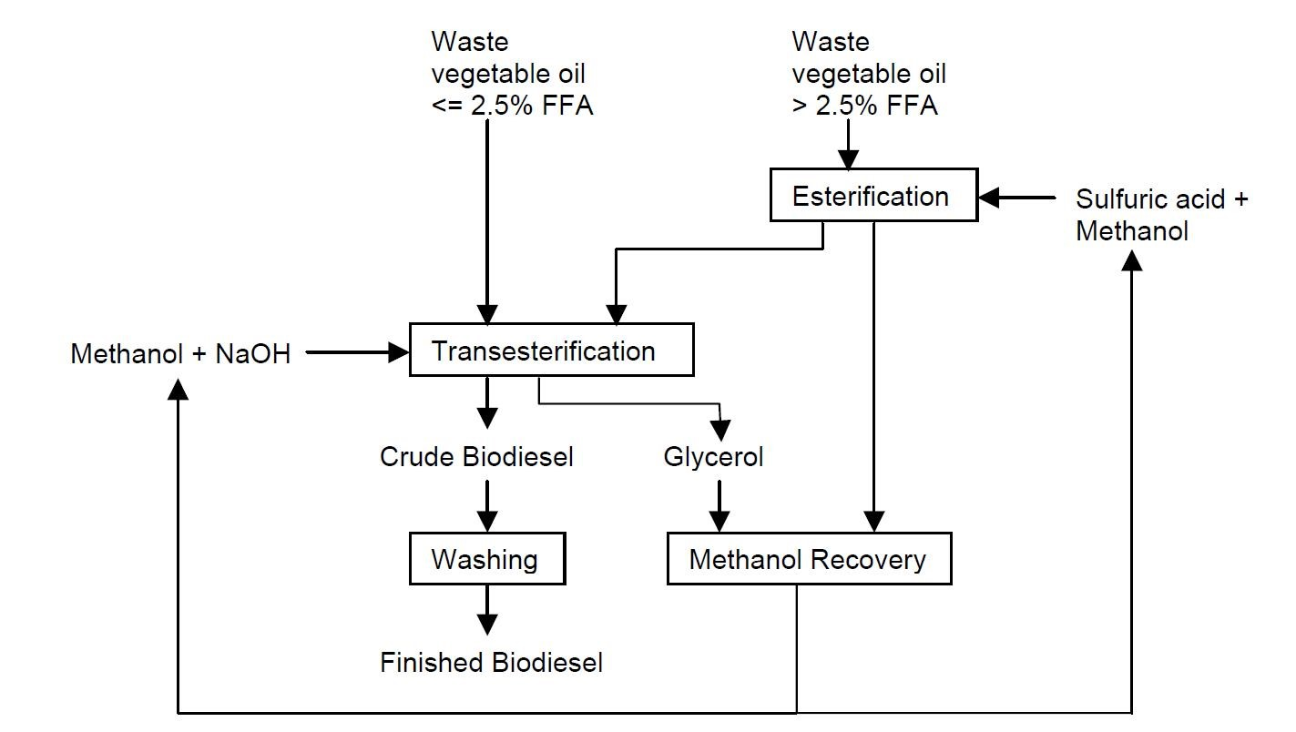

CHAPTER 4
TESTING AND IMPLEMENTATION

  - TESTING
Implementation is the stage of the project when the theoretical design is turned into a working system. This is the final and important phase in the system life cycle It is actually the process of converting the new system into a operational one.

4.1.1Unit Testing
Unit testing comprises the set of tests performed by an individual programmer prior to integration of the unit into a larger system. The module interface is tested to ensure that information properly flows into and out of the program unit. The local data structure is examined to ensure that data stored temporarily maintains its integrity during all steps in an algorithm’s execution. Boundary conditions are tested to ensure that the module operates properly at boundaries established to limit or restrict processing. All independent paths through the control structure are tested. All error-handling paths are tested.

4.1.2 Block Box Testing
Black-box testing is a method of software testing that examines the functionality of an application without peering into its internal structures or workings. This method of test can be applied virtually to every level of software testing: unit, integration, system and acceptance. It is sometimes referred to as specification-based testing.

4.2 SYSTEM IMPLEMENTATION
Implementation is the stage of the project when the theoretical design is turned into a working system. This is the final and important phase in the system life cycle It is actually the process of converting the new system into a operational one.

CHAPTER 5
CONCLUSION:
Biofuel is an alternative energy fuel that is converted from naturally grown renewable resources. With compelling benefits and potential over the economic, environmental, and social dimensions, it is deemed as one of the most promising and ideal alternatives for transportation fuel. To this end, governments around the world, including the U.S., are strongly supporting the development of biofuel production with various policies and regulations including mandate and subsidy programs. While technological and engineering advancements are key to the success of biofuel industry, providing an efficient and reliable supply chain network design and operations is another critical component to its success. This chapter provides an introduction to the nascent biofuel production industry and key features and issues of its biofuel supply chain. Starting from a basic supply chain design model, we review fundamental trade-offs and the main design and operational issues that rise in a biofuel supply chain and the related economic, social, and environmental contexts.

CHAPTER-6
REFERENCE
- 1. U.S. Department of Energy (2005) Biomass as feedstock for a bioenergy and bioproducts industry: The technical feasibility of a billion-ton annual supply. Oak Ridge National Laboratory. http://www1.eere.energy.gov/bioenergy/pdfs/final billionton vision report2.pdf
- 2. U.S. Department of Energy (2011) U.S. Billion-ton update. Oak Ridge National Laboratory. http://www1.eere.energy.gov/bioenergy/pdfs/billion ton update.pdf
- 3. National Research Council of the National Academies (2011) Renewable fuel standard: potential economic and environmental effects of U.S. biofuel policy. National Academies Press, Washington, D.C.
- 4. Environmental Protection Agency (2014) Renewable Fuels: Regulations and Standards. http://www.epa.gov/otaq/fuels/renewablefuels/index.htm
- 5. Shastri Y, Hansen A, Rodriquez L, Ting KC (2014) Engineering and Science of Biomass Feedstock Production and Provision. Springer, New York.
- 6. U.S. Energy Information Administration (2014) Data for petroleum and other liquids. http://www.eia.gov/petroleum/data.cfm
- 7. Energy Independence and Security Act (2007) Public Law. 110–140 http://www.gpo.gov/fdsys/pkg/PLAW-110publ140/html/PLAW-110publ140.htm
- 8. USDA Farm Service Agency (2014) Biomass Crop Assistance Program. http://www.fsa.usda.gov/FSA/webapp?area=home&subject=ener&topic=bcap
- 9. Wakeley HL, Hendrickson CT, Griffin WM, Matthews HS (2009) Economic and environmental transportation effects of large-scale ethanol production and distribution in the United States. Environ Sci Technol 43(7): 2228–2233
- 10. Papapostolou C, Kondili E, Kaldellis JK (2011) Development and implementation of an optimisation model for biofuels supply chain. Energy 36(10):6019–6026

