SMART PILL BOX SYSTEM FOR BIPOLAR DISORDER PEOPLE

ABSTRACT
The main purpose of the Smart Pill Box System project is helping patients with bipolar disorder or other illnesses to create their motivation to take medicine. Moreover, caregivers can take care of the patients more conveniently. Patients can use the application to setup the notification time for medication. Then the application will send the preset value to the pillbox system. The application will give an alert when it is time to take the medicine. In addition, when patients pick up the medicine from the pillbox system, they will receive points which will represent by the growing tree. Nevertheless, if the patient does not pick up the medicine within limited time, a notification will be sent to the caregiver to take further actions.

CHAPTER 2
2. SYSTEM ANALYSIS
  - EXISTING SYSTEM

- Pill boxes already exist but most of them are either has limited use, doesn’t fit for elder ages or even has a big size that makes it not suitable to take it with you anywhere.
- It helps the patients as well as the overseers of the patient by helping perfect add up to remember medication at the correct time.
- An assistive devices, smart pill boxes (SPB) such as Tricella, Pilldrill, Medfoliopillbox, E-Pill- multiplus, and E-Pill-Medsmartplus, which allow family members of the elderly to monitor whether medication has been taken or not to ensure effective health maintenance.
2.1.1 DRAWBACKS OF EXISTING SYSTEM :
- There are many suicide problems. Although the reasons for suicide are various, which are sensitive issues, one of the main reasons for suicide is depression.
- The advantages of the slot based sensing is that individual moment sensing is possible for detecting over dosage problems and incorrect dosage issues.
- It does not face the problem of inappropriate blockage of light or triggering due to external sources of light.
2.2. PROPOSED SYSTEM
- The proposed system is designed to help these patients to take the required medicine in the right proportion at the right time.
- In, an electronic pillbox called MedTracker was proposed; in the MedTracker, the time at which each lid was opened or closed is recorded, and transmitted to PC via a Bluetooth link.
- In, developed a medication safety and to avoid confusion in taking tablet among the elderly, this paper proposed a smart pillbox with remind and confirm functions. The proposed pill box can reduce family member’s responsibility towards ensuring the correct and timely consumption of medicines.
2.2.1. ADVANTAGES OF PROPOSED SYSTEM
- The current common techniques used in market for the reminder includes the normal alarm with a pill box.
- The Capacitive based Sensor was inalized ater the above testing owing to it its cheap and all time operation advantage over the light based sensor.
- It is a advantageous, secure and automated solution that organizes, reminds and dispenses medications so the patient can take medicine properly and on-time. To provides fast curing of patient health by using our advantageous system.

Literature Survey:
TITLE | AUTHORS | DESCRIPTION
Hopelessness depression: A theory-based subtype of depression | L. Y. Abramson, G. I. Metalsky, and L. B.Alloy. | If it is very short, then a major challenge will be to develop methods with sufficient temporal resolving power to determine if hopelessness indeed precedes the occurrence of the hypothesized symptoms of hopelessness depression
Depression: Causes and treatment | A. T. Beck and B. A. Alford. | Some scholars ensure that depression is a psychogenic disorder, while others claim that it is caused by organic factors
Smart Medicine Reminder Box | S. Bhati, H. Soni, V. Zala, P. Vyas, andM. Y. Sharma. | It is compulsory for the patient to take pills from the box at the right time otherwise our systems continues to make large sound until the medicine is taken out from the box.
Treatment of bipolar disorder | J. R. Geddes and D. J. Miklowitz. | The development of future treatments should consider both the neurobiological and psychosocial mechanisms underlying the disorder.

2.3 FEASIBILITY STUDY
The feasibility Analysis is an analytical program through project manager determines the project success ratio and through feasibility study project manager able to see either project. The key considerations involved in the feasibility analysis are:
- Economic Feasibility
- Technical Feasibility
- Operational Feasibility
- Environmental Feasibility
2.3.1 ECONOMICAL FEASIBILITY
Hence this project is economically feasible there is no need to involve any cost for this project.
2.3.2 TECHNICAL FEASIBILITY
Software Technologies used are PHP and MySql. In the educational institutions, it is possible to update the system in future. No special hardware is required for the purpose of using this system. Hence it is declared that this project is technically feasible.
2.3.3 OPERATIONAL FEASIBILITY
As the admin work mainly to maintain the Patient and Doctor .Doctor will predict patient cancer disease. Hence it is easy to operate with training. Therefore it is operationally feasible for implementation.
2.3.4 ENVIRONMENTAL FEASIBILITY
This project environment is correct as a admin has developed this system and no expenditure is involved under any head and this process is part of admin document management, this project environment is accessible.

2.4 SYSTEM REQUIREMENTS
- System : Pentium IV 2.4 GHz.
- Hard Disk : 40 GB.
- Monitor : 15 inch VGA Color.
- Mouse : Logitech Mouse.
- Ram : 512 MB
- Keyboard : Standard Keyboard

2.4.1 HARDWARE REQUIREMENTS
The Hardware of the computer consists of physical component such as Input Devices, Storage Devices, Processing & Control units and Output Devices. Computer includes external storage unit to store data in programs.
The Hardware Configuration involved in this project
- System : Pentium IV 2.4 GHz.
- Hard Disk : 40 GB.
- Monitor : 15 inch VGA Color.
- Mouse : Logitech Mouse.
- Ram : 512 MB
- Keyboard : Standard Keyboard

2.4.2 SOFTWARE REQUIREMENTS
Software is a group of programs that computers need to do a particular task. It is an essential requirement of Computer System. The Software used to develop the project is
- Operating System : Windows XP.
- Platform : DOT NET TECHNOLOGY
- Front End : ASP.Net 3.5
- Back End : SQL SERVER 2005

CHAPTER 3
SYSTEM DESIGN AND DEVELOPEMENT
SYSTEM ARCHICTURE

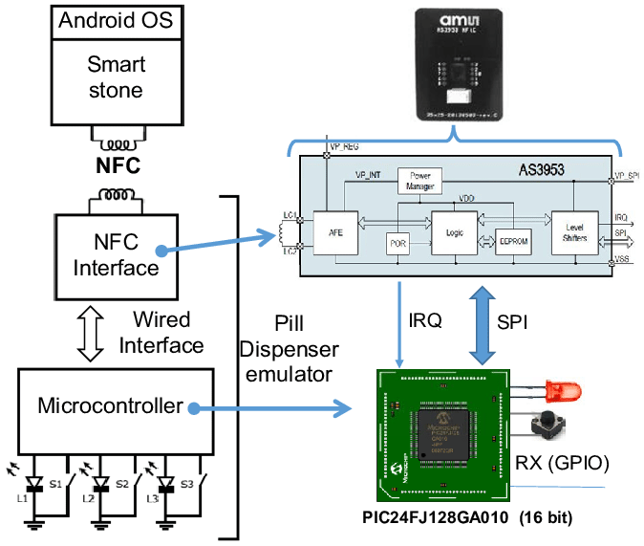B

CHAPTER 4
TESTING AND IMPLEMENTATION

  - TESTING
Implementation is the stage of the project when the theoretical design is turned into a working system. This is the final and important phase in the system life cycle It is actually the process of converting the new system into a operational one.

4.1.1Unit Testing
Unit testing comprises the set of tests performed by an individual programmer prior to integration of the unit into a larger system. The module interface is tested to ensure that information properly flows into and out of the program unit. The local data structure is examined to ensure that data stored temporarily maintains its integrity during all steps in an algorithm’s execution. Boundary conditions are tested to ensure that the module operates properly at boundaries established to limit or restrict processing. All independent paths through the control structure are tested. All error-handling paths are tested.

4.1.2 Block Box Testing
Black-box testing is a method of software testing that examines the functionality of an application without peering into its internal structures or workings. This method of test can be applied virtually to every level of software testing: unit, integration, system and acceptance. It is sometimes referred to as specification-based testing.

4.2 SYSTEM IMPLEMENTATION
Implementation is the stage of the project when the theoretical design is turned into a working system. This is the final and important phase in the system life cycle It is actually the process of converting the new system into a operational one.

CHAPTER 5
CONCLUSION:
In conclusion, this research aims to build the system that can help the bipolar disorder patients to gain motivation in taking medication. Moreover, caregivers can easily monitor and take care of patient. The system is created by using simple equipment and sensors. Therefore, the whole system cost is very low comparing with other commercial systems. Moreover, the growing tree animation is used to increase the motivation and help changing the behaviors of the patient. Besides, the system can send out the notification through the user LINE application which is one of the popular applications. Therefore, the system can easily integrate with the user application and receive the real time notification for taking a medication alert.

CHAPTER-6
REFERENCE
- [1] MED-Q Best Programmable PillDispenser - Watch the Video, URL https://medqpillbox.com/.
- [2] My Oasis :Calming and Relaxing, URL https://apps.apple.com/us/app/my-oasis-calming-andrelaxing/id1247889896.
- [3] Terrarium: Garden Idle, URL https://apps.apple.com/us/app/terrariumgarden-idle/id1401837582.
- [4] D. J. Miklowitz and S. L. Johnson. Bipolardisorder. John Wiley & Sons Inc, 2008.
- [5] L. Y. Abramson, G. I. Metalsky, and L. B.Alloy. Hopelessness depression: A theory-basedsubtype of depression. Psychological review, 96(2):358, 1989.
- [6] A. T. Beck and B. A. Alford. Depression:Causes and treatment. University of PennsylvaniaPress, 2009.
- [7] D. C. Jack. Silencing the self: Women and depression. Harvard University Press, 1991.
- [8] S. Bhati, H. Soni, V. Zala, P. Vyas, andM. Y. Sharma. Smart Medicine ReminderBox. IJSTE-International Journal of ScienceTechnology & Engineering, 3(10), 2017.
- [9] H. Grunze. Bipolar disorder. In Neurobiology ofbrain disorders, pages 655–673. Elsevier, 2015.
- [10] J. R. Geddes and D. J. Miklowitz. Treatment ofbipolar disorder. The lancet, 381(9878):1672–1682, 2013.

