HAZARDOUS GAS AND TEMPERATURE DETECTION IN MINING USING IOT

ABSTRACT
Eventually a day's a consequence of a general temperature alteration and atmosphere changes there are attempting conditions in field of coal mine. To decrease the cost and improve the productivity close by thing quality the atomization in the field of coal mine is irrefutably essential, which will in addition reduce the mine laborers endeavors. This paper proposes a structure of a WSN with the assistance of Raspberry pi processor which can screen the temperature, diligence, gas and status of smoke in an underground mine. This structure in addition controls the ventilation requesting to mine laborers relying upon present atmosphere conditions inside the mine field. This structure uses low force, practical Raspberry pi, and a temperature sensor LM35, clamminess sensor, and smoke sensor, gas sensor for recognizing the mine atmosphere parameters and Wi-Fi for remote logging of information at focal locale to control the air state with the assistance of engine and valve control hardware. Standard coal mine watching structures will all things considered be wired structure frameworks, which anticipate an enormous action in coal mine guaranteed creation.

CHAPTER 2
2. SYSTEM ANALYSIS
  - EXISTING SYSTEM

- We are working on modifies the existing safety model installed in the industrial areas and this system can also be used in houses and offices.
- We are working on a project in which we are using new technology which is being used to make every existing digital system more smart, internet of things (iot).
- When the target combustible gas exist, the sensors conductivity is higher along with the gas concentration rising.
2.1.1 DRAWBACKS OF EXISTING SYSTEM :
- The use of Air Conditioner (A/C) in the cars is more often this is dangerous to outer environment causing Global Warming like problems but as well as it affects the inner environment of a car.
- It causes problems like decrease in the oxygen level around 15% and increase in the level of harmful gases like Carbon mono oxide.
- Health Safety is a major issue in current era and good safety systems are needed to be implemented in places which are related to work, education and living.

2.2. PROPOSED SYSTEM
- They proposed prototype depicts a mini mobile robot which is capable to detect gas leakage in hazardous places.
- The gas leakage detection system was proposed, designed and successfully implemented in this paper for home safety and industrial applications.
- In this they proposed the use of MOS (Metal oxide Semiconductor) Gas Sensor. This information that is send over the server created on the internet and a Smartphone application can be used to notify.
2.2.1. ADVANTAGES OF PROPOSED SYSTEM
- This proposed system proves that this is efficient system than existing one. Used for public water quality maintain.
- This proposed framework used to screen the coal mineshaft boundary and alarm the treat alert for making sure about people.
- With gas leakage detection, this system gives a fully automated approach towards the gas booking.
- Real time weight measurement of the gas and its display on LCD makes it an efficient home system and also can be used in industries and other places to detect gas leaks.

Literature Survey:
TITLE | AUTHORS | DESCRIPTION
Spatial direct reuse in remote sensor network | Toby Berger. | The most efficient channel reuse configuration for WSN has been determined and the worst-interference scenario has been identified.
Design of Monitoring System for Coal Mine Safety Based on MSP430 | Dange, K.M., Patil, R.T. (2013), | This system also controls the ventelation demand to mine workers depending upon present climate conditions within the mine field.
A smart and intuitive machine condition monitoring in the Industry 4.0 scenario | G. Dinardo, L. Fabbiano, and G. Vacca, | The proposed procedure is based on the continuous monitoring of the energetic features of the vibration signals acquired from the equipment under analysis.
A survey on wearable sensor-based systems for health monitoring and prognosis | A. Pantelopoulos and N. G. Bourbakis, | A variety of system implementations are compared in an approach to identify the technological shortcomings of the current state-of-the-art in wearable biosensor solutions.

2.3 FEASIBILITY STUDY
The feasibility Analysis is an analytical program through project manager determines the project success ratio and through feasibility study project manager able to see either project. The key considerations involved in the feasibility analysis are:
- Economic Feasibility
- Technical Feasibility
- Operational Feasibility
- Environmental Feasibility
2.3.1 ECONOMICAL FEASIBILITY
Hence this project is economically feasible there is no need to involve any cost for this project.
2.3.2 TECHNICAL FEASIBILITY
Software Technologies used are PHP and MySql. In the educational institutions, it is possible to update the system in future. No special hardware is required for the purpose of using this system. Hence it is declared that this project is technically feasible.
2.3.3 OPERATIONAL FEASIBILITY
As the admin work mainly to maintain the Patient and Doctor .Doctor will predict patient cancer disease. Hence it is easy to operate with training. Therefore it is operationally feasible for implementation.
2.3.4 ENVIRONMENTAL FEASIBILITY
This project environment is correct as a admin has developed this system and no expenditure is involved under any head and this process is part of admin document management, this project environment is accessible.

2.4 SYSTEM REQUIREMENTS
- System : Pentium IV 2.4 GHz.
- Hard Disk : 40 GB.
- Monitor : 15 inch VGA Color.
- Mouse : Logitech Mouse.
- Ram : 512 MB
- Keyboard : Standard Keyboard

2.4.1 HARDWARE REQUIREMENTS
The Hardware of the computer consists of physical component such as Input Devices, Storage Devices, Processing & Control units and Output Devices. Computer includes external storage unit to store data in programs.
The Hardware Configuration involved in this project
- System : Pentium IV 2.4 GHz.
- Hard Disk : 40 GB.
- Monitor : 15 inch VGA Color.
- Mouse : Logitech Mouse.
- Ram : 512 MB
- Keyboard : Standard Keyboard

2.4.2 SOFTWARE REQUIREMENTS
Software is a group of programs that computers need to do a particular task. It is an essential requirement of Computer System. The Software used to develop the project is
- Operating System : Windows XP.
- Platform : DOT NET TECHNOLOGY
- Front End : ASP.Net 3.5
- Back End : SQL SERVER 2005

CHAPTER 3
SYSTEM DESIGN AND DEVELOPEMENT
SYSTEM ARCHICTURE

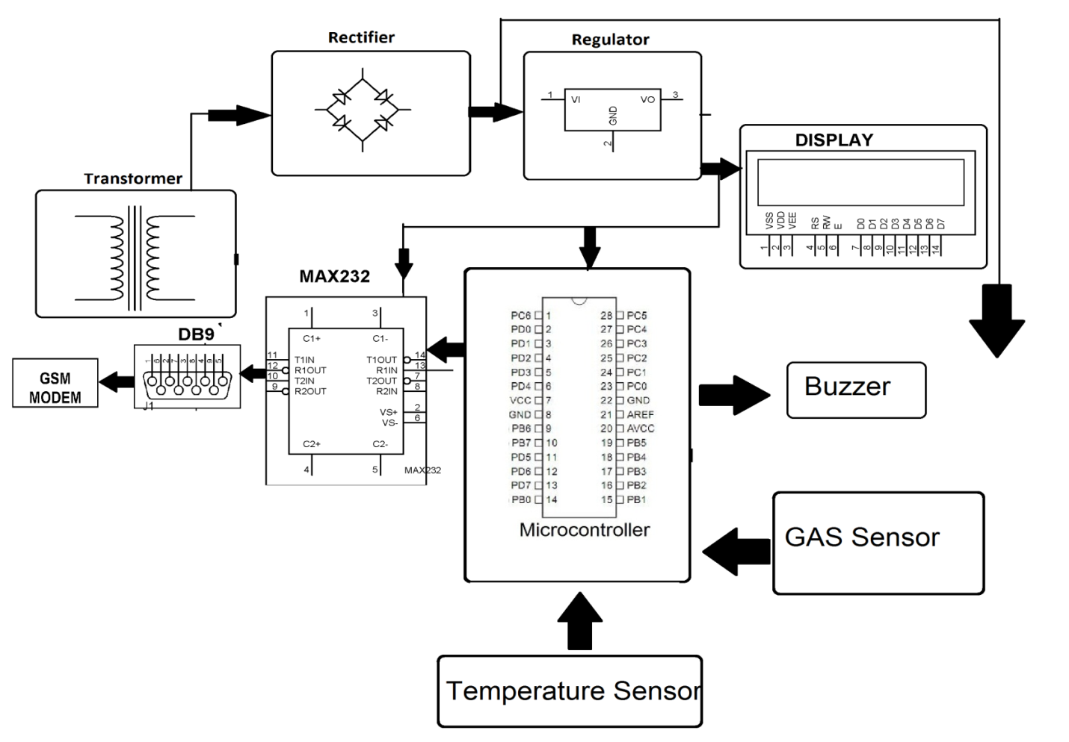

CHAPTER 4
TESTING AND IMPLEMENTATION

  - TESTING
Implementation is the stage of the project when the theoretical design is turned into a working system. This is the final and important phase in the system life cycle It is actually the process of converting the new system into a operational one.

4.1.1Unit Testing
Unit testing comprises the set of tests performed by an individual programmer prior to integration of the unit into a larger system. The module interface is tested to ensure that information properly flows into and out of the program unit. The local data structure is examined to ensure that data stored temporarily maintains its integrity during all steps in an algorithm’s execution. Boundary conditions are tested to ensure that the module operates properly at boundaries established to limit or restrict processing. All independent paths through the control structure are tested. All error-handling paths are tested.

4.1.2 Block Box Testing
Black-box testing is a method of software testing that examines the functionality of an application without peering into its internal structures or workings. This method of test can be applied virtually to every level of software testing: unit, integration, system and acceptance. It is sometimes referred to as specification-based testing.

4.2 SYSTEM IMPLEMENTATION
Implementation is the stage of the project when the theoretical design is turned into a working system. This is the final and important phase in the system life cycle It is actually the process of converting the new system into a operational one.

CHAPTER 5
CONCLUSION:
We implemented and constructed IOT coal mine system with monitoring in internet done successfully in this proposed system we integrated all input modules and output modules to the Raspberry Pi Micro processor. We obtained results accurately. This proposed system proves that this is efficient system than existing one. Used for public water quality maintain.

CHAPTER-6
REFERENCE
- [1] Dange, K.M., Patil, R.T. (2013), Design of Monitoring System for Coal Mine Safety Based on MSP430.
- [2] Toby Berger. Spatial direct reuse in remote sensor network[j]. Remote Network, 2008,14(2):133-146.
- [3] Dheeraj "IoT in burrowing for distinguishing, Monitoring and desire for underground mines Roof support", assembling on progressing information and progress development 2018
- [4] Dong "Coal Mine prosperity Monitoring system subject to Zigbee and GPRS ", Applied Mechanics and Material Volume 422,2013.
- [5] Tao Zhiyong, Li Xin. "Remote Temperature System Design Based on nRF905", Journal of Zhongguo Technology I mformation, 2007.22, p.53.
- [6] G. Dinardo, L. Fabbiano, and G. Vacca, “A smart and intuitive machine condition monitoring in the Industry 4.0 scenario,” Meas. J. Int. Meas. Confed., 2018, doi: 10.1016/j.measurement.2018.05.041.
- [7] A. Pantelopoulos and N. G. Bourbakis, “A survey on wearable sensor-based systems for health monitoring and prognosis,” IEEE Transactions on Systems, Man and Cybernetics Part C: Applications and Reviews. 2010, doi: 10.1109/TSMCC.2009.2032660.
- [8] A. Schütze, N. Helwig, and T. Schneider, “Sensors 4.0 - Smart sensors and measurement technology enable Industry 4.0,” J. Sensors Sens. Syst., 2018, doi: 10.5194/jsss-7-359-2018.

