Suggest a solution to help municipal bodies maximize solid waste collection with their given resources

ABSTRACT
Municipal solid waste management is one of the major challenges that cities in developing countries are facing. Although waste collection services are critical to build a smart city, the focus of both scholarship and action/activism has been more on the utilization of waste than on collection. We devised a choice experiment to elicit the preferences of municipal residents with regard to the various attributes of solid waste collection services in the Bharatpur Metropolitan City of Nepal. The study showed that households identify waste collection frequency, timing of door-to-door waste collection services, and cleanliness of the streets as the critical elements of municipal waste collection that affect their welfare and willingness to pay. While almost all households (95%) were participating in the waste collection service in the study area, more than half (53%) expressed dissatisfaction with the existing service. Women were the main actors engaged in waste collection and disposal at household level. The results of the choice analysis suggest that households prefer a designated waste collection time with waste collection bins placed at regular intervals on the streets for use by pedestrians who often throw garbage on the streets in the absence of bins. For these improvements, households were willing to pay an additional service fee of 10–28% on top of what they were already paying. The study also finds that municipal waste collection can be improved through the involvement of Tole Lane Committees in designing the timing and frequency of the service and by introducing a system of progressive tariffs based on the number of storeys per house.

CHAPTER 2
2. SYSTEM ANALYSIS
  - EXISTING SYSTEM

- The circular economy can play an important role in reducing materials use for construction projects, as well as reducing GHG emissions and energy and water demand of existing buildings.
- To implement these overarching plans, G20 countries are scaling up the use of existing and new policy instruments, including market, regulatory, education and information-based instruments, as well as public financial support and co-operation across value chains.
- A clear vision for the circular economy can address the fragmentation of existing initiatives and ensure continuity beyond political cycles.
2.1.1 DRAWBACKS OF EXISTING SYSTEM :
- Municipal solid waste (MSW) is a critical environmental issue in urban areas.
- Municipal residents are aware of the environmental and health issues associated with MSW due to both to widening access to electronic media and increased levels of education and awareness.
- The municipal authority has to either cover the cost of waste management from other sources at the expense of other public services or face environmental problems in the city due to neglect of solid waste management.
2.2. PROPOSED SYSTEM
- Municipal solid waste incineration (MSWI) is the burning of waste in a controlled process within a specific facility that has been built for this purpose.
- The main purpose of the paper is to provide a comprehensive view of the decentralized approach to solid waste management along with the appropriate technologies to solve the problem of processing and treatment of waste.
- Farmers generally use urea for agricultural purposes without taking care of fertility of soil.
2.2.1. ADVANTAGES OF PROPOSED SYSTEM
- There is a gap between the demand and supply of these services in terms of quality and efficiency.
- An efficient design requires prior information about the parameters, which can be obtained through various methods.
- Efficient waste management is fundamental to improve the service to citizen.
- In addition, users of smart city services have about the utility, safety, accessibility and efficiency of those services.

Literature Survey:
TITLE | AUTHORS |  | DESCRIPTION
Municipal solid waste management in Lahore city district, Pakistan | Batool, S.A.; Ch, M.N. | A GIS map of Data Ganj Bakhsh Town (DGBT) of Lahore City District showing communal storage facilities is also provided.
Environmental impact of solid waste treatment methods in Korea | Seo, S.; Aramaki, T.; Hwang, Y.; Hanaki, K. | The environmental impact of various solid waste treatment methods being used in Korea was assessed to provide useful information for decision making in solid waste management strategy.
Waste Mismanagement in Developing Countries: A Review of Global Issues | Ferronato, N.; Torretta, V. | This paper reviews the main impacts due to waste mismanagement in developing countries, focusing on environmental contamination and social issues.
Composting and compost utilization: Accounting of greenhouse gases and global warming contributions | Boldrin, A.; Andersen, J.K.; Møller, J.; Christensen, T.H.; Favoino, E. | Greenhouse gas (GHG) emissions related to composting of organic waste and the use of compost were assessed from a waste management perspective.

2.3 FEASIBILITY STUDY
The feasibility Analysis is an analytical program through project manager determines the project success ratio and through feasibility study project manager able to see either project. The key considerations involved in the feasibility analysis are:
- Economic Feasibility
- Technical Feasibility
- Operational Feasibility
- Environmental Feasibility
2.3.1 ECONOMICAL FEASIBILITY
Hence this project is economically feasible there is no need to involve any cost for this project.
2.3.2 TECHNICAL FEASIBILITY
Software Technologies used are PHP and MySql. In the educational institutions, it is possible to update the system in future. No special hardware is required for the purpose of using this system. Hence it is declared that this project is technically feasible.
2.3.3 OPERATIONAL FEASIBILITY
As the admin work mainly to maintain the Patient and Doctor .Doctor will predict patient cancer disease. Hence it is easy to operate with training. Therefore it is operationally feasible for implementation.
2.3.4 ENVIRONMENTAL FEASIBILITY
This project environment is correct as a admin has developed this system and no expenditure is involved under any head and this process is part of admin document management, this project environment is accessible.

2.4 SYSTEM REQUIREMENTS
- System : Pentium IV 2.4 GHz.
- Hard Disk : 40 GB.
- Monitor : 15 inch VGA Color.
- Mouse : Logitech Mouse.
- Ram : 512 MB
- Keyboard : Standard Keyboard

2.4.1 HARDWARE REQUIREMENTS
The Hardware of the computer consists of physical component such as Input Devices, Storage Devices, Processing & Control units and Output Devices. Computer includes external storage unit to store data in programs.
The Hardware Configuration involved in this project
- System : Pentium IV 2.4 GHz.
- Hard Disk : 40 GB.
- Monitor : 15 inch VGA Color.
- Mouse : Logitech Mouse.
- Ram : 512 MB
- Keyboard : Standard Keyboard

2.4.2 SOFTWARE REQUIREMENTS
Software is a group of programs that computers need to do a particular task. It is an essential requirement of Computer System. The Software used to develop the project is
- Operating System : Windows XP.
- Platform : DOT NET TECHNOLOGY
- Front End : ASP.Net 3.5
- Back End : SQL SERVER 2005

CHAPTER 3
SYSTEM DESIGN AND DEVELOPEMENT
SYSTEM ARCHICTURE

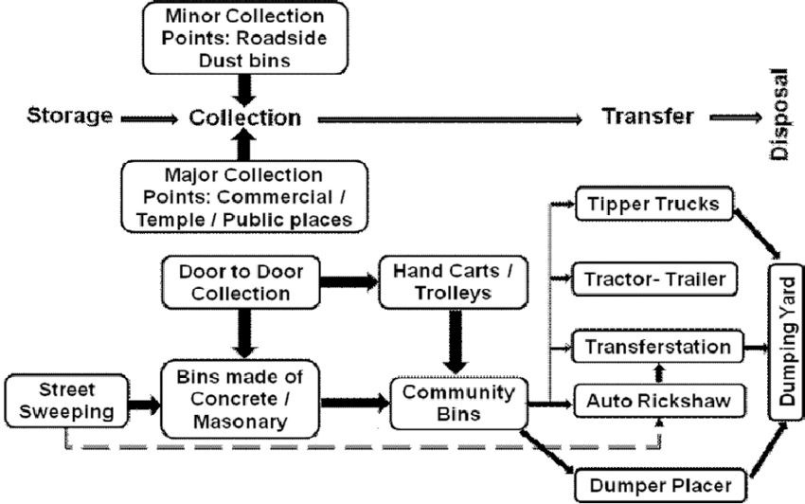

CHAPTER 4
TESTING AND IMPLEMENTATION

  - TESTING
Implementation is the stage of the project when the theoretical design is turned into a working system. This is the final and important phase in the system life cycle It is actually the process of converting the new system into a operational one.

4.1.1Unit Testing
Unit testing comprises the set of tests performed by an individual programmer prior to integration of the unit into a larger system. The module interface is tested to ensure that information properly flows into and out of the program unit. The local data structure is examined to ensure that data stored temporarily maintains its integrity during all steps in an algorithm’s execution. Boundary conditions are tested to ensure that the module operates properly at boundaries established to limit or restrict processing. All independent paths through the control structure are tested. All error-handling paths are tested.

4.1.2 Block Box Testing
Black-box testing is a method of software testing that examines the functionality of an application without peering into its internal structures or workings. This method of test can be applied virtually to every level of software testing: unit, integration, system and acceptance. It is sometimes referred to as specification-based testing.

4.2 SYSTEM IMPLEMENTATION
Implementation is the stage of the project when the theoretical design is turned into a working system. This is the final and important phase in the system life cycle It is actually the process of converting the new system into a operational one.

CHAPTER 5
CONCLUSION:
The study also suggests that waste separation at the household level without a separate pick up service may not address the problem since all waste goes together in the landfill even though households painstakingly sort it at home, which is one of the major issues of MSW management currently in BMC. Households tend to lose interest in sorting waste when the collector dumps everything in the same truck. The lifespan of the landfill site could be prolonged if waste collection and transfer are carried out separately for degradable and non-degradable waste and degradable waste is either composted or converted to energy. There has been increased interest among South Asian policy makers and stakeholders on converting waste to energy. Further study is needed in order investigate the incentives that would motivate waste collection service providers to collect and transfer degradable and non-degradable waste separately. This may provide cost effective solutions for enhancing the efficiency of MSW management through re-cycling and reusing rather than resorting to the establishment of new waste management facilities as the solution. This could be an effective way to build smart cities in developing economies.

CHAPTER-6
REFERENCE
- 1. Batool, S.A.; Ch, M.N. Municipal solid waste management in Lahore city district, Pakistan. Waste Manag. 2009, 29, 1971–1981.
- 2. Seo, S.; Aramaki, T.; Hwang, Y.; Hanaki, K. Environmental impact of solid waste treatment methods in Korea. J. Environ. Eng. 2004, 130, 81–89.
- 3. Koda, E.; Sieczka, A.; Osinski, P. Ammonium concentration and migration in groundwater in the vicinity of waste management site located in the neighborhood of protected areas of Warsaw, Poland. Sustainability 2016, 8, 1253.
- 4. Ferronato, N.; Torretta, V. Waste Mismanagement in Developing Countries: A Review of Global Issues. Int. J. Environ. Res. Public Health 2019, 16, 1060.
- 5. Boldrin, A.; Andersen, J.K.; Møller, J.; Christensen, T.H.; Favoino, E. Composting and compost utilization: Accounting of greenhouse gases and global warming contributions. Waste Manag. Res. 2009, 27, 800–812.
- 6. Mohareb, A.K.; Warith, M.A.; Diaz, R. Modelling greenhouse gas emissions for municipal solid waste management strategies in Ottawa, Ontario, Canada. Resour. Conserv. Recycl. 2008, 52, 1241–1251.
- 7. Figueroa, V.K.; Mackie, K.R.; Guarriello, N.; Cooper, C.D. A robust method for estimating landfill methane emissions. J. Air Waste Manag. Assoc. 2009, 59, 925–935.
- 8. Rowe, R.K.; Armstrong, M.D.; Cullimore, D.R. Mass loading and the rate of clogging due to municipal solid waste leachate. Can. Geotech. J. 2000, 37, 355–370.
- 9. Pervin, I.A.; Rahman, S.M.; Nepal, M.; Hague, A.E.; Karim, H.; Dhakal, G. Adaapting to urban flooding: A case of two cities in South Asia. Water Policy 2019.
- 10. Yukalang, N.; Clarke, B.; Ross, K. Solid waste management solutions for a rapidly urbanizing area in Thailand: Recommendations based on stakeholder input. Int. J. Environ. Res. Public Health 2018, 15, 1302.

