RURAL BANKING USING CLOUD COMPUTING

ABSTRACT
The Rural Banking introduced in villages to give good and better services to the people for the development of their agriculture sector or to help for their small-scale business. The banking sector in India has witnessed a complete transformation both in its functioning and delivery of services to their customers.The banking services in rural areas helps in developing economic factor that changed the profile of the village and the life of its residents. The rural banking plays a major role in the economic development of a country cannot be overlooked. The main goal is based on Cloud computing to help rural banking. Today technology being the main driving force for businesses has made banking customers to sit back at home and run their accounts without walking into the banks for anything and everything. As the advancement of technology has taken place with immense use of internet, mobile phones and online bill payments banking sector in India has a new facet altogether. The cloud computing is one of the developing technology which is being use by all industrial domain in the IT field. In this paper, I proposed the concept of using cloud computing to develop a banking system for rural areas. It considers various factors such as lack of devices and amenities in rural areas and provides efficient functionality to fulfil those gaps. It uses the latest variations of cloud computing technology for filling in the various technological gaps in village areas.The new technologies had made banks to offer new services and products to its customers, which would help improve economic activities.

CHAPTER 2
2. SYSTEM ANALYSIS
  - EXISTING SYSTEM

- These are not specific contactless payment applications in their own right, simply combinations of existing contactless retail applications (or a magnetic stripe or chip-based debit or credit card application) with either open-loop or closed-loop transit applications combined on a single payment instrument.
- However, banks should not be misled — not surprisingly, the participants for these pilots tend to be customers with a much higher propensity to be early adopters of new technology; that is, they are not a typical cross-section of a bank's existing customer base.
2.1.1 DRAWBACKS OF EXISTING SYSTEM :
- The farmers mostly lives in the rural population and need credit for agricultural activities which has the following problems related to banks. The problem in the villages is, either there is an ATM of a particular bank or there is no ATM.
- As the working expenses of the public sector banks have shot up extensively, it has become a huge problem for the public sector banks to open up and run them, making the rural banking profitable.
- To overcome these problems and make a profitable outcome to run a bank in rural areas, cloud technology helps to do in a well suitable manner to all people and in the banking sector.
2.2. PROPOSED SYSTEM
- All the user details are invisible and every informations are encrypted .it is difficult to hack.
- The properly information is given regarding the credit & debit card details.
- Using AES (Advanced encryption standard) algorithm.
- In this paper we have discussed various encryption algorithms to overcome this security issue, deals with advantages and disadvantages of these algorithms.
2.2.1. ADVANTAGES OF PROPOSED SYSTEM
- There is also a part of India which is very far away from technology and its advantages that is the rural side of India. Banks will enjoy improved efficiency ratios and operating leverage.
- Banks are offering Internet banking and moving the payment function to the cloud, simply because of the great promise of cost savings, efficiency and reliability.
- By advantage on standard development processes, scalability and collaboration enabled by the cloud, the banks will be able to create new and Innovative product and service offerings for their customers.

2.3 FEASIBILITY STUDY
The feasibility Analysis is an analytical program through project manager determines the project success ratio and through feasibility study project manager able to see either project. The key considerations involved in the feasibility analysis are:
- Economic Feasibility
- Technical Feasibility
- Operational Feasibility
- Environmental Feasibility
2.3.1 ECONOMICAL FEASIBILITY
Hence this project is economically feasible there is no need to involve any cost for this project.
2.3.2 TECHNICAL FEASIBILITY
Software Technologies used are PHP and MySql. In the educational institutions, it is possible to update the system in future. No special hardware is required for the purpose of using this system. Hence it is declared that this project is technically feasible.
2.3.3 OPERATIONAL FEASIBILITY
As the admin work mainly to maintain the Patient and Doctor .Doctor will predict patient cancer disease. Hence it is easy to operate with training. Therefore it is operationally feasible for implementation.
2.3.4 ENVIRONMENTAL FEASIBILITY
This project environment is correct as a admin has developed this system and no expenditure is involved under any head and this process is part of admin document management, this project environment is accessible.

2.4 SYSTEM REQUIREMENTS
- System : Pentium IV 2.4 GHz.
- Hard Disk : 40 GB.
- Monitor : 15 inch VGA Color.
- Mouse : Logitech Mouse.
- Ram : 512 MB
- Keyboard : Standard Keyboard

2.4.1 HARDWARE REQUIREMENTS
The Hardware of the computer consists of physical component such as Input Devices, Storage Devices, Processing & Control units and Output Devices. Computer includes external storage unit to store data in programs.
The Hardware Configuration involved in this project
- System : Pentium IV 2.4 GHz.
- Hard Disk : 40 GB.
- Monitor : 15 inch VGA Color.
- Mouse : Logitech Mouse.
- Ram : 512 MB
- Keyboard : Standard Keyboard

2.4.2 SOFTWARE REQUIREMENTS
Software is a group of programs that computers need to do a particular task. It is an essential requirement of Computer System. The Software used to develop the project is
- Operating System : Windows XP.
- Platform : DOT NET TECHNOLOGY
- Front End : ASP.Net 3.5
- Back End : SQL SERVER 2005

CHAPTER 3
SYSTEM DESIGN AND DEVELOPEMENT
SYSTEM ARCHICTURE

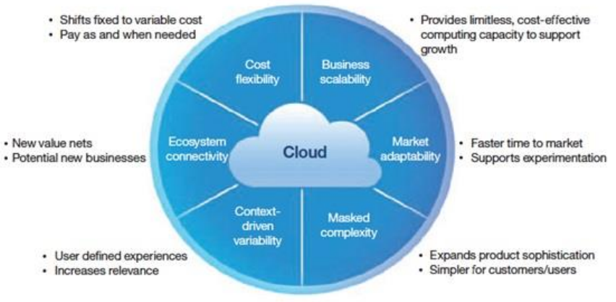

CHAPTER 4
TESTING AND IMPLEMENTATION

  - TESTING
Implementation is the stage of the project when the theoretical design is turned into a working system. This is the final and important phase in the system life cycle It is actually the process of converting the new system into a operational one.

4.1.1Unit Testing
Unit testing comprises the set of tests performed by an individual programmer prior to integration of the unit into a larger system. The module interface is tested to ensure that information properly flows into and out of the program unit. The local data structure is examined to ensure that data stored temporarily maintains its integrity during all steps in an algorithm’s execution. Boundary conditions are tested to ensure that the module operates properly at boundaries established to limit or restrict processing. All independent paths through the control structure are tested. All error-handling paths are tested.

4.1.2 Block Box Testing
Black-box testing is a method of software testing that examines the functionality of an application without peering into its internal structures or workings. This method of test can be applied virtually to every level of software testing: unit, integration, system and acceptance. It is sometimes referred to as specification-based testing.

4.2 SYSTEM IMPLEMENTATION
Implementation is the stage of the project when the theoretical design is turned into a working system. This is the final and important phase in the system life cycle It is actually the process of converting the new system into a operational one.

CHAPTER 5
CONCLUSION:
In future, Cloud technologies along with analytics, mobile technologies and big data will enable banks to unlock value from existing data and processes to address risk management and drive customer engagement. By advantage on standard development processes, scalability and collaboration enabled by the cloud, the banks will be able tocreate new and Innovative product and service offerings for their customers. The cloud architecture also offers flexibility in deployment models, thereby; enabling banks to become more agile and respond to market changes must faster and transform their businesses. As far as security in the cloud is concerned, in many cases, the security mechanisms put in place by global cloud providers may actually be stronger than those in many banks’ internal systems. The future of banking in the cloud holds great promise. Already banks in emerging markets are using the cloud to reach the unbanked population by offering mobile and electronic banking services. No doubt, possibilities of expansion using the cloud are endless for banks in the upcoming years.

CHAPTER-6
REFERENCE
- [1] http://www.netmagicsolutions.com/blog/cloudcomputing-and-the-banking-industry-a-leap-offaith#.V8WVoDYko2w/Nitin Mishra
- [2]http://www.thecloudcomputingaustralia.com/tag/ruralbanking-in-india-using-cloud-computing/Neeraj Sawant
- [3] http://www.thehindubusinessline.com/info-tech/banksconsider-cloud-computing-to-improve-efficiency-cutcosts/article2577074.ece/Priya Nair
- [4] http://www.bankingtech.com/236322/six-reasons-whycloud-computing-will-transform-the-way-banks-serveclients-and-the-five-hurdles-to-overcome/bank tech
- [5]http://ijact.org/volume2issue5/IJ0250041.pdf/Neelam Swarnkar, Asst. Professor, Dept. of Computer Science Engineering
- [6] http://www.mapsofindia.com/my-india/business/howtechnology-can-help-in-making-rural-bankingprofitable/Sanchita Paul
- [7]http://searchnetworking.techtarget.com/definition/clientserver

