EAD-NET A NOVEL LESION SEGMENTATION METHOD IN DIABETIC RETINOPATHY USING NEURAL NETWORKS

ABSTRACT
Diabetic retinopathy (DR) is a common chronic fundus disease, which has four different kinds of microvessel structure and microvascular lesions: microaneurysms (MAs), hemorrhages (HEs), hard exudates, and soft exudates. Accurate detection and counting of them are a basic but important work. The manual annotation of these lesions is a labor-intensive task in clinical analysis. To solve the problem, we proposed a novel segmentation method for different lesions in DR. Our method is based on a convolutional neural network and can be divided into encoder module, attention module, and decoder module, so we refer it as EAD-Net. After normalization and augmentation, the fundus images were sent to the EAD-Net for automated feature extraction and pixel-wise label prediction. Given the evaluation metrics based on the matching degree between detected candidates and ground truth lesions, our method achieved sensitivity of 92.77%, specificity of 99.98%, and accuracy of 99.97% on the e_ophtha_EX dataset and comparable AUPR (Area under Precision-Recall curve) scores on IDRiD dataset. Moreover, the results on the local dataset also show that our EAD-Net has better performance than original U-net in most metrics, especially in the sensitivity and F1-score, with nearly ten percent improvement. The proposed EAD-Net is a novel method based on clinical DR diagnosis. It has satisfactory results on the segmentation of four different kinds of lesions. These effective segmentations have important clinical significance in the monitoring and diagnosis of DR.
CHAPTER 2
2. SYSTEM ANALYSIS
  - EXISTING SYSTEM

- They differ in the number of studies that built their own CNN structure, and those who preferred to use the existing structures, such as VGG, ResNet, or AlexNet, with transfer learning is slightly small.
- It is notable that the accuracy of the system which built their own CNN structure is higher than those using the existing structures.
- The existence of a reliable DR screening system capable of detecting different lesions types and DR stages leads to an effective follow up system for DR patients, which averted the danger of losing sight.
2.1.1 DRAWBACKS OF EXISTING SYSTEM :
- It is a global public health problem related to microcirculation disorders which seriously affects human health.
- With the residual structure, the gradient can propagate directly through the skip connection from later layers to the earlier layers, so the vanishing gradient problem can be inhibited.
- There exist many small or fuzzy lesions and too many pooling layers might lead too much semantic information loss, we only use the max pooling layer once to avoid this problem.
2.2. PROPOSED SYSTEM
- We propose a novel local structure feature called a ring gradient descriptor (RGD) to describe the structural differences between an object and its surrounding area.
- To make up for the lack of traditional features, a novel local structure feature called ring gradient descriptor (RGD) is proposed, which scans the background around the target in an annular way to find the region most similar to the target and calculates the similarity between the region and the target.
- To accomplish this, we propose a novel candidate extraction algorithm based on dual-gray threshold segmentation and morphological processing.
2.2.1. ADVANTAGES OF PROPOSED SYSTEM
- To a certain degree, the performance of our method on e_ophtha_EX dataset can demonstrate its robustness to normal samples.
- The candidate pixels belonging to red lesions and blood vessels are separated from a reconstructed retinal image with modified coefficients, and then, the full curvelet-based blood vessels are removed, leaving the remaining part as detected red lesions.
- In contrast, our study used a single network structure and only a few changes are needed for the hyper parameter settings.
Literature Survey:
TITLE | AUTHORS | DESCRIPTION
Indian Diabetic Retinopathy Image Dataset (IDRiD): a database for diabetic retinopathy screening research | P. Porwal and S. Pachade, | Diverse and representative retinal image sets are essential for developing and testing digital screening programs and the automated algorithms at their core.
The DIARETDB1 diabetic retinopathy database and evaluation protocol | T. Kauppi, V. Kalesnykiene, J. Kamarainen et al., | The research interest is justified by the excellent potential for new products in the medical industry and significant reductions in health care costs.
Automatic detection of microaneurysms in retinopathy fluoro-angiogram | B. Lay, C. Baudoin, and J. C. Klein, | The micro aneurysms are extracted using a shape criterion which selects almost circular particles among stretched particles in one direction.
An automated microaneurysm detector as a tool for identification of diabetic retinopathy in rural optometric practice | H. Jelinek, M. J. Cree, D. R. Worsley, A. Luckie, and P. Nixon, | This study aimed to assess whether automated identification of diabetic retinopathy based on the presence of microaneurysms is an effective tool in clinical practice.

2.3 FEASIBILITY STUDY
The feasibility Analysis is an analytical program through project manager determines the project success ratio and through feasibility study project manager able to see either project. The key considerations involved in the feasibility analysis are:
- Economic Feasibility
- Technical Feasibility
- Operational Feasibility
- Environmental Feasibility
2.3.1 ECONOMICAL FEASIBILITY
Hence this project is economically feasible there is no need to involve any cost for this project.
2.3.2 TECHNICAL FEASIBILITY
Software Technologies used are PHP and MySql. In the educational institutions, it is possible to update the system in future. No special hardware is required for the purpose of using this system. Hence it is declared that this project is technically feasible.
2.3.3 OPERATIONAL FEASIBILITY
As the admin work mainly to maintain the Patient and Doctor .Doctor will predict patient cancer disease. Hence it is easy to operate with training. Therefore it is operationally feasible for implementation.
2.3.4 ENVIRONMENTAL FEASIBILITY
This project environment is correct as a admin has developed this system and no expenditure is involved under any head and this process is part of admin document management, this project environment is accessible.

2.4 SYSTEM REQUIREMENTS
- System : Pentium IV 2.4 GHz.
- Hard Disk : 40 GB.
- Monitor : 15 inch VGA Color.
- Mouse : Logitech Mouse.
- Ram : 512 MB
- Keyboard : Standard Keyboard

2.4.1 HARDWARE REQUIREMENTS
The Hardware of the computer consists of physical component such as Input Devices, Storage Devices, Processing & Control units and Output Devices. Computer includes external storage unit to store data in programs.
The Hardware Configuration involved in this project
- System : Pentium IV 2.4 GHz.
- Hard Disk : 40 GB.
- Monitor : 15 inch VGA Color.
- Mouse : Logitech Mouse.
- Ram : 512 MB
- Keyboard : Standard Keyboard

2.4.2 SOFTWARE REQUIREMENTS
Software is a group of programs that computers need to do a particular task. It is an essential requirement of Computer System. The Software used to develop the project is
- Operating System : Windows XP.
- Platform : DOT NET TECHNOLOGY
- Front End : ASP.Net 3.5
- Back End : SQL SERVER 2005

CHAPTER 3
SYSTEM DESIGN AND DEVELOPEMENT
SYSTEM ARCHICTURE

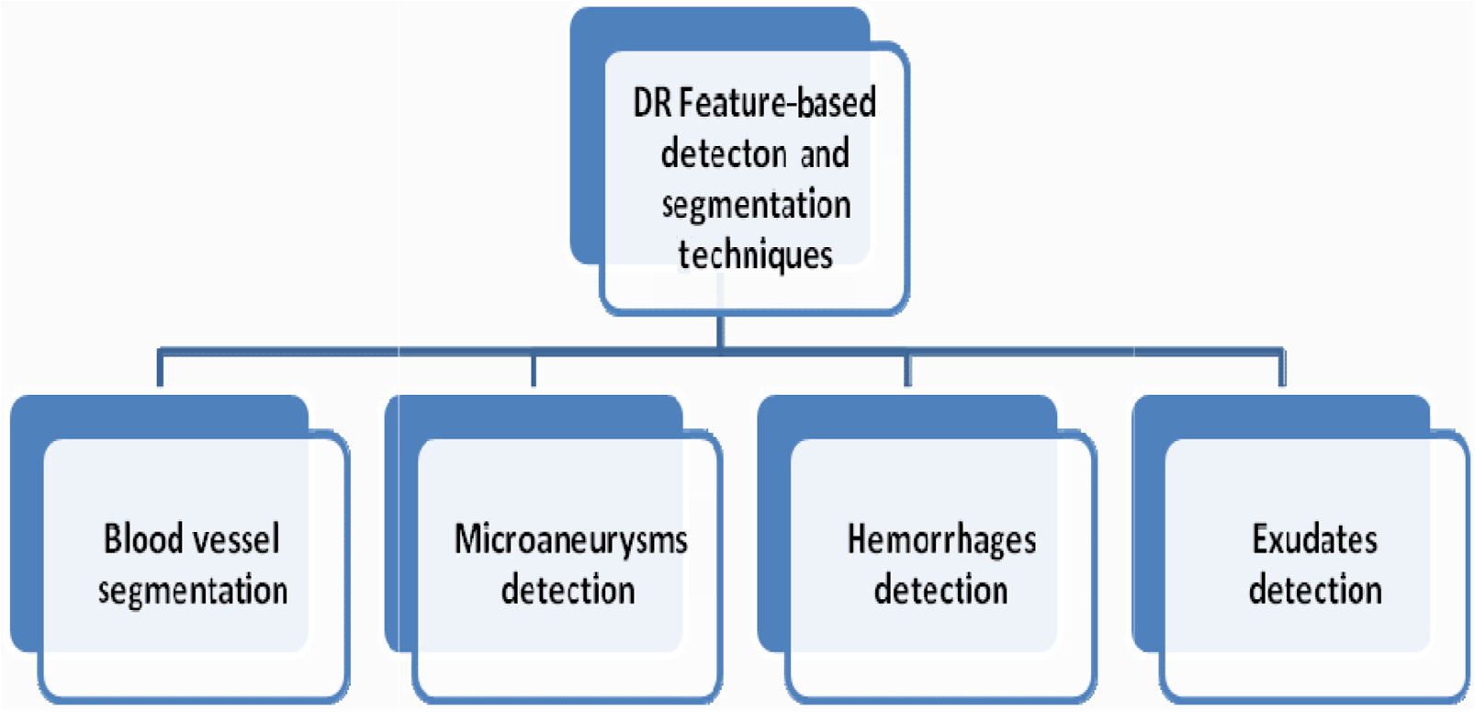

CHAPTER 4
TESTING AND IMPLEMENTATION

  - TESTING
Implementation is the stage of the project when the theoretical design is turned into a working system. This is the final and important phase in the system life cycle It is actually the process of converting the new system into a operational one.

4.1.1Unit Testing
Unit testing comprises the set of tests performed by an individual programmer prior to integration of the unit into a larger system. The module interface is tested to ensure that information properly flows into and out of the program unit. The local data structure is examined to ensure that data stored temporarily maintains its integrity during all steps in an algorithm’s execution. Boundary conditions are tested to ensure that the module operates properly at boundaries established to limit or restrict processing. All independent paths through the control structure are tested. All error-handling paths are tested.

4.1.2 Block Box Testing
Black-box testing is a method of software testing that examines the functionality of an application without peering into its internal structures or workings. This method of test can be applied virtually to every level of software testing: unit, integration, system and acceptance. It is sometimes referred to as specification-based testing.

4.2 SYSTEM IMPLEMENTATION
Implementation is the stage of the project when the theoretical design is turned into a working system. This is the final and important phase in the system life cycle It is actually the process of converting the new system into a operational one.

CHAPTER 5
CONCLUSION:
The DR-AI research based directly on lesions is in line with clinical diagnostic thinking of ophthalmology. In this paper, we propose a convolutional neural network architecture EAD-Net for the lesion segmentation task. The architecture can be divided into three parts: encoder module, dual attention module, and decoder module. On both public and local datasets, we compare the performance of the EAD-Net with other state-of-the-art methods and prove its superiority. Experimental results show that our network has satisfactory results on the segmentation of four different kinds of lesions. These effective segmentation results have important clinical significance in the screening and diagnosis of DR. With more accurate performance and appropriate diagnostic rules based on the lesions, the proposed method will be more suitable for the clinical application.

CHAPTER-6
REFERENCE
- [1] P. Porwal and S. Pachade, “Indian Diabetic Retinopathy Image Dataset (IDRiD): a database for diabetic retinopathy screening research,” Data, vol. 3, no. 3, p. 25, 2018.
- [2] T. Kauppi, V. Kalesnykiene, J. Kamarainen et al., “The DIARETDB1 diabetic retinopathy database and evaluation protocol,” in Proceedings of the British Machine Vision Conference, vol. 1, pp. 1–10, Warwick, UK, 2007.
- [3] M. Javidi, A. Harati, and H. R. Pourreza, “Retinal image assessment using bi-level adaptive morphological component analysis,” Artificial Intelligence in Medicine, vol. 99, article 101702, 2019.
- [4] H. Jelinek, M. J. Cree, D. R. Worsley, A. Luckie, and P. Nixon, “An automated microaneurysm detector as a tool for identification of diabetic retinopathy in rural optometric practice,” Clinical & Experimental Optometry, vol. 89, no. 5, pp. 299– 305, 2006.
- [5] B. Antal and A. Hajdu, “An ensemble-based system for microaneurysm detection and diabetic retinopathy grading,” IEEE Transactions on Biomedical Engineering, vol. 59, no. 6, pp. 1720–1726, 2012.
- [6] B. Lay, C. Baudoin, and J. C. Klein, “Automatic detection of microaneurysms in retinopathy fluoro-angiogram,” in Proceedings of Spie the International Society for Optical Engineering, vol. 1, pp. 165–173, San Diego, USA, 1984.
- [7] L. Seoud, T. Hurtut, J. Chelbi, F. Cheriet, and J. P. Langlois, “Red lesion detection using dynamic shape features for diabetic retinopathy screening,” IEEE Transactions on Medical Imaging, vol. 35, no. 4, pp. 1116–1126, 2016.
- [8] B. Harangi and A. Hajdu, “Automatic exudate detection by fusing multiple active contours and regionwise classification,” Computers in Biology and Medicine, vol. 54, no. 1, pp. 156– 171, 2014.
- [9] C. Pereira, L. Goncalves, and M. Ferreira, “Exudate segmentation in fundus images using an ant colony optimization approach,” Information Sciences, vol. 296, no. 1, pp. 14–24, 2015
- [10] L. Seoud, T. Faucon, T. Hurtut, J. Chelbi, and J. P. Langlois, “Automatic detection of microaneurysms and haemorrhages in fundus images using dynamic shape features,” in 2014 IEEE 11th International Symposium on Biomedical Imaging (ISBI), vol. 1, pp. 101–104, Beijing, China, 2014.

