System would Identification of System Generated, Spoof Calls landing at Dial 100 Control Room

ABSTRACT
Caller ID (caller identification) is a service provided by telephone carriers to transmit the phone number and/or the name of a caller to a callee. Today, most people trust the caller ID information, and it is increasingly used to authenticate customers (e.g., by banks or credit card companies). However, with the proliferation of smartphones and VoIP, it is easy to spoof caller ID by installing corresponding Apps on smartphones or by using fake ID providers. As telephone networks are fragmented between enterprises and countries, no mechanism is available today to easily detect such spoofing attacks. This vulnerability has already been exploited with crucial consequences such as faking caller IDs to emergency services (e.g., 9-1-1) or to commit fraud. In this paper, we propose an end-to-end caller ID verification mechanism CallerDec that works with existing combinations of landlines, cellular and VoIP networks. CallerDec can be deployed at the liberty of users, without any modification to the existing infrastructures. We implemented our scheme as an App for Android-based phones and validated the effectiveness of our solution in detecting spoofing attacks in various scenarios.

CHAPTER 2
2. SYSTEM ANALYSIS
  - EXISTING SYSTEM

- Existing caller ID protocols do not provide real authentication and hence are untrustworthy for authenticating callers’ locations or identities, because caller IDs are vulnerable to spoofing attacks; i.e., an attacker can easily send a fake caller ID to a callee.
- The detection solution should only change telephone terminals but not the existing telephone infrastructure, because adding any extra hardware to the existing infrastructure or introducing new protocols to the core telephone networks would be a great expense to all telephone carriers.
2.1.1 DRAWBACKS OF EXISTING SYSTEM :
- To overcome the problem, we leverage Android hidden APIs of ITelephony interface using java reflection. Moreover, telephone carriers may not be able to solve the problem even if they can redesign the protocols.
- While the problem of caller ID spoofing is generally known, previously proposed solutions typically require the cooperation and modification of phone provider networks, which imposes extra cost.
- However, it does not address the problem of fake ID providers, which have both incentive and means to fake most of this meta-data.
2.2. PROPOSED SYSTEM
- We propose CallerDec, end-to-end caller ID verification schemes that require no modification to the existing telephone infrastructure.
- This is aggravated by the fact that the proposed authentication scheme is only useful if widely deployed, so that unauthenticated calls can be rejected.
- Several ways of comparing the call’s meta-data with the claimed caller ID are proposed, however, it does not address the problem of fake ID providers, which have both incentive and means to fake most of this meta-data.
2.2.1. ADVANTAGES OF PROPOSED SYSTEM
- The CallerDec performance in various scenarios, and show that it can detect spoofed caller ID effectively and efficiently (i.e. incurring almost no extra energy overhead).
- The Bayesian classifier is an efficient method for calculating posterior probability based on prior probability and likelihood in the training data.
- However, Caller ID has been increasingly used to authenticate the identities of callers, or to verify their physical locations in several systems, ranging from 9-1-1 emergency services, automatic telephone banking systems, credit card activation systems, to voicemail services.
2.3 FEASIBILITY STUDY
The feasibility Analysis is an analytical program through project manager determines the project success ratio and through feasibility study project manager able to see either project. The key considerations involved in the feasibility analysis are:
- Economic Feasibility
- Technical Feasibility
- Operational Feasibility
- Environmental Feasibility
2.3.1 ECONOMICAL FEASIBILITY
Hence this project is economically feasible there is no need to involve any cost for this project.
2.3.2 TECHNICAL FEASIBILITY
Software Technologies used are PHP and MySql. In the educational institutions, it is possible to update the system in future. No special hardware is required for the purpose of using this system. Hence it is declared that this project is technically feasible.
2.3.3 OPERATIONAL FEASIBILITY
As the admin work mainly to maintain the Patient and Doctor .Doctor will predict patient cancer disease. Hence it is easy to operate with training. Therefore it is operationally feasible for implementation.

2.3.4 ENVIRONMENTAL FEASIBILITY
This project environment is correct as a admin has developed this system and no expenditure is involved under any head and this process is part of admin document management, this project environment is accessible.
2.4 SYSTEM REQUIREMENTS
- System : Pentium IV 2.4 GHz.
- Hard Disk : 40 GB.
- Monitor : 15 inch VGA Color.
- Mouse : Logitech Mouse.
- Ram : 512 MB
- Keyboard : Standard Keyboard
2.4.1 HARDWARE REQUIREMENTS
The Hardware of the computer consists of physical component such as Input Devices, Storage Devices, Processing & Control units and Output Devices. Computer includes external storage unit to store data in programs.
The Hardware Configuration involved in this project
- System : Pentium IV 2.4 GHz.
- Hard Disk : 40 GB.
- Monitor : 15 inch VGA Color.
- Mouse : Logitech Mouse.
- Ram : 512 MB
- Keyboard : Standard Keyboard

2.4.2 SOFTWARE REQUIREMENTS
Software is a group of programs that computers need to do a particular task. It is an essential requirement of Computer System. The Software used to develop the project is
- Operating System : Windows XP.
- Platform : DOT NET TECHNOLOGY
- Front End : ASP.Net 3.5
- Back End : SQL SERVER 2005

CHAPTER 3
SYSTEM DESIGN AND DEVELOPEMENT
SYSTEM ARCHICTURE

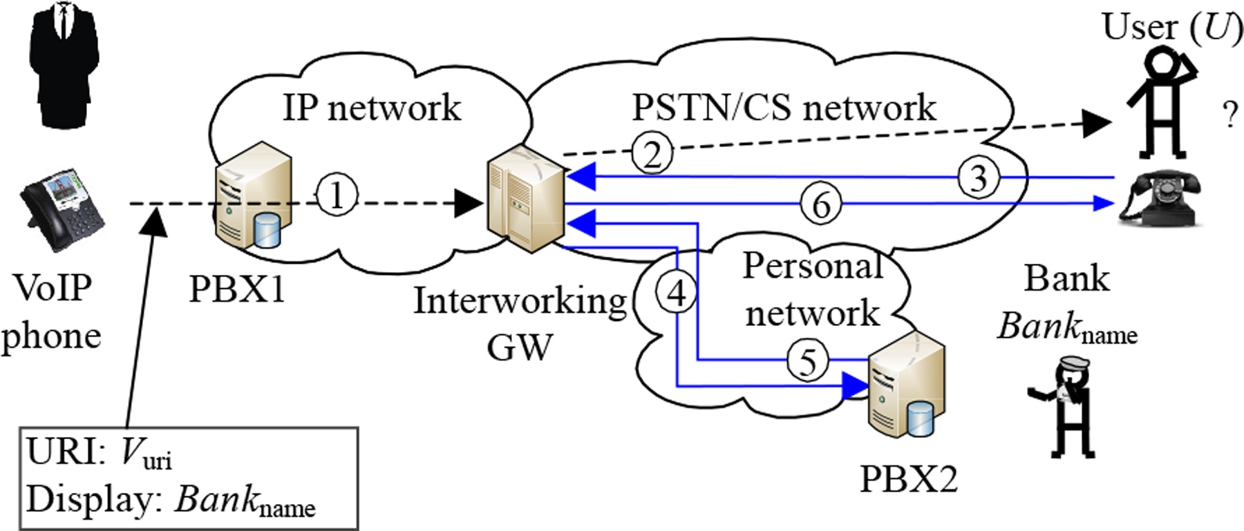

CHAPTER 4
TESTING AND IMPLEMENTATION

  - TESTING
Implementation is the stage of the project when the theoretical design is turned into a working system. This is the final and important phase in the system life cycle It is actually the process of converting the new system into a operational one.

4.1.1Unit Testing
Unit testing comprises the set of tests performed by an individual programmer prior to integration of the unit into a larger system. The module interface is tested to ensure that information properly flows into and out of the program unit. The local data structure is examined to ensure that data stored temporarily maintains its integrity during all steps in an algorithm’s execution. Boundary conditions are tested to ensure that the module operates properly at boundaries established to limit or restrict processing. All independent paths through the control structure are tested. All error-handling paths are tested.

4.1.2 Block Box Testing
Black-box testing is a method of software testing that examines the functionality of an application without peering into its internal structures or workings. This method of test can be applied virtually to every level of software testing: unit, integration, system and acceptance. It is sometimes referred to as specification-based testing.

4.2 SYSTEM IMPLEMENTATION
Implementation is the stage of the project when the theoretical design is turned into a working system. This is the final and important phase in the system life cycle It is actually the process of converting the new system into a operational one.

CHAPTER 5
CONCLUSION:
In this paper, we investigated caller ID spoofing attacks and identified that it is the network interconnection protocols that make caller ID spoofing possible. We designed an end-to-end solution, which we call CallerDec, to detect a spoofed caller ID. CallerDec verifies the caller ID using a covert channel, which is built on top of the verification call from the callee to the claimed caller, and CallerDec uses timing estimation together with the call status for verification. We implemented CallerDec in Android-based phones and validated that CallerDec can effectively verify caller ID. Although the end-to-end delay for completing a verification takes a few seconds, such delay can be hidden when the verification is performed in parallel to the voice call. We studied CallerDec on Android-based phones as a case study, but CallerDec can be integrated to other types of phone terminals to protect end users from caller ID spoofing attacks. In addition, the current CallerDec will conclude NOTSUPPORTED when CallerDec is not implemented by a phone terminal. We envision that NOTSUPPORTED can be eliminated once the CallerDec is supported on all telephone terminals.

CHAPTER-6
REFERENCE
- [1] B. Schneier, http://www.schneier.com/blog/archives/2006/03/- caller_id_spoof.html.
- [2] ABCNews, Caller ID Scam Solicits Personal Info, Money. abcnews.go.com/GMA/Consumer/story?id=3305916, 2007.
- [3] D. Cuellar, Pranksters Terrorize Delco Family in “swatting” Call. WPVI-TV, Philadelphia, PA, 2010.
- [4] Rep. Engel Anti-Spoofing Bill Passes House, http://engel.house.gov/latest-news1/rep-engel-anti-spoofingbill-passes-house.
- [5] US Congress, Truth in Caller ID Act of 2009. www.gpo.gov.
- [6] X-Lite. www.counterpath.com/x-lite.html.
- [7] Caller ID Faker-Fake a Call! www.calleridfaker.com.
- [8] TrustID. www.trustid.com.
- [9] ETSI, UMTS, www.etsi.org.
- [10] ——, W-CDMA, www.etsi.org.

