Develop a Smart Attendance Capturing Mobile App

ABSTRACT
Student’s attendance tracking is a vital issue in order to monitor students’ performance in the classroom as well as in their studies. It becomes a key concern because the university authority maintains a rule that one student can only attend in the exam if his/her attendance is higher or equal to several percentages (60%,70% or 80% etc.) otherwise not. The traditional attendance system needs student’s to physically sign the attendance sheet each time for the attendance of each class. This is unnecessarily timeconsuming to notice and mark student's name on the attendance sheet. This also happens that some students may accidentally or willingly mark the student's name like as proxy. The hard copy of attendance sheet may get lost. Using Smartphone like as Android Technology the course teacher will be able to take attendance easily by our designed mobile application and save the attendance in the phone as well as in server and can check percentage and also can print as hard copy. Using the stored information, this system is able to mark attendance, marking intruders’ entry, attendance percentage calculations, send emails, and send SMS to the guardian to keep them updated about their child’s attendance at the Institute. The designed system has an online access from any place and any moment which may extraordinarily assist the course teacher with keeping track of their student’s attendance.

CHAPTER 2
2. SYSTEM ANALYSIS
  - EXISTING SYSTEM

- The existing system is a manual entry for the students. Here the attendance will be carried out in the hand written registers.
- It will be a tedious job to maintain the record for the user. The human effort is more here. The retrieval of the information is not as easy as the records are maintained in the hand written registers.
- This application requires correct feed on input into the respective field. Suppose the wrong inputs are entered, the application resist to work and if the register is lost the data cannot be retrieved back.
2.1.1 DRAWBACKS OF EXISTING SYSTEM :
- Student’s attendance tracking is a vital issue in order to monitor students’ performance in the classroom as well as in their studies.
- Endeavoring to peruse a few tags at any given moment may bring about flag impact and eventually to data misfortune in RFID system, our system is free from this type of problem.
- In bar coding system there arise some problems like as optical observable pathway checking, constrained perceptibility, confined traceability, unequipped for item level tracking, work concentrated, defense less to ecological destruction, inclined to human blunder.
2.2. PROPOSED SYSTEM
- The proposed system will store, retrieve and sent the student information to the concerned person.
- In, proposed a framework for maintaining student attendance and also it tracks the illegal use of mobile phones during class hours.
- In, proposed location based and attendance system to record and track staff arrivals in their office premises.
- With the proposed software of database space manager ready and fully functional the client is now able to manage and hence run the entire work in a much better, accurate and error free manner.
2.2.1. ADVANTAGES OF PROPOSED SYSTEM
- In the performance measure, a course teacher can easily use and edit the excel data.
- The student’s academic information consists of monitoring their performance and progress periodically which seems to be a huge workload on lecturers to handle and update on the progress of subjects for the respective classes.
- In order to reduce the manual work and to achieve more efficiency in managing student’s information, a smart phone based mobile application using android can be applied to make this process more easy and beneficial in every way.

Literature Survey:
TITLE | AUTHORS | DESCRIPTION
Research on the management system of University Students | G.P. Zhang, | The informationization of student status archives management system in colleges and universities has become a hot topic of concern.
Automating a student class attendance register using radio frequency identification in South Africa | B. N. Gatsheni, R. B. Kuriakose and F. Aghdasi, | We have automated the class attendance register using radio frequency identification technology in combination with internet hotspot.
Fingerprint attendance system for classroom needs | B. K. P. Mohamed and C. V. Raghu, | Fingerprint attendance system aims to automate the attendance procedure of an educational institution using biometric technology.
Smart NFC Interface Platform and its Applications | M. Strommer et al., | The proposed solution takes advantage of the Near Field Communications technology, which is simple and intuitive to use, to enable advanced user interaction.

2.3 FEASIBILITY STUDY
The feasibility Analysis is an analytical program through project manager determines the project success ratio and through feasibility study project manager able to see either project. The key considerations involved in the feasibility analysis are:
- Economic Feasibility
- Technical Feasibility
- Operational Feasibility
- Environmental Feasibility
2.3.1 ECONOMICAL FEASIBILITY
Hence this project is economically feasible there is no need to involve any cost for this project.
2.3.2 TECHNICAL FEASIBILITY
Software Technologies used are PHP and MySql. In the educational institutions, it is possible to update the system in future. No special hardware is required for the purpose of using this system. Hence it is declared that this project is technically feasible.
2.3.3 OPERATIONAL FEASIBILITY
As the admin work mainly to maintain the Patient and Doctor .Doctor will predict patient cancer disease. Hence it is easy to operate with training. Therefore it is operationally feasible for implementation.
2.3.4 ENVIRONMENTAL FEASIBILITY
This project environment is correct as a admin has developed this system and no expenditure is involved under any head and this process is part of admin document management, this project environment is accessible.

2.4 SYSTEM REQUIREMENTS
- System : Pentium IV 2.4 GHz.
- Hard Disk : 40 GB.
- Monitor : 15 inch VGA Color.
- Mouse : Logitech Mouse.
- Ram : 512 MB
- Keyboard : Standard Keyboard

2.4.1 HARDWARE REQUIREMENTS
The Hardware of the computer consists of physical component such as Input Devices, Storage Devices, Processing & Control units and Output Devices. Computer includes external storage unit to store data in programs.
The Hardware Configuration involved in this project
- System : Pentium IV 2.4 GHz.
- Hard Disk : 40 GB.
- Monitor : 15 inch VGA Color.
- Mouse : Logitech Mouse.
- Ram : 512 MB
- Keyboard : Standard Keyboard

2.4.2 SOFTWARE REQUIREMENTS
Software is a group of programs that computers need to do a particular task. It is an essential requirement of Computer System. The Software used to develop the project is
- Operating System : Windows XP.
- Platform : DOT NET TECHNOLOGY
- Front End : ASP.Net 3.5
- Back End : SQL SERVER 2005

CHAPTER 3
SYSTEM DESIGN AND DEVELOPEMENT
SYSTEM ARCHICTURE

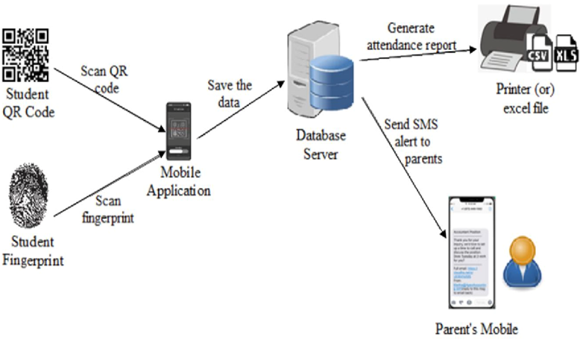

CHAPTER 4
TESTING AND IMPLEMENTATION

  - TESTING
Implementation is the stage of the project when the theoretical design is turned into a working system. This is the final and important phase in the system life cycle It is actually the process of converting the new system into a operational one.

4.1.1Unit Testing
Unit testing comprises the set of tests performed by an individual programmer prior to integration of the unit into a larger system. The module interface is tested to ensure that information properly flows into and out of the program unit. The local data structure is examined to ensure that data stored temporarily maintains its integrity during all steps in an algorithm’s execution. Boundary conditions are tested to ensure that the module operates properly at boundaries established to limit or restrict processing. All independent paths through the control structure are tested. All error-handling paths are tested.

4.1.2 Block Box Testing
Black-box testing is a method of software testing that examines the functionality of an application without peering into its internal structures or workings. This method of test can be applied virtually to every level of software testing: unit, integration, system and acceptance. It is sometimes referred to as specification-based testing.

4.2 SYSTEM IMPLEMENTATION
Implementation is the stage of the project when the theoretical design is turned into a working system. This is the final and important phase in the system life cycle It is actually the process of converting the new system into a operational one.

CHAPTER 5
CONCLUSION:
Smartphone-based Student Attendance System will significantly develop the conventional procedure of student attendance framework in a university/college/school surroundings. Smartphone-based Student Attendance System is a computerized information accumulation technology, which leads to more precise data entry. The stored student attendance data are framed and investigate inevitably without any loss of data, compared to a traditional recording method. A course teacher can easily monitor the attendance of students which may develop the excellence of instruction because the fewer time required to collect and process data. Implementing the system in educational environment helps the user to identify attendance, proxy attendance, calculate percentage etc. SMS and Email messages are sent via the system automatically to inform parents so that they can get notified about their child’s progress in the institution.

CHAPTER-6
REFERENCE
- [1] G.P. Zhang, “Research on the management system of University Students,” Northeast Normal University, China, pp. 17-19, 2013.
- [2] B. N. Gatsheni, R. B. Kuriakose and F. Aghdasi, "Automating a student class attendance register using radio frequency identification in South Africa," 2007 IEEE International Conference on Mechatronics, Kumamoto, pp. 1-5, 2007.
- [3] Z. Zhang, P. Gong, L. Cao and Y. Chen, "Design and Implementation of Educational Administration Attendance Management System Based on B/S and C/S," 2007 First IEEE International Symposium on Information Technologies and Applications in Education, Kunming, pp. 606-609, 2007.
- [4] B. K. P. Mohamed and C. V. Raghu, "Fingerprint attendance system for classroom needs," 2012 Annual IEEE India Conference (INDICON), Kochi, pp. 433-438, 2012.
- [5] M. Strommer et al., “Smart NFC Interface Platform and its Applications,” in T. Tuikka and M. Isomursu, (Eds.), Touch the Future with a Smart Touch, 2009.
- [6] RFID Sens Net Lab, “A white paper on Automatic Attendance System,” Texas A & M University, Texas, USA, 2005.
- [7] B. Soewito, F. L. Gaol, E. Simanjuntak and F. E. Gunawan, "Attendance system on Android smartphone," 2015 International Conference on Control, Electronics, Renewable Energy and Communications (ICCEREC), Bandung, pp. 208-211, 2015.
- [8] S. A. M. Noor, N. Zaini, M. F. A. Latip and N. Hamzah, "Android-based attendance management system," 2015 IEEE Conference on Systems, Process and Control (ICSPC), Bandar Sunway, pp. 118-122, 2015.
- [9] M. Kassim, H. Mazlan, N. Zaini and M. K. Salleh, "Web-based student attendance system using RFID technology," 2012 IEEE Control and System Graduate Research Colloquium, Shah Alam, Selangor, pp. 213- 218, 2012.

